11/17

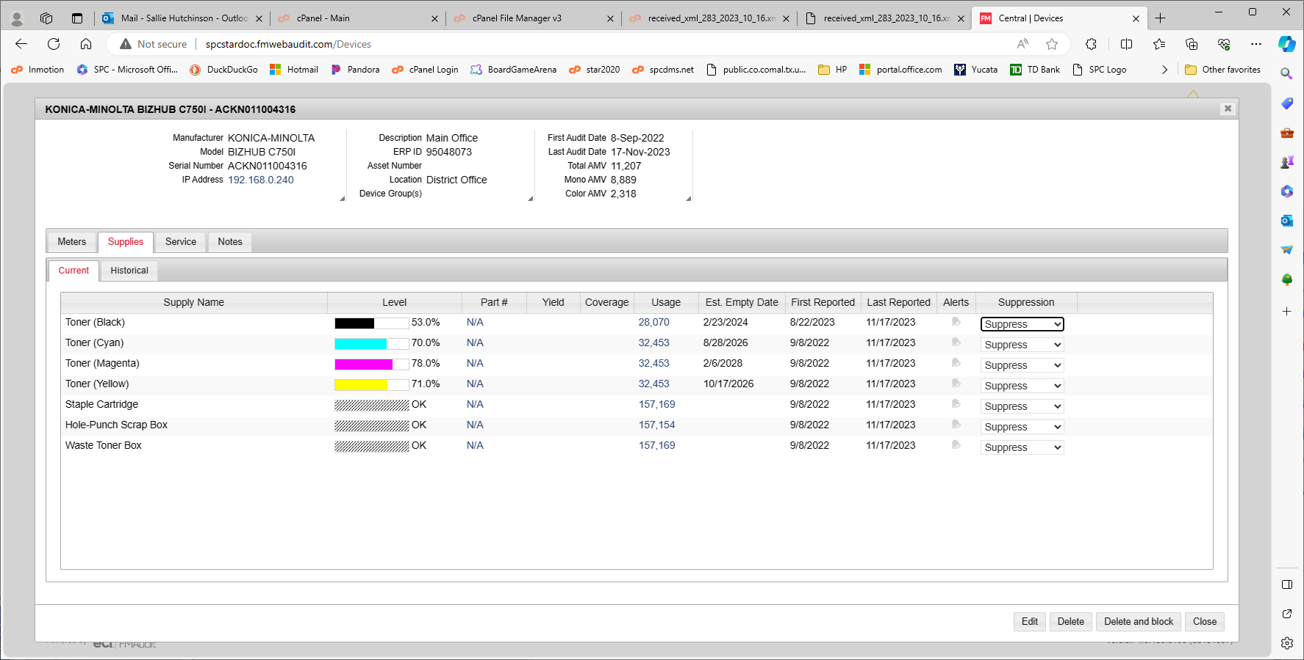

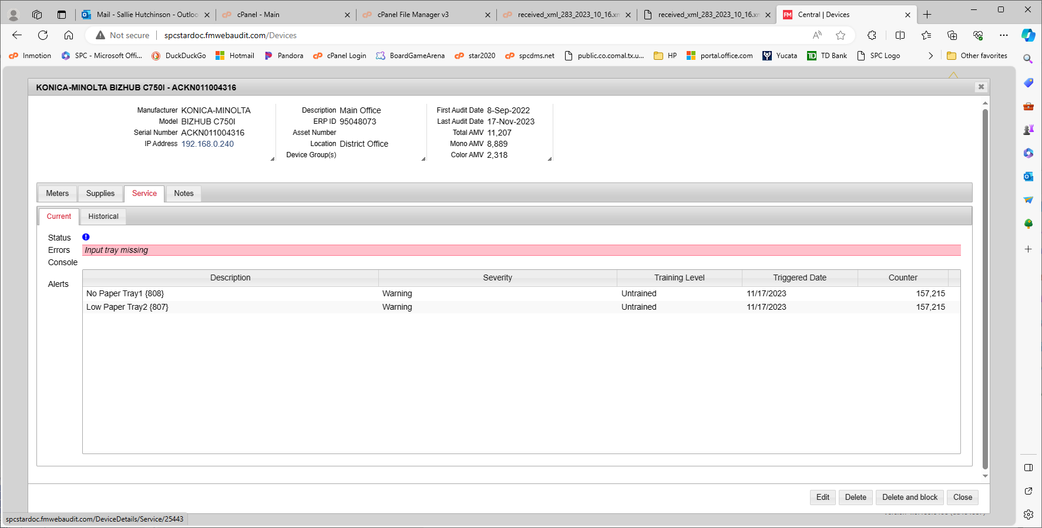

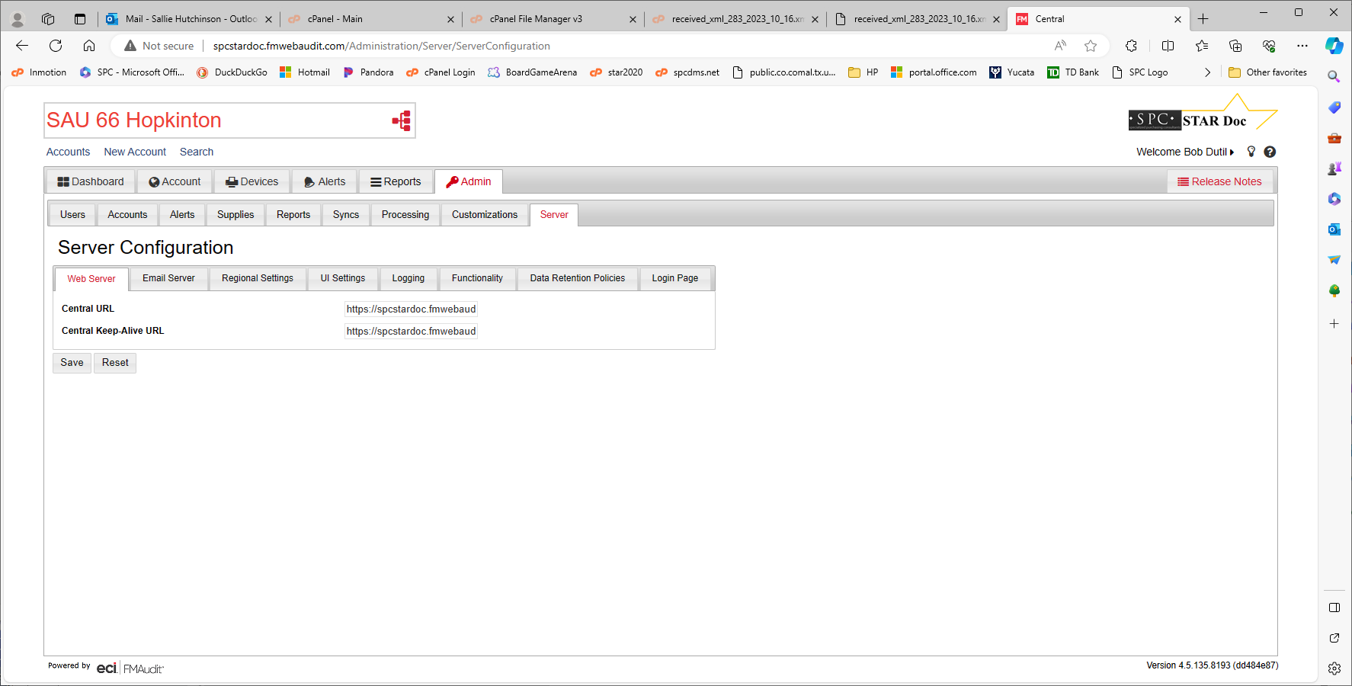

<AlertHashCode>1808486362</AlertHashCode>

<AlertSeverityLevel>Warning</AlertSeverityLevel>

<AlertTrainingLevel>Unknown</AlertTrainingLevel>

<AlertGroup>input</AlertGroup>

<AlertGroupIndex>2</AlertGroupIndex>

<AlertLocation>136327424</AlertLocation> <AlertLocation>11302</AlertLocation>

<AlertCode>inputMediaSupplyLow</AlertCode>

<AlertDescription>Paper Low Tray 1</AlertDescription>

<AlertTime>0001-01-01T00:00:00</AlertTime>

</FMADeviceAlertEntry>

<FMADeviceAlertEntry Version="4.5.135.8193" APIVersion="4.5.135.8193">

<AuditDate>2023-11-17T02:14:05.353</AuditDate>

<AlertAllEvents>0</AlertAllEvents>

<AlertCriticalEvents>0</AlertCriticalEvents>

<AlertSysUpTime>0001-01-01T00:00:00</AlertSysUpTime>

<AlertIndex>0</AlertIndex>

Errors according to validator

&nbsp;

nowrap

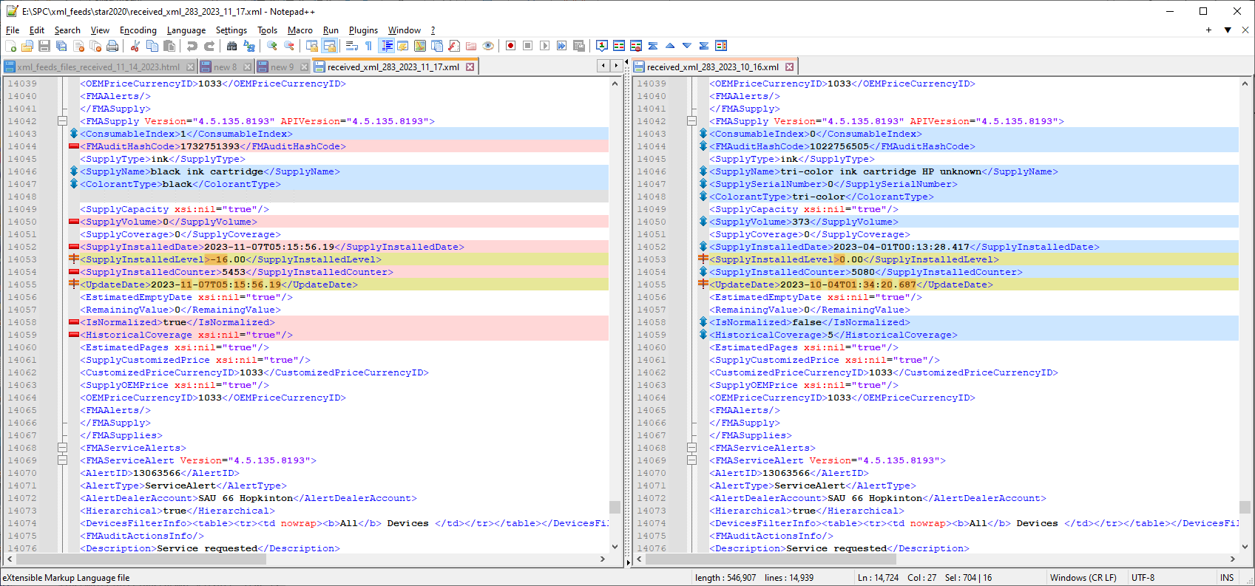

<FMADeviceAlertEntry Version="4.5.135.8193" APIVersion="4.5.135.8193">

<AuditDate>2023-11-17T02:14:05.353</AuditDate>

<AlertAllEvents>0</AlertAllEvents>

<AlertCriticalEvents>0</AlertCriticalEvents>

<AlertSysUpTime>0001-01-01T00:00:00</AlertSysUpTime>

<AlertIndex>0</AlertIndex>

<AlertHashCode>1441520651</AlertHashCode>

<AlertSeverityLevel>Warning</AlertSeverityLevel>

<AlertTrainingLevel>Unknown</AlertTrainingLevel>

<AlertGroup>input</AlertGroup>

<AlertGroupIndex>2</AlertGroupIndex>

<AlertLocation>136327680</AlertLocation>

<AlertCode>inputMediaSupplyLow</AlertCode>

<AlertDescription>Low Paper Tray2</AlertDescription>

<AlertTime>0001-01-01T00:00:00</AlertTime>

</FMADeviceAlertEntry>

/****************************/

SELECT * FROM `floorplan_machines` WHERE proposed_serial_number = 'ACKN011004316';

SELECT * FROM `meters` WHERE serial_number = 'ACKN011004316' order by created_date desc;

select * from machine_statuses where serial_number = 'ACKN011004316' order by created_date desc;

SELECT * FROM `meters` WHERE created_date > '2023-11-16 00:00:00' order by created_date desc;

select * from a_xml_feeds_meters where serial_number = 'ACKN011004316';

select * from a_xml_feeds_machine_statuses where serial_number = 'ACKN011004316';

select * from org_x_fmaudit where fmaudit_client_id = 283;

select * from organizations where org_id = 1919;

fpm_id 45927 ($ID)

Fields for processxml

<AccountID>283</AccountID>

<Name>SAU 66 Hopkinton</Name>

FMAMeters Children

<Date>2023-11-17T00:36:56.69</Date>

<Name>PageCountTotal</Name>

<Value>156938</Value>

<SerialNumber>ACKN011004316</SerialNumber>

<MacAddress>00-20-6B-F9-0A-48</MacAddress>

<IpAddress>192.168.0.240</IpAddress>

<Location>District Office</Location>

<DeviceID>25443</DeviceID> ($fmaudit_id)

<ModelID>0</ModelID>

<Model>BIZHUB C750I</Model> (model_details model_id for this model = 3500)

<Manufacturer>KONICA-MINOLTA</Manufacturer>

<Description>Main Office</Description>

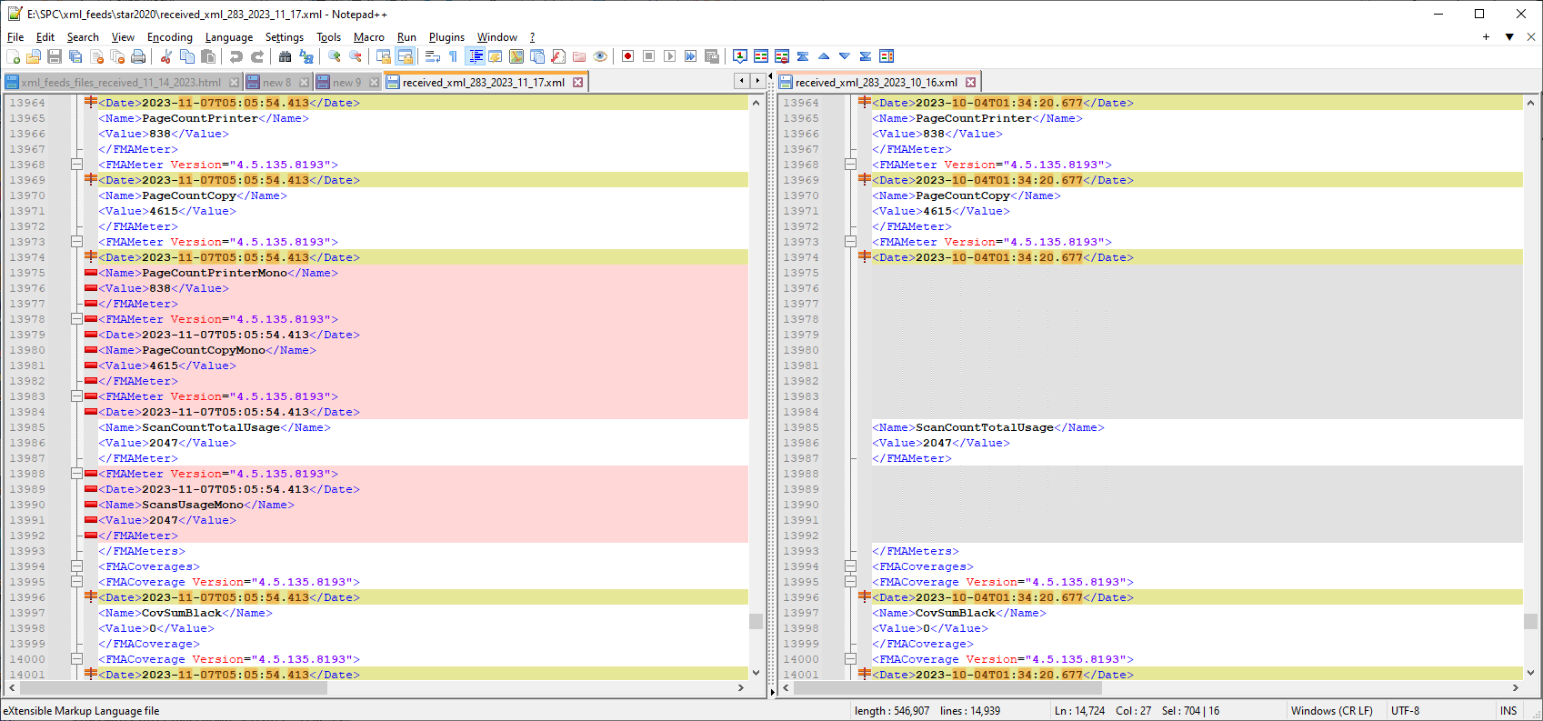

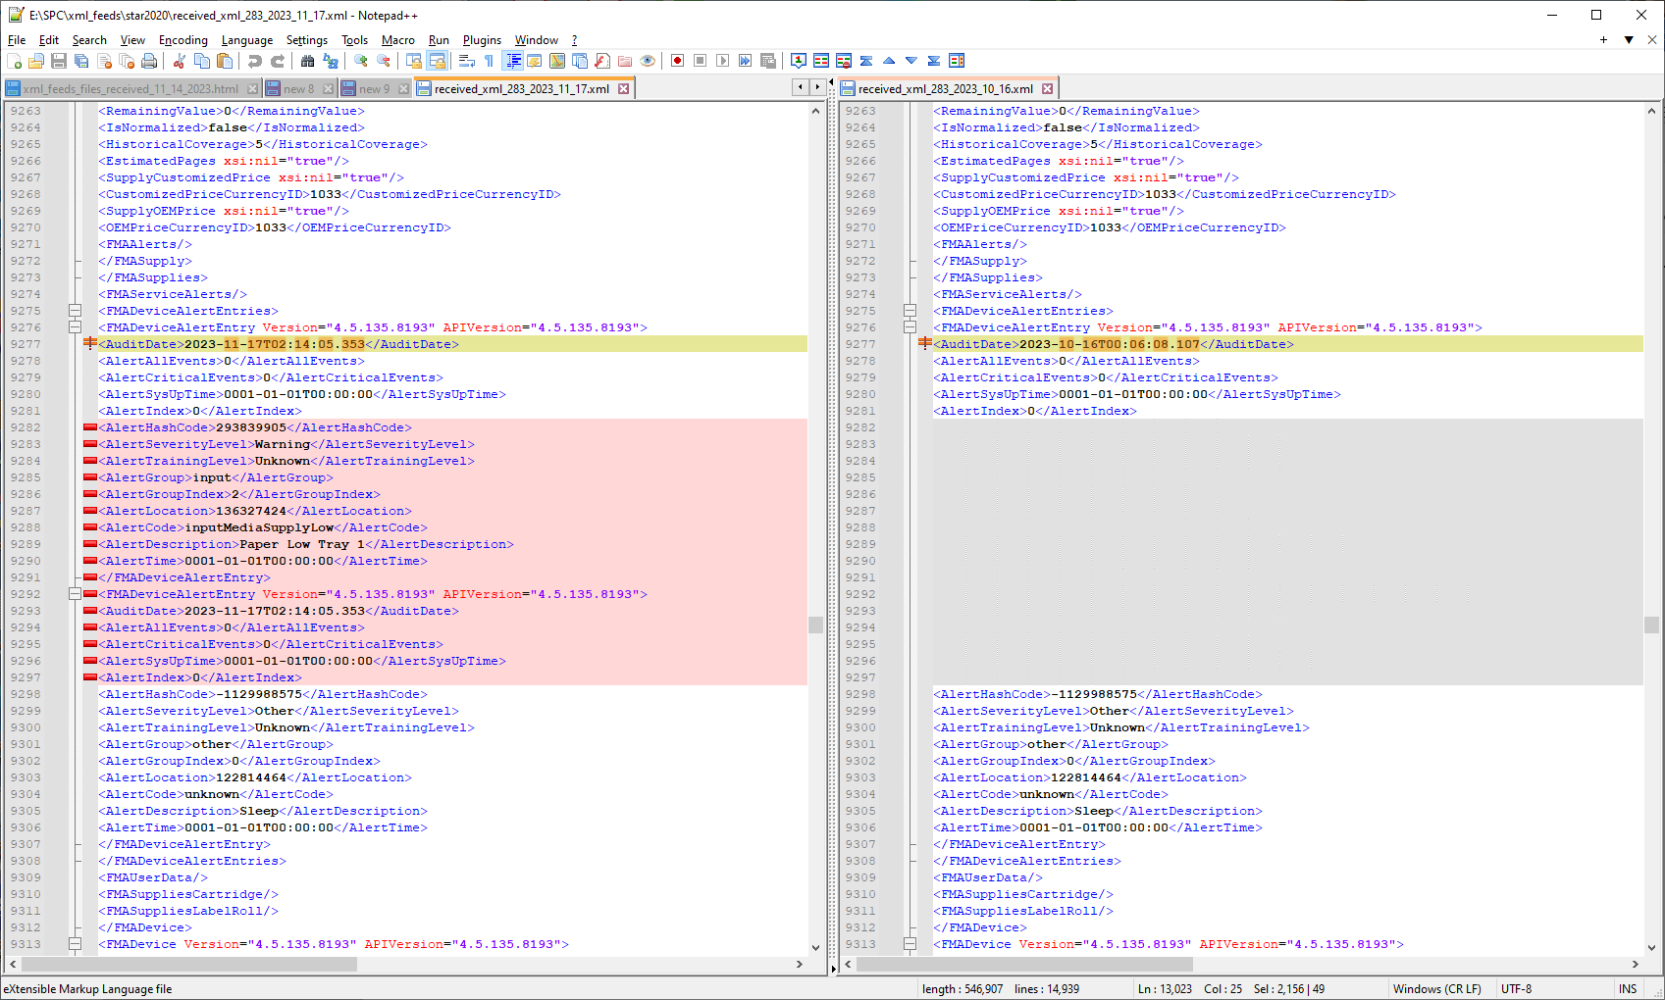

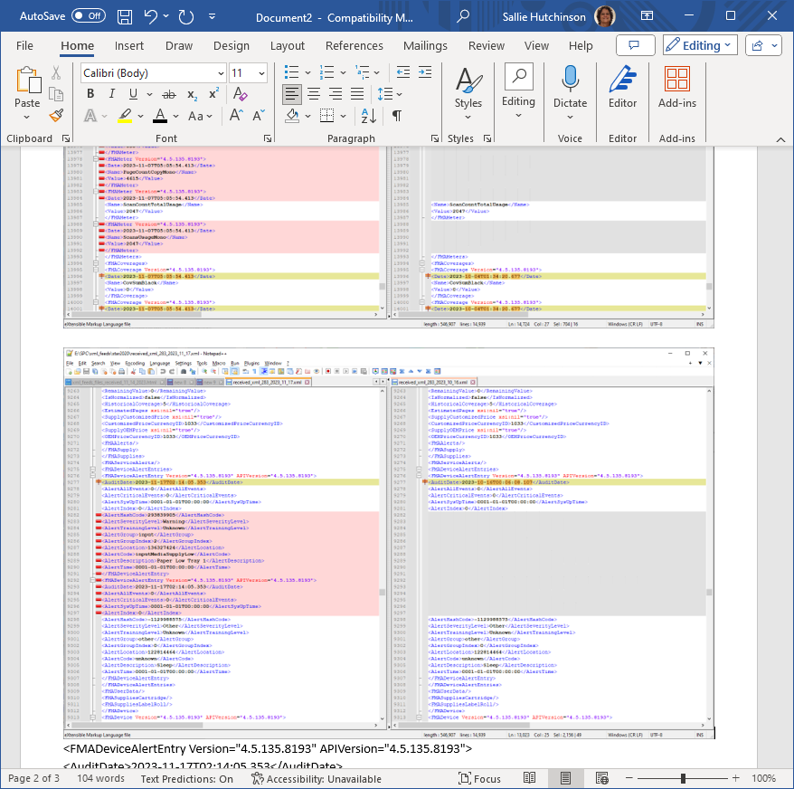

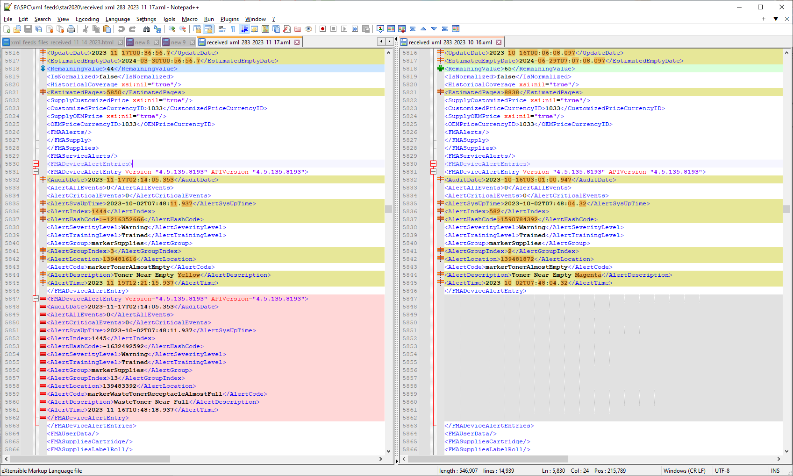

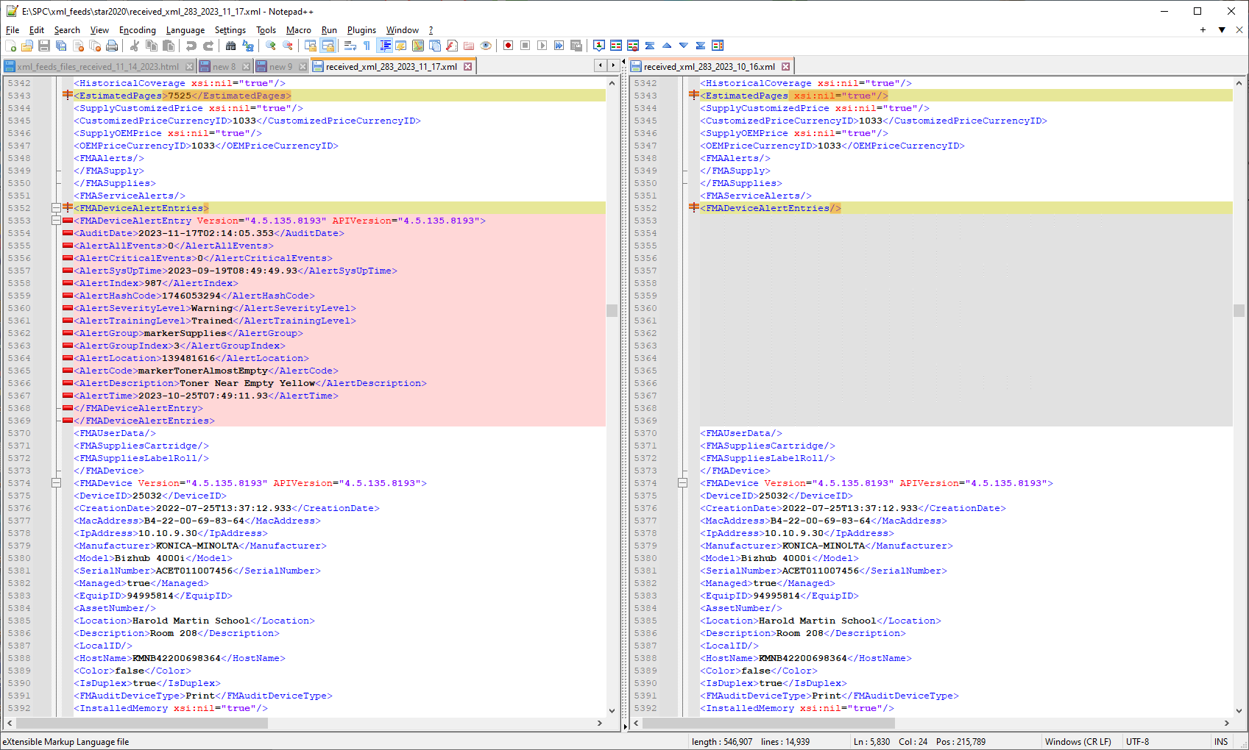

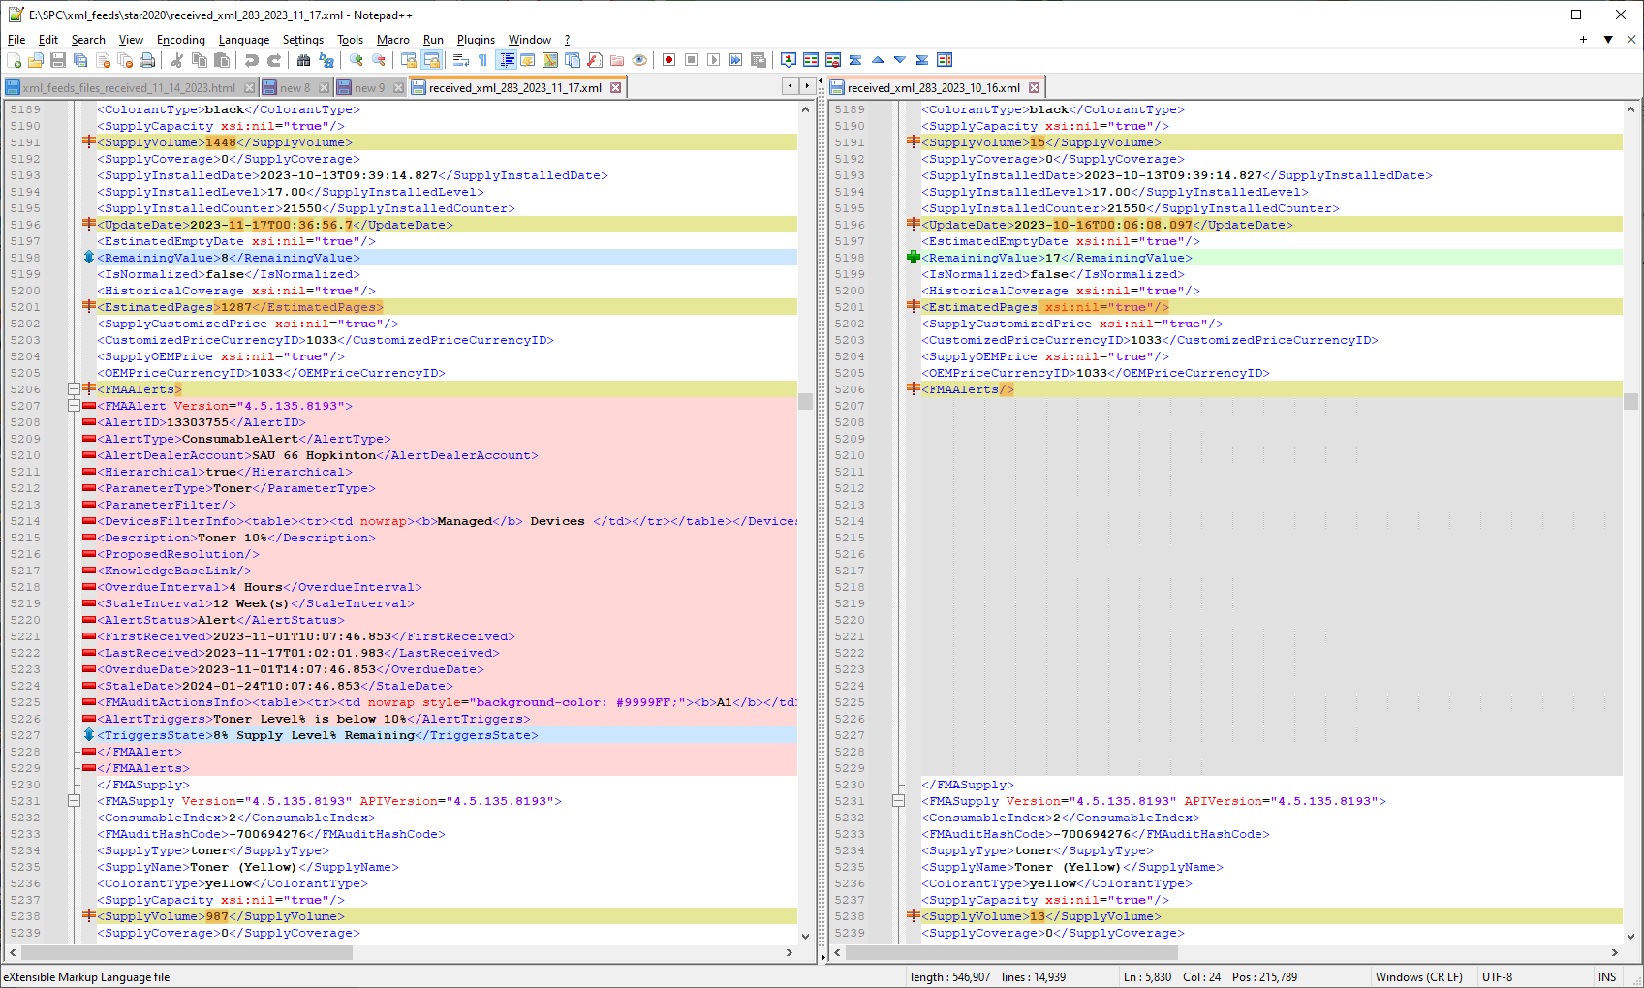

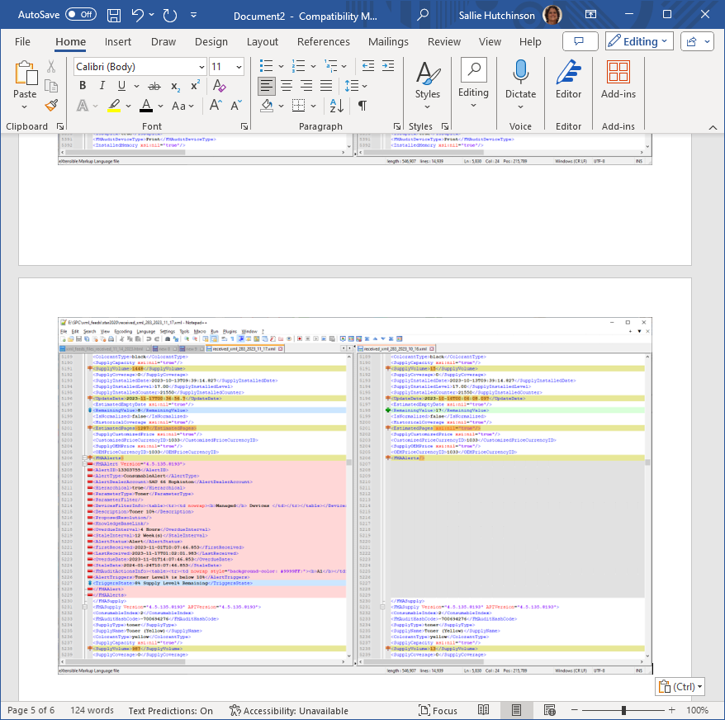

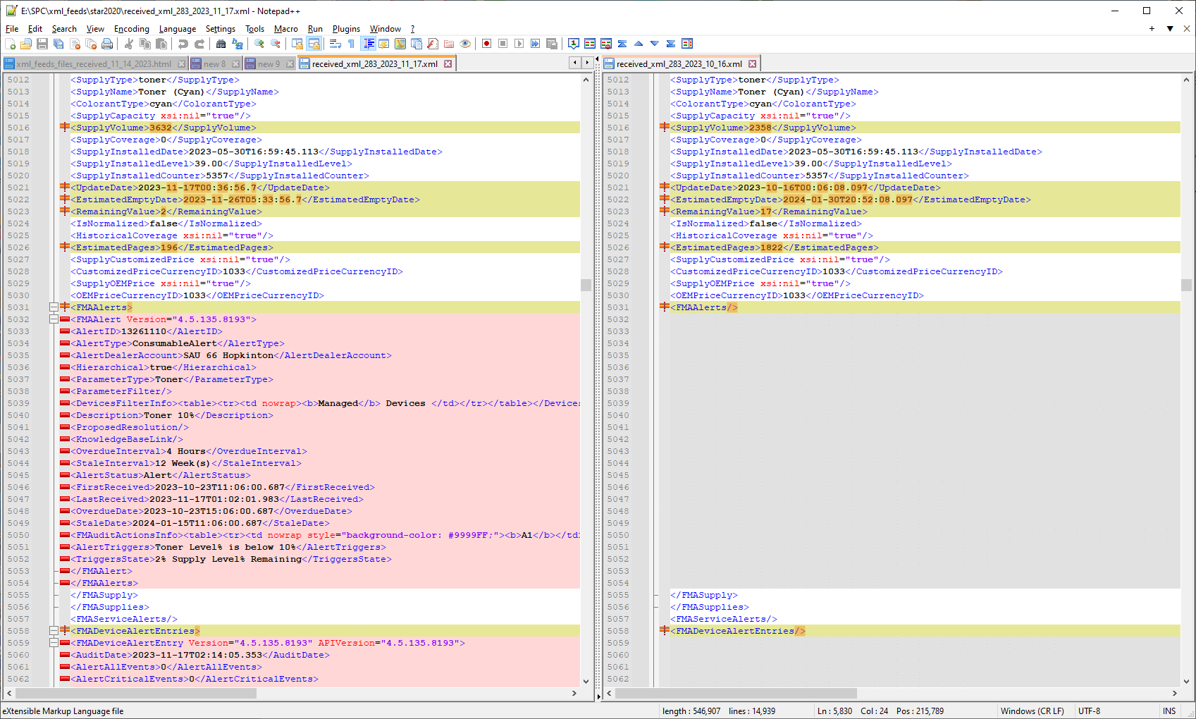

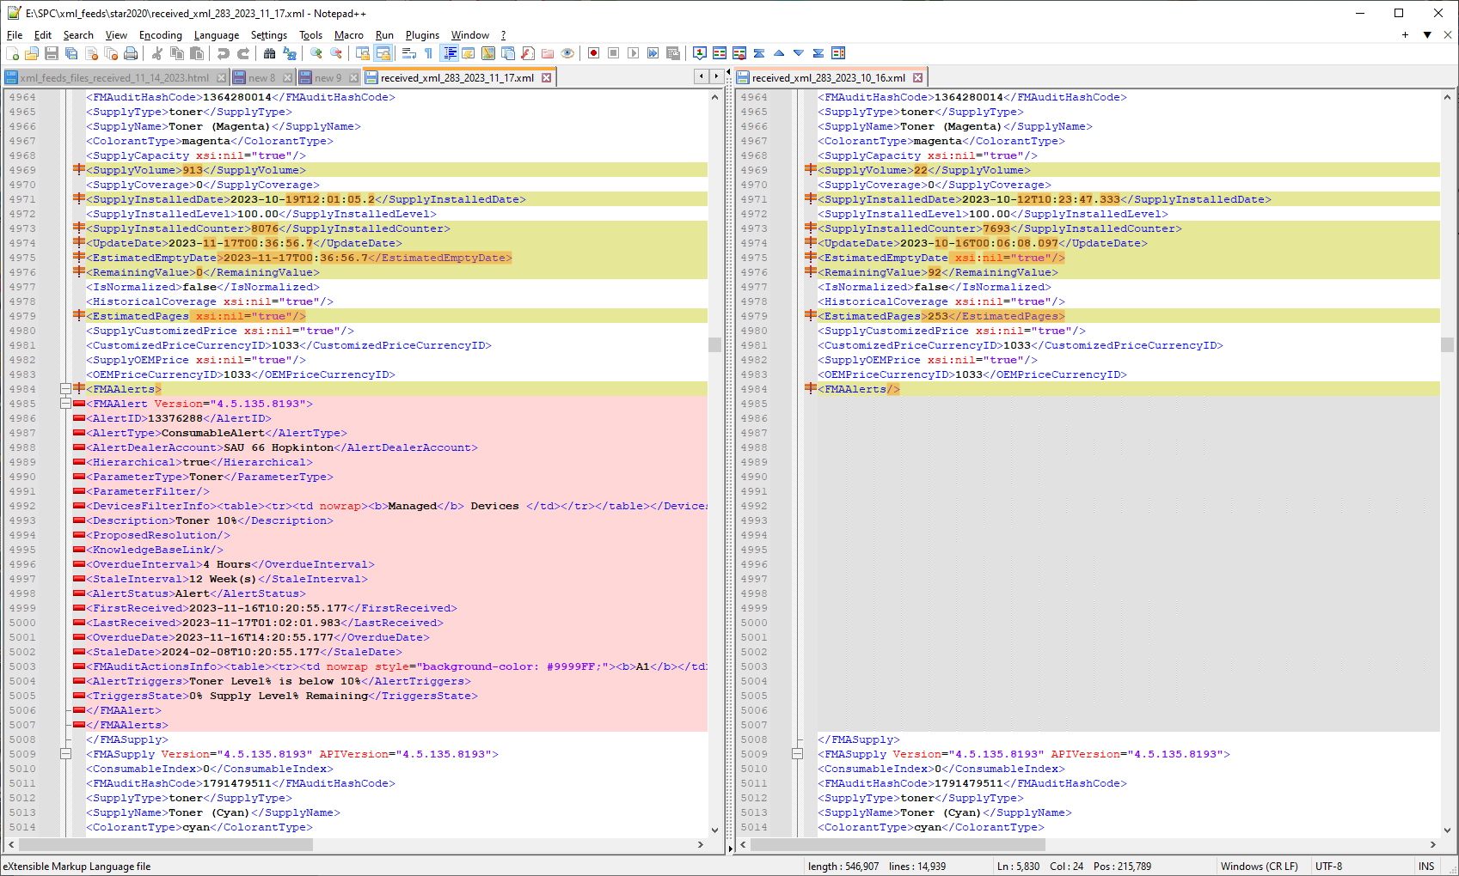

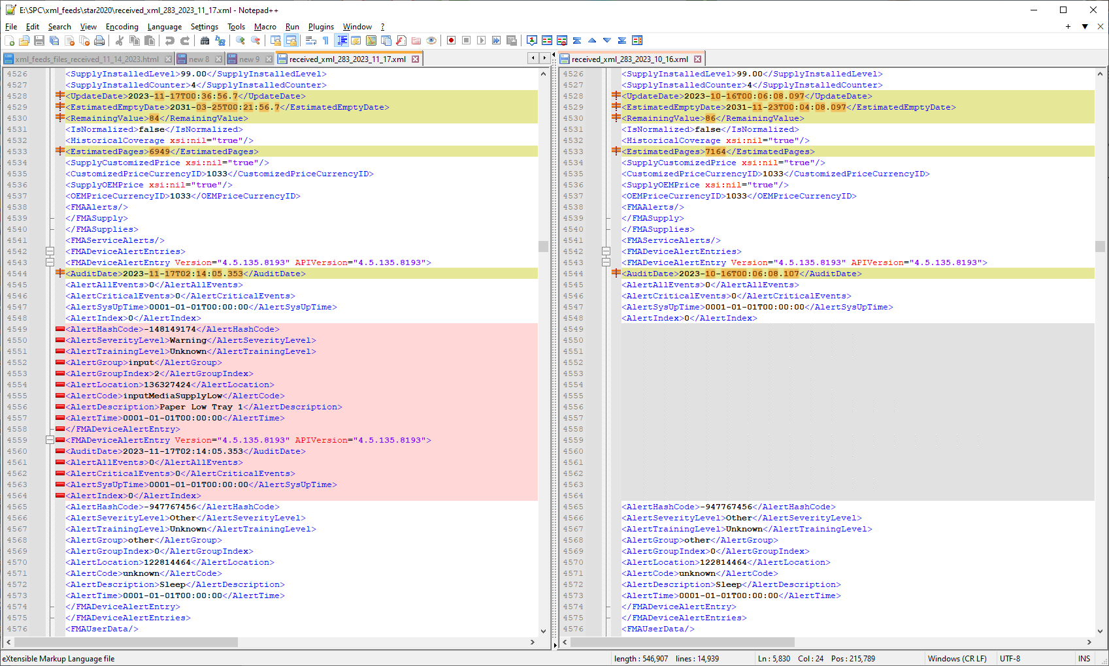

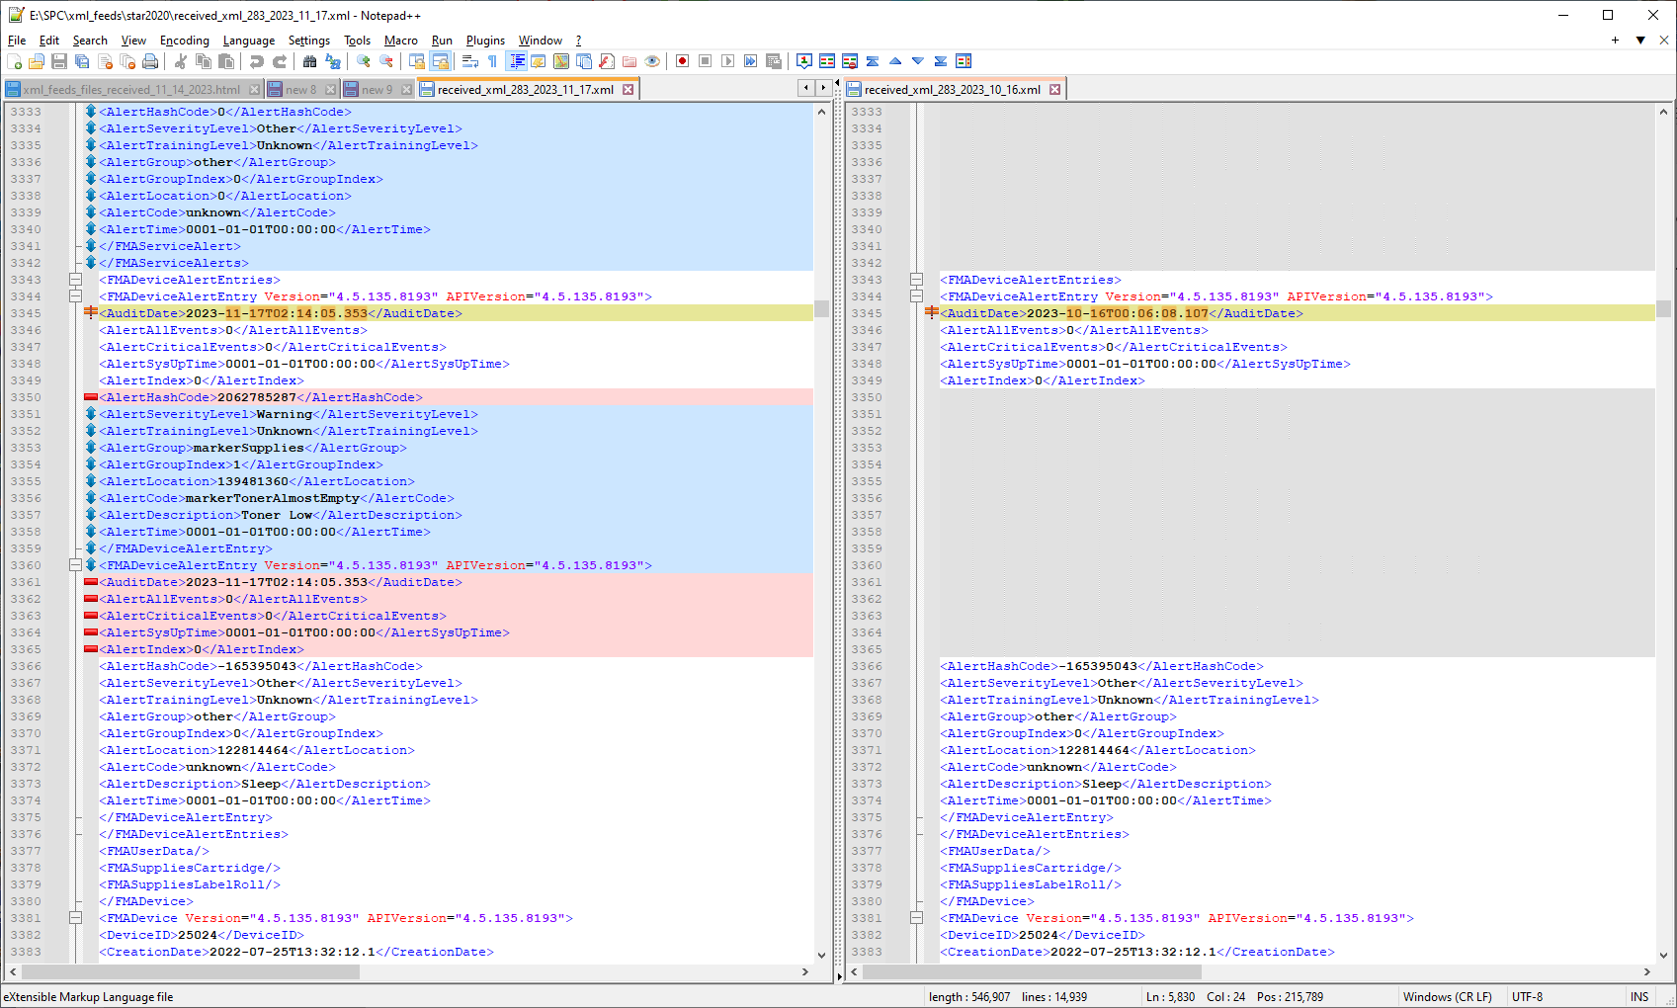

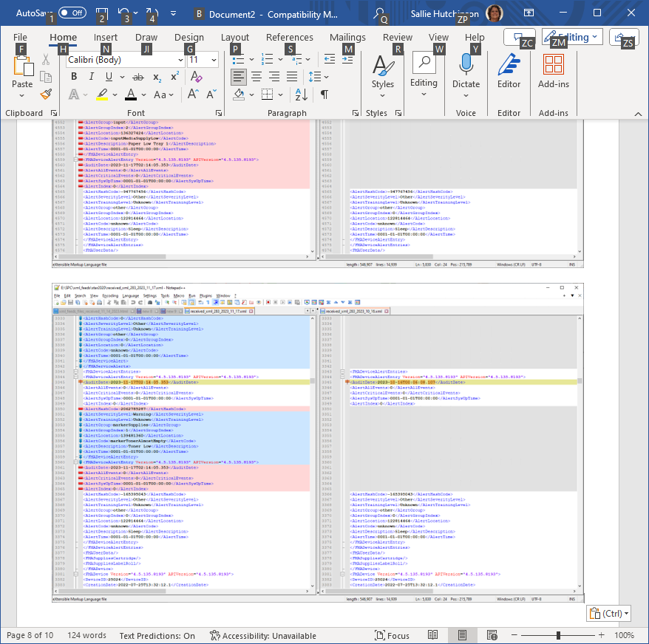

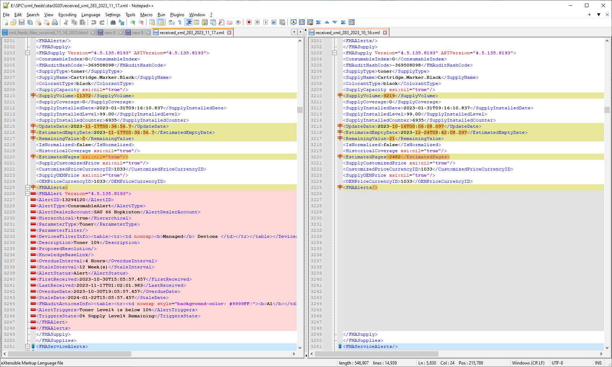

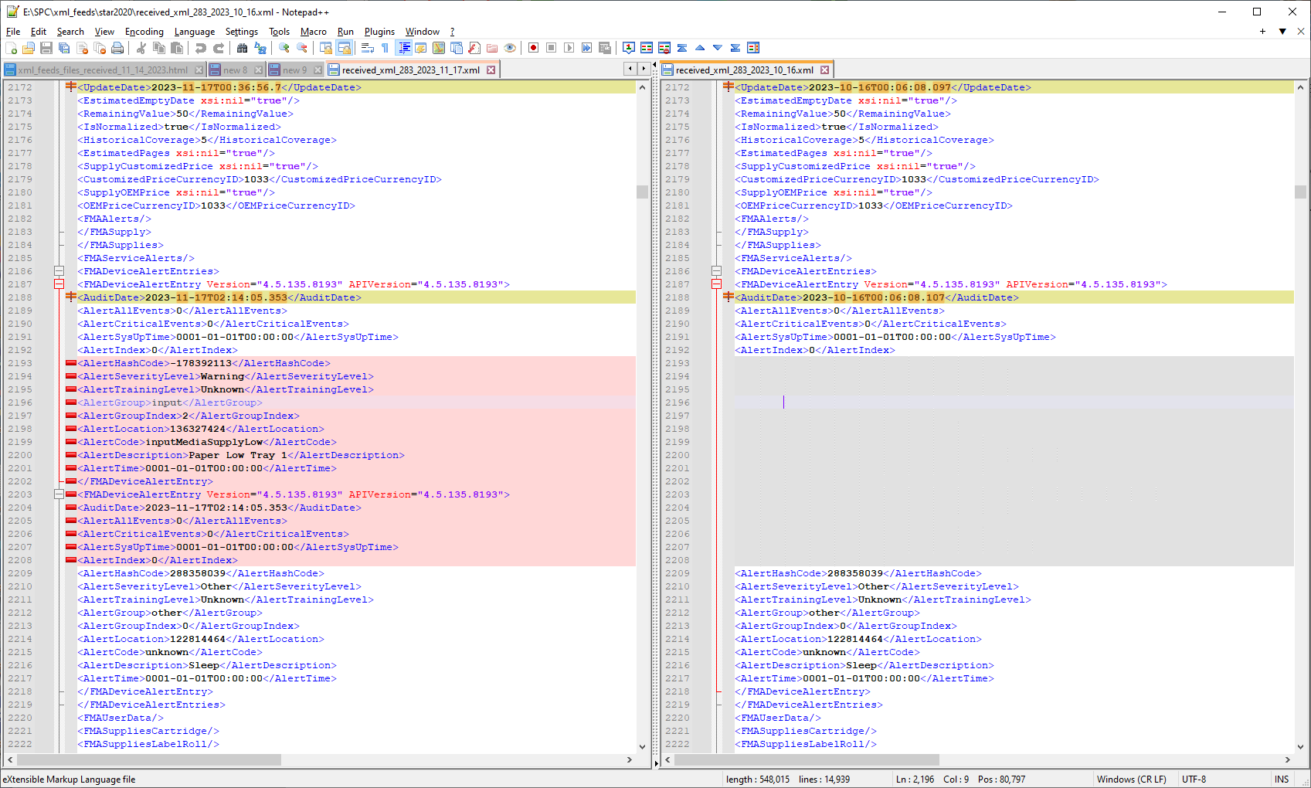

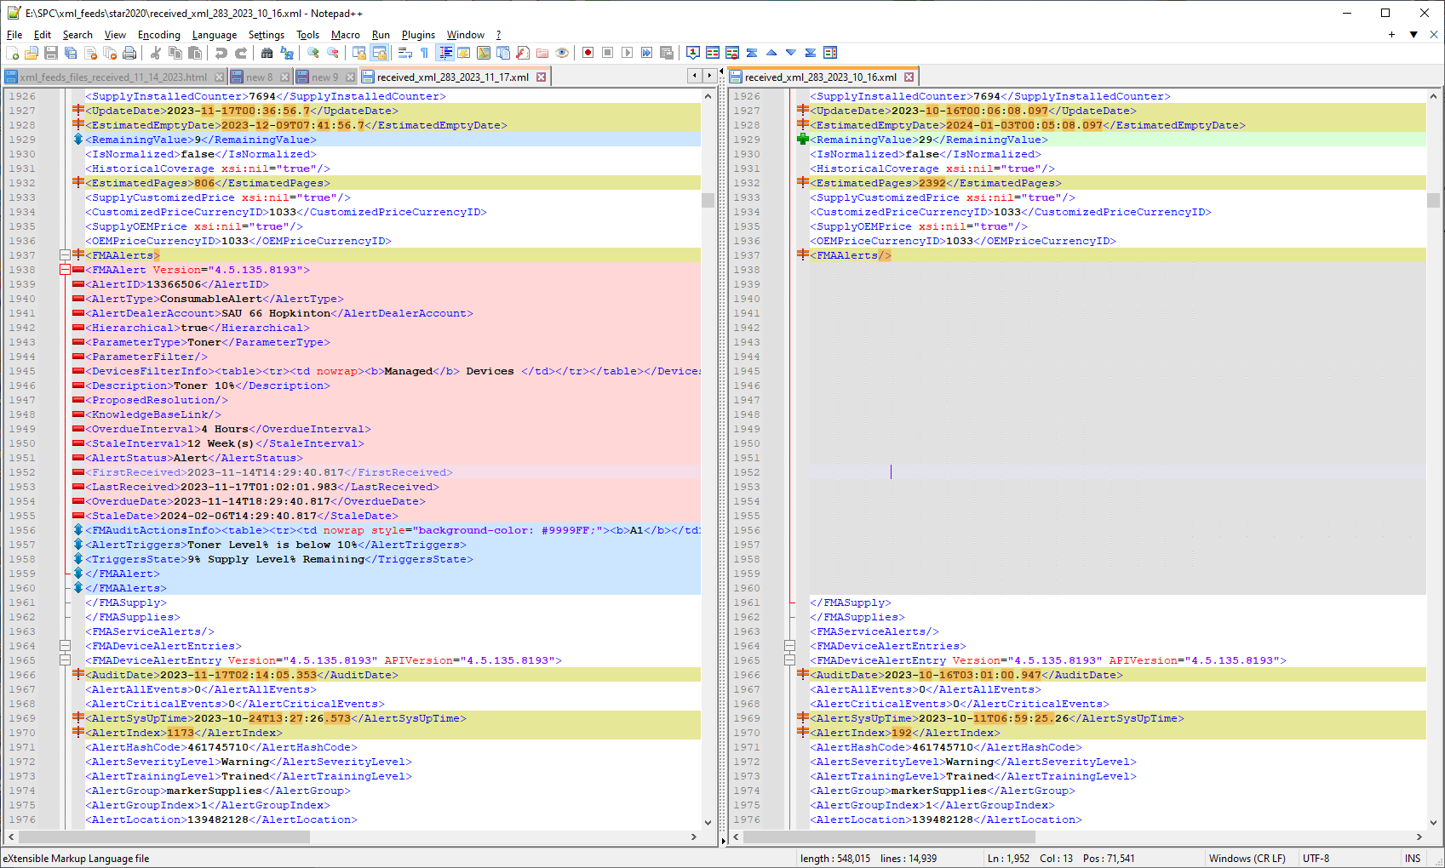

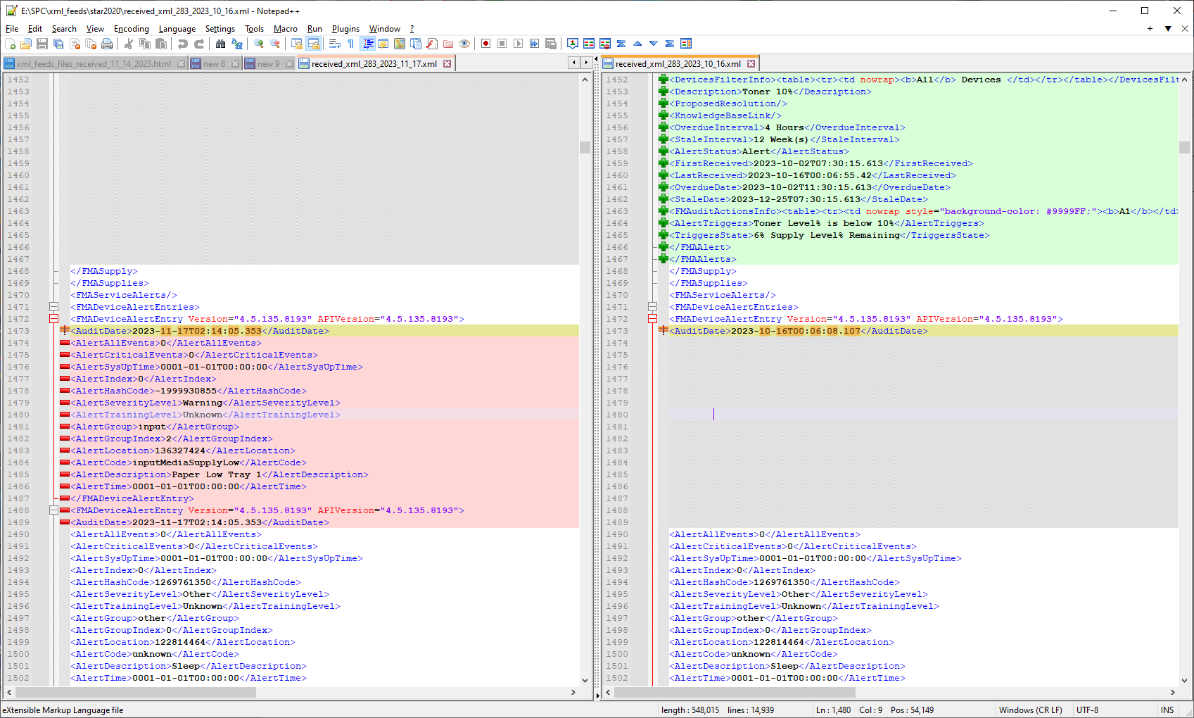

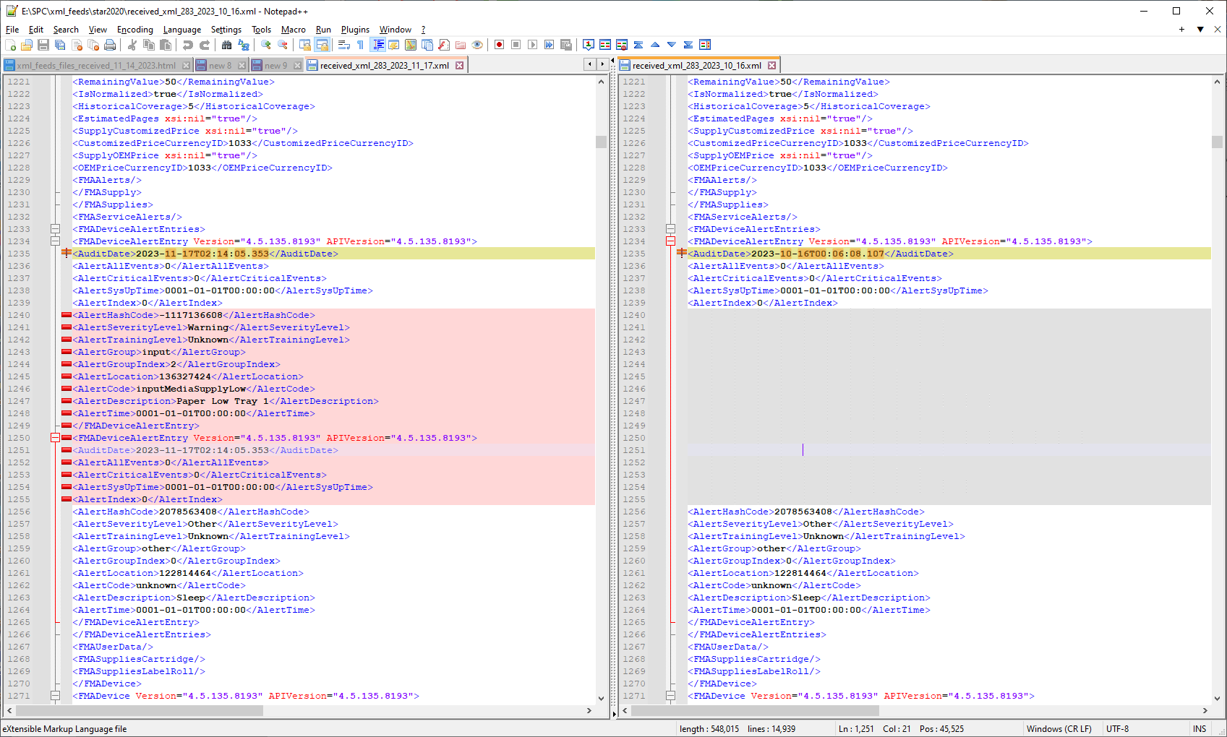

<FMADeviceAlertEntry Version="4.5.135.8193" APIVersion="4.5.135.8193">

<AuditDate>2023-11-17T02:14:05.353</AuditDate>

<AlertAllEvents>0</AlertAllEvents>

<AlertCriticalEvents>0</AlertCriticalEvents>

<AlertSysUpTime>2023-10-02T07:48:11.937</AlertSysUpTime>

<AlertIndex>1445</AlertIndex>

<AlertHashCode>-1632492592</AlertHashCode>

<AlertSeverityLevel>Warning</AlertSeverityLevel>

<AlertTrainingLevel>Trained</AlertTrainingLevel>

<AlertGroup>markerSupplies</AlertGroup>

<AlertGroupIndex>13</AlertGroupIndex>

<AlertLocation>139483392</AlertLocation>

<AlertCode>markerWasteTonerReceptacleAlmostFull</AlertCode>

<AlertDescription>WasteToner Near Full</AlertDescription>

<AlertTime>2023-11-16T10:48:18.937</AlertTime>

</FMADeviceAlertEntry>

<FMADeviceAlertEntry Version="4.5.135.8193" APIVersion="4.5.135.8193">

<AuditDate>2023-11-17T02:14:05.353</AuditDate>

<AlertAllEvents>0</AlertAllEvents>

<AlertCriticalEvents>0</AlertCriticalEvents>

<AlertSysUpTime>0001-01-01T00:00:00</AlertSysUpTime>

<AlertIndex>0</AlertIndex>

<AlertHashCode>783411014</AlertHashCode>

<AlertSeverityLevel>Warning</AlertSeverityLevel>

<AlertTrainingLevel>Unknown</AlertTrainingLevel>

<AlertGroup>input</AlertGroup>

<AlertGroupIndex>3</AlertGroupIndex>

<AlertLocation>135279360</AlertLocation>

<AlertCode>inputMediaSupplyEmpty</AlertCode>

<AlertDescription>No Paper Tray3</AlertDescription>

<AlertTime>0001-01-01T00:00:00</AlertTime>

</FMADeviceAlertEntry>

<FMADeviceAlertEntry Version="4.5.135.8193" APIVersion="4.5.135.8193">

<AuditDate>2023-11-17T02:14:05.353</AuditDate>

<AlertAllEvents>0</AlertAllEvents>

<AlertCriticalEvents>0</AlertCriticalEvents>

<AlertSysUpTime>0001-01-01T00:00:00</AlertSysUpTime>

<AlertIndex>0</AlertIndex>

<AlertHashCode>732764961</AlertHashCode>

<AlertSeverityLevel>Warning</AlertSeverityLevel>

<AlertTrainingLevel>Unknown</AlertTrainingLevel>

<AlertGroup>input</AlertGroup>

<AlertGroupIndex>4</AlertGroupIndex>

<AlertLocation>135279616</AlertLocation>

<AlertCode>inputMediaSupplyEmpty</AlertCode>

<AlertDescription>No Paper Tray4</AlertDescription>

<AlertTime>0001-01-01T00:00:00</AlertTime>

</FMADeviceAlertEntry>

<FMADeviceAlertEntry Version="4.5.135.8193" APIVersion="4.5.135.8193">

<AuditDate>2023-11-17T02:14:05.353</AuditDate>

<AlertAllEvents>0</AlertAllEvents>

<AlertCriticalEvents>0</AlertCriticalEvents>

<AlertSysUpTime>0001-01-01T00:00:00</AlertSysUpTime>

<AlertIndex>0</AlertIndex>

<AlertHashCode>35468960</AlertHashCode>

<AlertSeverityLevel>Warning</AlertSeverityLevel>

<AlertTrainingLevel>Unknown</AlertTrainingLevel>

<AlertGroup>markerSupplies</AlertGroup>

<AlertGroupIndex>1</AlertGroupIndex>

<AlertLocation>139481360</AlertLocation>

<AlertCode>markerTonerAlmostEmpty</AlertCode>

<AlertDescription>Toner Near Empty Black</AlertDescription>

<AlertTime>0001-01-01T00:00:00</AlertTime>

</FMADeviceAlertEntry>

</FMADeviceAlertEntries>