The Register page
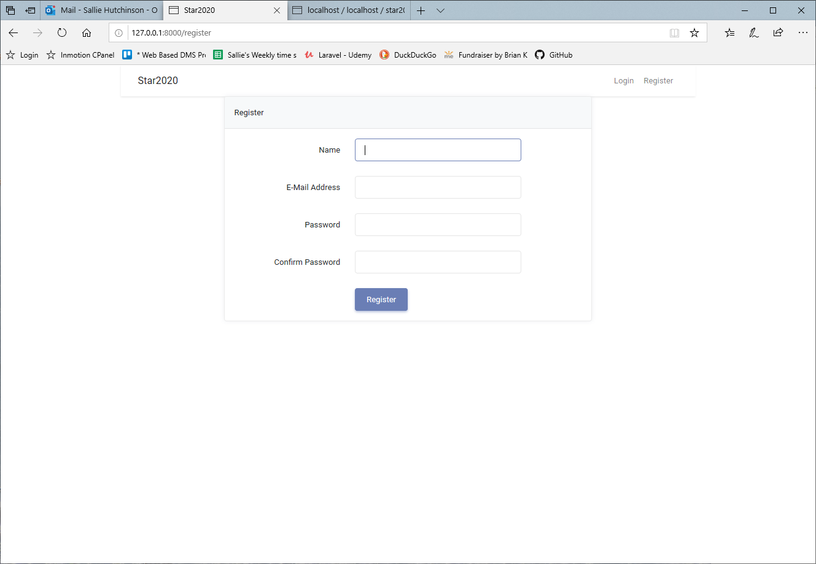

The login page
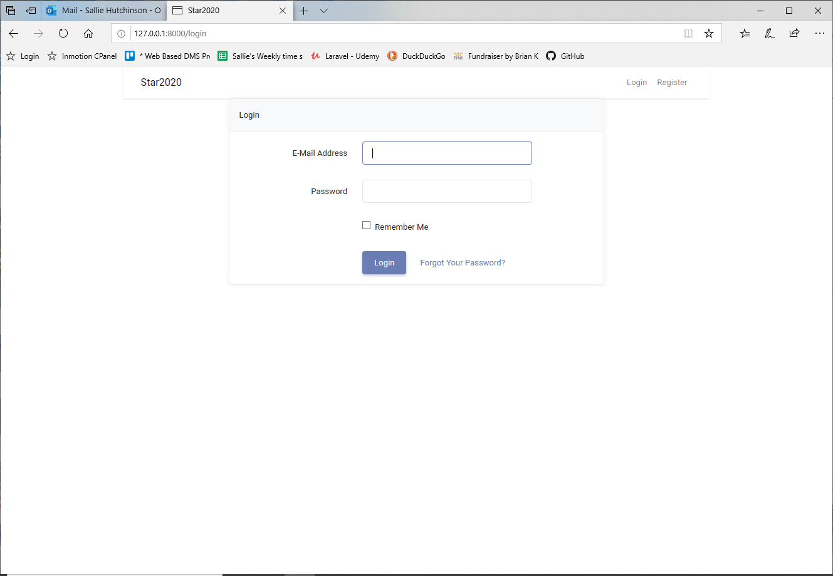

The login page -showing the placeholder for error messages
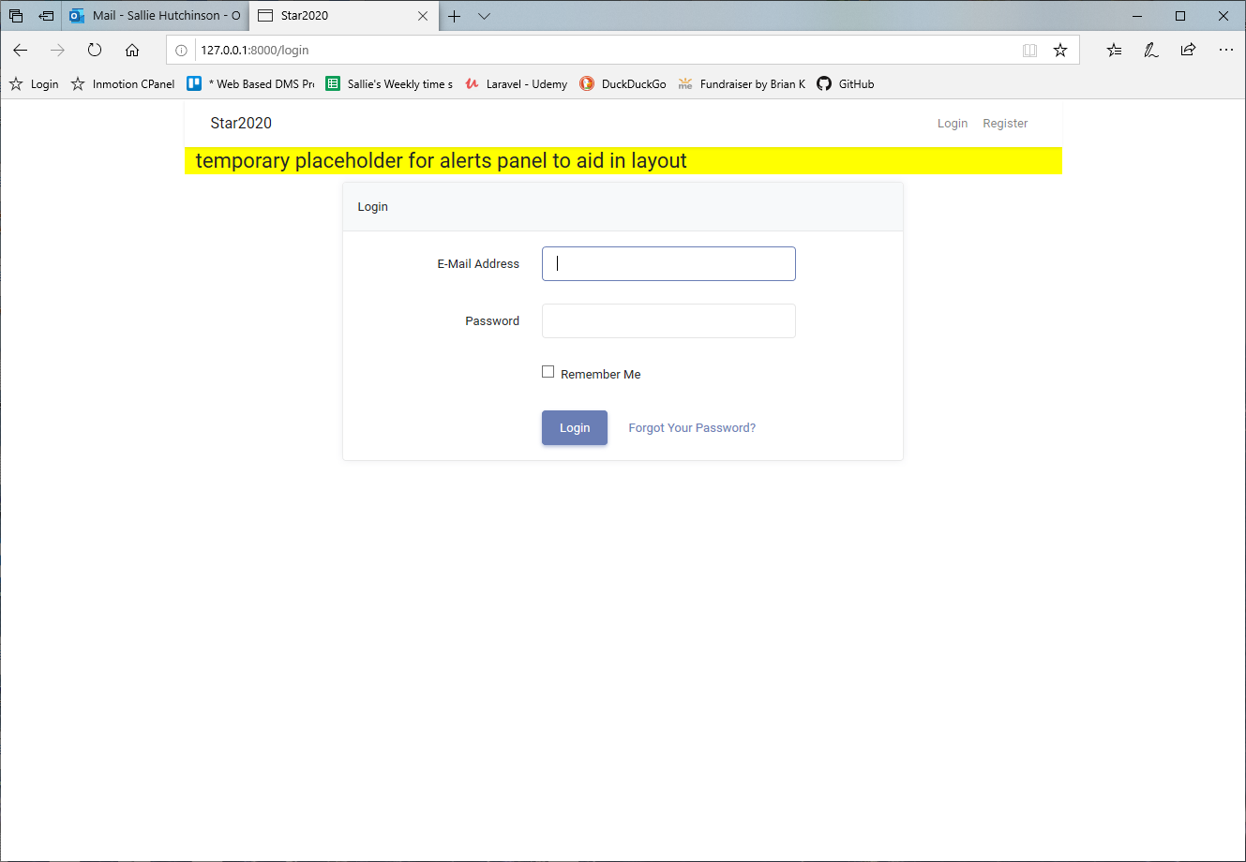
Login page - when wrong password is entered
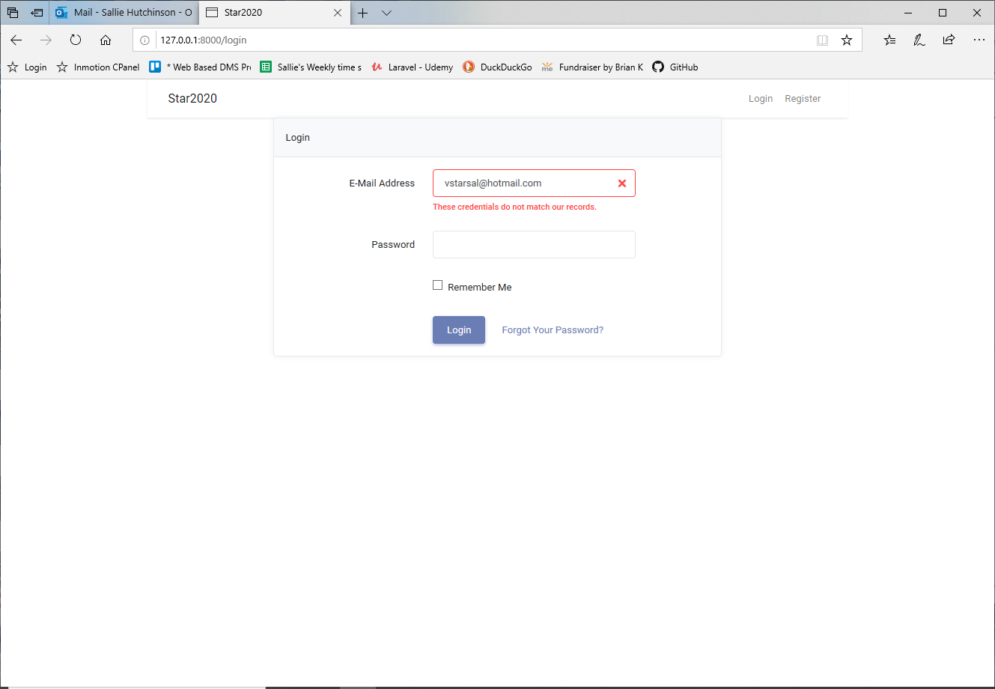
After successful login - the nav menu is now visible
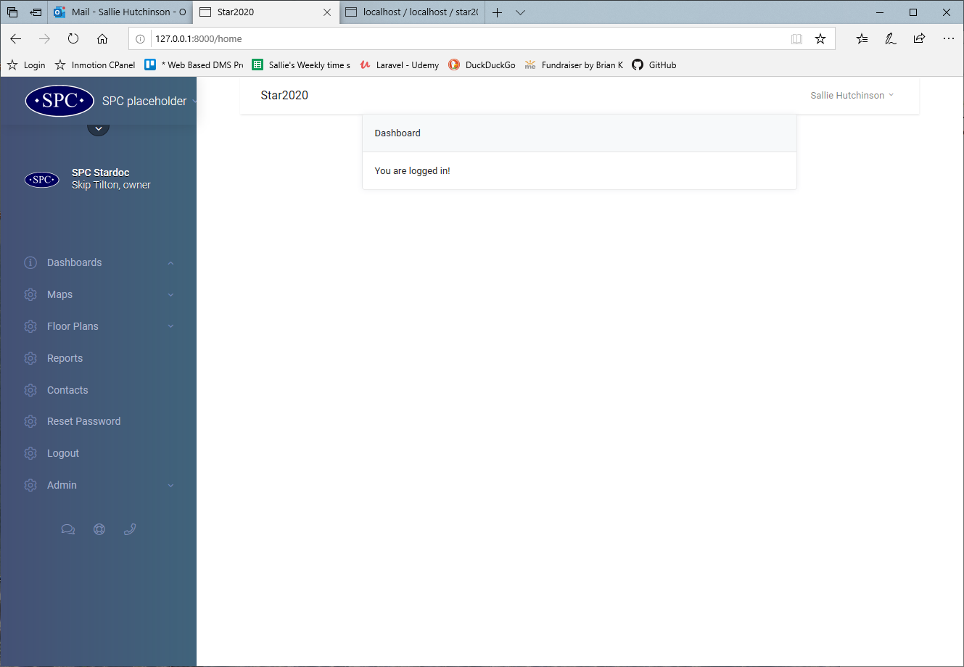
Contacts Page - with organization dropdown showing ONLY Active clients

