Star2020 11/19/2023 - Sunday
received_xml__2023_11_19_14_02_57_217868.xml
AccountID&gt;80&lt;/AccountID&gt;
&lt;Name&gt;SAU 49 Wolfeboro&lt;/Name&gt; Governor Wentworth??

received_xml__2023_11_19_13_05_34_356739.xml
AccountID&gt;340&lt;/AccountID&gt;
&lt;Name&gt;Swanton Elementary&lt;/Name&gt; active?

received_xml__2023_11_19_06_32_17_521059.xml
AccountID&gt;20&lt;/AccountID&gt;
&lt;Name&gt;SAU 35 - Littleton&lt;/Name&gt; inactive

received_xml__2023_11_19_06_28_16_150259.xml
AccountID&gt;38&lt;/AccountID&gt;
&lt;Name&gt;RSU 14 - Windham&lt;/Name&gt;

received_xml__2023_11_19_04_04_57_312283.xml
AccountID&gt;22&lt;/AccountID&gt;
&lt;Name&gt;SU 06 - Bennington/Rutland&lt;/Name&gt;
NOW Bennington-Rutland Supervisory UnionRSU 06 mSAD 06 - Buxton

received_xml__2023_11_19_04_03_59_193936.xml
AccountID&gt;76&lt;/AccountID&gt;
&lt;Name&gt;SD 16 South Burlington&lt;/Name&gt; NOW South Burlington School District

received_xml__2023_11_19_03_05_13_246449.xml
AccountID&gt;76&lt;/AccountID&gt;
&lt;Name&gt;SD 16 South Burlington&lt;/Name&gt;

received_xml__2023_11_19_03_02_49_324276.xml
AccountID&gt;50&lt;/AccountID&gt;
&lt;Name&gt;SAU 42 - Nashua&lt;/Name&gt;

received_xml__2023_11_19_02_04_29_600344.xml
AccountID&gt;272&lt;/AccountID&gt;
&lt;Name&gt;Timberlane Regional School District&lt;/Name&gt;

received_xml__2023_11_19_02_03_21_740888.xml
AccountID&gt;76&lt;/AccountID&gt;
&lt;Name&gt;SD 16 South Burlington&lt;/Name&gt;

received_xml__2023_11_19_01_05_08_317559.xml
AccountID&gt;76&lt;/AccountID&gt;
&lt;Name&gt;SD 16 South Burlington&lt;/Name&gt;

received_xml__2023_11_19_00_03_52_285605.xml
AccountID&gt;76&lt;/AccountID&gt;
&lt;Name&gt;SD 16 South Burlington&lt;/Name&gt;

Processed fully – my tests
received_xml__2023_11_18_23_46_27_691356.xml
<AccountID>258</AccountID><Name>SU 20 - Franklin Northeast</Name>

received_xml__2023_11_18_23_41_23_904313.xml
<AccountID>258</AccountID><Name>SU 20 - Franklin Northeast</Name>

received_xml__2023_11_18_22_03_49_637485.xml
AccountID&gt;231&lt;/AccountID&gt;
&lt;Name&gt;RSU 20 - Searsport&lt;/Name&gt;
&lt;City&gt;Searsport&lt;/City&gt;

received_xml__2023_11_18_22_03_33_295531.xmlAccountID&gt;279&lt;/AccountID&gt;
&lt;Name&gt;Windsor Central Unified Union Supervisory Union&lt;/Name&gt;
&lt;City&gt;Woodstock&lt;/City&gt;

received_xml__2023_11_18_22_03_04_006232.xml
AccountID&gt;285&lt;/AccountID&gt;
&lt;Name&gt;Wiscasset School Department&lt;/Name&gt;
&lt;City&gt;Wiscasset&lt;/City&gt;
&lt;State&gt;ME&lt;/State&gt;

received_xml__2023_11_18_20_03_07_298902.xml
AccountID&gt;277&lt;/AccountID&gt;
&lt;Name&gt;SAU 81 Hudson&lt;/Name&gt;
&lt;City&gt;Hudson&lt;/City&gt;
&lt;State&gt;NH&lt;/State&gt;

received_xml__2023_11_18_16_23_05_498897.xml
<AccountID>42</AccountID><Name>AOS 91 - Mt Desert, ME</Name>

All files between these 2 are AOS 91

received_xml__2023_11_18_15_20_00_000638.xml
<AccountID>42</AccountID><Name>AOS 91 - Mt Desert, ME</Name>

received_xml__2023_11_18_14_40_46_287055.xml
<AccountID>20</AccountID><Name>SAU 35 - Littleton</Name>

received_xml__2023_11_18_11_03_44_765058.xml
AccountID&gt;72&lt;/AccountID&gt;
&lt;Name&gt;SD 10 Milton&lt;/Name&gt;
&lt;City&gt;Milton&lt;/City&gt;
&lt;State&gt;VT&lt;/State&gt;

Stardoc Nov 5, Sunday
received_xml_315_2023_11_05.xml
<AccountID>315</AccountID><Name>Winooski School District</Name>

received_xml_283_2023_11_05.xml
<AccountID>283</AccountID><Name>SAU 66 Hopkinton</Name>

received_xml_321_2023_11_05.xml
<AccountID>321</AccountID><Name>Leroy Smith</Name>

received_xml_276_2023_11_05.xml
<AccountID>276</AccountID><Name>Addison Northwest School District</Name>

received_xml_232_2023_11_05.xml
<AccountID>232</AccountID><Name>SAU 80 - Shaker Region School District</Name>
received_xml_122_2023_11_05.xml
<AccountID>122</AccountID><Name>Norway Savings Bank</Name>

received_xml_115_2023_11_05.xml
<AccountID>115</AccountID><Name>SAU 87 - Mascenic</Name>

received_xml_73_2023_11_05.xml
<AccountID>73</AccountID><Name>SU 36</Name>

received_xml_79_2023_11_05.xml
<AccountID>79</AccountID><Name>SU 22 Franklin West</Name>

received_xml_77_2023_11_05.xml
<AccountID>77</AccountID><Name>RSU 34</Name>

I could ONLY view these pages, unlike the others. Maybe because of the huge size??
received_xml_78_2023_11_05.xml
<AccountID>78</AccountID><Name>SAU 54 Rochester</Name>

received_xml_80_2023_11_05.xml
<AccountID>80</AccountID><Name>SAU 49 Wolfeboro</Name>

received_xml_35_2023_11_05.xml
<AccountID>35</AccountID><Name>RSU 64 - East Corinth</Name>

received_xml_38_2023_11_05.xml
<AccountID>38</AccountID><Name>RSU 14 - Windham</Name>

received_xml_22_2023_11_05.xml
<AccountID>22</AccountID><Name>SU 06 - Bennington/Rutland</Name>

received_xml_27_2023_11_05.xml
<AccountID>27</AccountID><Name>SAU 57 - Salem</Name>

received_xml_13_2023_11_05.xml
<AccountID>13</AccountID><Name>Rochester, City of</Name>

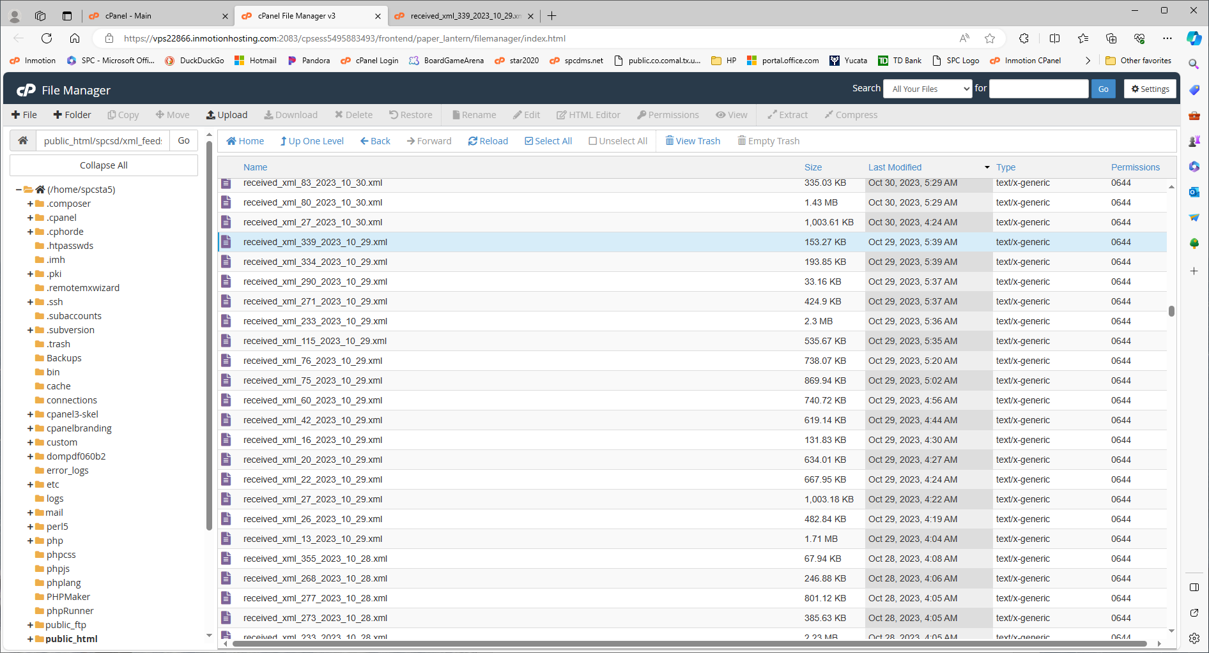

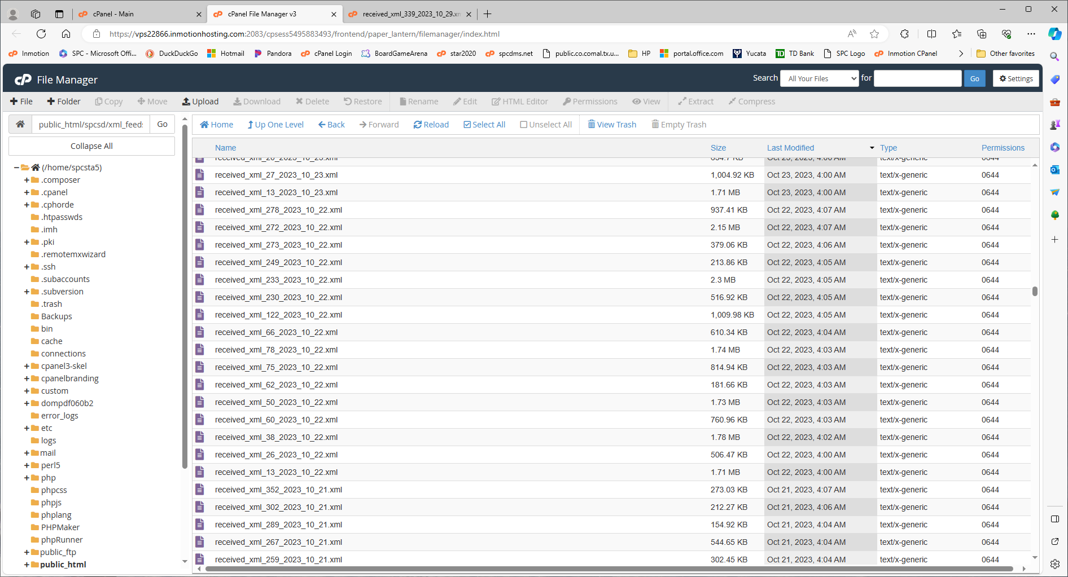

10/15/2023 No files

