11/17

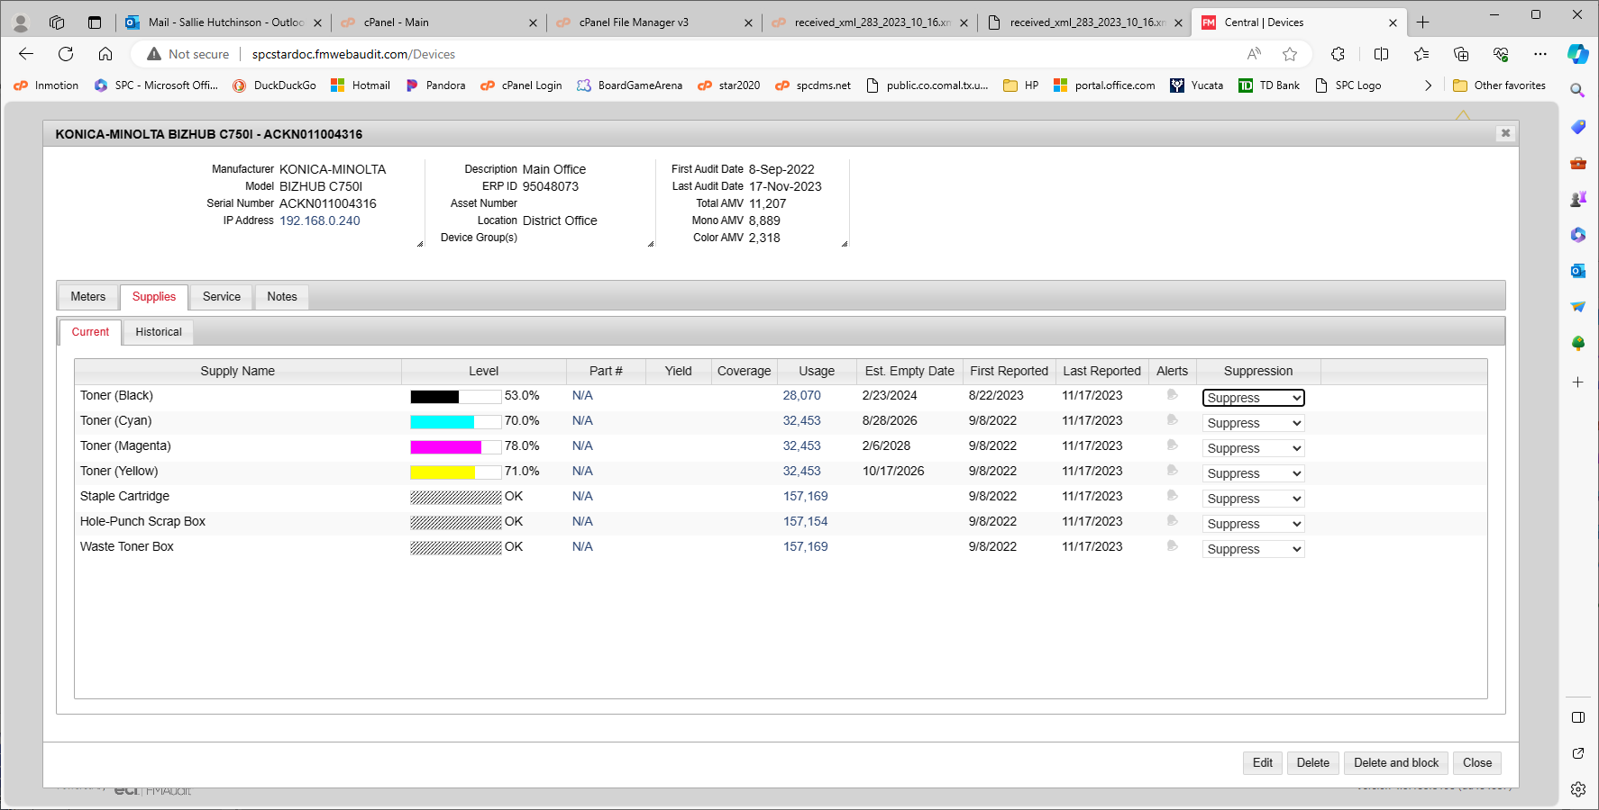
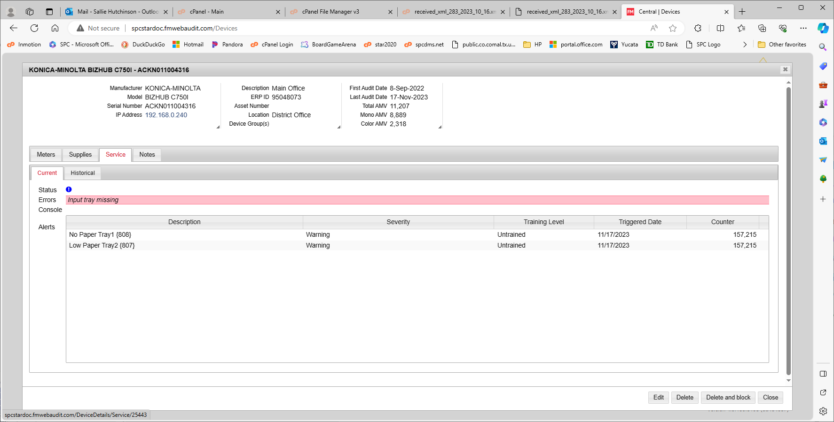

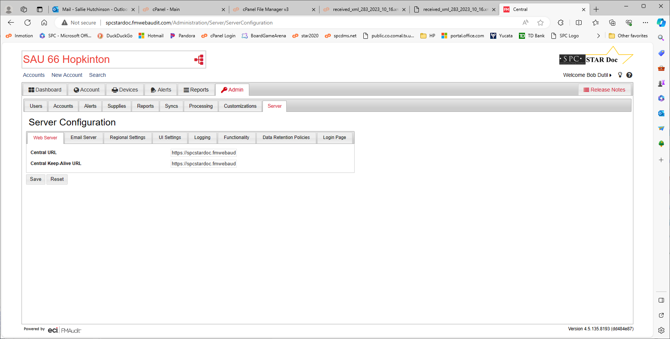
<AlertHashCode>1808486362</AlertHashCode>
<AlertSeverityLevel>Warning</AlertSeverityLevel>
<AlertTrainingLevel>Unknown</AlertTrainingLevel>
<AlertGroup>input</AlertGroup>
<AlertGroupIndex>2</AlertGroupIndex>
<AlertLocation>136327424</AlertLocation> <AlertLocation>11302</AlertLocation>
<AlertCode>inputMediaSupplyLow</AlertCode>
<AlertDescription>Paper Low Tray 1</AlertDescription>
<AlertTime>0001-01-01T00:00:00</AlertTime>
</FMADeviceAlertEntry>
<FMADeviceAlertEntry Version="4.5.135.8193" APIVersion="4.5.135.8193">
<AuditDate>2023-11-17T02:14:05.353</AuditDate>
<AlertAllEvents>0</AlertAllEvents>
<AlertCriticalEvents>0</AlertCriticalEvents>
<AlertSysUpTime>0001-01-01T00:00:00</AlertSysUpTime>
<AlertIndex>0</AlertIndex>

Errors according to validator
&nbsp;
nowrap
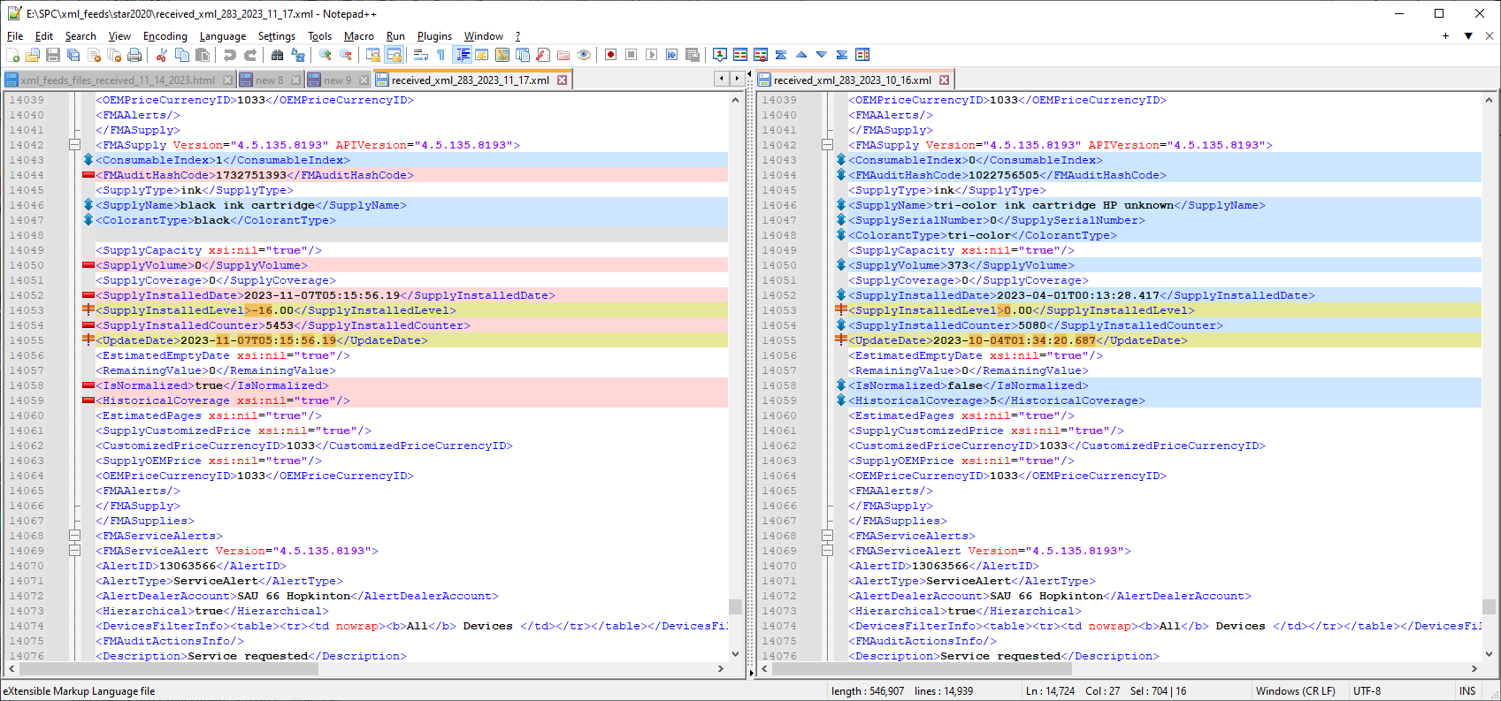
<FMADeviceAlertEntry Version="4.5.135.8193" APIVersion="4.5.135.8193">
<AuditDate>2023-11-17T02:14:05.353</AuditDate>
<AlertAllEvents>0</AlertAllEvents>
<AlertCriticalEvents>0</AlertCriticalEvents>
<AlertSysUpTime>0001-01-01T00:00:00</AlertSysUpTime>
<AlertIndex>0</AlertIndex>
<AlertHashCode>1441520651</AlertHashCode>
<AlertSeverityLevel>Warning</AlertSeverityLevel>
<AlertTrainingLevel>Unknown</AlertTrainingLevel>
<AlertGroup>input</AlertGroup>
<AlertGroupIndex>2</AlertGroupIndex>
<AlertLocation>136327680</AlertLocation>
<AlertCode>inputMediaSupplyLow</AlertCode>
<AlertDescription>Low Paper Tray2</AlertDescription>
<AlertTime>0001-01-01T00:00:00</AlertTime>
</FMADeviceAlertEntry>

/****************************/
SELECT * FROM `floorplan_machines` WHERE proposed_serial_number = 'ACKN011004316';
SELECT * FROM `meters` WHERE serial_number = 'ACKN011004316' order by created_date desc;
select * from machine_statuses where serial_number = 'ACKN011004316' order by created_date desc;
SELECT * FROM `meters` WHERE created_date > '2023-11-16 00:00:00' order by created_date desc;

select * from a_xml_feeds_meters where serial_number = 'ACKN011004316';
select * from a_xml_feeds_machine_statuses where serial_number = 'ACKN011004316';
select * from org_x_fmaudit where fmaudit_client_id = 283;
select * from organizations where org_id = 1919;

fpm_id 45927 ($ID)
Fields for processxml
<AccountID>283</AccountID>
<Name>SAU 66 Hopkinton</Name>

FMAMeters Children
<Date>2023-11-17T00:36:56.69</Date>
<Name>PageCountTotal</Name>
<Value>156938</Value>

<SerialNumber>ACKN011004316</SerialNumber>
<MacAddress>00-20-6B-F9-0A-48</MacAddress>
<IpAddress>192.168.0.240</IpAddress>
<Location>District Office</Location>
<DeviceID>25443</DeviceID> ($fmaudit_id)
<ModelID>0</ModelID>
<Model>BIZHUB C750I</Model> (model_details model_id for this model = 3500)
<Manufacturer>KONICA-MINOLTA</Manufacturer>
<Description>Main Office</Description>
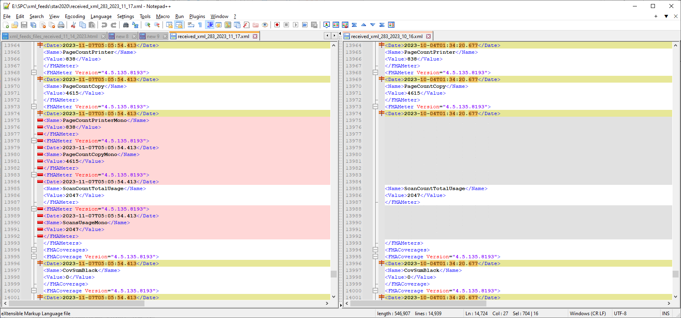

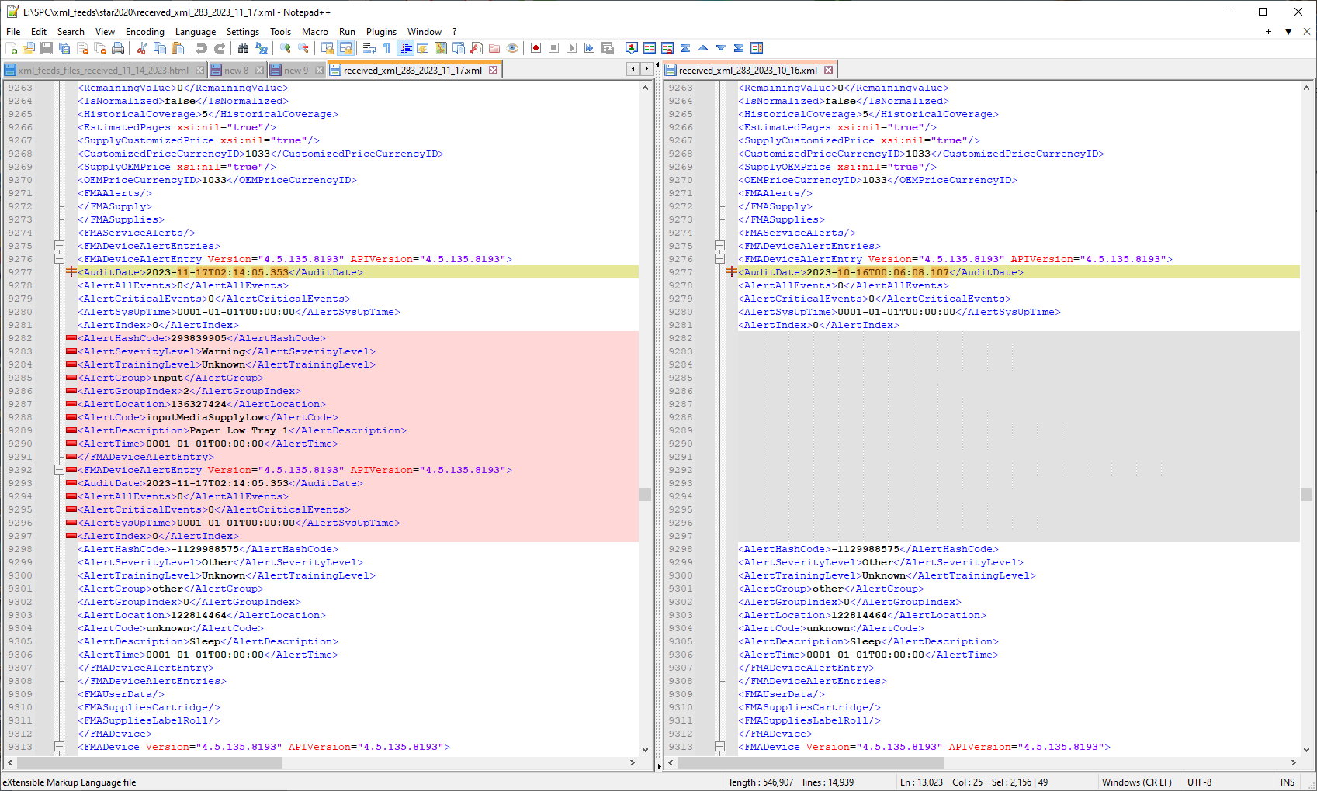

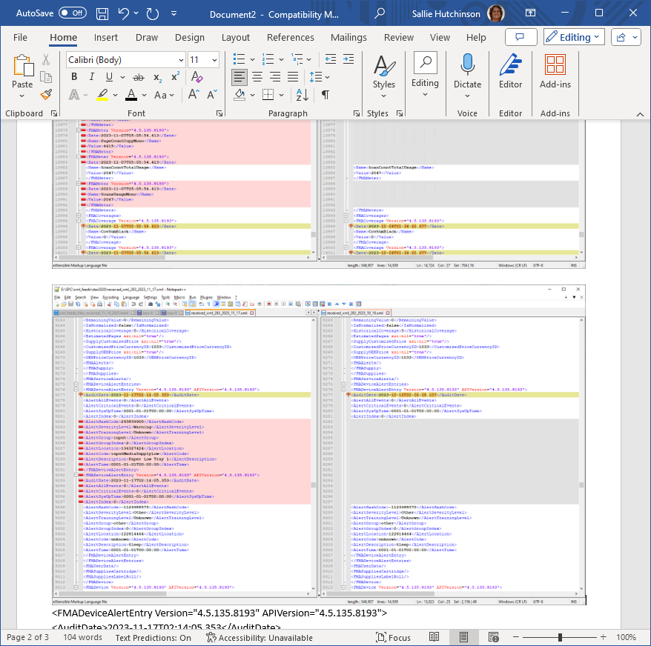

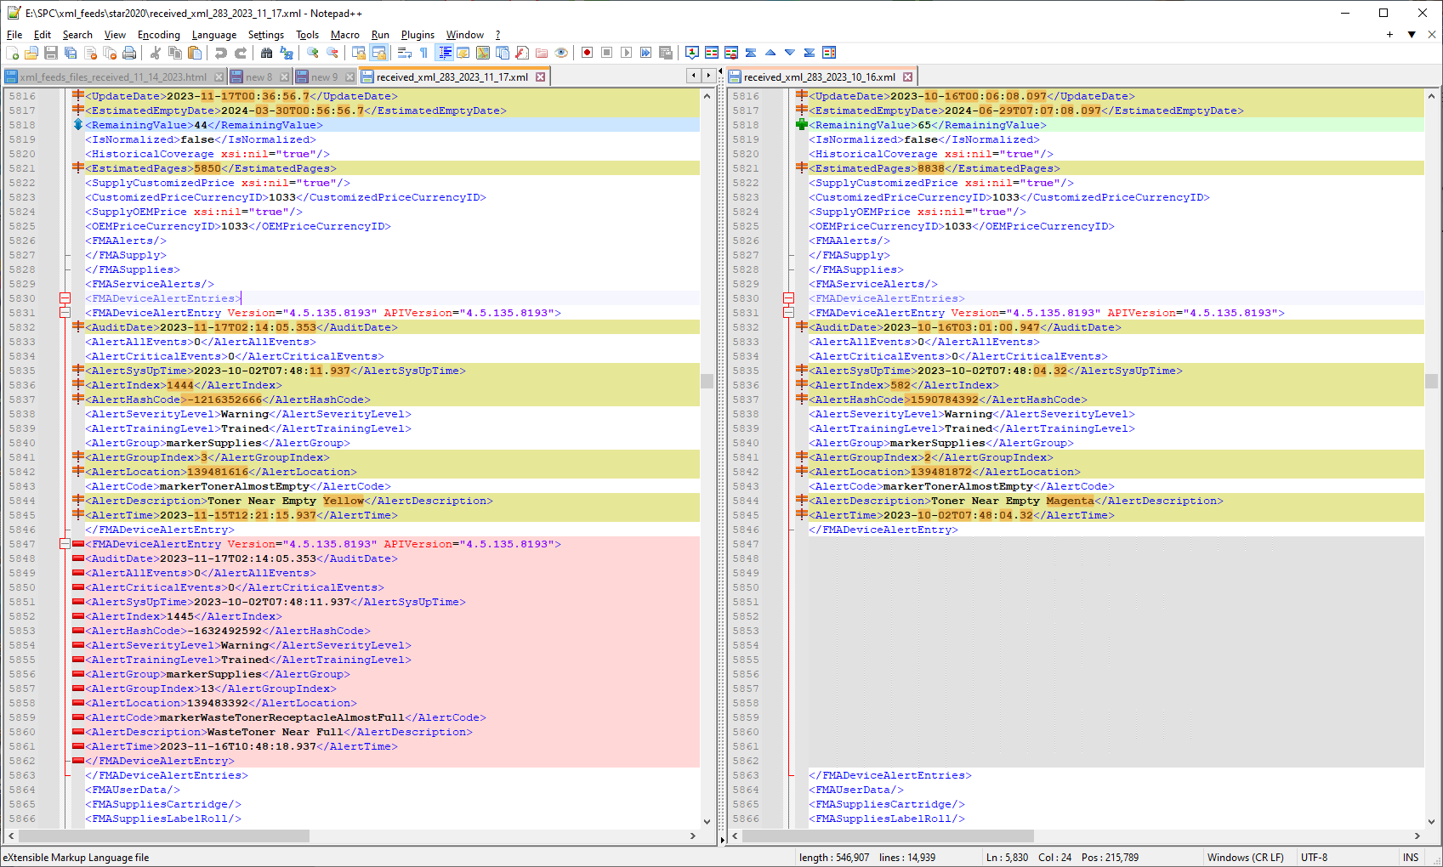

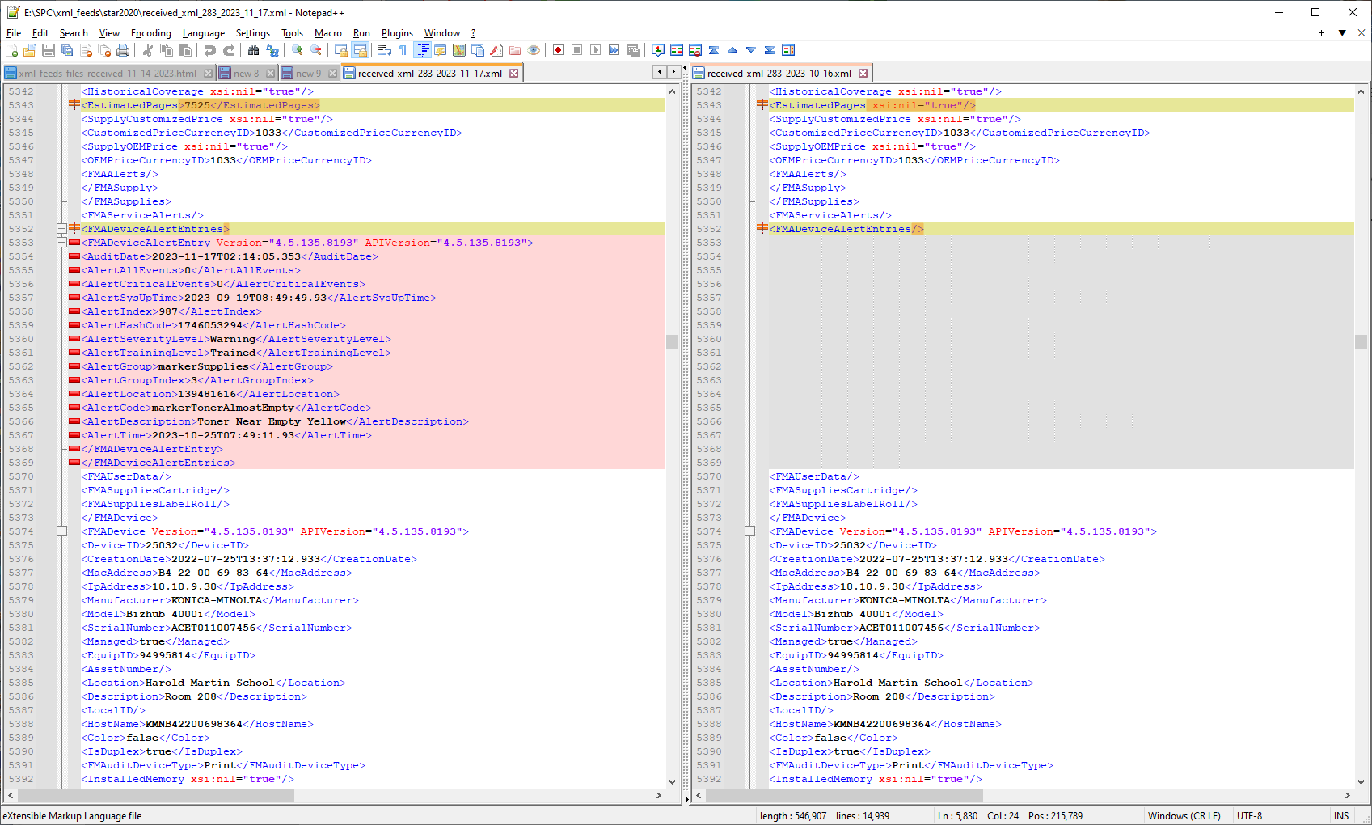

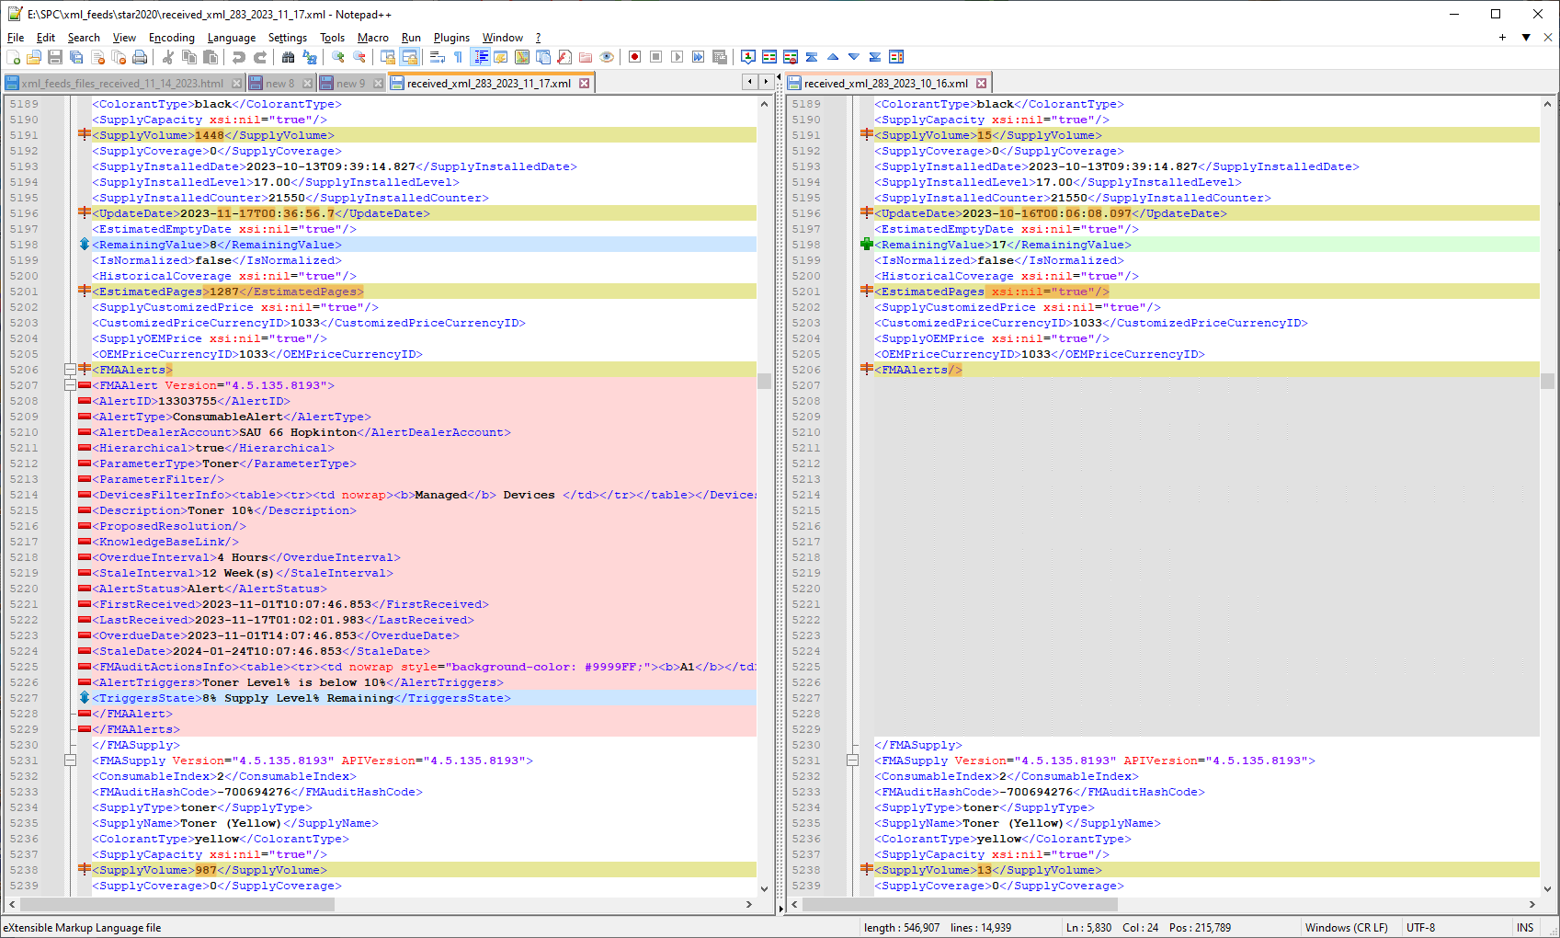

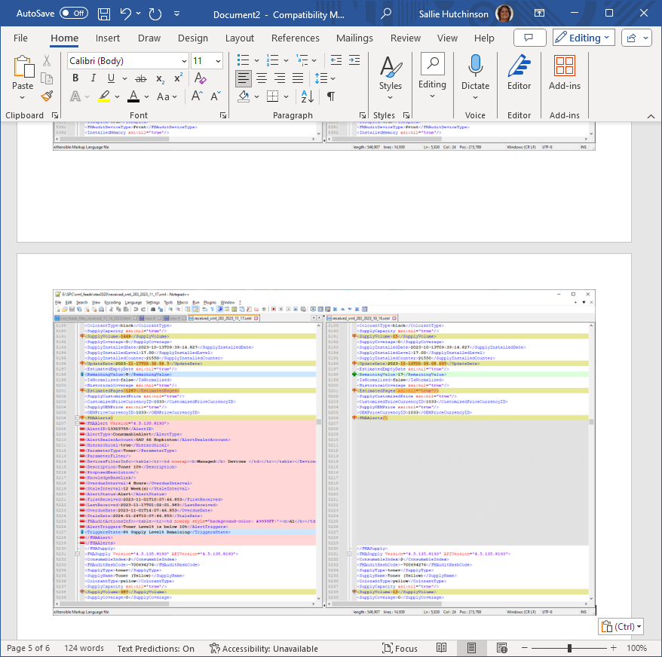

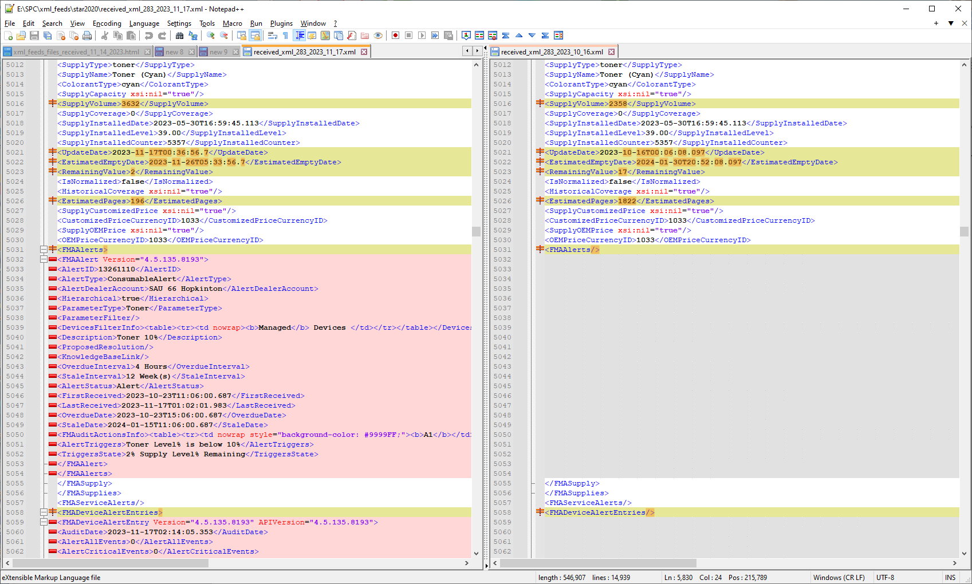

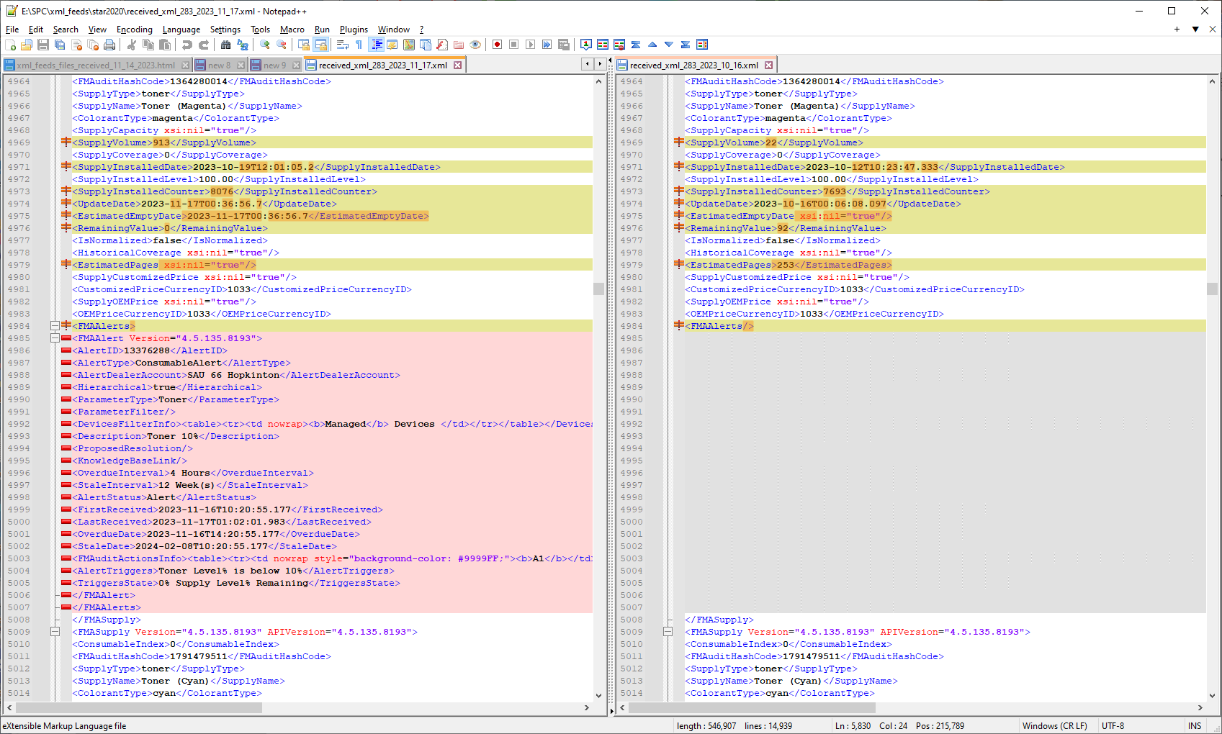

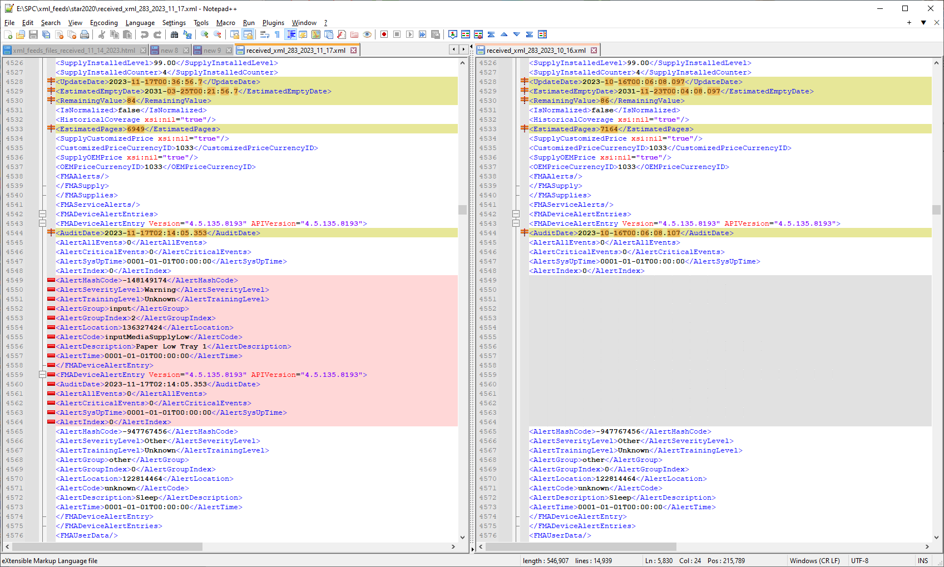

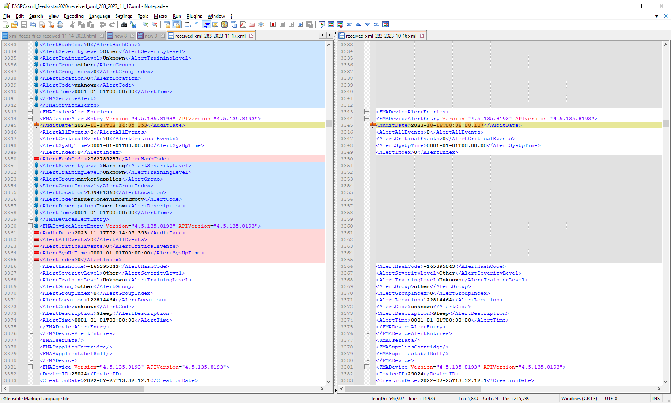

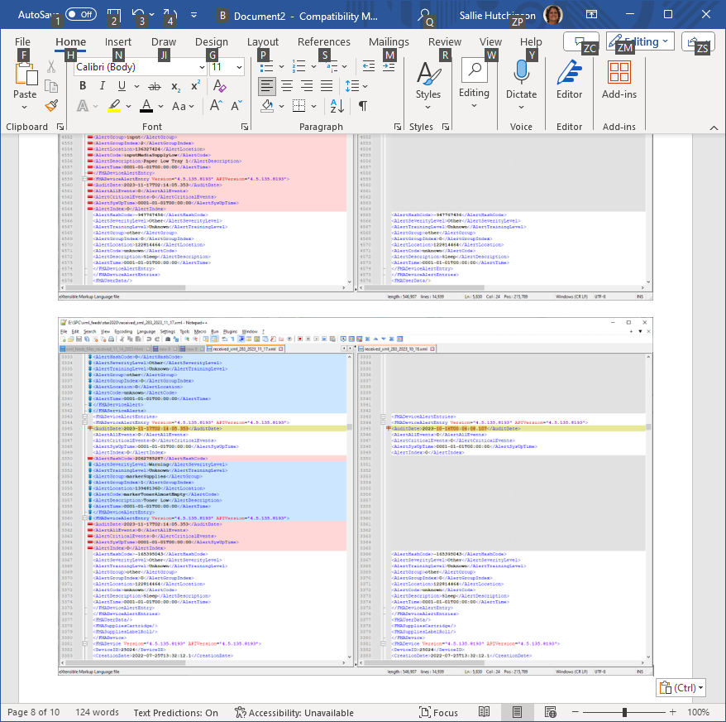

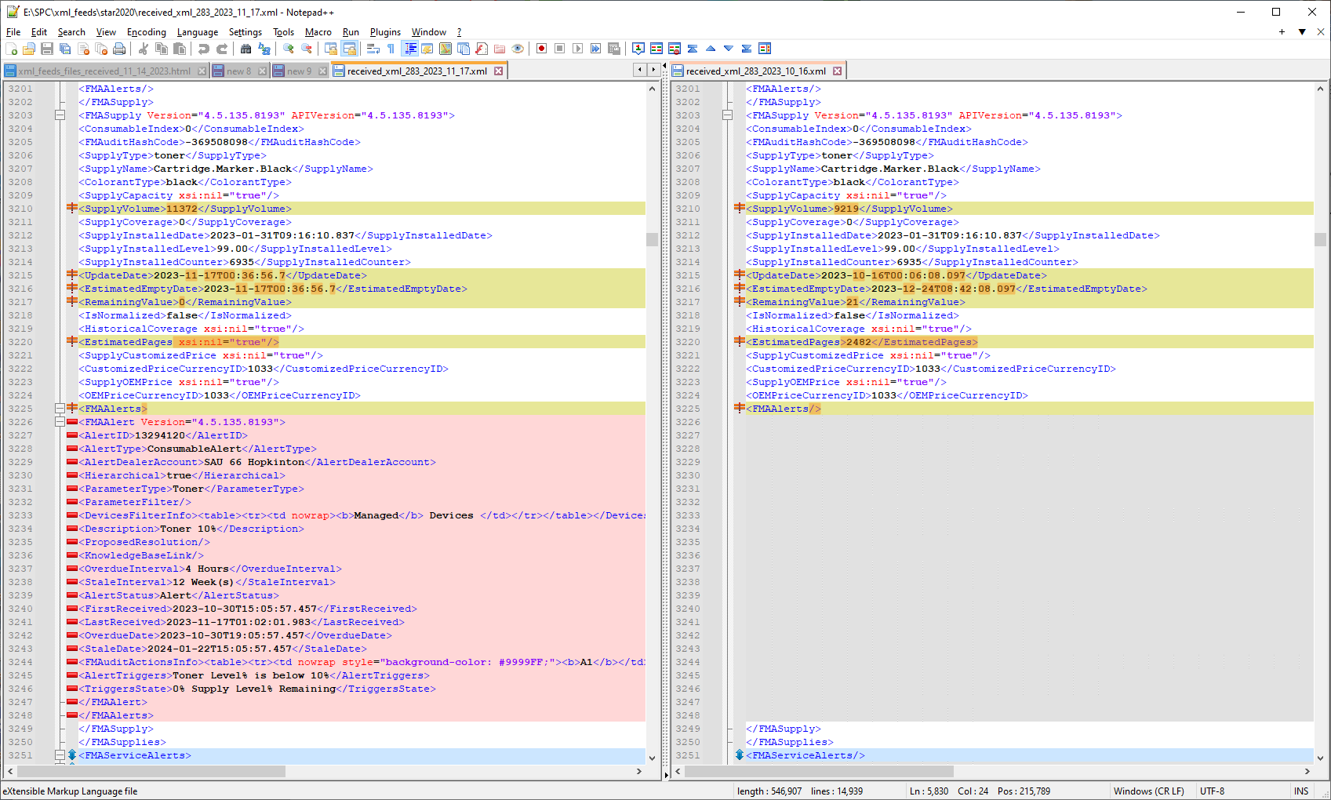

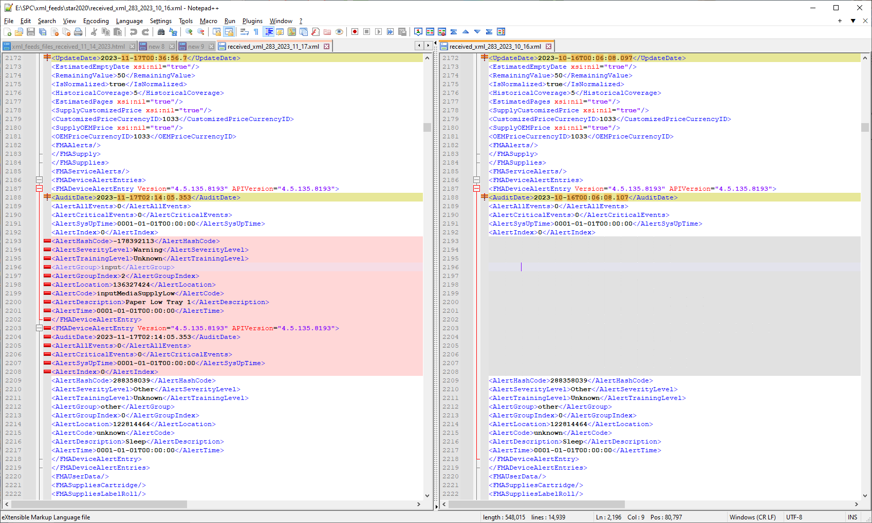

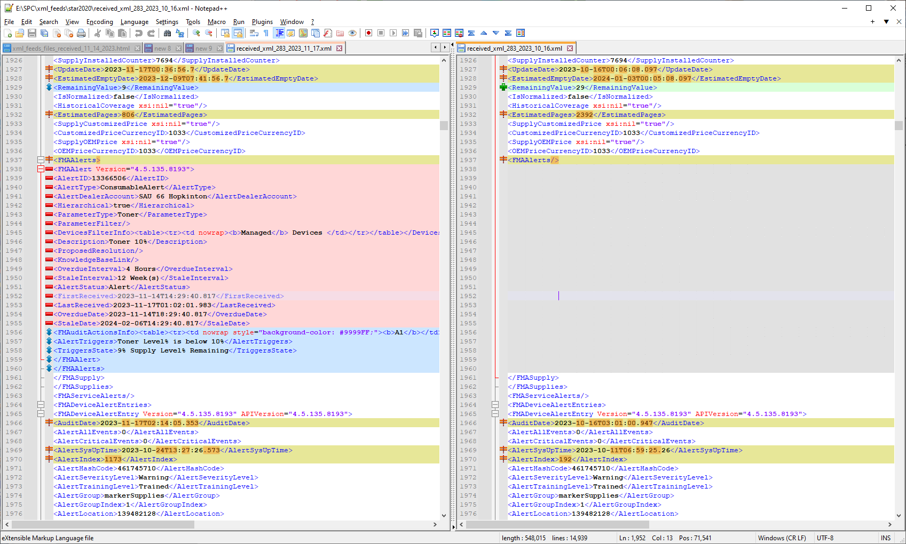

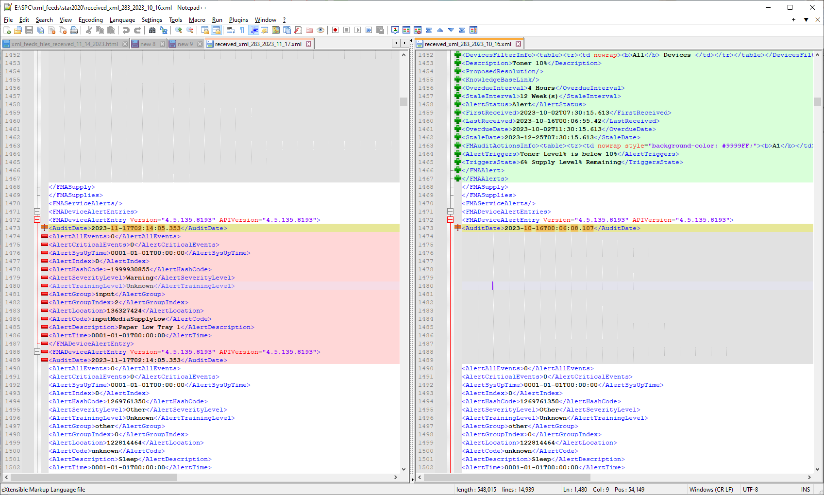

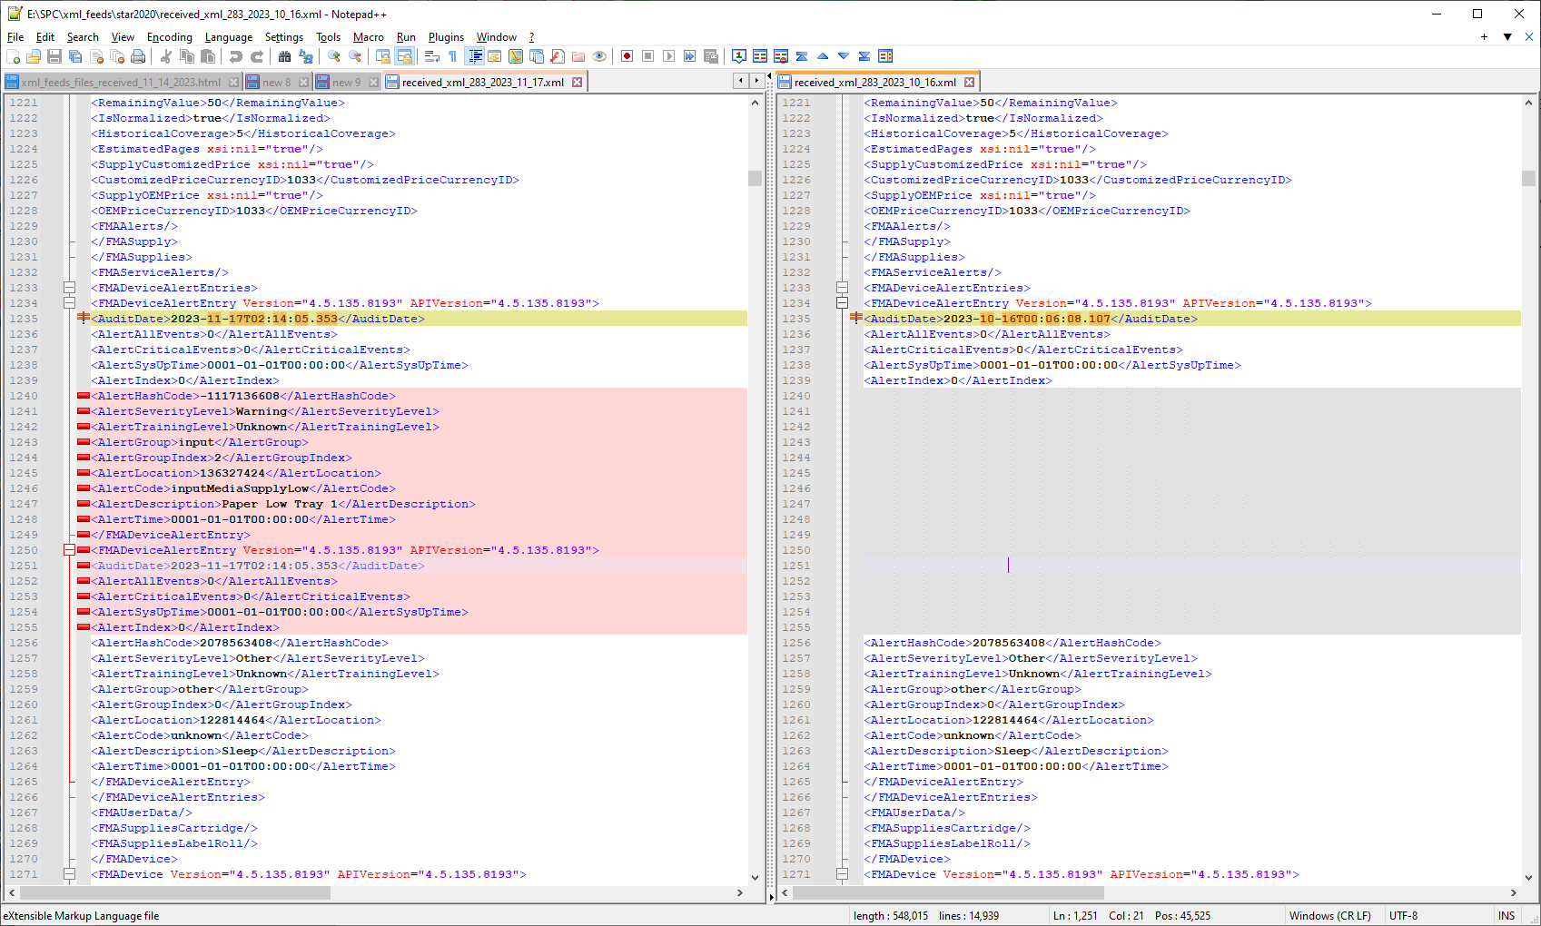

<FMADeviceAlertEntry Version="4.5.135.8193" APIVersion="4.5.135.8193">
<AuditDate>2023-11-17T02:14:05.353</AuditDate>
<AlertAllEvents>0</AlertAllEvents>
<AlertCriticalEvents>0</AlertCriticalEvents>
<AlertSysUpTime>2023-10-02T07:48:11.937</AlertSysUpTime>
<AlertIndex>1445</AlertIndex>
<AlertHashCode>-1632492592</AlertHashCode>
<AlertSeverityLevel>Warning</AlertSeverityLevel>
<AlertTrainingLevel>Trained</AlertTrainingLevel>
<AlertGroup>markerSupplies</AlertGroup>
<AlertGroupIndex>13</AlertGroupIndex>
<AlertLocation>139483392</AlertLocation>
<AlertCode>markerWasteTonerReceptacleAlmostFull</AlertCode>
<AlertDescription>WasteToner Near Full</AlertDescription>
<AlertTime>2023-11-16T10:48:18.937</AlertTime>
</FMADeviceAlertEntry>

<FMADeviceAlertEntry Version="4.5.135.8193" APIVersion="4.5.135.8193">
<AuditDate>2023-11-17T02:14:05.353</AuditDate>
<AlertAllEvents>0</AlertAllEvents>
<AlertCriticalEvents>0</AlertCriticalEvents>
<AlertSysUpTime>0001-01-01T00:00:00</AlertSysUpTime>
<AlertIndex>0</AlertIndex>
<AlertHashCode>783411014</AlertHashCode>
<AlertSeverityLevel>Warning</AlertSeverityLevel>
<AlertTrainingLevel>Unknown</AlertTrainingLevel>
<AlertGroup>input</AlertGroup>
<AlertGroupIndex>3</AlertGroupIndex>
<AlertLocation>135279360</AlertLocation>
<AlertCode>inputMediaSupplyEmpty</AlertCode>
<AlertDescription>No Paper Tray3</AlertDescription>
<AlertTime>0001-01-01T00:00:00</AlertTime>
</FMADeviceAlertEntry>
<FMADeviceAlertEntry Version="4.5.135.8193" APIVersion="4.5.135.8193">
<AuditDate>2023-11-17T02:14:05.353</AuditDate>
<AlertAllEvents>0</AlertAllEvents>
<AlertCriticalEvents>0</AlertCriticalEvents>
<AlertSysUpTime>0001-01-01T00:00:00</AlertSysUpTime>
<AlertIndex>0</AlertIndex>
<AlertHashCode>732764961</AlertHashCode>
<AlertSeverityLevel>Warning</AlertSeverityLevel>
<AlertTrainingLevel>Unknown</AlertTrainingLevel>
<AlertGroup>input</AlertGroup>
<AlertGroupIndex>4</AlertGroupIndex>
<AlertLocation>135279616</AlertLocation>
<AlertCode>inputMediaSupplyEmpty</AlertCode>
<AlertDescription>No Paper Tray4</AlertDescription>
<AlertTime>0001-01-01T00:00:00</AlertTime>
</FMADeviceAlertEntry>
<FMADeviceAlertEntry Version="4.5.135.8193" APIVersion="4.5.135.8193">
<AuditDate>2023-11-17T02:14:05.353</AuditDate>
<AlertAllEvents>0</AlertAllEvents>
<AlertCriticalEvents>0</AlertCriticalEvents>
<AlertSysUpTime>0001-01-01T00:00:00</AlertSysUpTime>
<AlertIndex>0</AlertIndex>
<AlertHashCode>35468960</AlertHashCode>
<AlertSeverityLevel>Warning</AlertSeverityLevel>
<AlertTrainingLevel>Unknown</AlertTrainingLevel>
<AlertGroup>markerSupplies</AlertGroup>
<AlertGroupIndex>1</AlertGroupIndex>
<AlertLocation>139481360</AlertLocation>
<AlertCode>markerTonerAlmostEmpty</AlertCode>
<AlertDescription>Toner Near Empty Black</AlertDescription>
<AlertTime>0001-01-01T00:00:00</AlertTime>
</FMADeviceAlertEntry>
</FMADeviceAlertEntries>

