Modifications were made on 12/9/2021 to the processxml.php file and other tasks were completed to allow an org to have more than one fmaudit_client_id processed from the xml feeds.

Union 69 Hope/Appleton 282
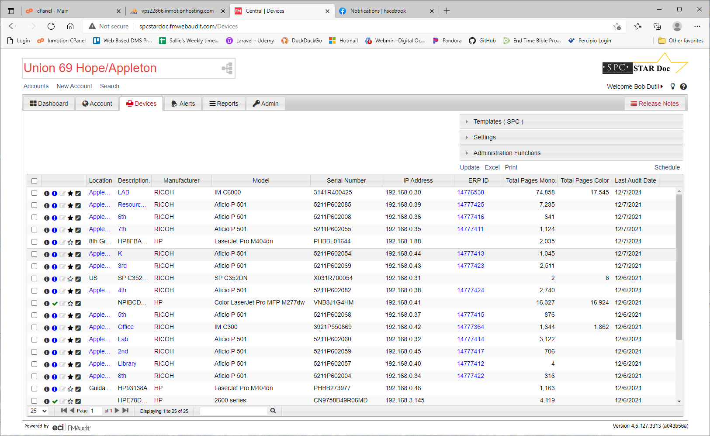
Floorplan id = 1412
Building id = 1497
Building name = Hope Elementary School
Org 1909 = Union 69

select * from floorplan_machines where serial_number = '3141R200158';
select * from floorplans where id = 1412;
select * from buildings where id = 1497;
select * from organization where id IN(1909, 99);
select * from buildings where org_id = 1909;
select * from organization where fmaudit_client_id IN(290, 108, 289);
select * from buildings where org_id = 99;

select * from floorplan_machines where fmaudit_id is null and floorplan_id = 1412; All 18 machines for this floorplan have null fmaudit_id values. This actually has no effect on the process.

- Other orgs experiencing this issue besides Harwood?
- Why did this ser num appear on 12/4 and not 12/5?
- Was any parent data changed?

The 2 serial_numbers here with matching IP Addresses are both in today's feed and they both have fmaudit_id values in the floorplan_machines table.

select * from floorplan_machines where serial_number IN('VNB3B41242', 'X031R700054');
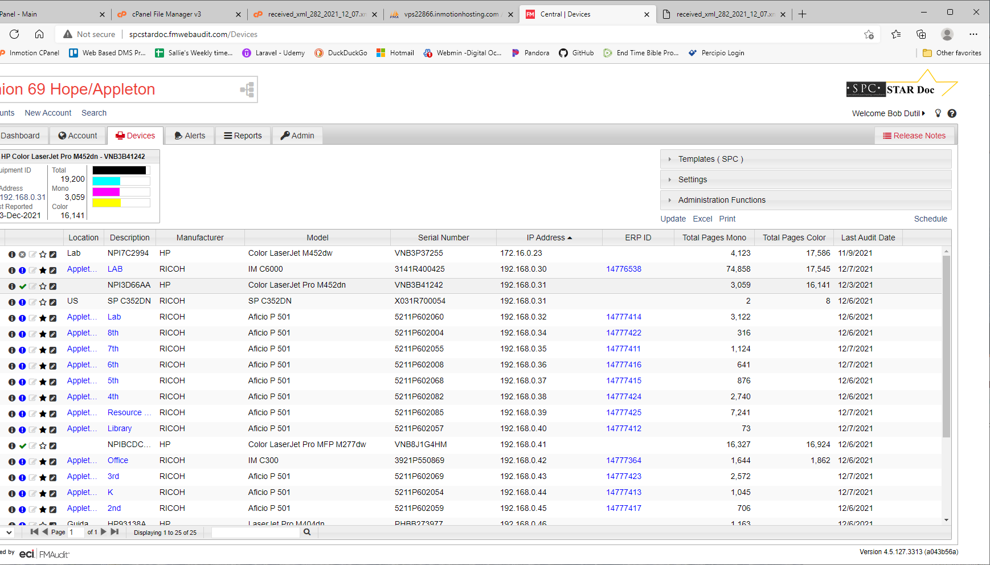

Red serial numbers have no fmaudit_client_id in floorplan_machines table
Geen serial numbers Do have an fmaudit_client_id in floorplan_machines table

In feed 289_2021_12_07, floorplan_id 1412
- 5211P602058
- 4451R500734
- 5211P602084
- 5211P602166
- 5211P602067
- 5211P602064
- 5211P602056
- 5211P602065
- 5211P602063
- 5211P602009
- 5211P602010
- 5211P602011
- 3141R200158
- 3351P503136
- 5211P602066
- 5211P602005
In feed, not in query
- PHBB273986
- X031R700101
- X031R700102

In feed 282_2021_12_07, floorplan_id 1411
- VNB3P37255 meter last date 11/9
- 5211P602060 meter last date 12/6
- 3141R400425
- 5211P602085
- 5211P602057
- 5211P602004
- PHBB273977
- VNB3B41242
- 5211P602059
- 5211P602008
- 5211P602068
- 3921P550869
- 5211P602055
- VNB8J1G4HM
- 5211P602069
- PHBBL01644
- 5211P602054
- 5211P602082
- CN9758B49R06MD
- X031R700054

In feed, not in query
- 3351P503138
- 5211P501020
- 5211P602062
- 4451R500478
- 5211P602061

289_2021_12_07 - Following the process for this feed
- $xml_file = xml_feeds/raw/received_xml__2021_12_07.xml
- write $xml_post into $xml_file
- $xml_post has values, so Convert $xml_file into object and save into $xmldata
- $account = 289
- $xml_file = xml_feeds/received_xml_289_2021_12_07.xml'
- write $xml_post into $xml_file (the non-raw one)
- $account_name = Hope Elementary School
- Iterating through the devices, this query brings up null because the fmaudit_client_id for org_id 1909 is 282. The break statement exits the loop because the condition of If (!$org_id) is true.
  - SELECT id FROM organization where fmaudit_client_id = 289;
    - Possibly have a csv of fmaudit_client_id values in the organization table for orgs with > one??
    - Then iterate through this list
    - What else would be affected by changing the value in the org table?
    - Possibly create a crosswalk table with org and fmaudit_client_id columns. This is the option that resolved the issue.
    - Then query this new table.
    - This option will not affect other processes because it would only be queried by this process
- $meterDataFeed is also null because org_id is null
  - $meterDataFeed = ew_ExecuteScalar("SELECT MeterDataFeed FROM organization where id = 289;
- $meterDataFeed != "PRESENT", so run this query to get the id of 43918
  - $ID = ew_ExecuteScalar("SELECT id FROM floorplan_machines where serial_number = '5211P602058';
- This block does NOT get processed because org_id is Null and $ID Does have a value (43918) lines 309-371
  - if (!$ID && $org_id && ($serial_number || $MAC_Address) && $meterDataFeed != "PRESENT")
- Process this prepared query (lines 374-383)
  - replace into meter (serial_number, machine_id, black_meter, color_meter,date_timestamp) values ('5211P602058', 43918, 2520, :color_meter, 2021-12-06T20:29:53.673)
- Process this prepared query (lines 432-436)
  - replace into machine_status (serial_number, machine_id, toner, service_needed,date_timestamp) values ('5211P602058', 43918, :toner,:service_needed, 2021-12-06T20:29:53.673)

Resolution to test
- CREATE crosswalk table
  - CREATE TABLE org_x_fmaudit (org_id INT NOT NULL, fmaudit_client_id INT NOT NULL);
- INSERT values for org 1909
  - INSERT INTO org_x_fmaudit(org_id, fmaudit_client_id) VALUES(1909, 282), (1909, 289), (1909, 290);
- Create processxmltest.php and add code to get org_id from the new table
  - $org_id = ew_ExecuteScalar("SELECT org_id FROM org_x_fmaudit where fmaudit_client_id = " . $xmldata->AccountID); (line 150)
- Send the file to the url processxmltest.php, which is the modified version of processxml.php. The screenshot below shows where to change this url on fmaudit.
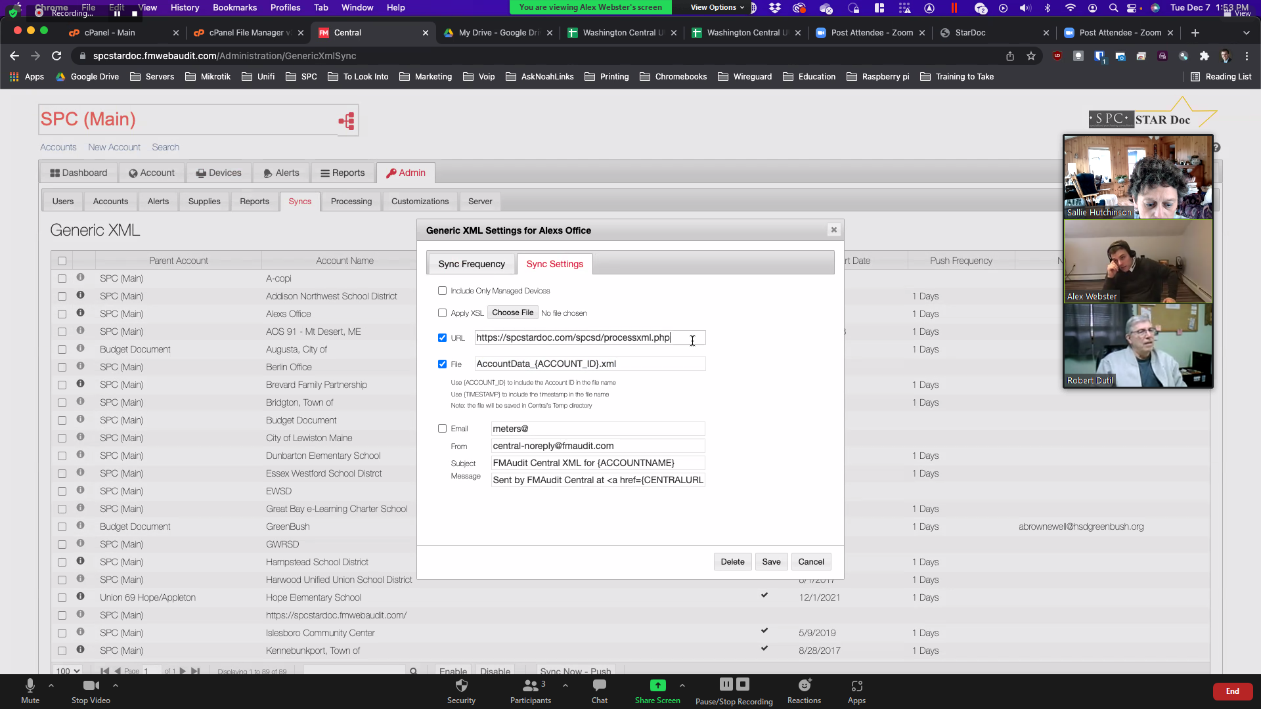
- Insert into org_x_fmaudit all orgs and their fmaudit_client_ids from the organization table
  - INSERT INTO org_x_fmaudit(org_id, fmaudit_client_id) SELECT id, fmaudit_client_id FROM organization WHERE fmaudit_client_id IS NOT NULL ORDER BY id;
- Get a list from Alex of all orgs that have child fmaudit_client ids to insert into the new table
  - For orgs that have more than one fmaudit_client_id, the url for the sync needs to be processxmltest.php.
  - For orgs that only have one fmaudit_client_id, the url for the sync will remain processxml.php for now.
  - Once Alex has finished creating the additional fmaudit_client_ids, the url for all syncs will need to be changed to processxml.php and the processxmltest.php will need to be renamed to processxml.php. This will mean that ALL orgs, no matter how many fmaudit_client_ids, will point to the same processxml.php. The first line of the feed (coded in processxmltest) will need to be changed from TEST to PROD.
- Ask Alex about moving old log files to separate file or deleting. Need permissions to do this.
  - Renamed log file fmaudit_processing.log to fmaudit_processing_before_12_10_21.log. This can be deleted after a couple of months logs are appended to the new fmaudit_processing.log.
  - Deleted fmaudit_processing.log.1 (files from 2013 to part of 2018)
- Discuss the discrepancy between black meter reads between the 12/8 feed and what was inserted into the meter table. 2127 is in meter table, but 2129 is the value in the feed. The 12/9 insert agrees with the 12/9 feed value. Alex, Bob, and I all agreed that this is nothing to be concerned with. There may have been another meter read that day from somewhere else.
- Meet with Alex and Bob to discuss what was done to fulfill Alex's request.
I compared the feeds from 12/8/2021 and 12/9/2021 to the data inserted into meter and machine_status. Below are the queries for the 5 serial numbers I checked for fmaudit_client_id 290. The values in the 2 tables matched what was in the feeds for those days.

FROM 290
select * from meter where serial_number IN('5211P602061', '5211P602062', '5211P501020', '3351P503138', '4451R500478')
ORDER BY serial_number, date_timestamp;

FROM 290
select * from machine_status where serial_number IN('5211P602061', '5211P602062', '5211P501020', '3351P503138', '4451R500478')
ORDER BY serial_number, date_timestamp;

Test of modifications
The log file for fmaudit_client_ids that point to processxmltest.php will have Test in the first line of the feed. Prod will replace Test for orgs that currently only have 1 fmaudit_client_id.

-----Start Test processing of FMAudit XML feed------
-- Processing started at: 2021_12_09-16-51-58
-- File: xml_feeds/received_xml_282_2021_12_09.xml
-- Account: Union 69 Hope/Appleton
-- Total Devices: 19
-- Matched Devices: 19
-- Processing ended at: 2021_12_09-16-51-58
-----End processing of FMAudit XML feed------

-----Start Test processing of FMAudit XML feed------
-- Processing started at: 2021_12_09-16-51-59
-- File: xml_feeds/received_xml_289_2021_12_09.xml
-- Account: Hope Elementary School
-- Total Devices: 19
-- Matched Devices: 19
-- Processing ended at: 2021_12_09-16-51-59
-----End processing of FMAudit XML feed------

-----Start Test processing of FMAudit XML feed------
-- Processing started at: 2021_12_09-16-52-01
-- File: xml_feeds/received_xml_290_2021_12_09.xml
-- Account: Union 69 District Office
-- Total Devices: 5
-- Matched Devices: 5
-- Processing ended at: 2021_12_09-16-52-01
-----End processing of FMAudit XML feed------

