Issues with Bahnschrift font – 4/10/2023
I tried adding this font to the TCPDF font library, but it errored out. I then was researching how to proceed and came upon a multitude of articles describing how this font does NOT work well. I have added fonts to the TCPDF font library previously with no issues for most of them (goodfish is one), but there were some I tried to add that could not be added. Those were the OTF files. Most of the below links say that Bahnschrift is an OTF file, even though the versions I downloaded were TTF. I am thinking that this may be one that cannot be added to TCPDF. Possibly the conversion from OTF to TTF is missing something??
Have you previously used this font with success going from web to pdf?

Following are some of the sites that have documented issues with this font.
Bahnschrift font - major issues - Microsoft Community
What’s so special about the Bahnschrift font? - Office Watch (office-watch.com)
Solved: The problem is that Bahnschrift is an OpenType Var... - Adobe Support Community - 11318343
Bahnschrift font display problem in PDF files - LayOut - SketchUp Community

Error on 8/28/2023 when attempting to convert to a TCPDF compatible font version
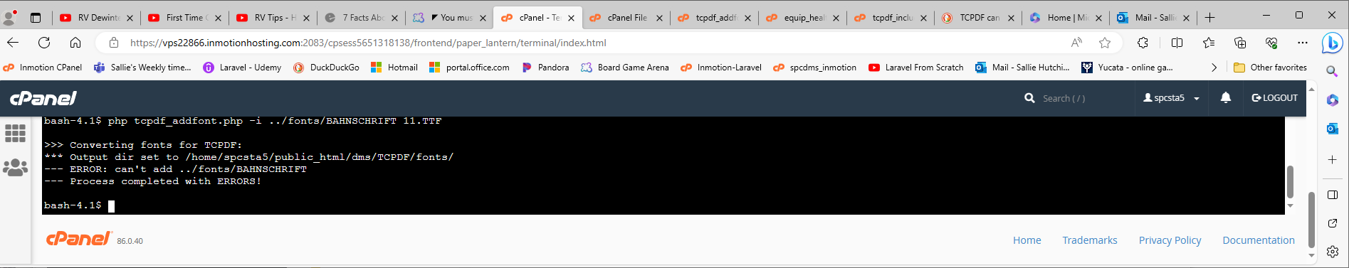

I was able to successfully add Roboto on 8/28/2023
