How to Add Fonts to TCPDF in Your Project

How to Add Fonts to TCPDF in Your Project - DEV Community
ekastryaJul 3, 2020
(Versi Bahasa Indonesia: https://medium.com/@ekastrya/cara-menambah-font-untuk-tcpdf-17af6808b76)
Earlier today, I was assigned a simple task to add two custom fonts for a client's project. It took me 15 minutes on Stack Overflow to find a fast way to do this. Found it and here are the steps:
- Install / download / require the tcpdf library into your project.
- Open the library folder (for example mine was: ./vendor/tecnickcom/tcpdf).
- Notice and enter to the tools folder.
- Copy the TTF file(s) into this tools folder. SJH - I placed mine into fonts folder. See note for #5
- Run this command from the terminal (still from the tools folder): $ php tcpdf_addfont -i BOOKOS.TTF (Replace BOOKOS.TTF with your own fonts) - Note from SJH on 5/1/2021 Run the command from within the tools directory. The fonts .ttf file doesn't need to be in the tools folder as long as you have the path correct. I ran this command successfully (I had to remove the $ sign (not the prompt one) and preceding space from the command. The screenshot (line 2)shows the error with the $ sign and space, then the success when they were removed. Also, I had to add the .php extension into the command.)
- Repeat steps (4-5) for each font desired.
Coding time..
To change between fonts from your php code, use the following scripts.
$pdf->SetFont($font_family = ‘bookos’, $variant = ‘’, $fontsize = 11);
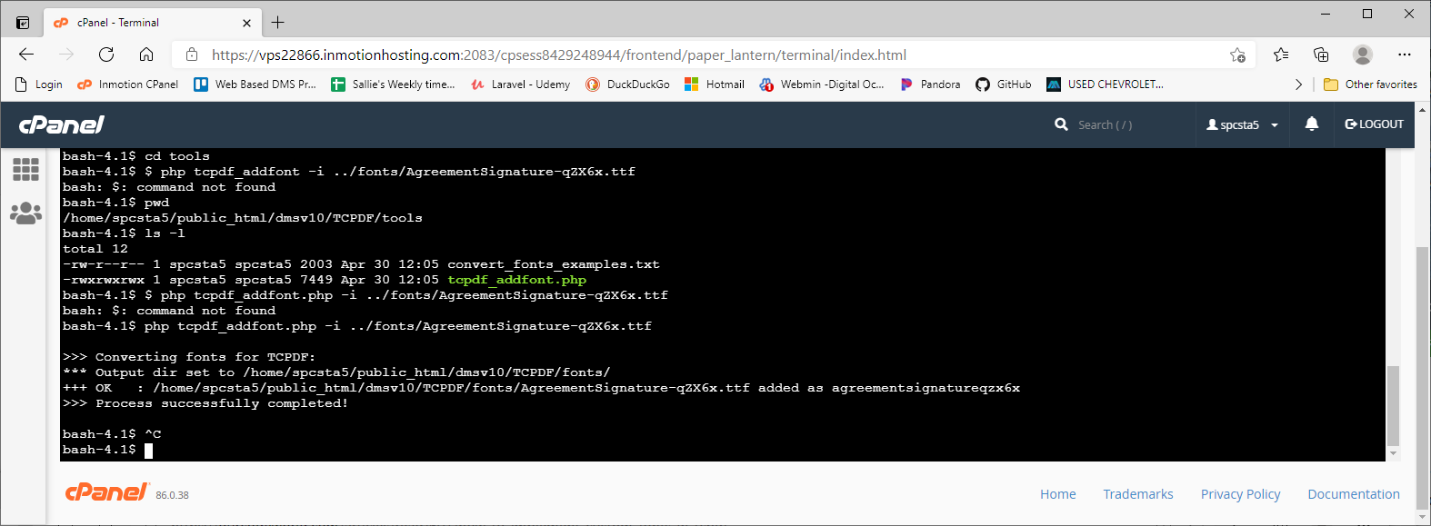
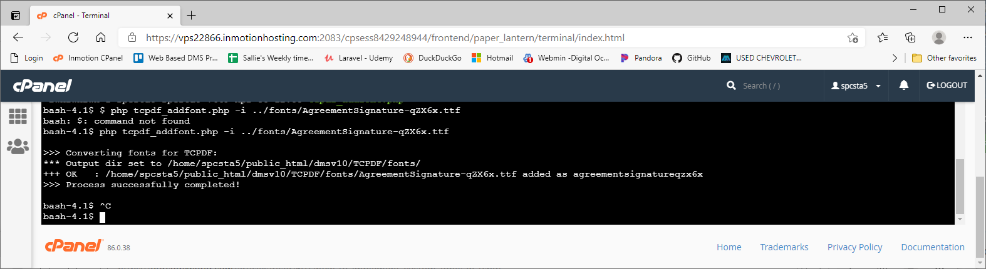

php tcpdf_addfont.php -i ../fonts/litoln.ttf
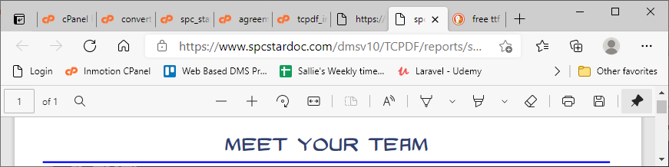

php tcpdf_addfont.php -i ../fonts/Risky101.ttf
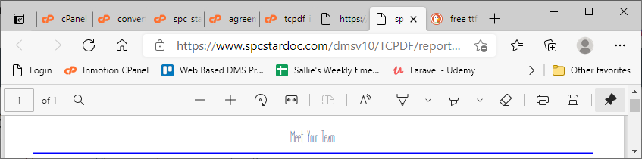

php tcpdf_addfont.php -i ../fonts/fawn.ttf
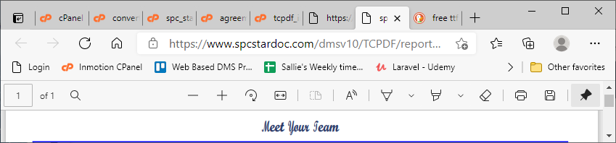

php tcpdf_addfont.php -i ../fonts/ekmukta_med.ttf
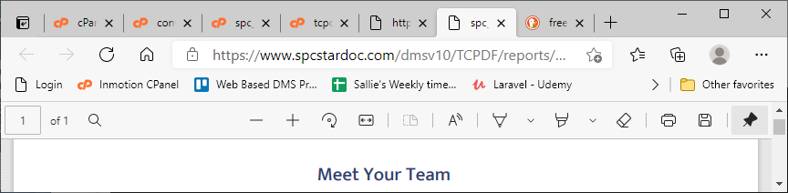

php tcpdf_addfont.php -i ../fonts/trajan_pro.ttf
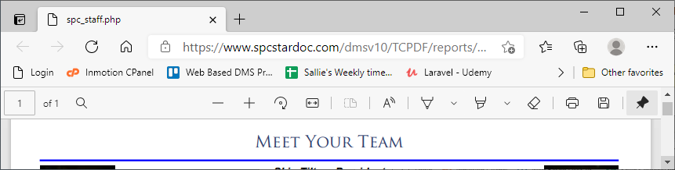

php tcpdf_addfont.php -i ../fonts/midtown_roman.ttf
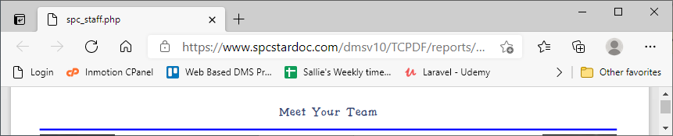

php tcpdf_addfont.php -i ../fonts/memoriam.ttf
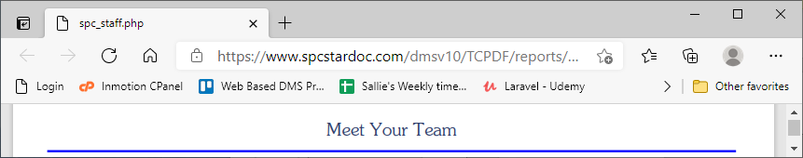

php tcpdf_addfont.php -i ../fonts/standard_med.ttf


php tcpdf_addfont.php -i ../fonts/wright.ttf
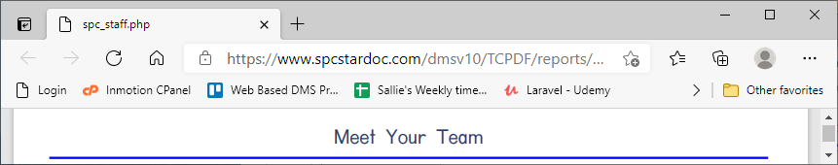
php tcpdf_addfont.php -i ../fonts/wichitabold.ttf


php tcpdf_addfont.php -i ../fonts/whackadoo.ttf


php tcpdf_addfont.php -i ../fonts/wallaby_db_reg.ttf


TCPDF included font - freeserifi
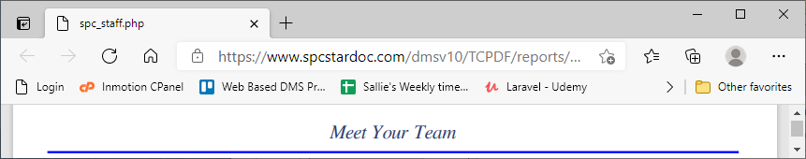

TCPDF included font - freeserif


TCPDF included font - freesans


TCPDF included font - freemono
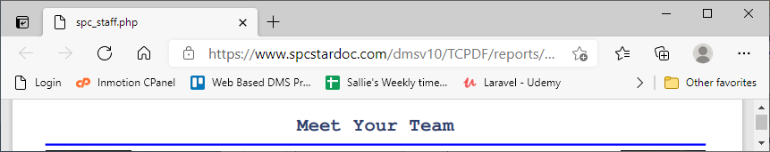

TCPDF included font - dejavuserif
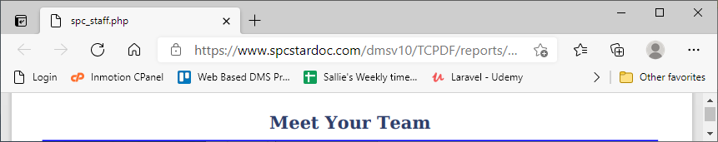

TCPDF included font - aefurat
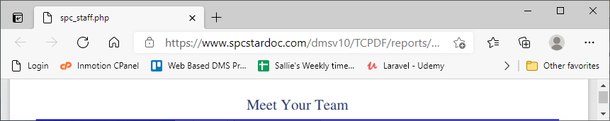

php tcpdf_addfont.php -i ../fonts/alegreya_sans_itl.ttf

php tcpdf_addfont.php -i ../fonts/alegreya_sans_med.ttf


php tcpdf_addfont.php -i ../fonts/alegreya_sans_reg.ttf
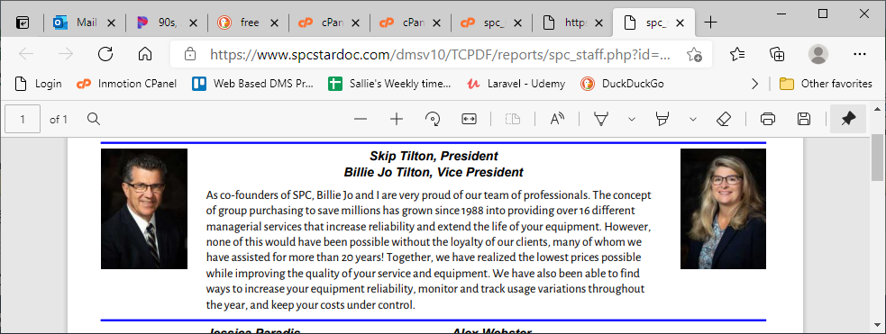

php tcpdf_addfont.php -i ../fonts/barlow_itl.ttf

php tcpdf_addfont.php -i ../fonts/barlow_med.ttf


php tcpdf_addfont.php -i ../fonts/barlow_reg.ttf


php tcpdf_addfont.php -i ../fonts/nunito_blk.ttf


php tcpdf_addfont.php -i ../fonts/nunito_reg.ttf


php tcpdf_addfont.php -i ../fonts/josefin_sans_itl.ttf


php tcpdf_addfont.php -i ../fonts/josefin_sans_reg.ttf


php tcpdf_addfont.php -i ../fonts/goodfish_bd_it.ttf
php tcpdf_addfont.php -i ../fonts/goodfish_bd.ttf
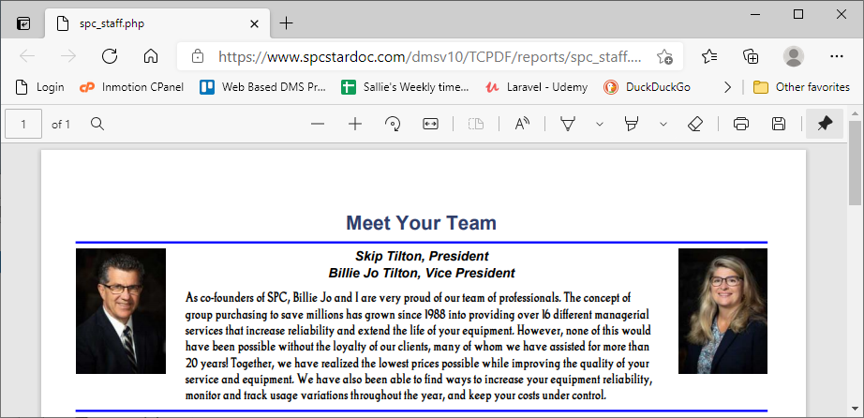

php tcpdf_addfont.php -i ../fonts/goodfish_rg_it.ttf
php tcpdf_addfont.php -i ../fonts/goodfish_rg.ttf
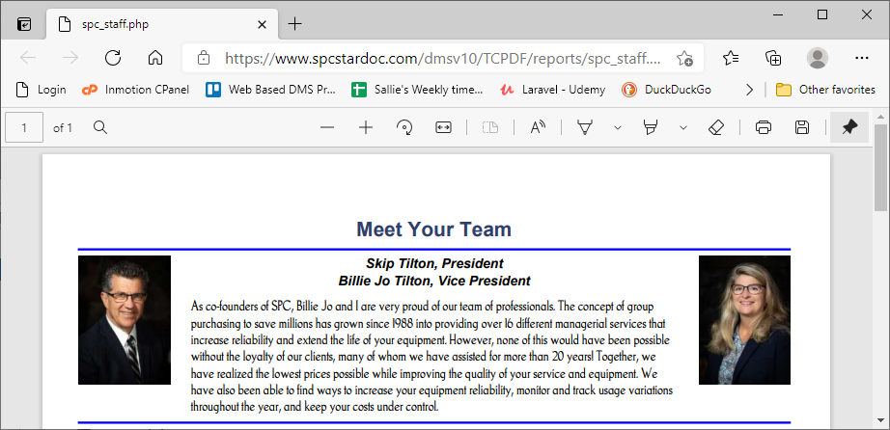

php tcpdf_addfont.php -i ../fonts/josefin_sans_semi_bld.ttf
php tcpdf_addfont.php -i ../fonts/josefin_sans_semi_bld_itl.ttf
php tcpdf_addfont.php -i ../fonts/josefin_sans_bld.ttf
php tcpdf_addfont.php -i ../fonts/open_sans_cond_bld.ttf
php tcpdf_addfont.php -i ../fonts/open_sans_cond_light.ttf
php tcpdf_addfont.php -i ../fonts/open_sans_cond_light_itl.ttf

php tcpdf_addfont.php -i ../fonts/ostrich_black.ttf
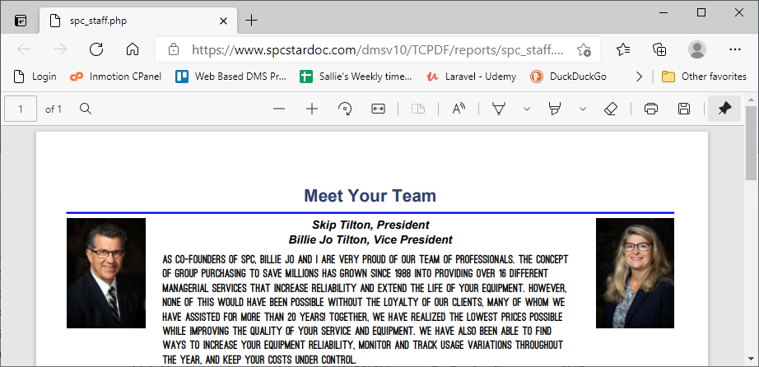

php tcpdf_addfont.php -i ../fonts/ostrich_reg.ttf
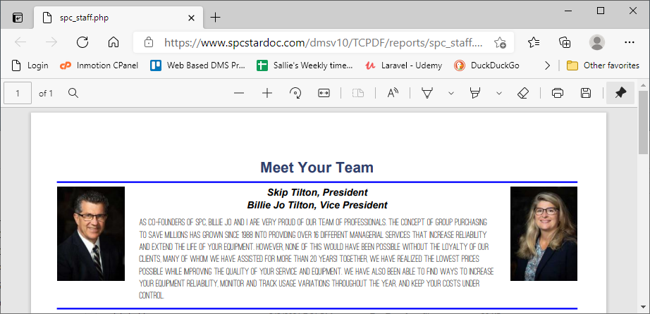

php tcpdf_addfont.php -i ../fonts/oswald_reg.ttf
php tcpdf_addfont.php -i ../fonts/oswald_bld.ttf
php tcpdf_addfont.php -i ../fonts/oswald_light.ttf
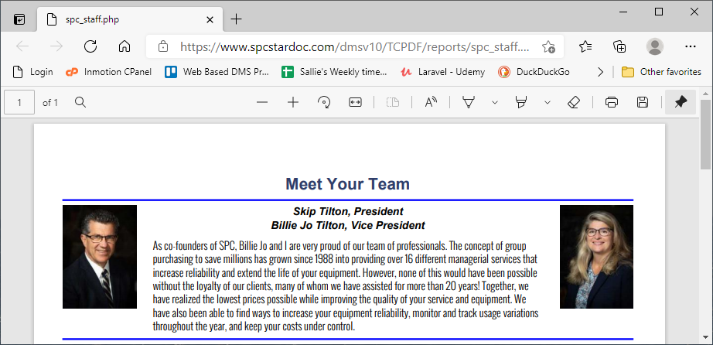

php tcpdf_addfont.php -i ../fonts/d_din.ttf
php tcpdf_addfont.php -i ../fonts/d_din_cond.ttf
php tcpdf_addfont.php -i ../fonts/d_din_cond_bld.ttf
php tcpdf_addfont.php -i ../fonts/d_din_exp.ttf

Summary
- Find ttf file for desired font
- upload this ttf file to the TCPDF/fonts folder
- run this command on command line from within tools folder, replacing yellow highlighted name w/ file name
  - php tcpdf_addfont.php -i ../fonts/wallaby_db_reg.ttf
- Use the font-family by using the filename (without extension) to call it.
  - font-family:wallaby_db_reg;

Free fonts websites
- https://www.1001fonts.com

These do not work. I can convert to php, but the presentation is gibberish:
- php tcpdf_addfont.php -i ../fonts/AgreementSignature-ALx9x.otf
- php tcpdf_addfont.php -i ../fonts/agreementsignatureqzx6x
- php tcpdf_addfont.php -i ../fonts/cheddarcakefactory.ttf
- php tcpdf_addfont.php -i ../fonts/simpleman.ttf
- php tcpdf_addfont.php -i ../fonts/khatija_calligraphy.otf
- php tcpdf_addfont.php -i ../fonts/roboto_blk.ttf
- php tcpdf_addfont.php -i ../fonts/roboto_itl.ttf
- php tcpdf_addfont.php -i ../fonts/roboto_med.ttf
- php tcpdf_addfont.php -i ../fonts/roboto_reg.ttf
- php tcpdf_addfont.php -i ../fonts/ostrich_sans_inline_reg.ttf

