Updated on 10/31/2020 8/5/2022
I have commented this out as requested by Jamin via email. I do not know where this org_message value is set.
//echo $org_message; -- The message was Please do not rely on projections until November 2020.
Commented out on these pages
- dashboard3.php line 257
- dashboard.php line 418
- dashboard7.php line 385
- dashboard_department_gauges.php line 256
- dashboard_department_volume.php line 387
- dashboard_department_cost.php line 382

Changed Next Year's Black (and Color) from FY21 to FY22 on these pages
- dashboard.php line 483 (color on line 494) 475, 476, 486, 487 for FY23 AND 484, 495 FOR fy24
- dashboard7.php line 450 (color on line 461) 442, 443 453, 454, for FY23 AND 451, 462 FOR fy24
- dashboard_department_volume.php line 441 (color on line 443) LINES 440 - 443
- dashboard_department_cost.php line 436 (color on line 438) LINES 435 - 438

dashboard3.php(Dashboards/Building - Gauges page)
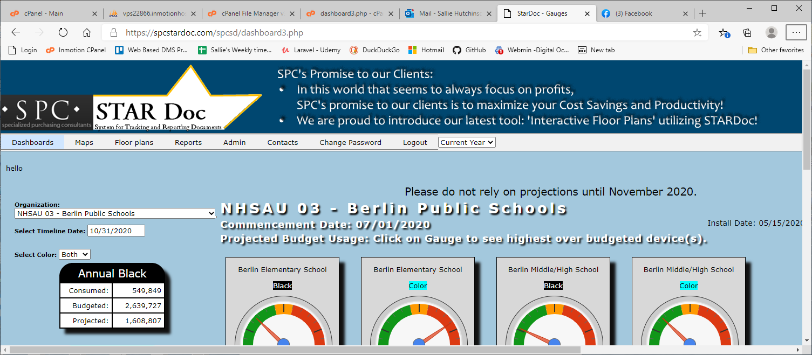

dashboard.php (Dashboards/Building - Volume page)
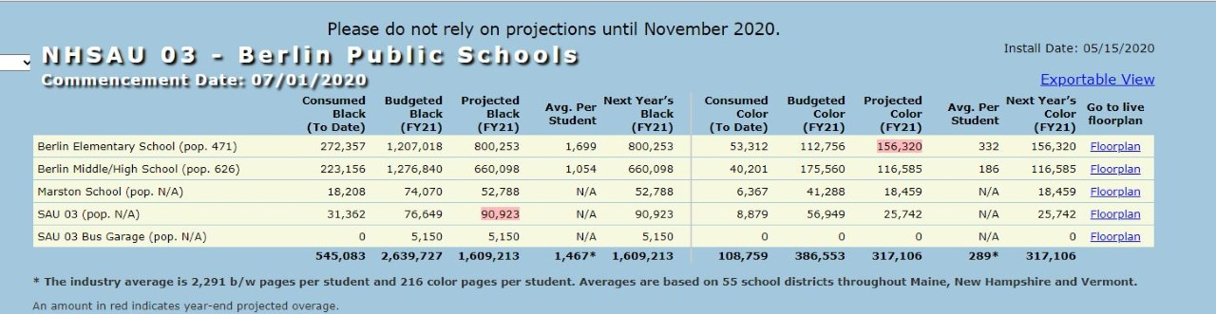

dashboard7.php (Dashboards/Building - Cost page)
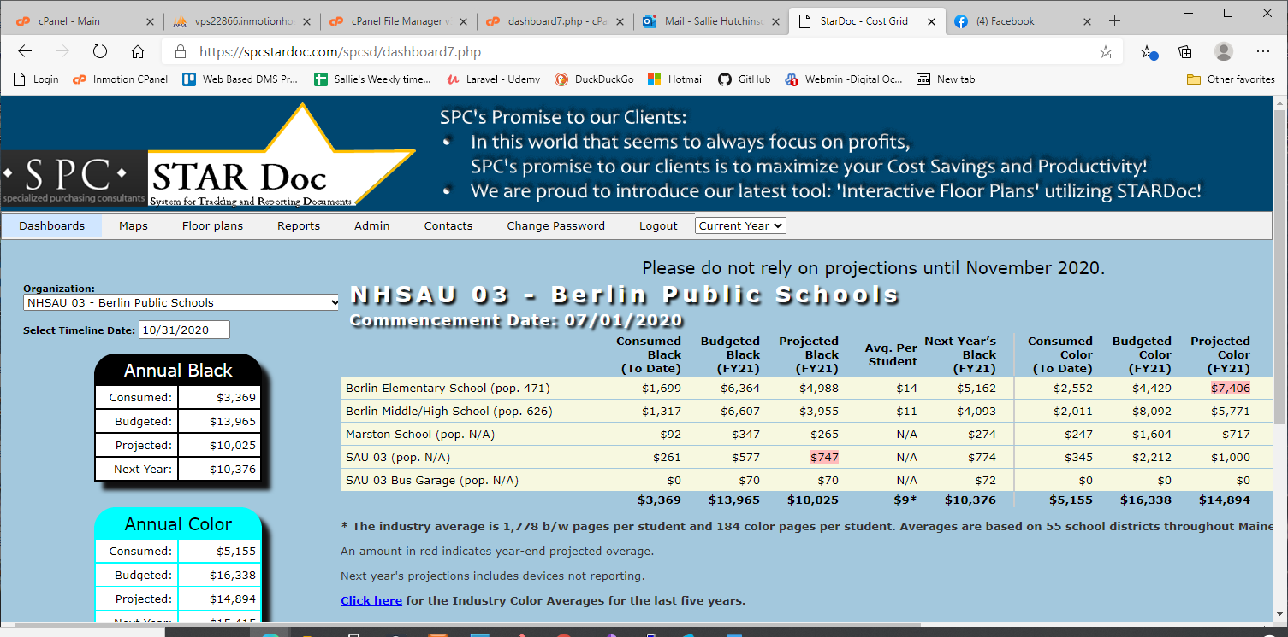
dashboard_department_gauges.php(Dashboards/Department - Gauges page)
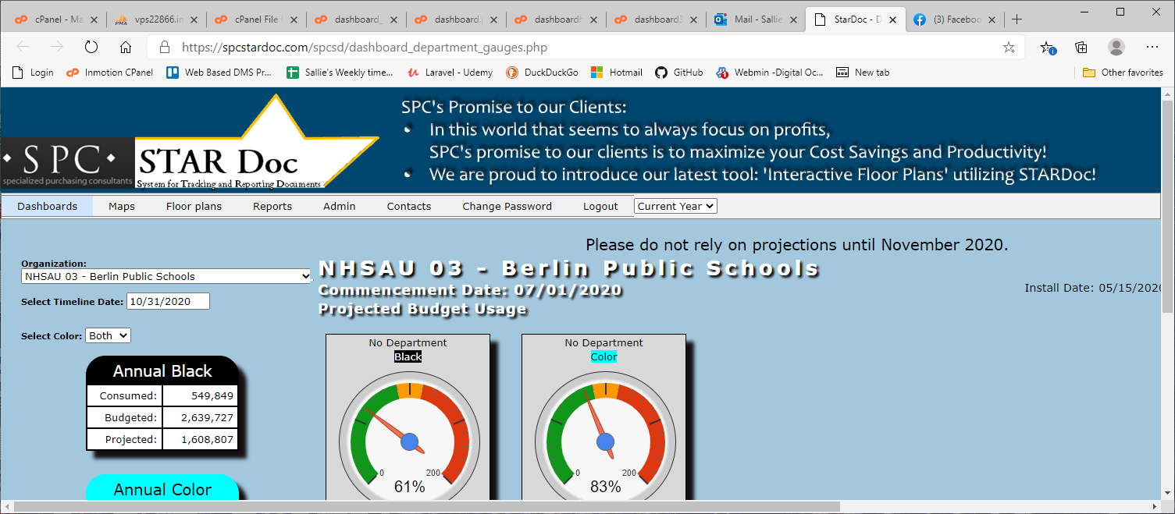
dashboard_department_cost.php (Dashboards/Department - Cost page)
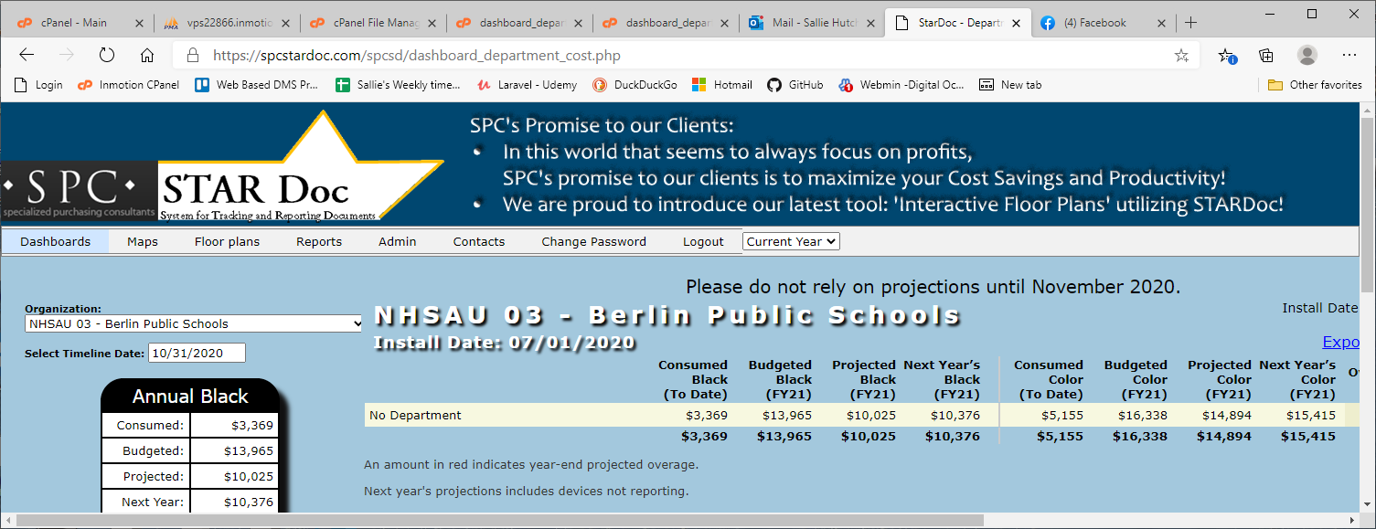

Add the new fiscal year to device_data.inc.php beginning at line 79
case ($current_date >= $start_year_2022 && $current_date <= $end_year_2022):
$table_year = 'Y2022_';
break;

