From Alex:

The projections for SAU 83 made no sense to me so I ran some numbers by hand. See the attached image. How are we that off?
Now I am questioning other projections. I have a lot of stuff to check now.

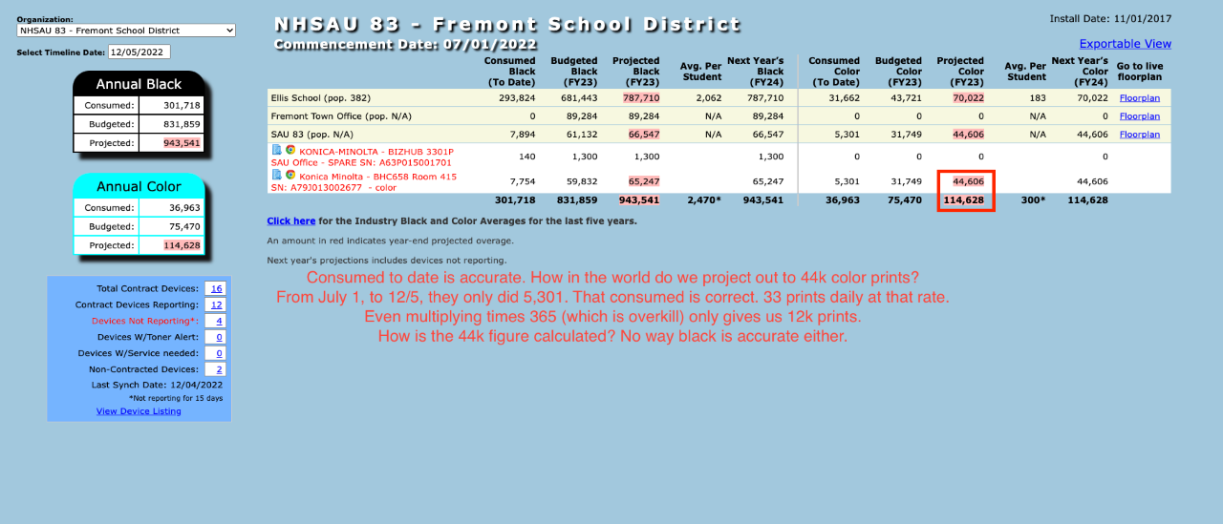
08/11/2022 - 07/01/2022 = 41 days
7754/41 = 189 prints per day
189 * 345 = 61,205

12/5/2022 – 07/01/2022 = 157 days
7754/157 = 49 prints per day
49 * 345 = 16, 905
ending_date = 12/5/2022
/*When fpm.commencement_date is null, or is < the org_commencement_date, device_commencement_date = org_commencement_date
otherwise device_commencement_date = fpm.commencement_date.*/
@device_commencement_date := (CASE WHEN fpm.commencement_date IS NULL THEN ' . $org_commencement_date .
' WHEN UNIX_TIMESTAMP(fpm.commencement_date) < ' . $org_commencement_date . ' THEN ' . $org_commencement_date .
' ELSE UNIX_TIMESTAMP(fpm.commencement_date) END) device_commencement_date

$org_commencement_date = 11/01/2017 – testing with 06/30/2022 testing with 07/01/2022
fpm.commencement_date is null so...... @device_commencement_date = $org_commencement_date = 11/01/2017
testing with 06/30/2022 testing with 07/01/2022

/*Get days between commencement date of the device and ending date (timeline date)*/
@cm_diff_orig := ((' . $endingDate . '- @device_commencement_date) /60/60/24) cm_diff_orig

@cm_diff_orig = 12/05/2022 - 11/01/2017 = 1860 days
testing with 12/05/22 - 06/30/2022 = 158 days testing with 12/05/2022 - 07/01/2022 = 157 days

/*Now, if this difference < 0, set cm_diff = 0. Otherwise cm_diff = cm_diff_orig.*/
@cm_diff := (CASE WHEN @cm_diff_orig < 0 THEN 0 ELSE @cm_diff_orig END) cm_diff
@cm_diff_orig is NOT < 0 so..... @cm_diff = @cm_diff_orig = 1860 days testing with 158 days testing with 157 days

@last_diff_orig := (CASE WHEN mtr.created_date IS NULL THEN 1
ELSE (UNIX_TIMESTAMP(mtr.created_date) - @device_commencement_date) / 60/60/24 END)
meter.created_date is not null so.... @last_diff_orig = mtr.created_date (8/11/2022) - @device_commencement_date (11/01/2017)= 1744 days
8/11/2022 – 06/30/2022 = 42 days testing with 08/11/2022 - 07/01/2022 = 41 days
@last_diff := (CASE WHEN @last_diff_orig <= 0 THEN 1 ELSE @last_diff_orig END)
@last_diff_orig is NOT < 0 so..... @last_diff = @last_diff_orig = 1744 days testing with 42 days testing with 41 days

/* When floorplan_machines.commencement_black_meter is null, set the c_blk (consumed black) = meters.black_meter,
otherwise set c_blk = meter.black_meters - floorplan_machines.commencement_black_meter.*/
@c_blk := (CASE WHEN fpm.commencement_black_meter IS NULL THEN mtr.black_meter
ELSE (mtr.black_meter - fpm.commencement_black_meter) END) c_blk

fpm.commencement_black_meter = 335263
fpm.commencement_color_meter = 203114
fpm.commencement_black_meter is not null so.....
c_blk (consumed_black) = meters.black_meter (343017) – fpm.commencement_black_meter (335263) = 7754

fpm.commencement_color_meter is not null so.....
c_col(consumed_color) = meters.color_meter (208415) – fpm.commencement_color_meter (203114) = 5301

/*$org_fiscal_days is the difference between the ending date and the org_commencement_date*/
$org_fiscal_days = ($endingDate - $org_commencement_date) /60/60/24; = 12/5/2022 – 11/01/2017 = 1860
testing with 12/05/2022 – 06/30/2022 = 158 days testing with 12/05/2022 - 07/01/2022 = 157 days

/* When cm_diff = 0, projected_black also = 0.
When org_commencement_date is NULL or < startingDate, projected_black = (@c_blk / @last_diff * 345).
Otherwise projected_black = @c_blk / @cm_diff * LEAST(' . $org_fiscal_days .', 345)*/
@projected_black := (CASE WHEN @cm_diff = 0 THEN 0 WHEN ' . $org_commencement_date . ' IS NULL THEN (@c_blk / @last_diff * 345)
WHEN ' . $org_commencement_date . ' < ' . $startingDate . ' THEN (@c_blk / @last_diff * 345)
ELSE (@c_blk / @cm_diff * LEAST(' . $org_fiscal_days .', 345)) END) projected_black

@cm_diff = 398 and $org_commencement_date (11/01/2017) is not null, but is < $startingDate (07/01/2022) so....
@projected_black = (@c_blk / @last_diff * 345) = (7754 /1744 * 345 ) = 1533.90
testing with 7754/42 * 345 = 63,693

The ELSE would return @c_blk / @cm_diff * LEAST(' . $org_fiscal_days .', 345) = 7754/1860 * 345 =1438
testing with 7754/158 * 158 = 7,754

testing with org_commencement_date and startingDate both = 07/01/2022
The ELSE would happen @c_blk / @cm_diff * LEAST(' . $org_fiscal_days .', 345)

testing with 7754/157*157 = 7,754

$fiscal_days = endingDate – startingDate = 12/05/2022 – 07/01/2022

/*If device is not reporting and $org_fiscal_days > 0 and budgeted_black > 0, then $projected_black = $budgeted_black.*/
if ($proj_blk_year_next < ($budgeted_black / $org_fiscal_days * $fiscal_days)) {
$projected_black = $budgeted_black;
$proj_blk_year_next = $projected_black;
}

