Re: Hi
RD
Robert Dutil <bobdutil@gmail.com>
Thu 10/29/2020 8:27 AM




To:
- You
Ok, thanks for the update, Sallie. Let me think about the next page, meanwhile yesterday Jamin had a request to update STARDoc which may help you. Let me know if you have any questions.

Jamin Tilton, [28.10.20 10:34]
Headers on stardoc are wrong, Next Years should be FY22
Jamin Tilton, [28.10.20 11:38]
Hey Bob, can you remove the org message 'Please do not rely on projections until November 2020.' for all clients on stardoc page?
The following pages need the updates.
https://spcstardoc.com/spcsd/dashboard3.php
https://spcstardoc.com/spcsd/dashboard.php
https://spcstardoc.com/spcsd/dashboard7.php
https://spcstardoc.com/spcsd/dashboard_department_gauges.php
https://spcstardoc.com/spcsd/dashboard_department_volume.php
https://spcstardoc.com/spcsd/dashboard_department_cost.php

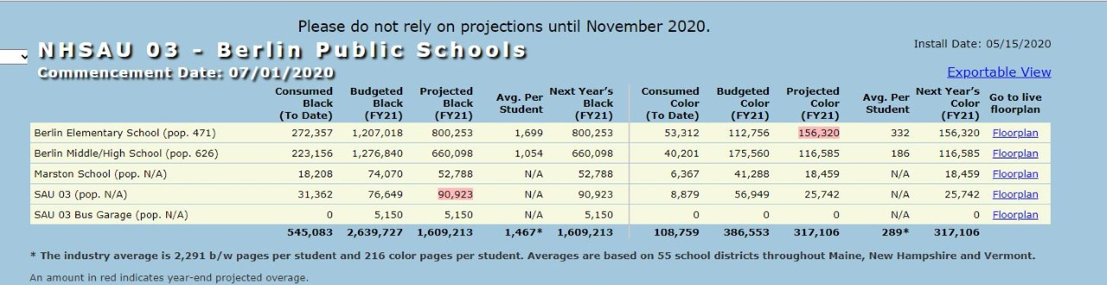

On Wed, Oct 28, 2020 at 9:40 PM Sallie Hutchinson <vStarSal@hotmail.com> wrote:
Hi Bob

I need to discuss priorities with you. I know we had discussed which pages were more important to do and thought I had a doc with those specs, but I cannot find it.

I looked at the Project & Estimation tracking on Google Sheets, but still need to talk with you. Being off this for so long I have forgotten the priorities.

I have also had to relearn some things that I had only just begun to learn. This is why I only logged a few hours last week and almost none for this week. I don't want to charge for learning time, even though I have been working on this project.

I am almost back up to speed with what I had learned before stopping for the annual report.

This week, I have been working on the database part of the buildings and machine types pages.

I have an issue with successfully updating machine types if I place a unique constraint on type_name. I can successfully update the record if I remove that constraint, but I do not see why I cannot use that constraint. I have researched this quite a bit and for now have decided to just remove the unique constraint.

For buildings, this is quite complex because I have the data coming from 4 different tables, which means that to do an update those 4 tables need to be updated. I need to think about whether or not there is a better way to handle this page. I would have no issue doing this in php, but laravel is quite different and seems to be designed to have 1 table per view as the default, even though you can have more than 1. There are many different ways to write the query depending on what data is needed and if it needs any special formatting.

With all of this in mind, I will attempt to create another page to show some progress and get back to the buildings page at a later date. I just need to know which page I should work on.

I was going to call you today, but got tied up with my mom.

Thanks,
Sallie

--
Sincerely,
Robert B. Dutil
207-743-8197 Home
603-733-4241 Office

