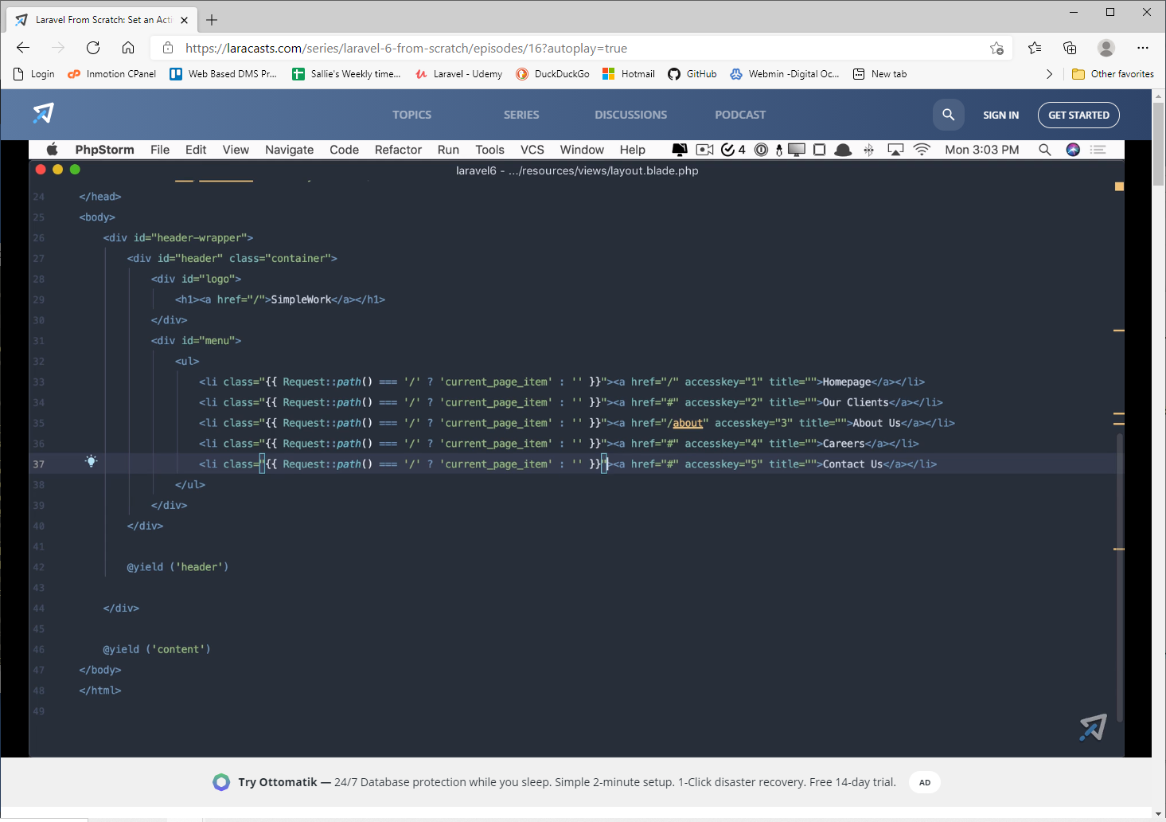
Using Request::path() to get the current part of the path that follows the /. This will only make the home button highlighted, but the code below will highlight whichever one the user is on.
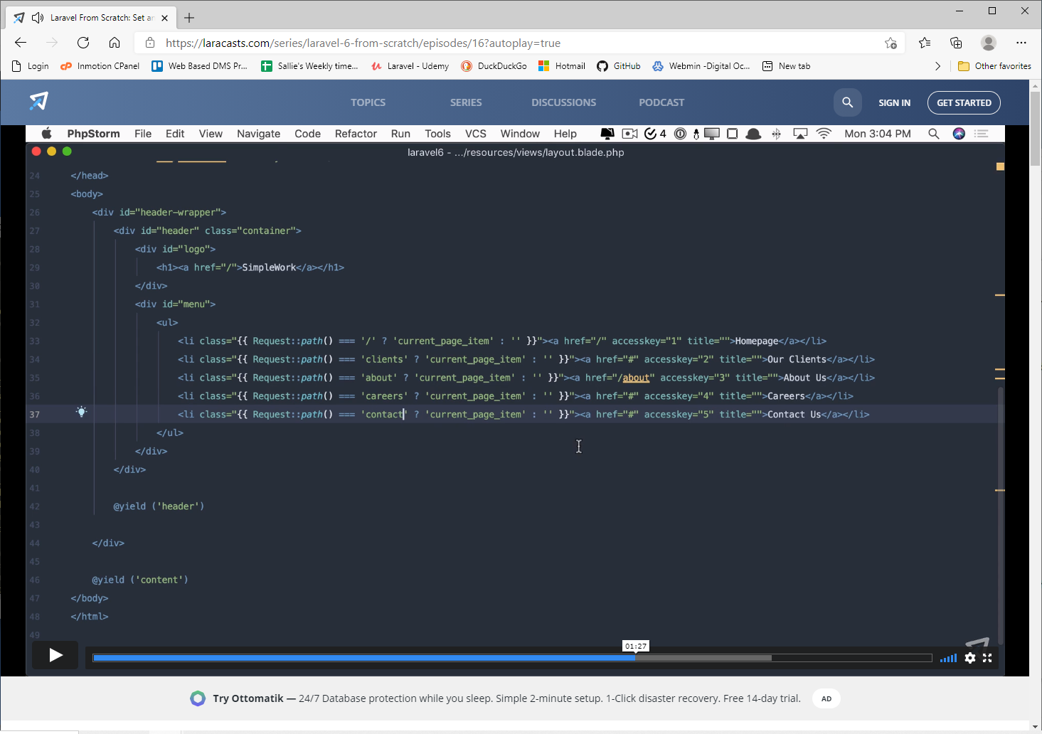
Another way is like the about in screenshot below.
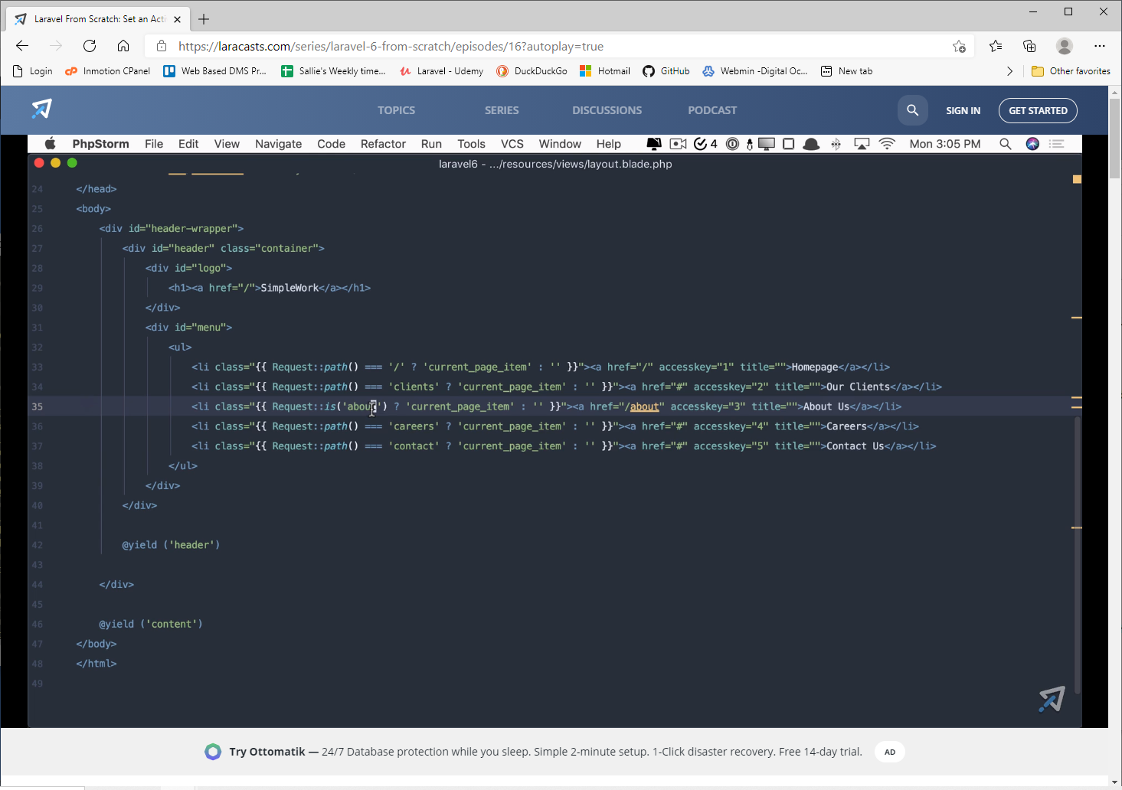
To order by the latest timestamp(this example is the update column) first use this
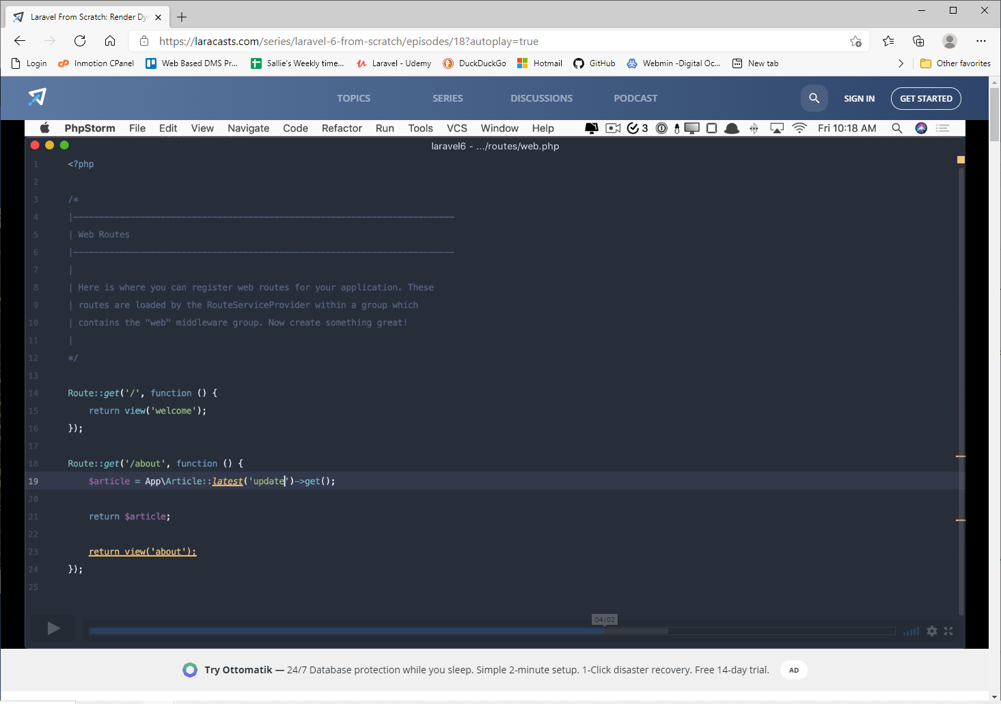
To limit the return to the latest 3 use this
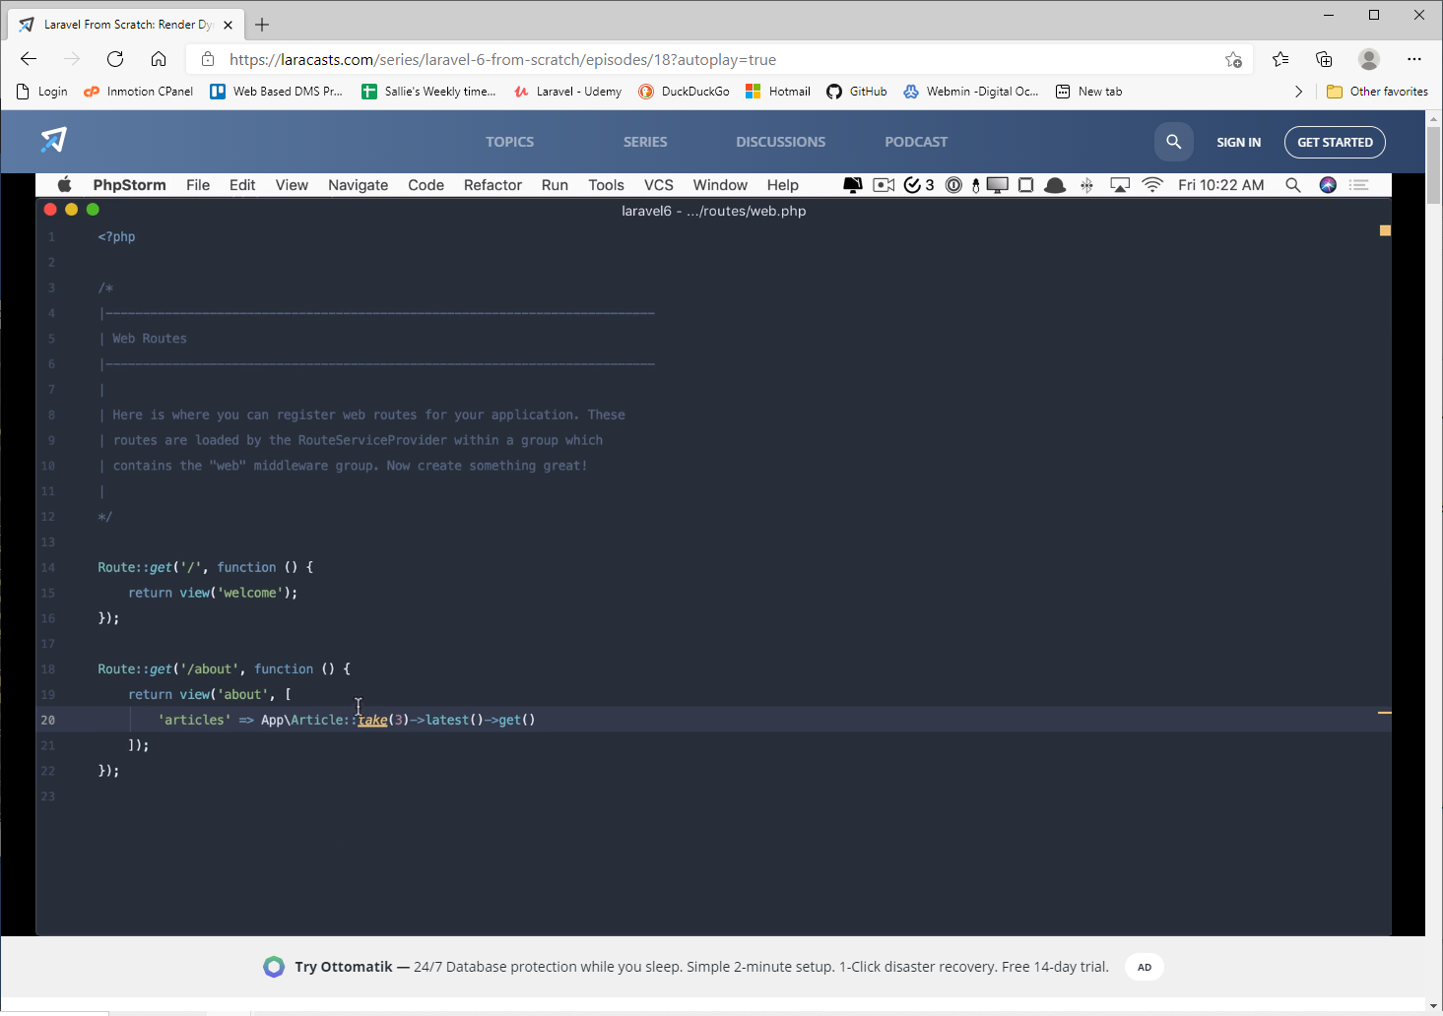

Foreach
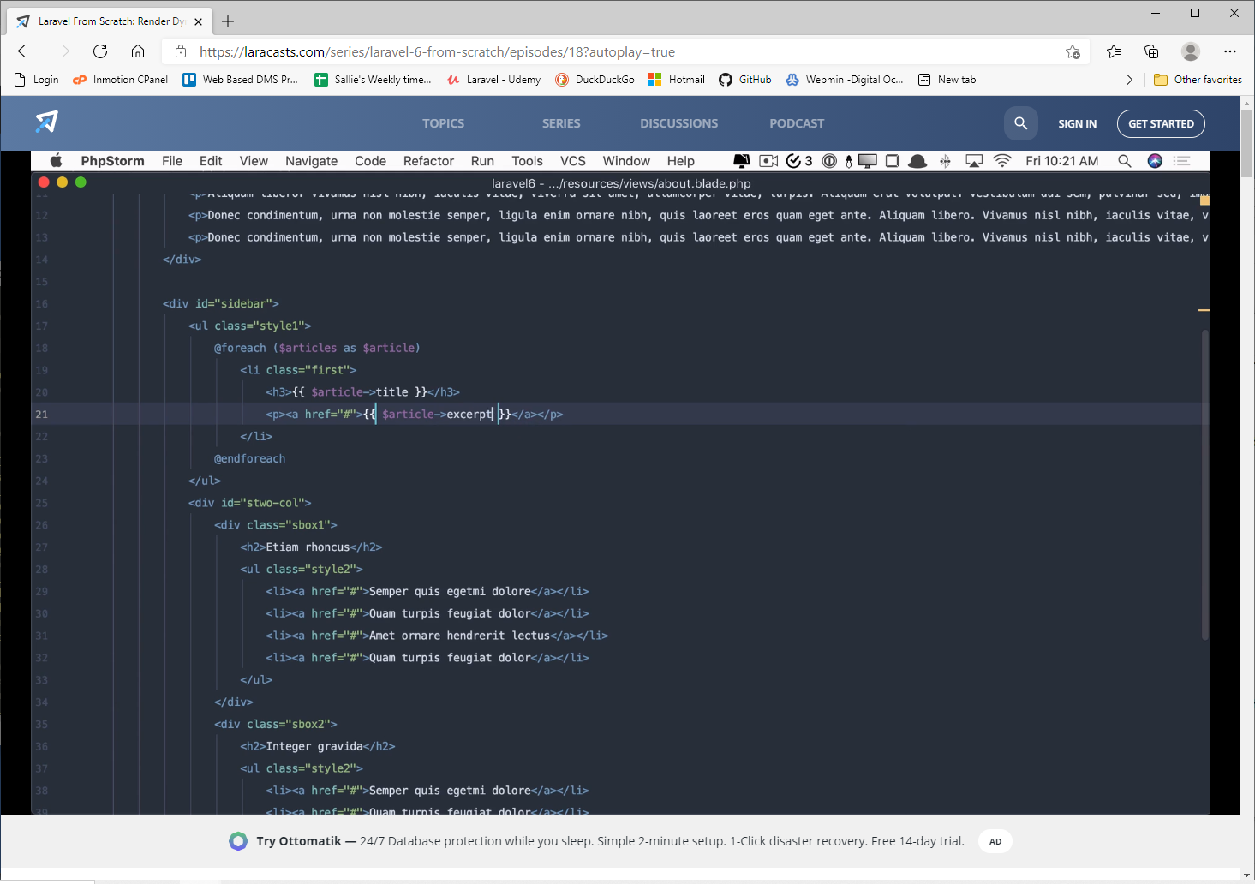
Order of routes matters.
In the following screenshot, the route with /articles/{article} takes precedence over the /articles/create
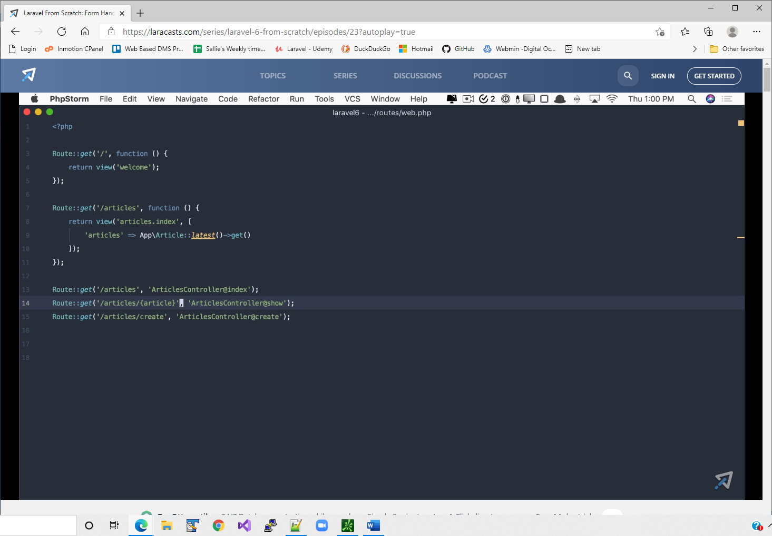
Validating input to protect against malicious
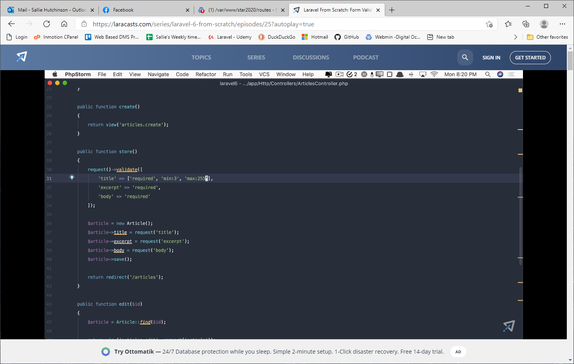
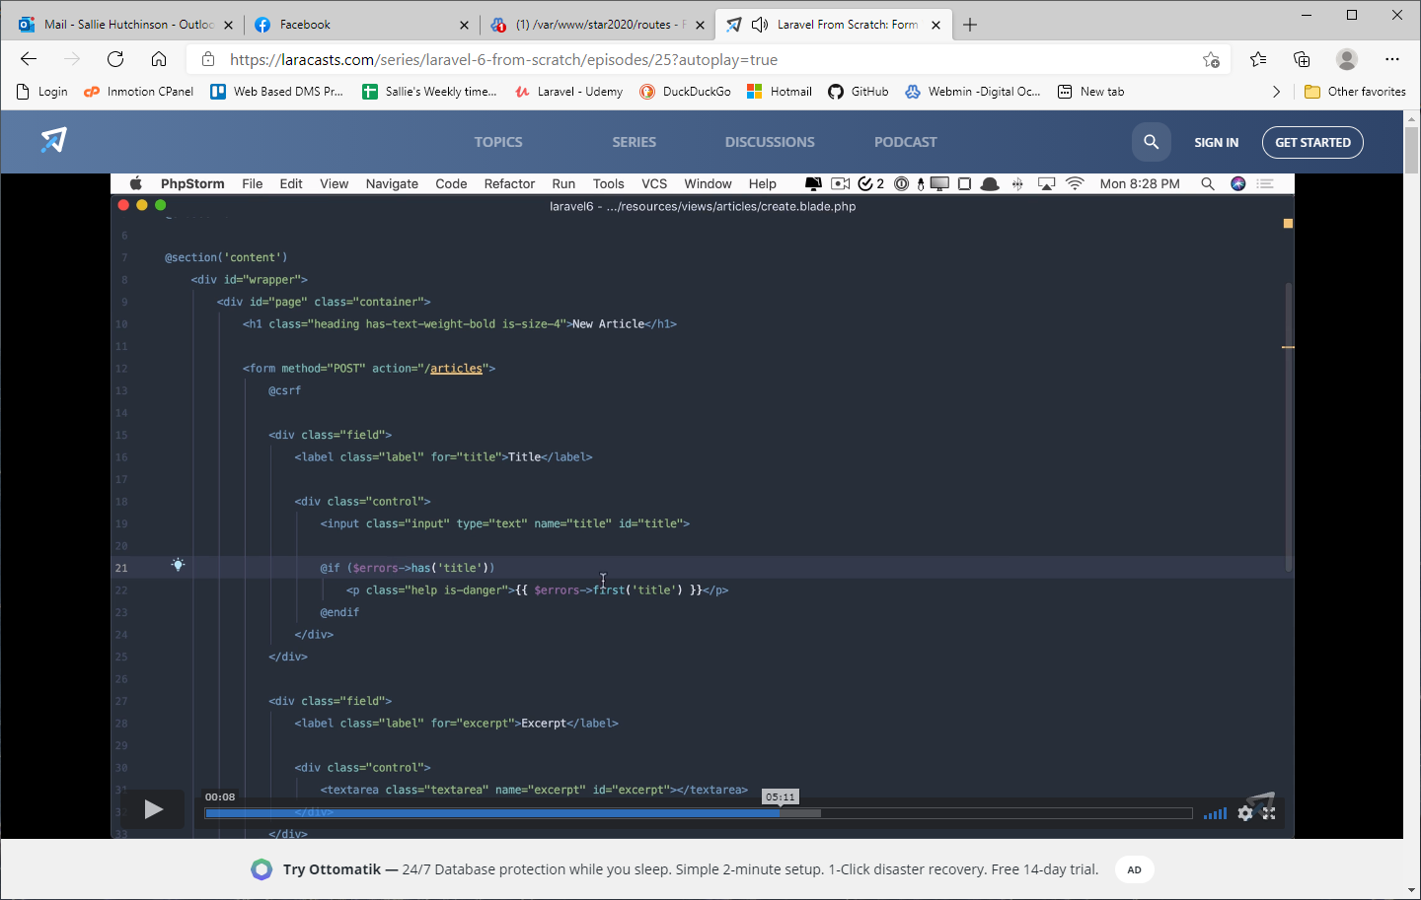
Placing a directive inside an html element.
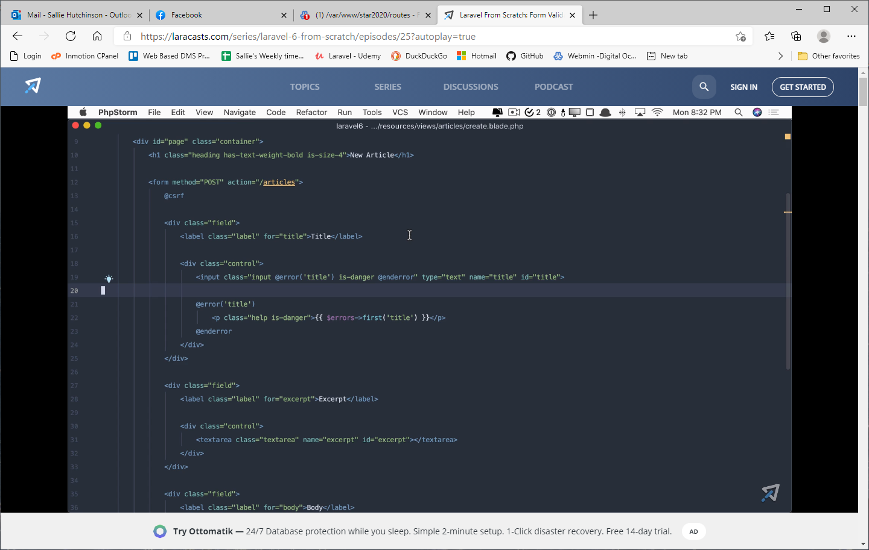
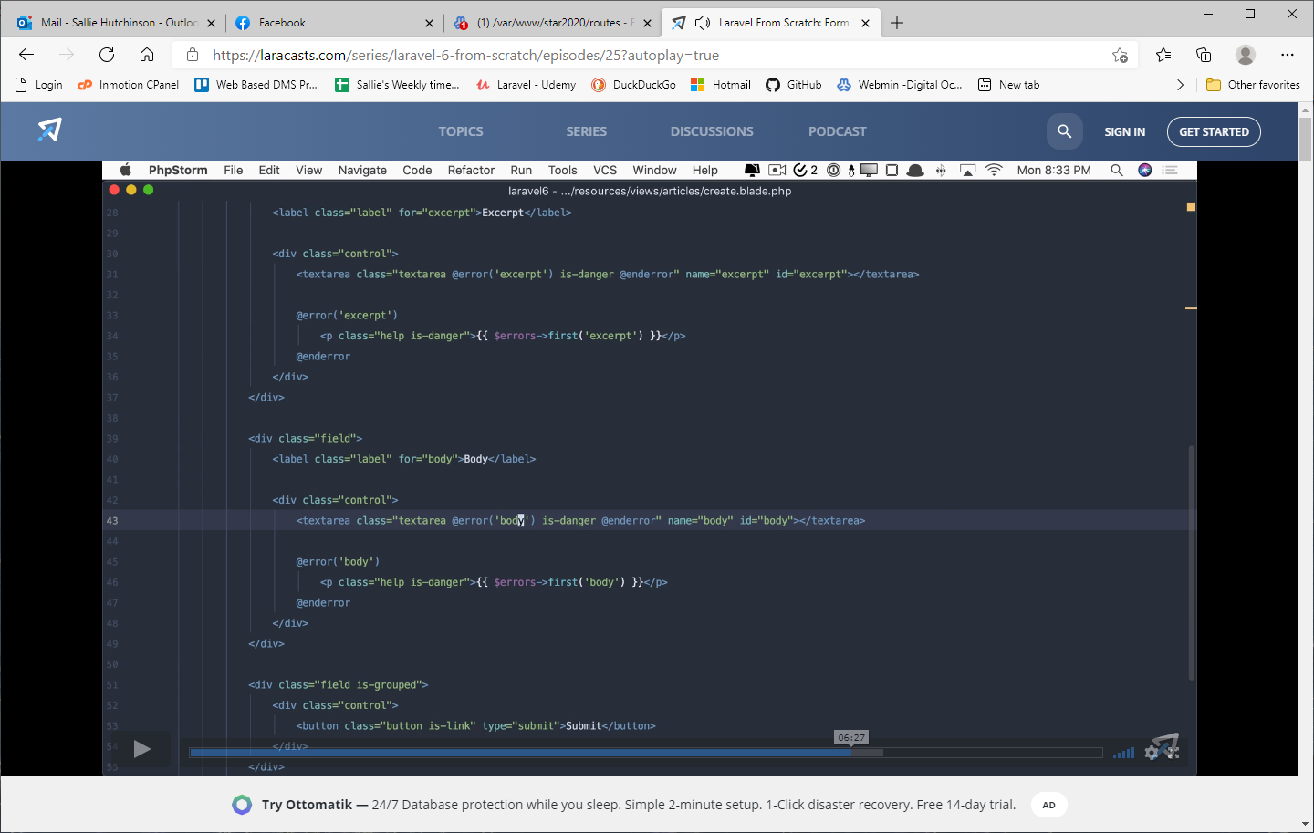
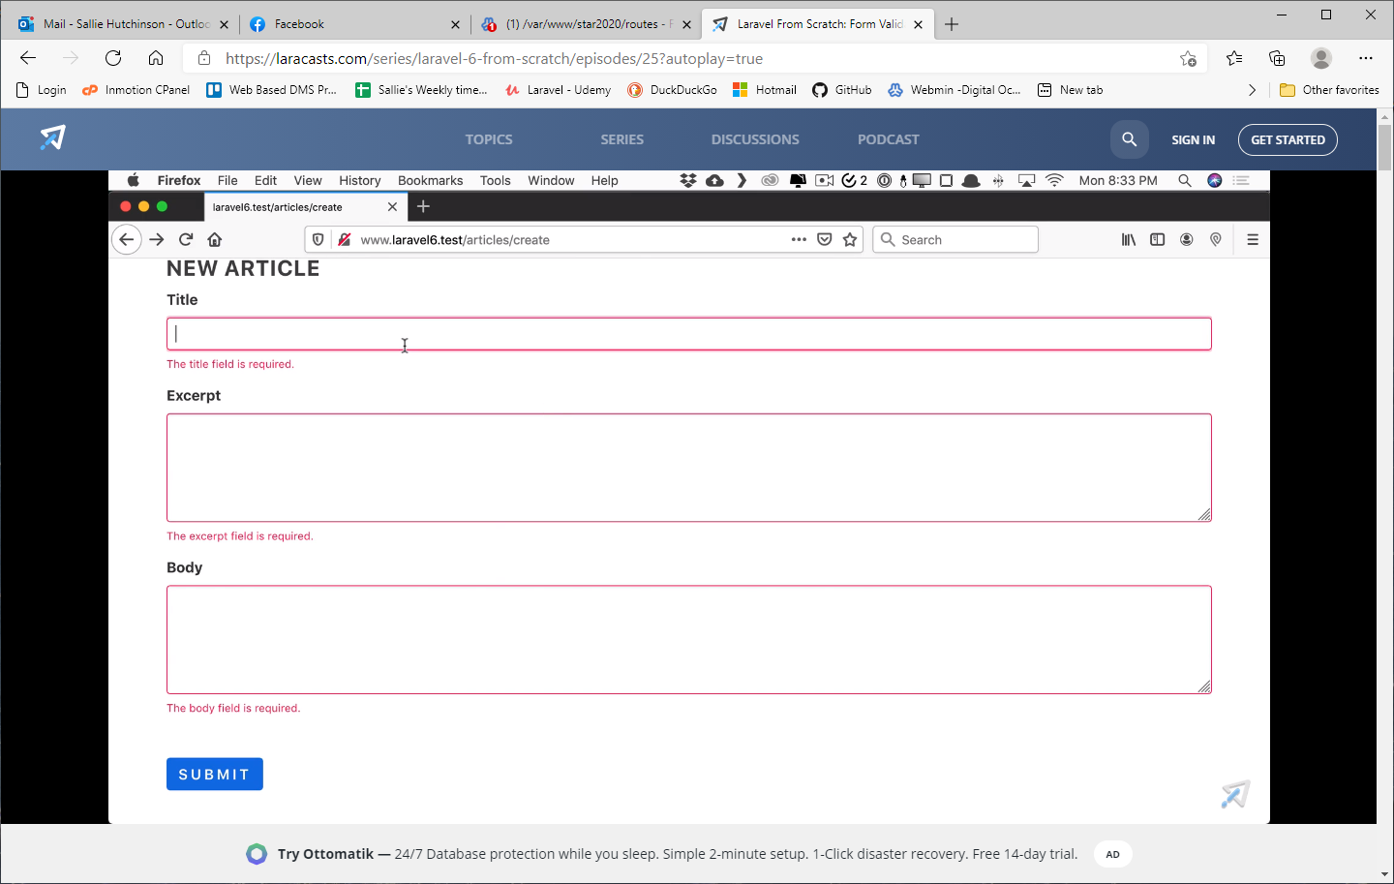
HTML attributes can be on their own lines (inside input tag)
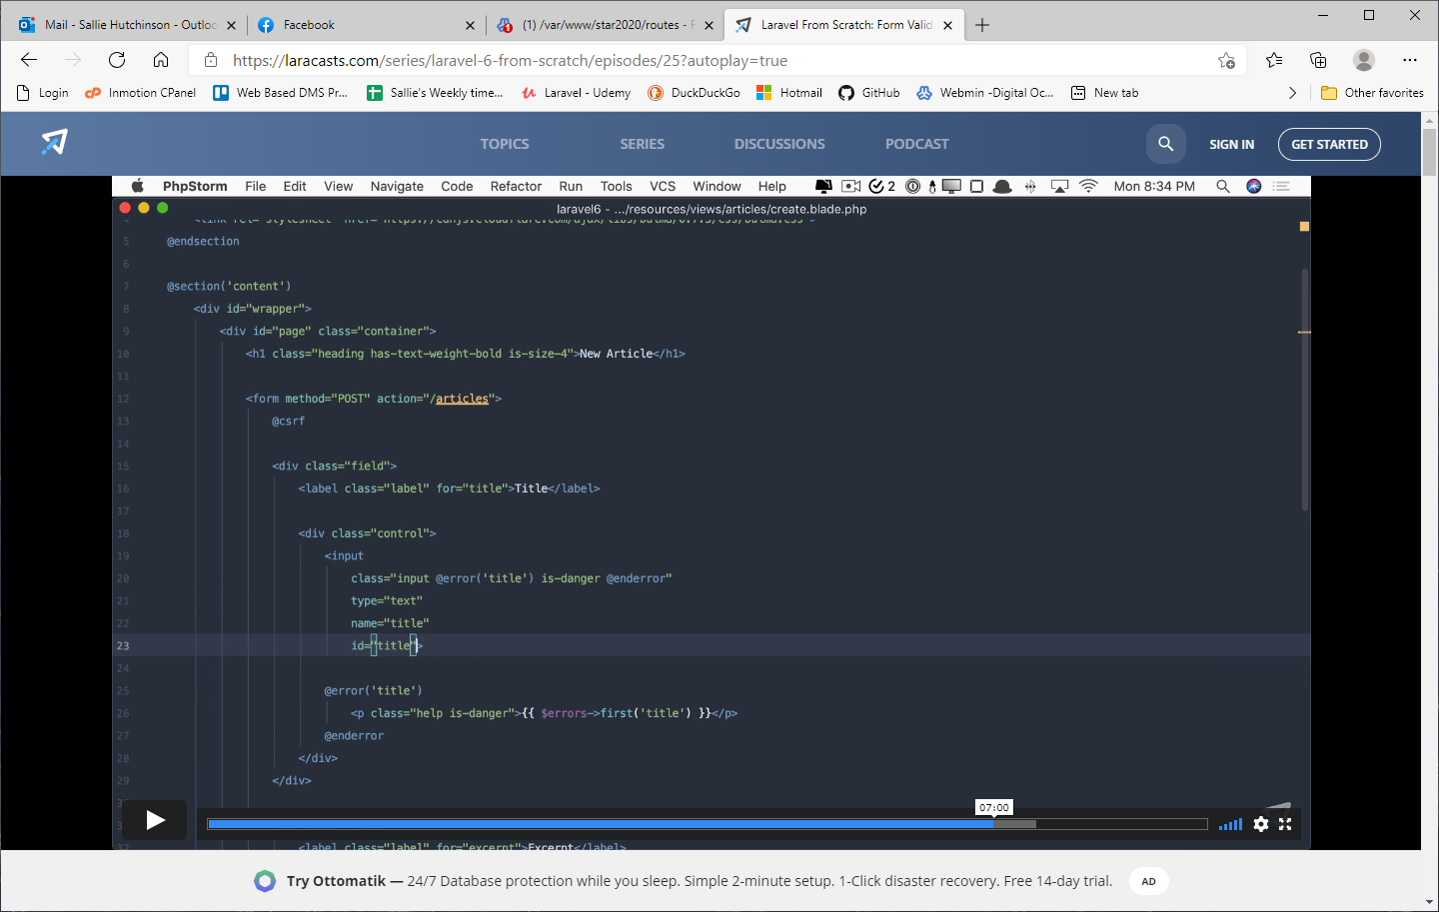
To keep value set value= "{{old('title')}}"
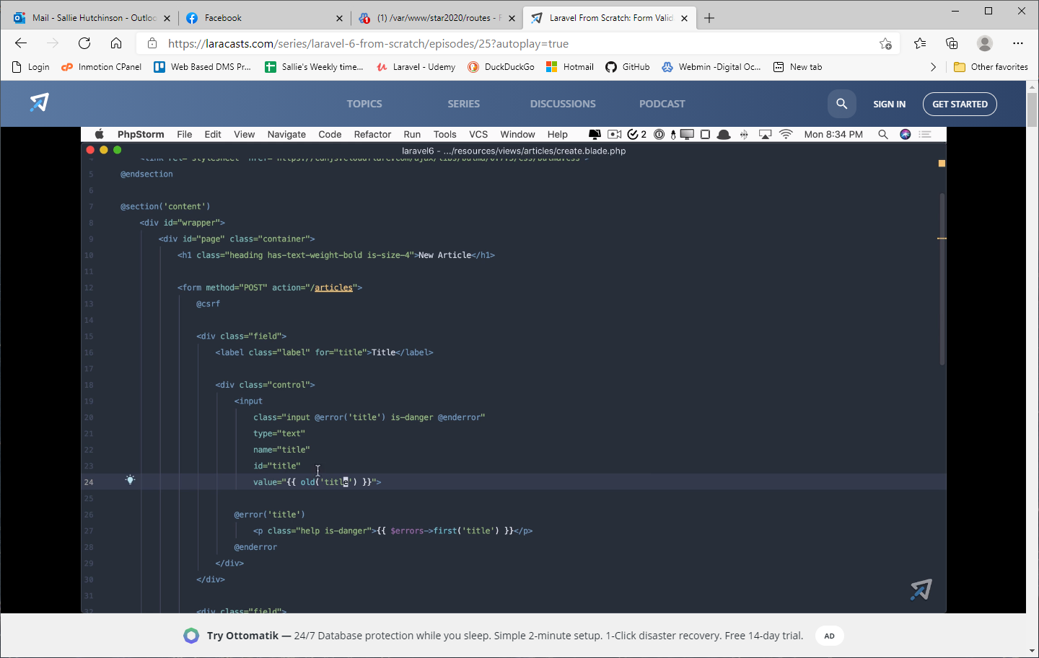
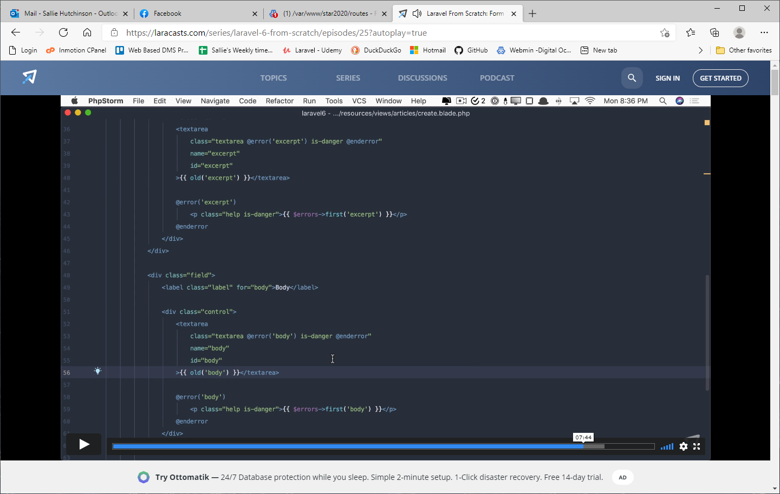
Passing the model as the wildcard. The first line in show is what happens behind the scenes when the model is passed. Make sure that the variable name in the route declaration is the same as the one in the controller method. episode 26
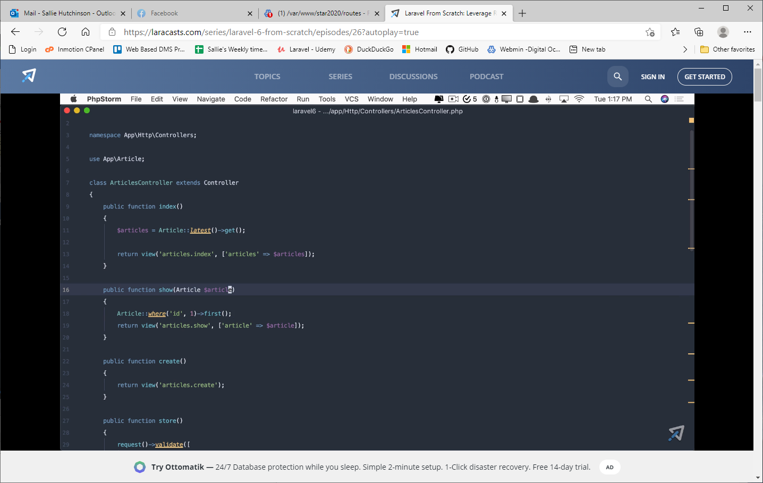
To have the controller base its resultset on a different column than the id you need to go into the Model and add a getRouteKeyName function that will return the column name.
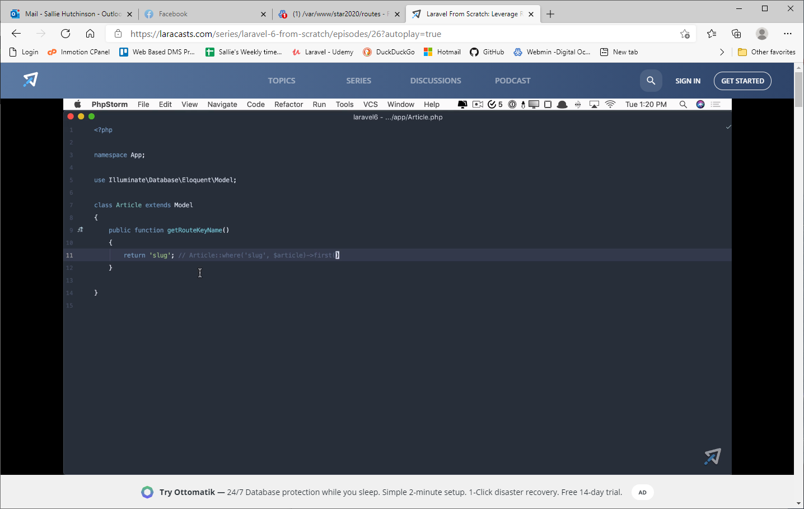
This will query for the Article record where the column 'slug' = $article. Give me the first result
Using the validated values in a create instead of having to list the columns twice
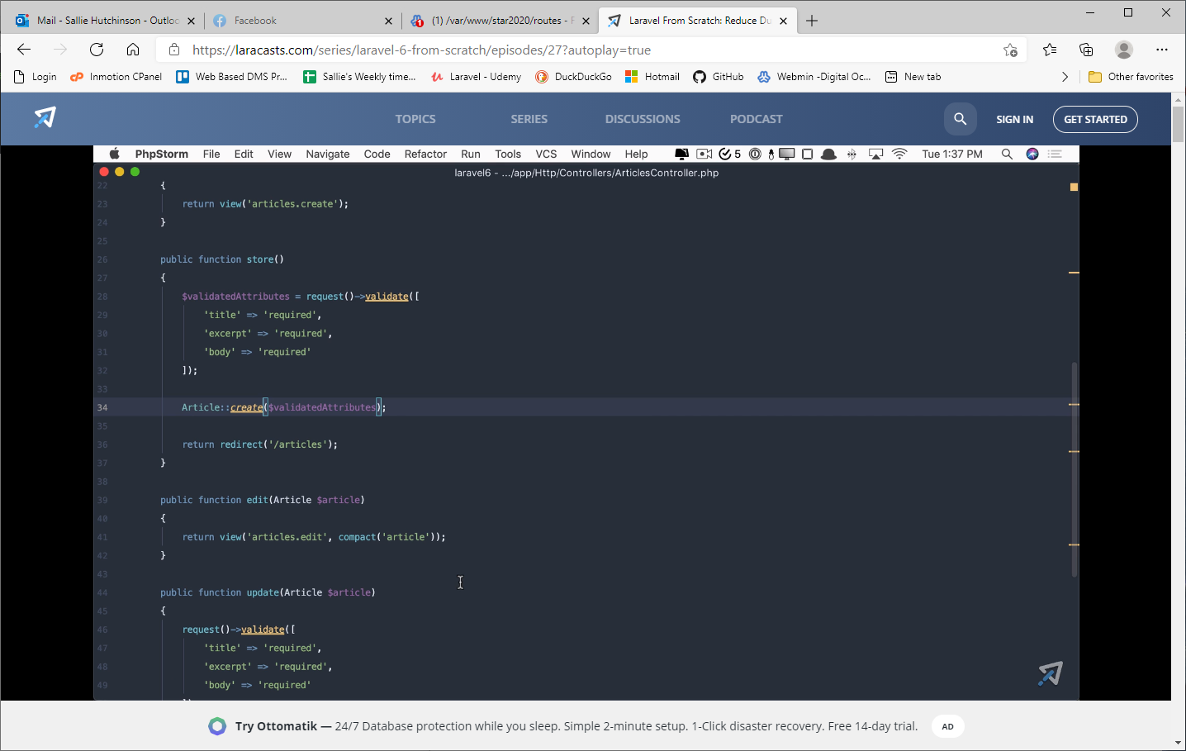
Going one step further - 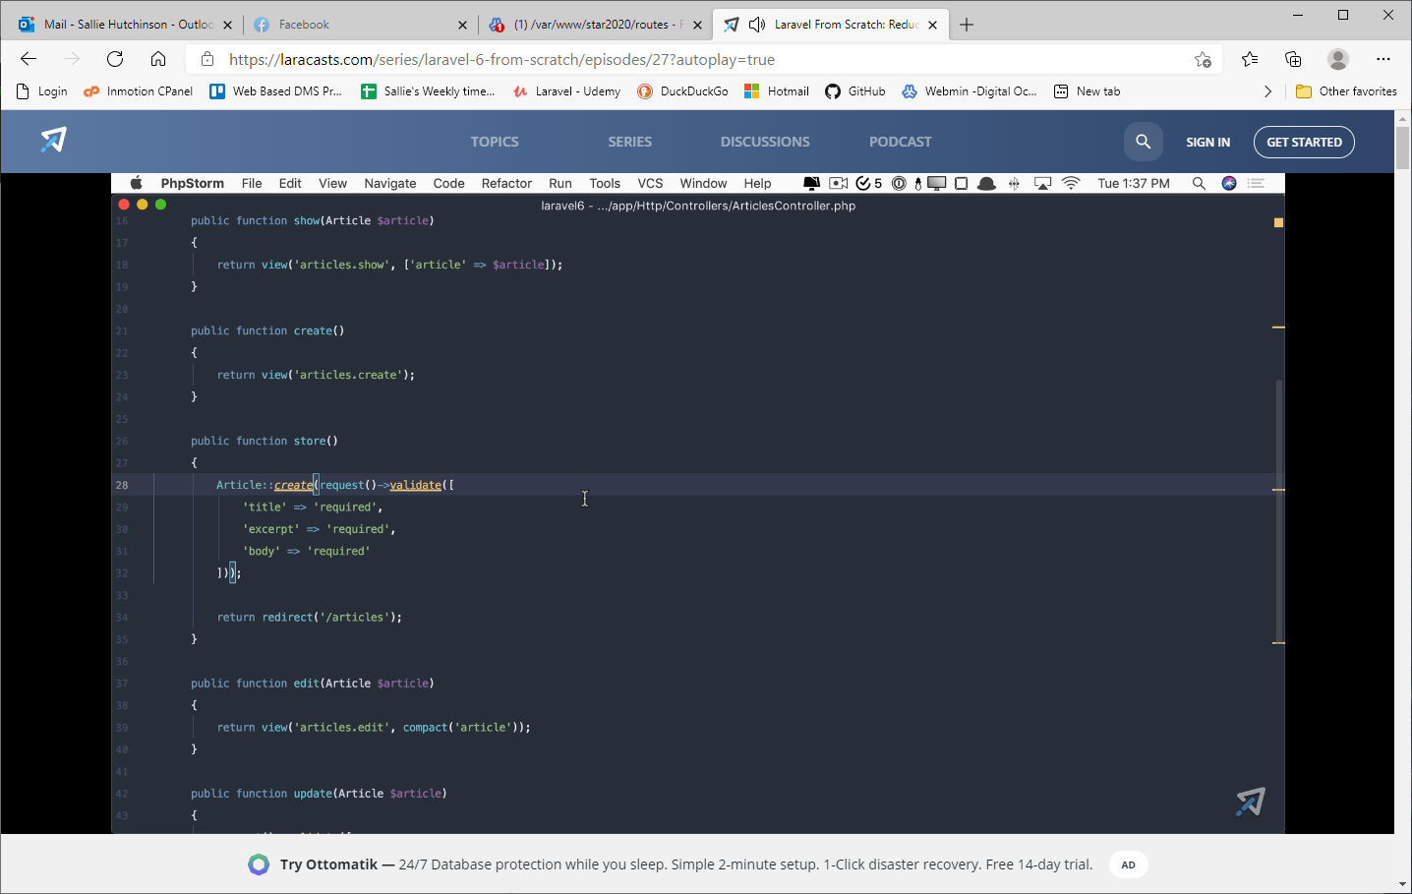
Passing the model->id or just the model
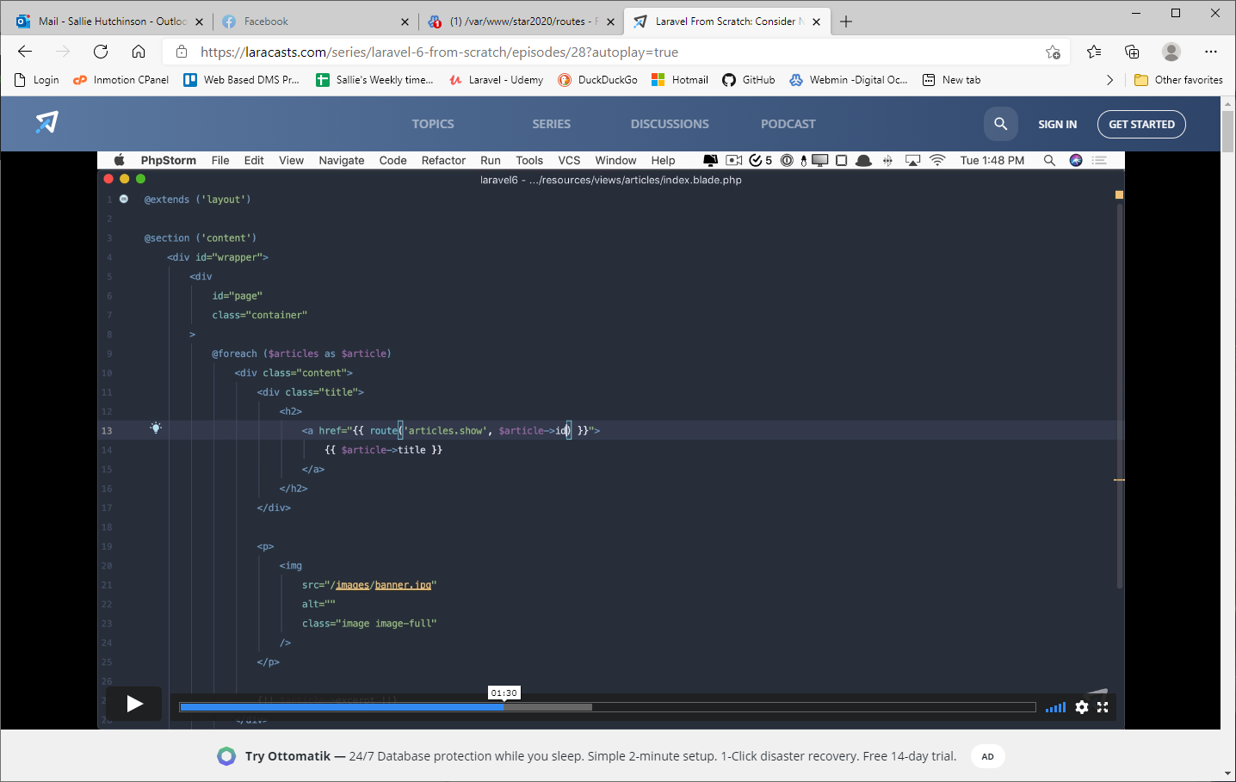
Here, Laravel automatically knows to fetch the correct keyName(column name)
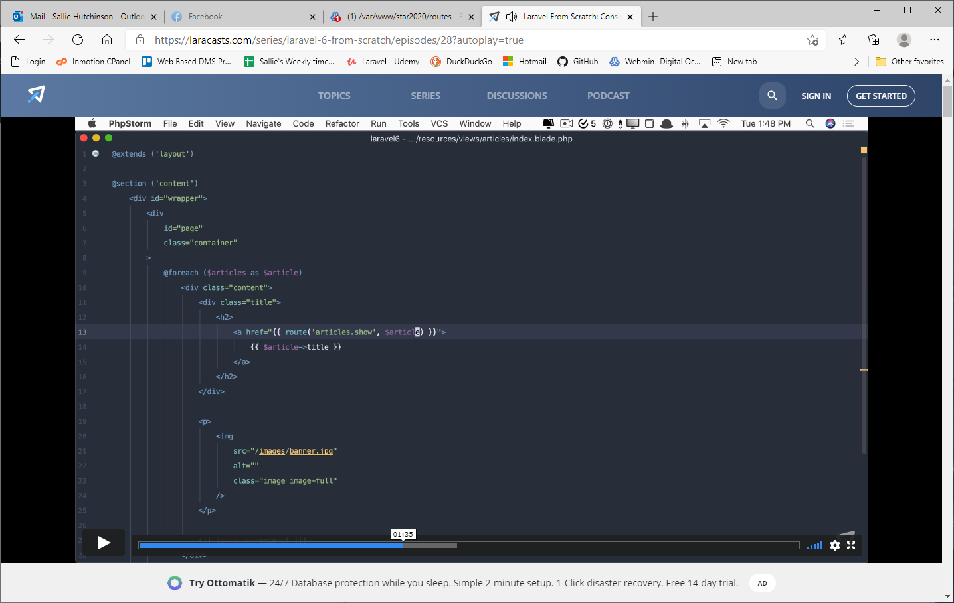
Remember to change the route in the controller redirect.
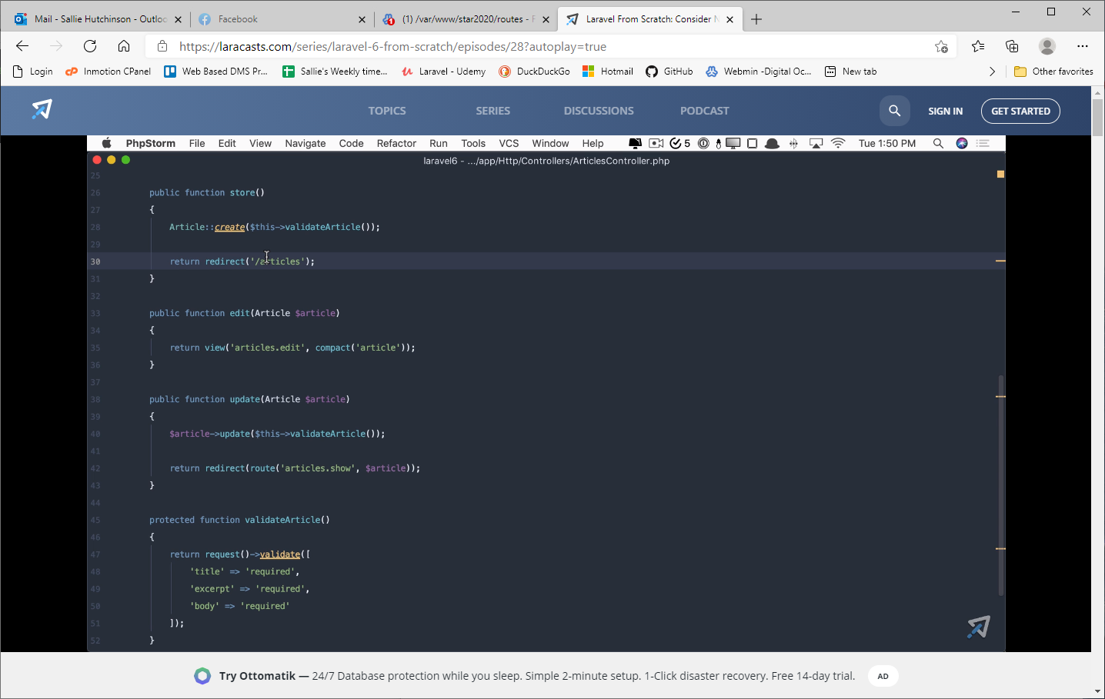
The actual sql created by the relationship declarations
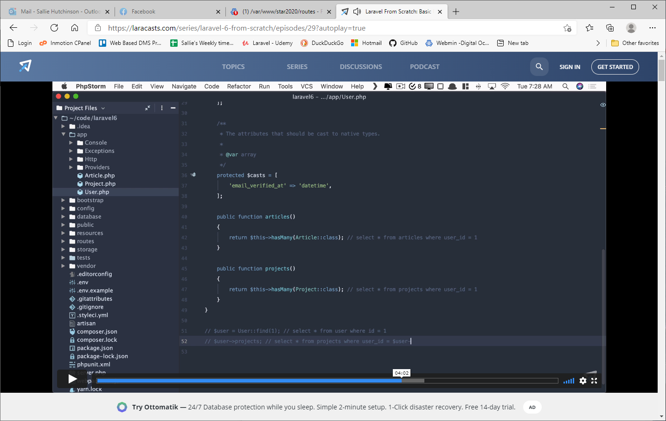
When defining relationships in a model, the relationship is based on the primary key, so if you want to create a function called author (to return the user who is actually the author) you need to add an arg to the belongsTo that specifies what the primary key actually is (in this example it is user_id).

Creating a xwalk table to enable many-to-many relationships
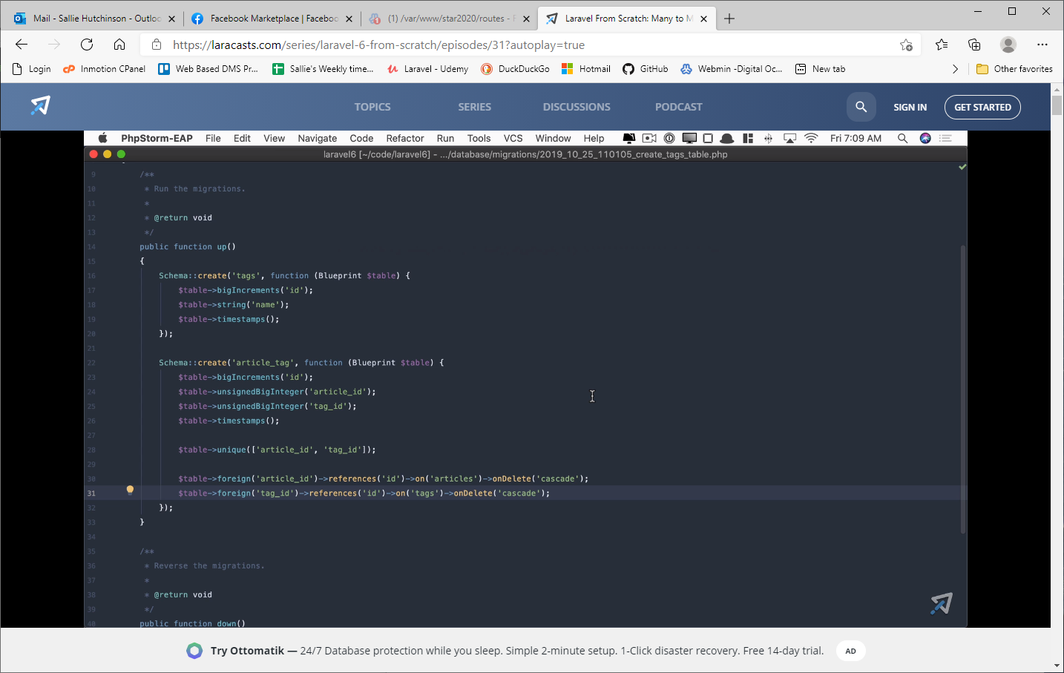
Now to fetch all tags for a given article we can use belongsToMany as shown below.
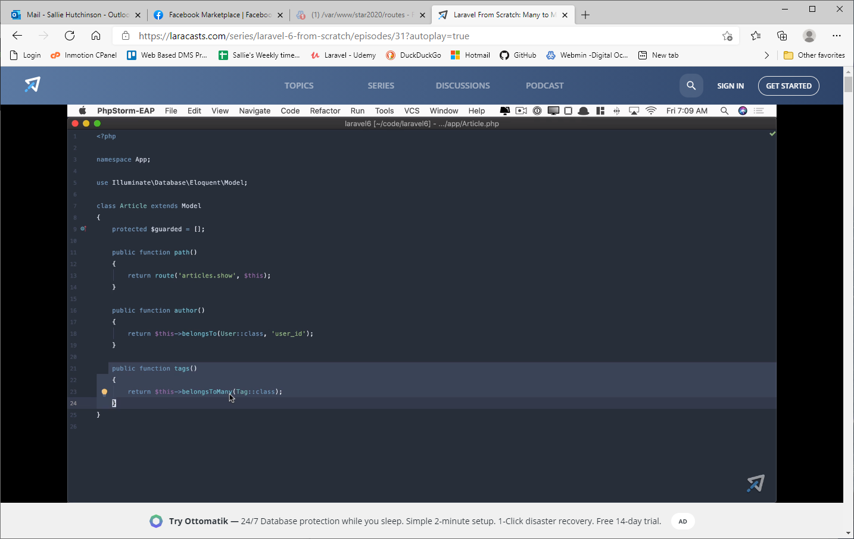
a href examples - episode 32
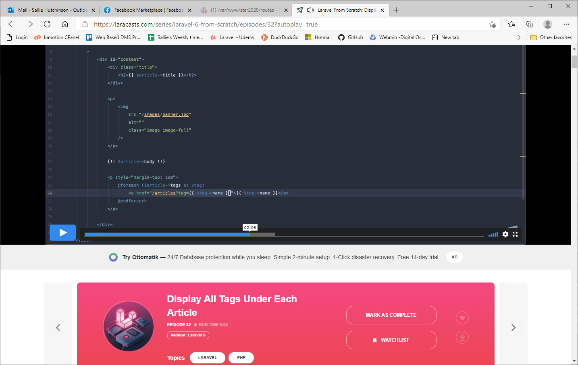
The url for the link is in lower left corner.
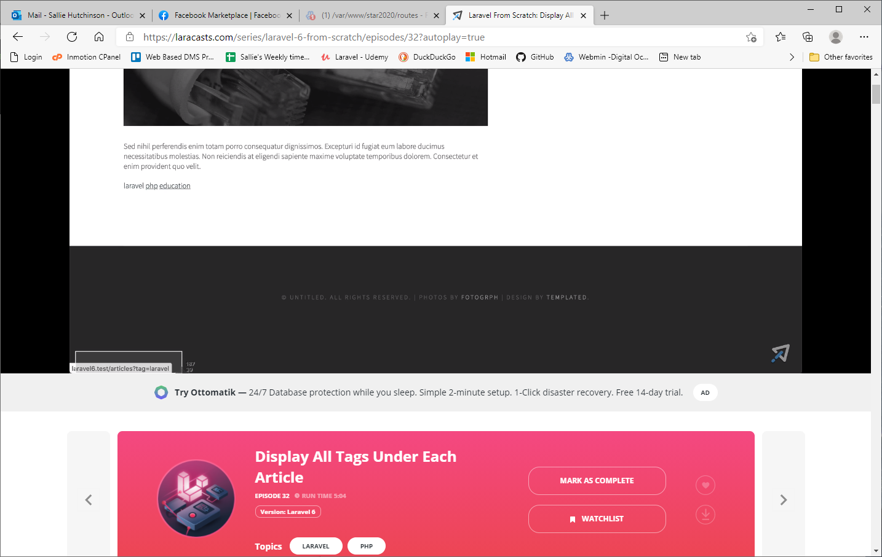

Going back to ArticlesController, we can say if(request('tag')) meaning if there is a tag key in the get url we can use it to limit the resultset.
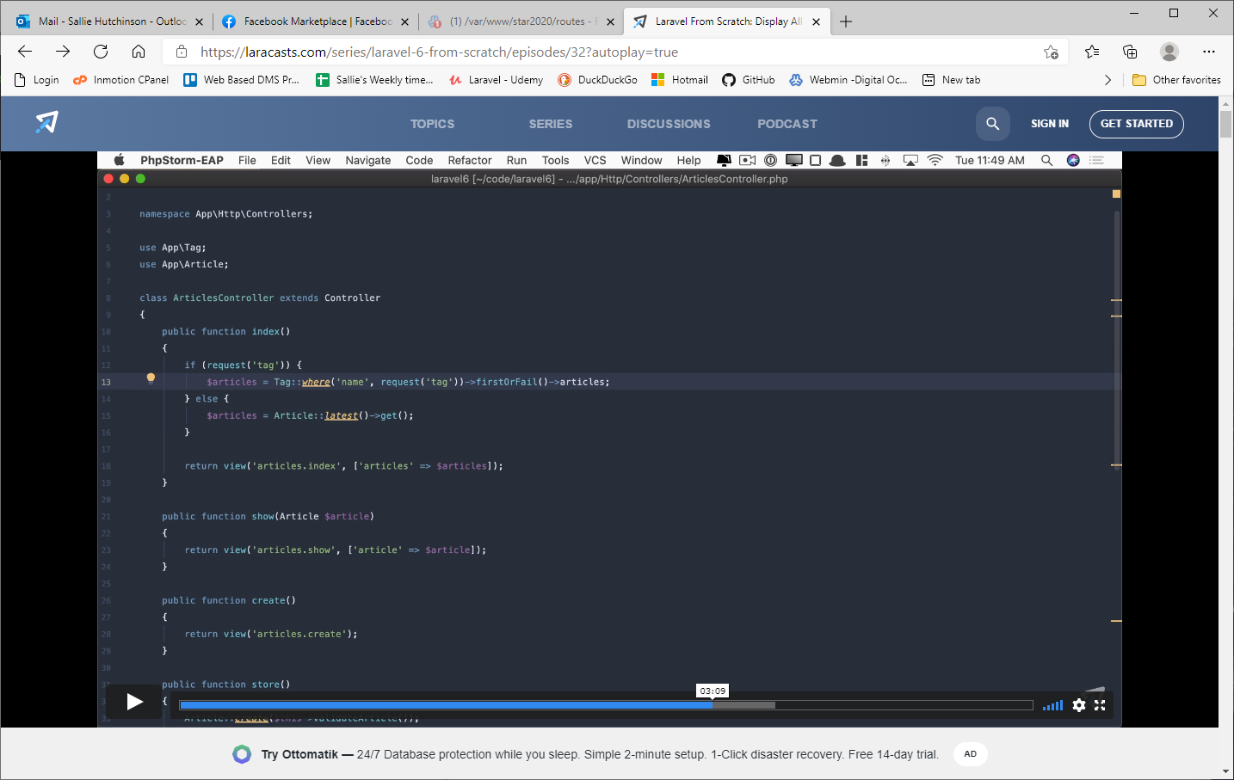
Using @forelse with @empty at the end will mimic a foreach, but if no records, then @empty will print your message.
