http://127.0.0.1:8000/todos

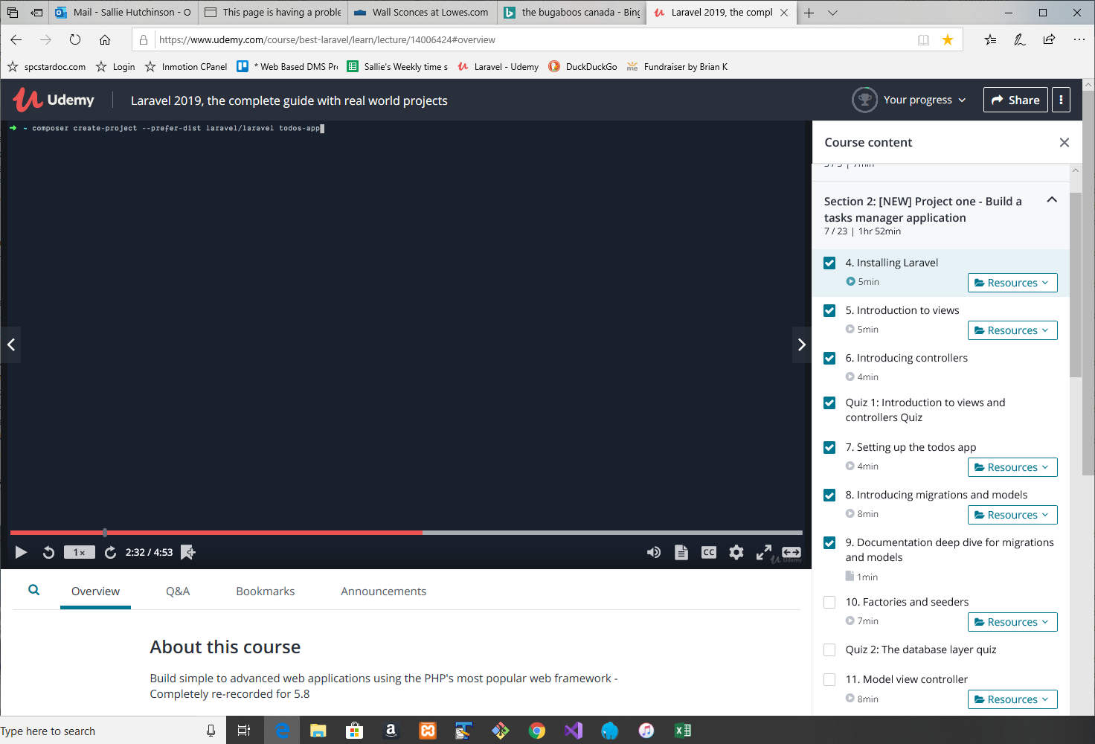

Later, I had to update the laravel/installer using

Composer Update Laravel installer
Panjeh
Nov 18, 2019 · 1 min read
Since I installed laravel/installer globally via
composer global require laravel/installer
So I update laravel/installer globally via:
composer global update laravel/installer
Then do:
composer global show
and I see
laravel/installer v2.3.0 Laravel application installer.
Now I can install a fresh Laravel with auth flag!
laravel new project --auth
This command:
laravel new my-test-app --auth
Is the shorthand of four following commands:
Laravel new my-test-app
cd my-test-app
composer require laravel/ui --dev
php artisan ui vue --auth
To initialize the Laravel project you need to:
php artisan migrate
npm install
npm run dev

E:\myPrograms\laragon
λ composer global update laravel/installer
Changed current directory to C:/Users/Sallie/AppData/Roaming/Composer
Loading composer repositories with package information
Updating dependencies (including require-dev)
Package operations: 0 installs, 1 update, 0 removals
- Updating laravel/installer (v2.1.0 => v2.3.0): Downloading (100%)
Writing lock file
Generating autoload files

E:\myPrograms\laragon
λ

Then composer global show

E:\myPrograms\laragon
λ composer global show
Changed current directory to C:/Users/Sallie/AppData/Roaming/Composer
guzzlehttp/guzzle 6.3.3 Guzzle is a PHP HTTP client library
guzzlehttp/promises v1.3.1 Guzzle promises library
guzzlehttp/psr7 1.5.2 PSR-7 message implementation that also provides common utilit...
laravel/installer v2.3.0 Laravel application installer.
psr/http-message 1.0.1 Common interface for HTTP messages
psr/log 1.1.0 Common interface for logging libraries
ralouphie/getallheaders 2.0.5 A polyfill for getallheaders.
symfony/console v3.4.22 Symfony Console Component
symfony/debug v3.4.22 Symfony Debug Component
symfony/filesystem v3.4.22 Symfony Filesystem Component
symfony/polyfill-ctype v1.10.0 Symfony polyfill for ctype functions
symfony/polyfill-mbstring v1.10.0 Symfony polyfill for the Mbstring extension
symfony/process v3.4.22 Symfony Process Component

Delete a project
rm -rf myProjectName

E:\myPrograms\laragon\www\cms
λ mysql -u root
Welcome to the MySQL monitor. Commands end with ; or \g.
Your MySQL connection id is 3
Server version: 5.7.24 MySQL Community Server (GPL)

Copyright (c) 2000, 2018, Oracle and/or its affiliates. All rights reserved.

Oracle is a registered trademark of Oracle Corporation and/or its
affiliates. Other names may be trademarks of their respective
owners.

Type 'help;' or '\h' for help. Type '\c' to clear the current input statement.

mysql>

mysql> create database cms;
Query OK, 1 row affected (0.00 sec)

mysql> exit
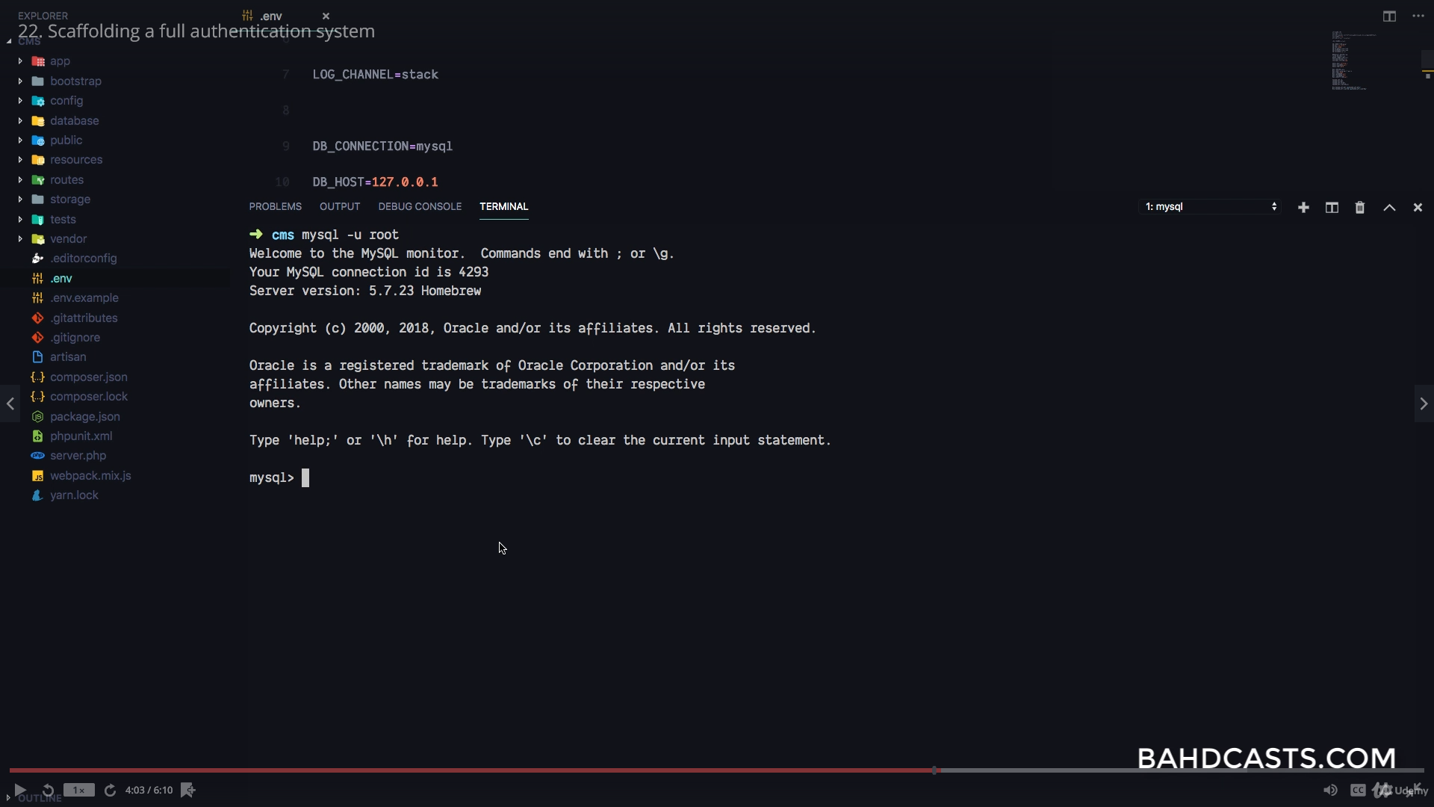

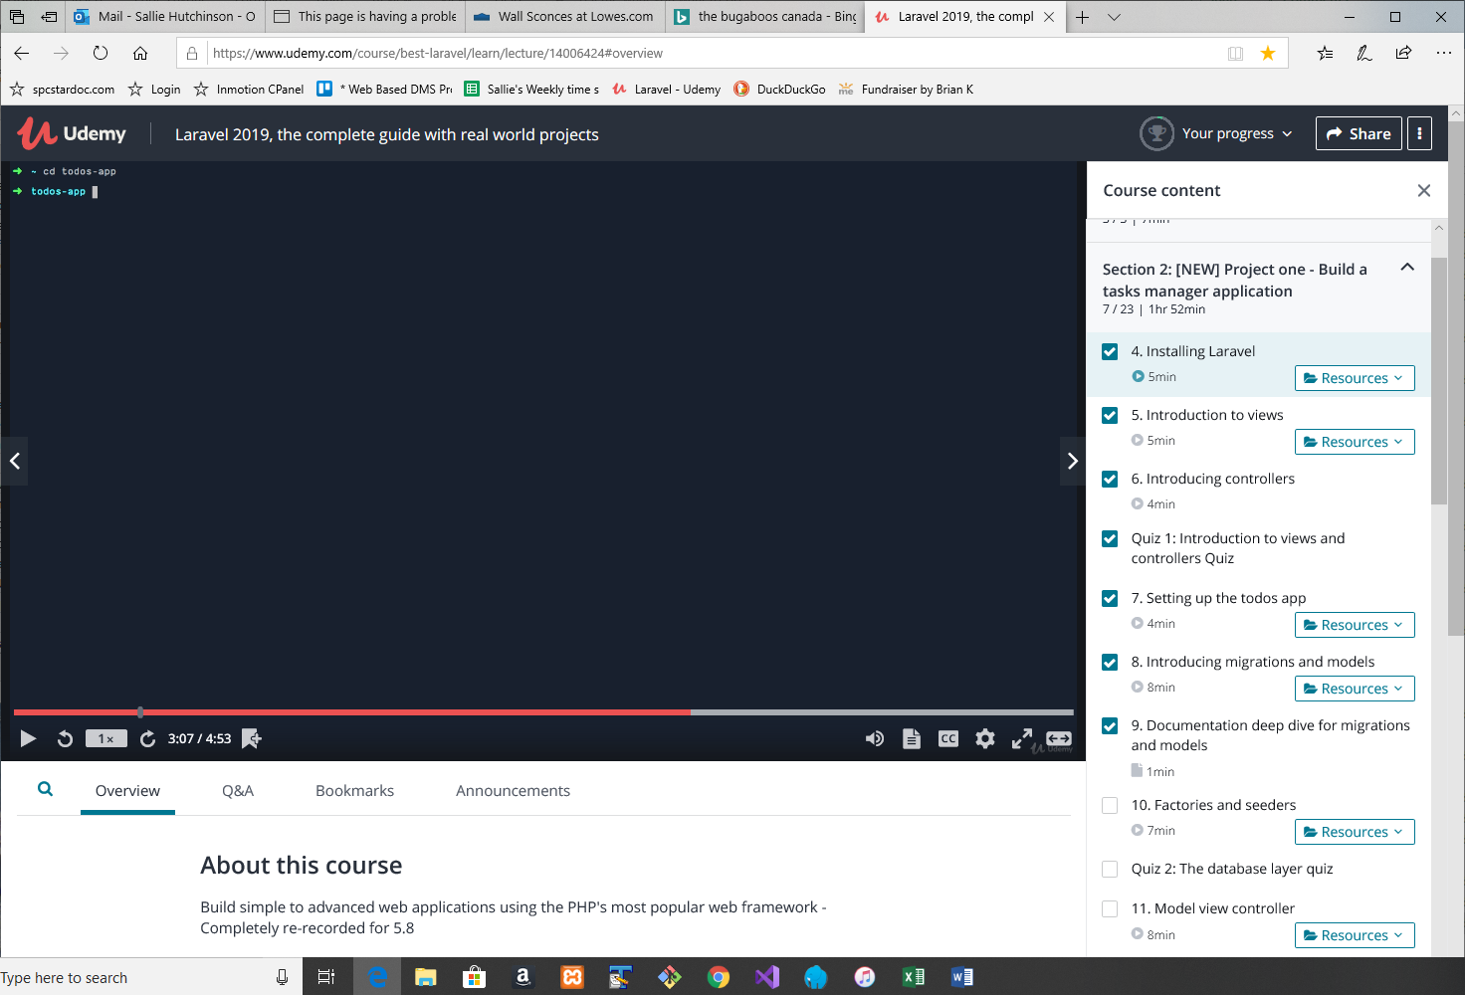
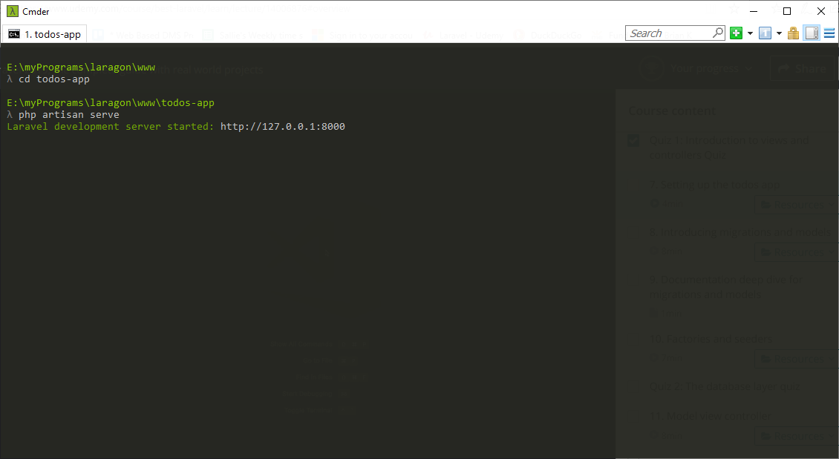
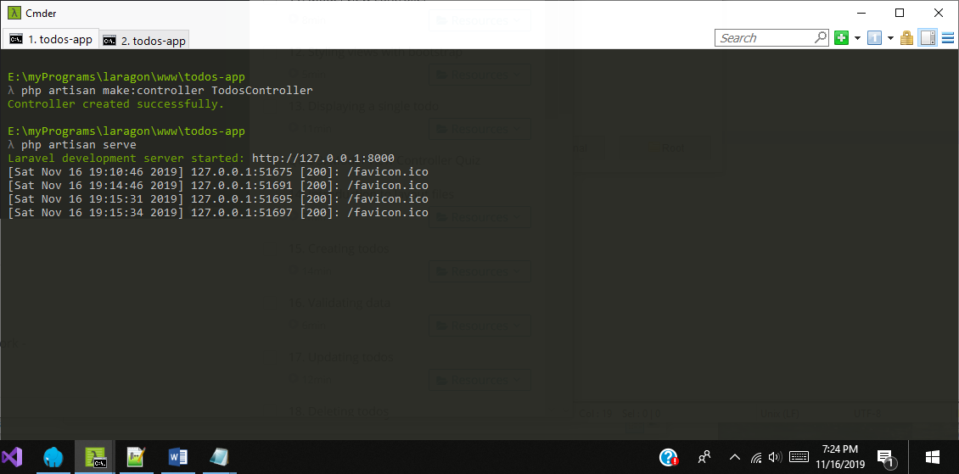
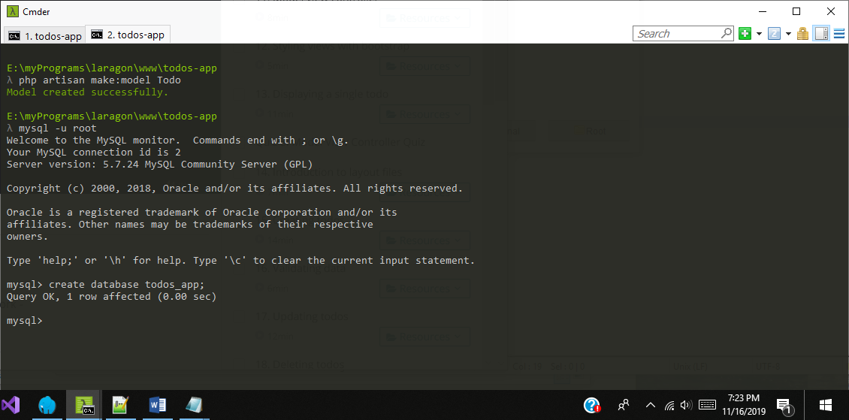
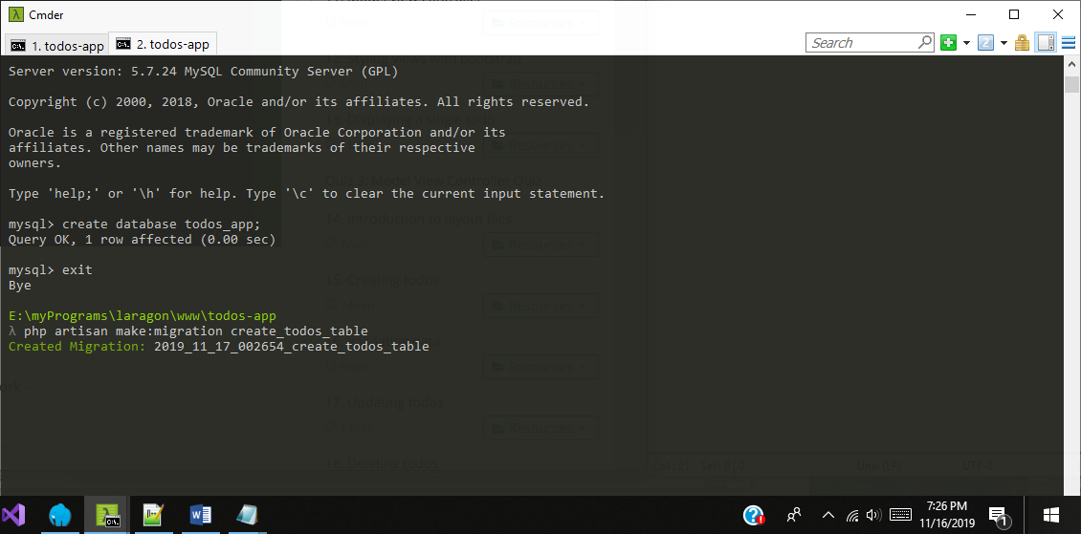
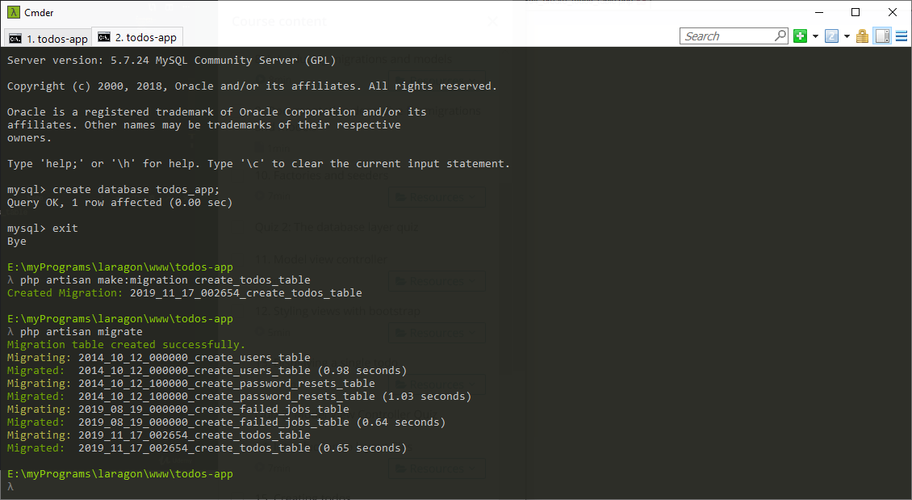

Create a controller
