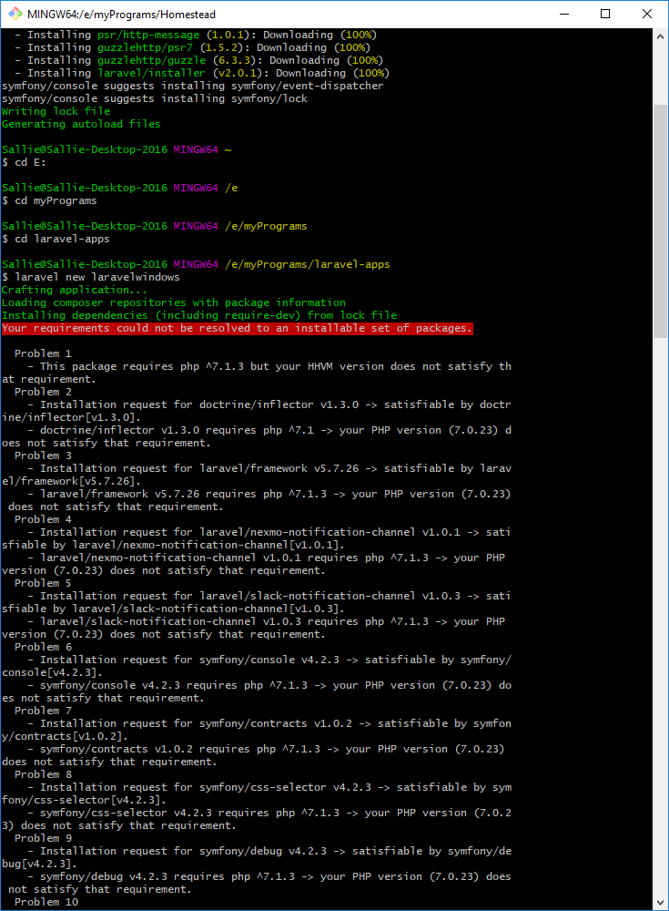

Hi Edwin
I am enjoying your course on installing Laravel. I have run into some issues that I cannot find answers to. I have tried several things myself and Googled all I can think of. I hope you can help. I followed your steps in the free course to the letter and my results looked like yours till I went to create a new laravelwindows. I got this
$ laravel new laravelwindows
Crafting application...
Loading composer repositories with package information
Installing dependencies (including require-dev) from lock file
Your requirements could not be resolved to an installable set of packages. There were many errors that all seemed to do with my php version. Some examples are:

Problem 1
- This package requires php ^7.1.3 but your HHVM version does not satisfy that requirement.
Problem 2
- Installation request for doctrine/inflector v1.3.0 -> satisfiable by doctrine/inflector[v1.3.0].
- doctrine/inflector v1.3.0 requires php ^7.1 -> your PHP version (7.0.23) does not satisfy that requirement.
So I attempted to download php from the php site and got successful results.
$ git clone http://git.php.net/repository/php-src.git
Cloning into 'php-src'...
remote: Counting objects: 783864, done.
remote: Compressing objects: 100% (178328/178328), done.
remote: Total 783864 (delta 632088), reused 755131 (delta 604136)
Receiving objects: 100% (783864/783864), 211.32 MiB | 594.00 KiB/s, done.
Resolving deltas: 100% (632088/632088), done.
Checking out files: 100% (19039/19039), done.

When I run vagrant up it fails. I am not good at installing and configuring programs and have tried to install Laravel a few times on my own, but cannot. Please help. This is what I get when I run vagrant up.
$ vagrant up
Bringing machine 'homestead-7' up with 'virtualbox' provider...
==> homestead-7: Checking if box 'laravel/homestead' version '7.1.0' is up to date...
==> homestead-7: Clearing any previously set forwarded ports...
==> homestead-7: Clearing any previously set network interfaces...
==> homestead-7: Preparing network interfaces based on configuration...
homestead-7: Adapter 1: nat
homestead-7: Adapter 2: hostonly
==> homestead-7: Forwarding ports...
homestead-7: 80 (guest) => 8000 (host) (adapter 1)
homestead-7: 443 (guest) => 44300 (host) (adapter 1)
homestead-7: 3306 (guest) => 33060 (host) (adapter 1)
homestead-7: 4040 (guest) => 4040 (host) (adapter 1)
homestead-7: 5432 (guest) => 54320 (host) (adapter 1)
homestead-7: 8025 (guest) => 8025 (host) (adapter 1)
homestead-7: 27017 (guest) => 27017 (host) (adapter 1)
homestead-7: 22 (guest) => 2222 (host) (adapter 1)
==> homestead-7: Running 'pre-boot' VM customizations...
==> homestead-7: Booting VM...
==> homestead-7: Waiting for machine to boot. This may take a few minutes...
homestead-7: SSH address: 127.0.0.1:2222
homestead-7: SSH username: vagrant
homestead-7: SSH auth method: private key
Timed out while waiting for the machine to boot. This means that
Vagrant was unable to communicate with the guest machine within
the configured ("config.vm.boot_timeout" value) time period.

If you look above, you should be able to see the error(s) that
Vagrant had when attempting to connect to the machine. These errors
are usually good hints as to what may be wrong.

If you're using a custom box, make sure that networking is properly
working and you're able to connect to the machine. It is a common
problem that networking isn't setup properly in these boxes.
Verify that authentication configurations are also setup properly,
as well.

If the box appears to be booting properly, you may want to increase
the timeout ("config.vm.boot_timeout") value.

