Create a custom class in Laravel
- Create a parent folder. I created Includes inside the app folder.
- Name the file the same as the class. If the class name is GaugesCalcs, do not name the file gauges_calcs.php. It should be named GaugesCalcs.php.
- Make sure to add the namespace at the top of the class file (namespace App\Includes)
- In the terminal, cd to the root folder (www/star2020) and run composer dump-autoload. You can see from the screenshot below that I named my files differently from the classes they held. First I renamed the gauges_counts.php to GaugesCounts.php. The 2nd block of yellow now shows only the gauges_calcs.php as not complying with psr-4 autoloading standards.

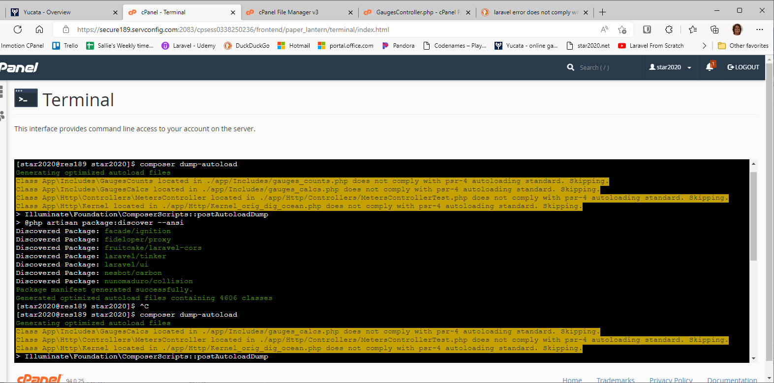

The 2nd block of yellow in the screenshot below now does not list gauges_calcs.php as not complying because I renamed the file to GaugesCalcs.php.
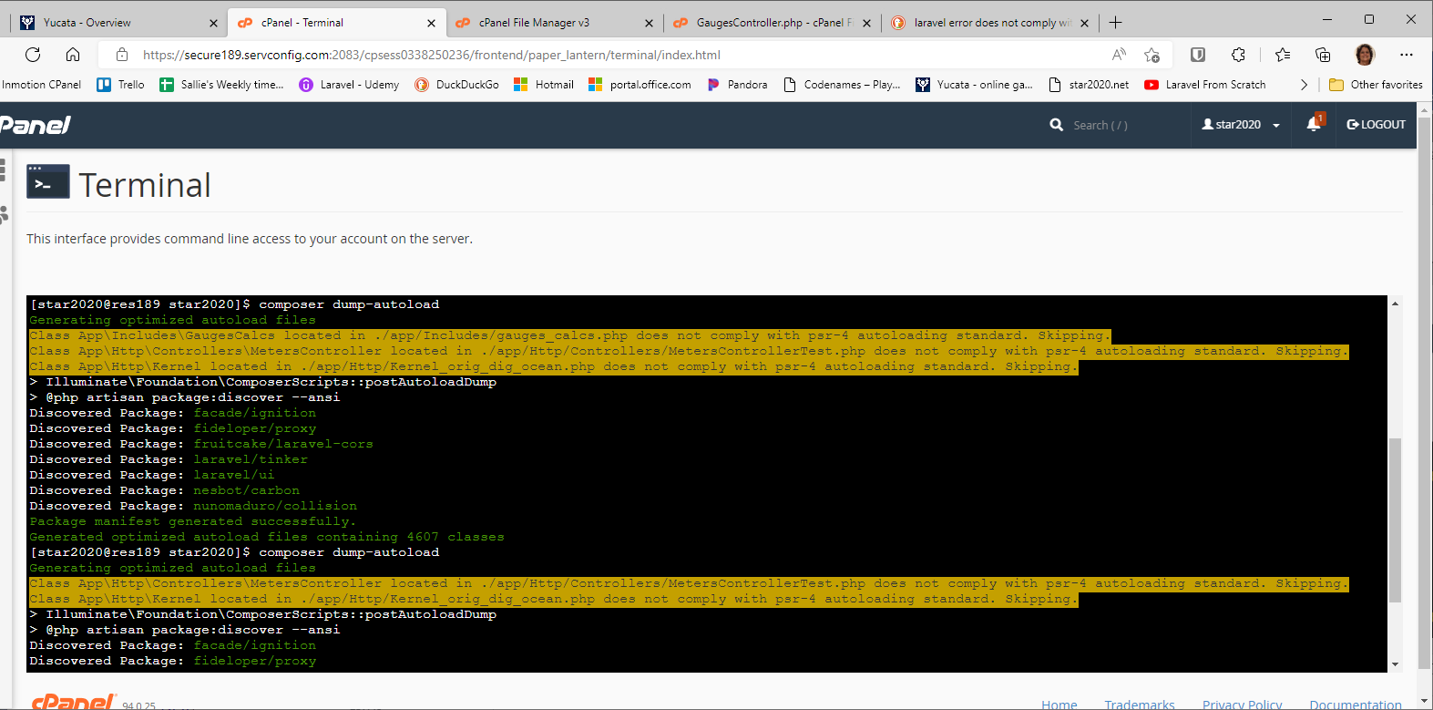
- Import the class into the controller that will call it (use App\Includes\GaugesCalcs)
- To use the class, instantiate an instance of it
$gCalc = new GaugesCalcs()
- Then use that variable to call the desired function
$startingDate = $gCalc->getStartingDate();

