Step 1 − Create a view file called resources/views/message.php and copy the following code in that file.
<html>
<head>
<title>Ajax Example</title>

<script src = "https://ajax.googleapis.com/ajax/libs/jquery/2.1.3/jquery.min.js">
</script>

<script>
function getMessage() {
$.ajax({
type:'POST',
url:'/getmsg',
data:'_token = <?php echo csrf_token() ?>',
success:function(data) {
$("#msg").html(data.msg);
}
});
}
</script>
</head>

<body>
<div id = 'msg'>This message will be replaced using Ajax.
Click the button to replace the message.</div>
<?php
echo Form::button('Replace Message',['onClick'=>'getMessage()']);
?>
</body>

</html>

Step 2 − Create a controller called AjaxController by executing the following command.
php artisan make:controller AjaxController --plain

Step 3 − After successful execution, you will receive the following output −
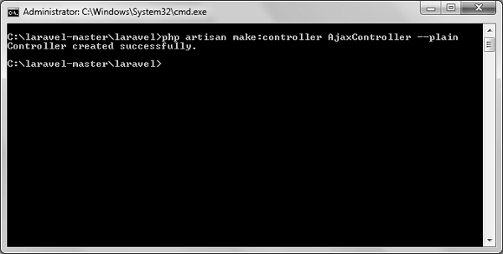
Step 4 − Copy the following code in
app/Http/Controllers/AjaxController.php
<?php

namespace App\Http\Controllers;

use Illuminate\Http\Request;
use App\Http\Requests;
use App\Http\Controllers\Controller;

class AjaxController extends Controller {
public function index() {
$msg = "This is a simple message.";
return response()->json(array('msg'=> $msg), 200);
}
}

Step 5 − Add the following lines in app/Http/routes.php.
Route::get('ajax',function() {
return view('message');
});
Route::post('/getmsg','AjaxController@index');
Step 6 − Visit the following URL to test the Ajax functionality.
http://localhost:8000/ajax
Step 7 − You will be redirected to a page where you will see a message as shown in the following image.
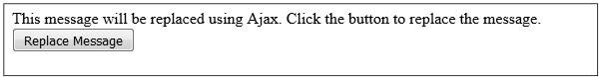
Step 8 − The output will appear as shown in the following image after clicking the button.
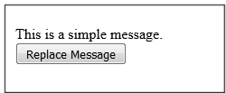

/**Test code*/
<?php $year_id = 17;
//$org_id = print("<script>getElementbyId('orgSel').value</script>");
//$doc = new DomDocument;
// create the DOMDocument object, and load HTML from a string
$dochtml = new DOMDocument();
$dochtml->loadHTML('show.php');

// get the element with id="dv1"
$elm = $dochtml->getElementById('orgSel');

// get the tag name, and content
$tag = $elm->tagName;
$org_id = $elm->nodeValue;

echo $tag. ' - '. $org_id;

// We need to validate our document before referring to the id
//$doc->validateOnParse = true;
//$doc->Load('show.blade.php');
//$org_id = $doc->getElementById('orgSel');
?>

