Check to see if the table row is clickable. It wouldn’t be in a plain old html table, I believe.
- data-click-to-select="true"

This button IN A TABLE CELL does not call the function
<td><button class="btn btn-danger btn-sm m-1" onclick="handleDeleteTest(91)">Delete3</button></td>

This same button OUTSIDE the TABLE does call the function.
<button class="btn btn-danger btn-sm m-1" onclick="handleDeleteTest(91)">Delete Me</button>

This function is working correctly
function handleDeleteTest(id){

$('#deleteSpcUser').attr('action', id);
$('#deleteSpcUser').attr('method', 'POST');

$('#deleteModal').modal('show');
}

This destroy function is working correctly
public function destroy(SpcUser $spc_user){

DB::update('update phones set deleted_at = ? where owner_type = ? AND owner_id = ?', [now(), 'U', $spc_user->user_id]);

SpcUser::destroy($spc_user->user_id);

session()->flash('success', 'User record successfully deleted');

return redirect(route('spc_users.index'));
}

All of the imports are in the app
The button outside the table calls the function, which calls the controller function and the record is soft-deleted.

Issue found
Bootstrap rows may be clickable by default. I found some info suggesting this, but nothing definitive.
From: jquery - How to make bootstrap clickable-row unavailable for a specific columns? - Stack Overflow
Question:
I am using bootstrap and I have a clickable row there. When you click the row a model will open. It is like below.

<tr class='clickable-row' data-toggle="modal" data-target="#editModal" style="cursor:pointer">

However in this row, there is a columns which contains a button. The issue is the button get clicked, but since the entire row is clickable, the model get opened first, then the button's commands get executed.
Below is the button column.
<td>
<form>
<label>
<input type="submit" name="buttonActDea" id="button" class="btn btn-primary" value="Activate">
</label>
</form>
</td>

How can I make the "clickable row" feature un-available only for the button column?

Response:
You can use jquery's stopPropagation();

$('#button').on('click',function(e) {
//button function

e.stopPropagation();
})

or remove the data atributes so the click event for the tr isn't triggered if it has a button child

$( document ).ready(function() {
$('.clickable-row').each(function () {
if ( $(this).find('#button').length)
{
$(this).removeAttr('data-toggle').removeAttr('data-target');
}
});
});

Trying to stop the row from being clickable
If I remove the myDataTable class from the table and replace it with table
<table id="myDataTable" class="table">
And add this to the document.ready function
$(".delete-button").click(function(event){
event.stopPropagation();
confirm("Are you sure you want to delete this contact?");
handleDeleteTest({{713}})
});

The button click WILL display the confirm
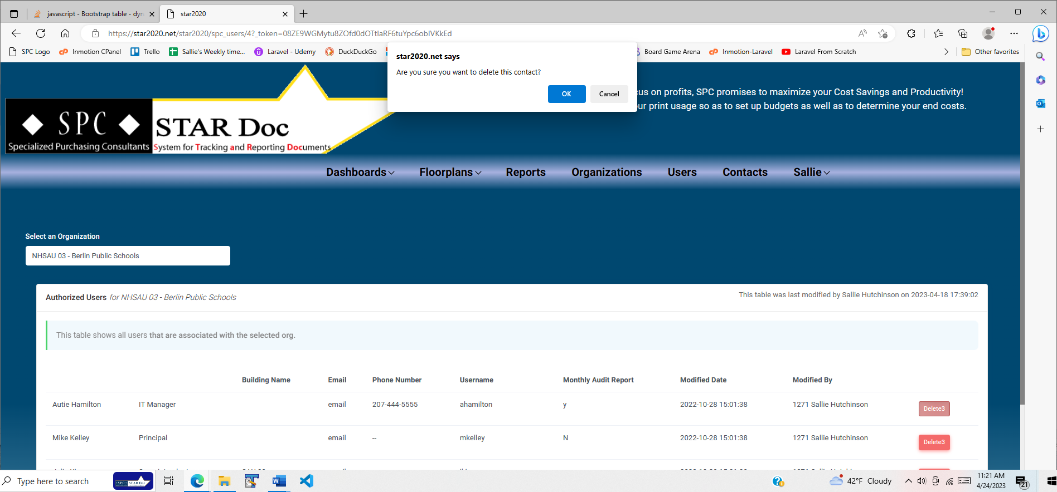

But, the call to handleDeleteTest(713) appears to not fire
function handleDeleteTest(id){
$('#deleteSpcUser').attr('action', id);
$('#deleteSpcUser').attr('method', 'POST');

$('#deleteModal').modal('show');
}

Try removing the click event from tr
$("table").on("click", "tr td", function () {
var col = $(this).index();
if(col != 2){
console.log("OK");
}
});

Tested snippets that work
/*This DOES display the alert when a table cell is clicked*/
$("table").on("click", "tr td", function () {
var col = $(this).index();
if(col != 2){
alert("wrong column");
}
});

/*This DOES also display the alert when a table cell is clicked*/
$("table").on("click", "tr", function () {
alert("wrong column");
});

/*This does NOT display the alert when a table cell is clicked*/
$("table").on("click", "tr", function () {
var col = $(this).index();
if(col != 2){
alert("wrong column");
}
});

$(".delete-button").click(function(event){

alert("The delete-button element was clicked.");

$(".non-click").on("click", function (event) {

//alert("wrong column to stop");

/*This prevented the default row behavior, so the delete button modal could
be shown and allowed to work. This HAS to be inside this function because when I take it out and place above the jQuery for the .delete-button click event, it makes <a href> elements in other table cells NOT be clickable.*/
event.preventDefault();

/*This DID NOT stop the behavior of the row when the delete button in the
cell in the table row was clicked.*/
//event.stopImmediatePropagation();
});

handleDeleteTest(this.id);

/*This prevents the modal from opening. It’s probably on the wrong element*/
//$(".non-click").event.stopPropagation();

});

This button only works when the event.preventDefault() is outside the jQuery for the .delete-button click event
<button class="btn btn-danger btn-sm m-1" onclick="handleSpcUserDelete({{$row->user_id, 'deleteSpcUser', 'spc_users/'}})">DeleteOnC</button>

