Modal forms – getting the value to pass to controller, which will pass to a Mailable object
View code (code for the blade view)
- In the view, wrap the entire modal body and footer in a form with a submit button.
- Assign post as the method so there will be post values to get using the Request object.
- Assign the route that will handle the action.
- Make sure that all elements have a name value. Post uses names to get input values.
<form method="post" action="{{route('send_email')}}">
@csrf
<div class="modal-body" name="requestForm">
<label class="control-label" for="comments">Comments</label>
<textarea id="comments" name="comments" class="form-control col-xs-12" rows="7" cols="50"
placeholder="What would you like {{$user_name}}?">
</textarea>

<div class="form-check">
<input class="form-check-input" type="checkbox" value="" id="annually" name="annually"/>
<label class="form-check-label" for="annually">Annually?</label>
</div>

<div>
<select name="month" id="month" name="month" style="display: none">
@if(isset($month_array))
@foreach($month_array as $value)
<option value={{$value}}>{{$value}}</option>
@endforeach
@endif
</select>
</div>
</div>

<div class="modal-footer">
<!—This doesn’t work because without post there will be no Request values from user input. -->
<!--<a href="{{route('send_email')}}" type="button" class="btn btn-primary" >Send Request</a>-->

<input type="submit" class="btn btn-primary" value="Send Request" />
<button type="button" class="btn btn-dark" data-dismiss="modal">Close</button>
</div>
</form>

Controller code
- Inject the Request object into the controller function that is called by the form action
- Access the input values as in the assignment to the $comments variable below.

public function send_email(Request $request)
{
$comments = $request->comments;
Mail::to('vstarsal@hotmail.com')->send(new ReqOrgServiceHistory($comments));

<!—Optionally the entire $request variable could be sent to the mailable object as below. Then it can be retrieved in
the view using $request->comments.-->

Mail::to('vstarsal@hotmail.com')->send(new ReqOrgServiceHistory($request));

If the request object is sent to _construct, there will need to be a public $request variable in the mailable object. The passed in $request will need to be assigned to the public variable. If done this way, there is no need to chain the with method to the return.

The entire Mailable class object passing the request object instead of individual variables.
<?php

namespace App\Mail;

use Illuminate\Bus\Queueable;
use Illuminate\Contracts\Queue\ShouldQueue;
use Illuminate\Mail\Mailable;
use Illuminate\Queue\SerializesModels;

class ReqOrgServiceHistory extends Mailable
{
use Queueable, SerializesModels;

public $request;

public function __construct($request)
{
$this->request = $request;
}

public function build()
{
return $this->view('emails/email')
->subject('Your Org Service History')
->text('emails/email')
->to('vstarsal@hotmail.com')
->cc('vstarsal@gmail.com');
}
}

echo '<h2>Your request has been sent. Thank you.</h2>';
//dd ($request);
//dd($request->all());
}

Using dd ($request); will return all request data, but the user input variables will be in request/parameters.
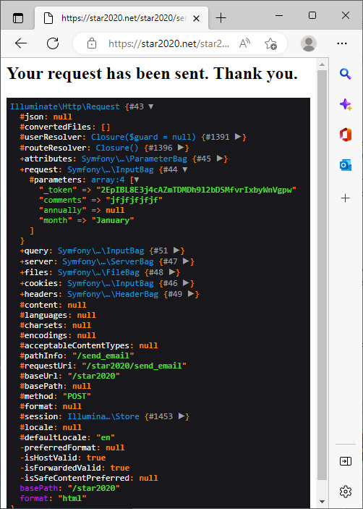

Using dd($request->all()); will return only the user input values.
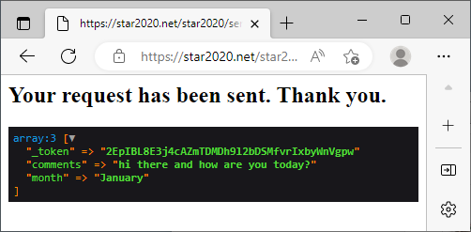

Mailable class code
The ReqOrgServiceHistory mailable is called by the EmailsController
- Add the variables as public so they will be accessible by the view
- Add the required attributes in the build function of the mailable object
- Chain the with() method, which contains the required variables of data.

public $comments;
public function __construct($comments)
{
$this->comments = $comments;
}

public function build()
{
return $this->view('emails/email')
->subject('Your Org Service History')
->text('emails/email')
->to('vstarsal@hotmail.com')
->cc('vstarsal@gmail.com')

->with([
'comments' => $this->comments
]);
}

web.php code (routes)
- Add the route to web.php
- I have used the following basically as a test. I could have just used Route::get...

/*This will use the route for GET or POST*/
Route::match(['GET', 'POST'], 'send_email', 'EmailsController@send_email')->name('send_email')->middleware('auth');

