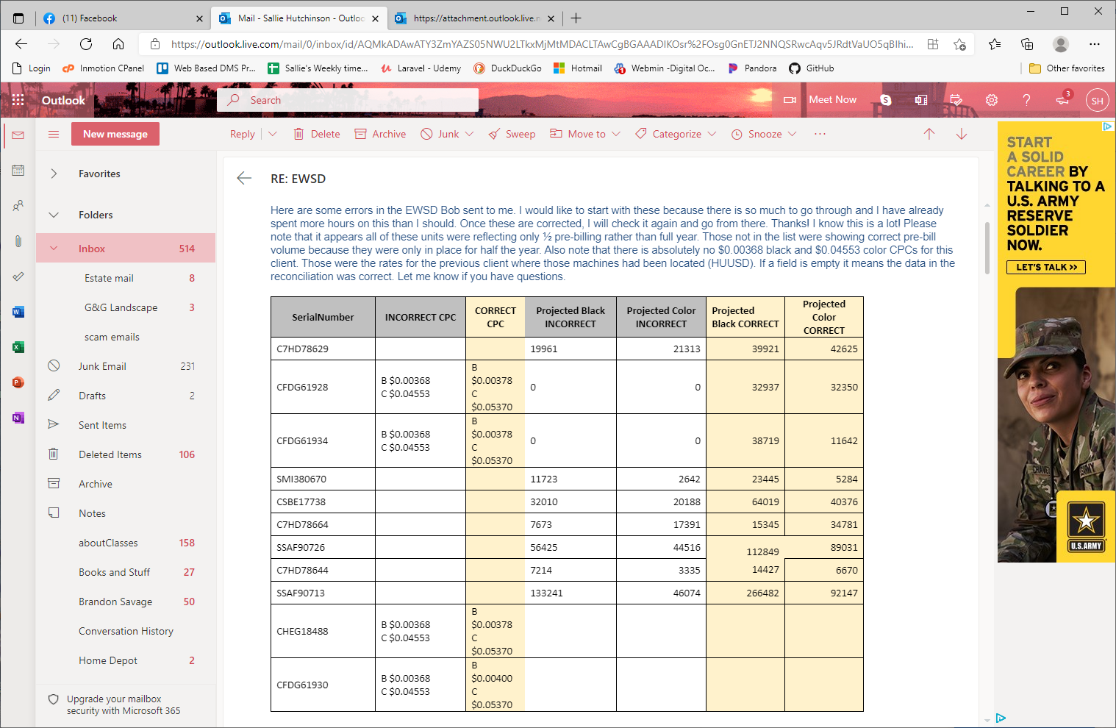
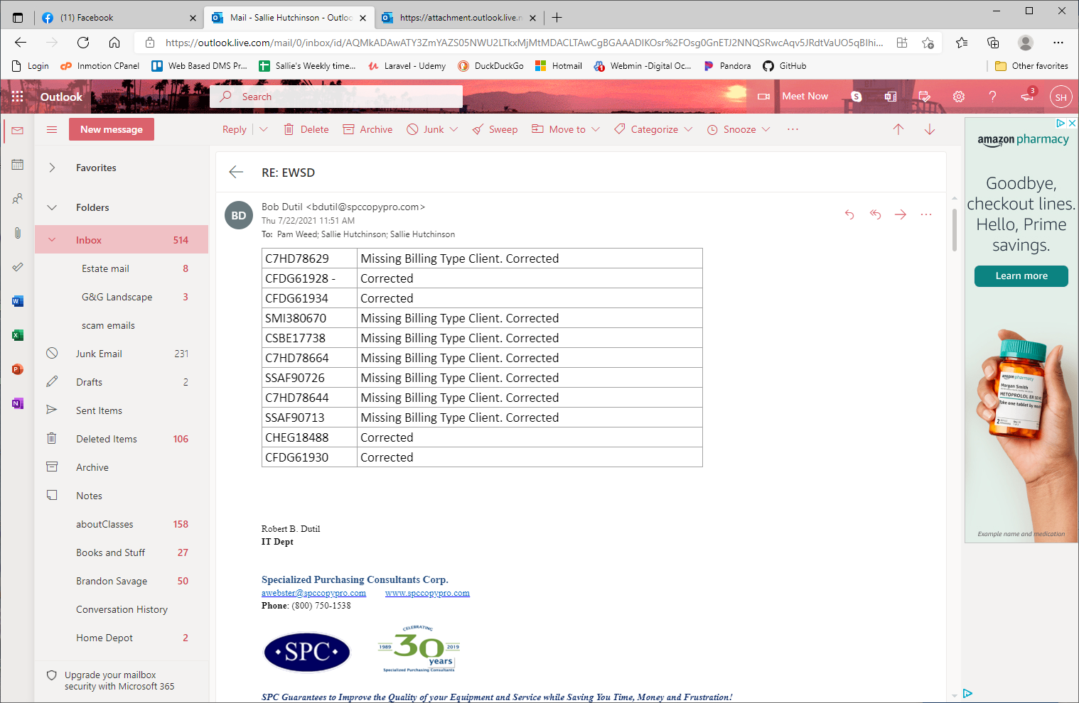
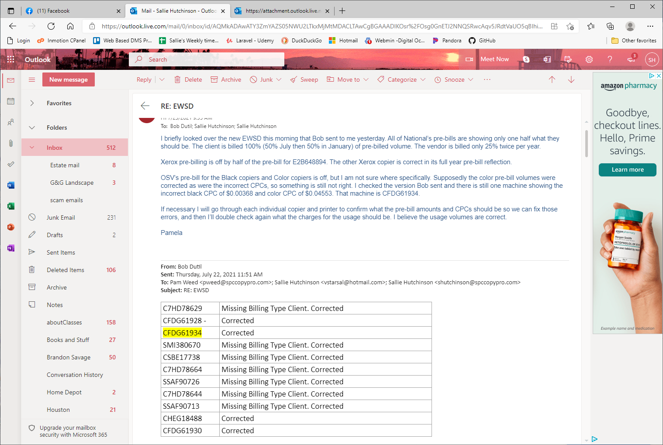
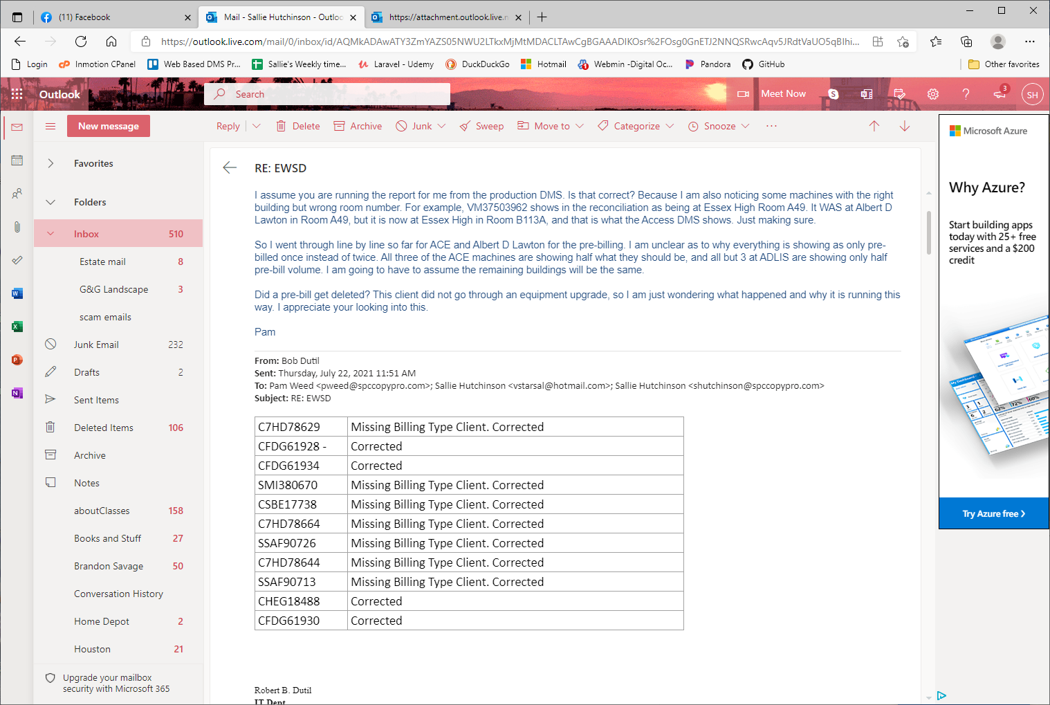
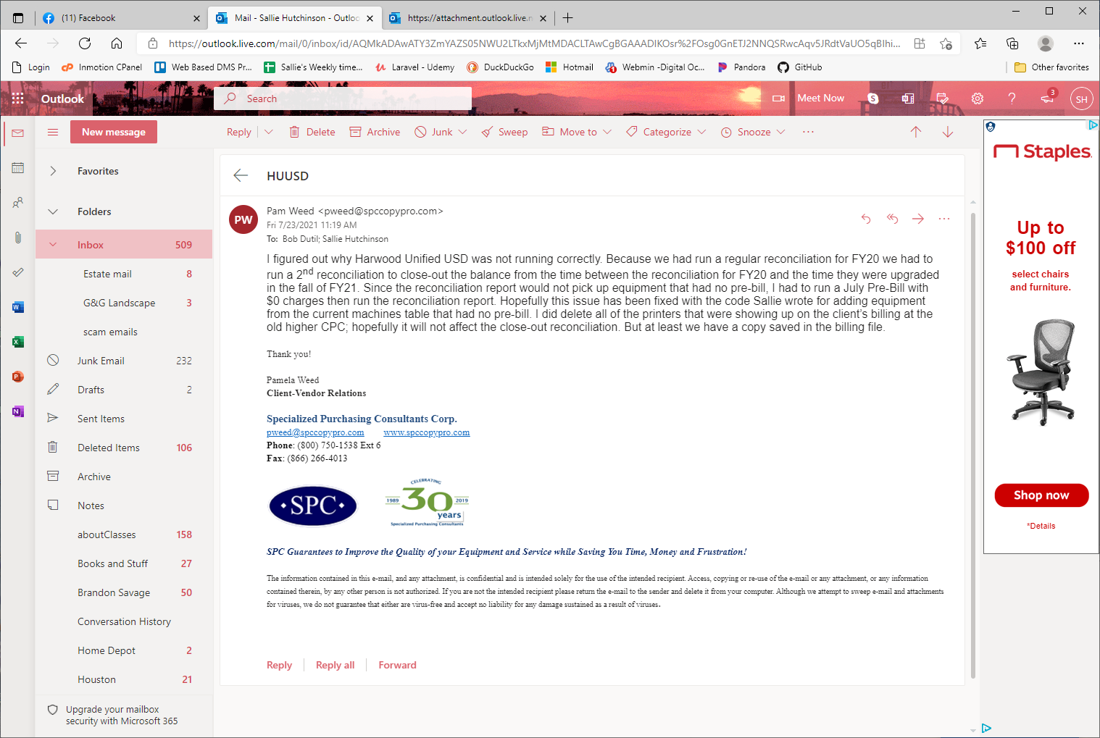
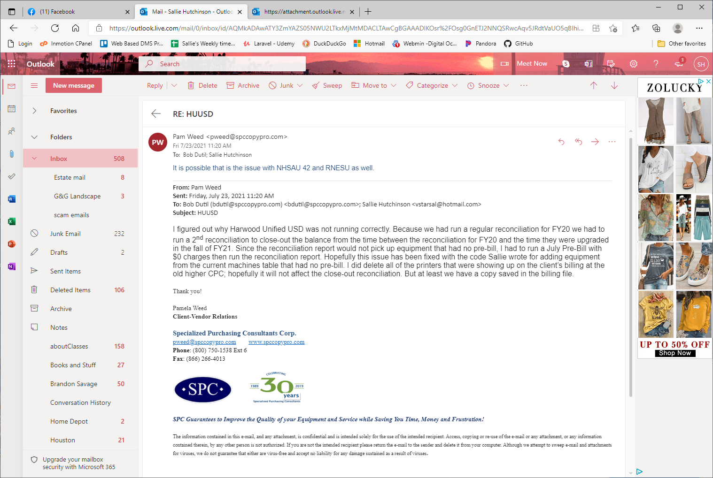

I’m thinking that is the case.
So, I ran the reconciliation and it looked good now. I archived the data and ran the pre-bill and it also looked good. I have moved on to RNESU, and I will let you know if I find a similar scenario.

Sallie, when we run Rutland Northeast Supervisory Union by Department we get the following error. Report won’t open.

Fatal error: Call to a member function bind_param() on boolean in /home/spcsta5/public_html/dms/TCPDF/reports/yearly_reconciliation.php on line 500

Sallie that’s in the Billing To Do and Id 2012.

