warranty_replaced_machines.php
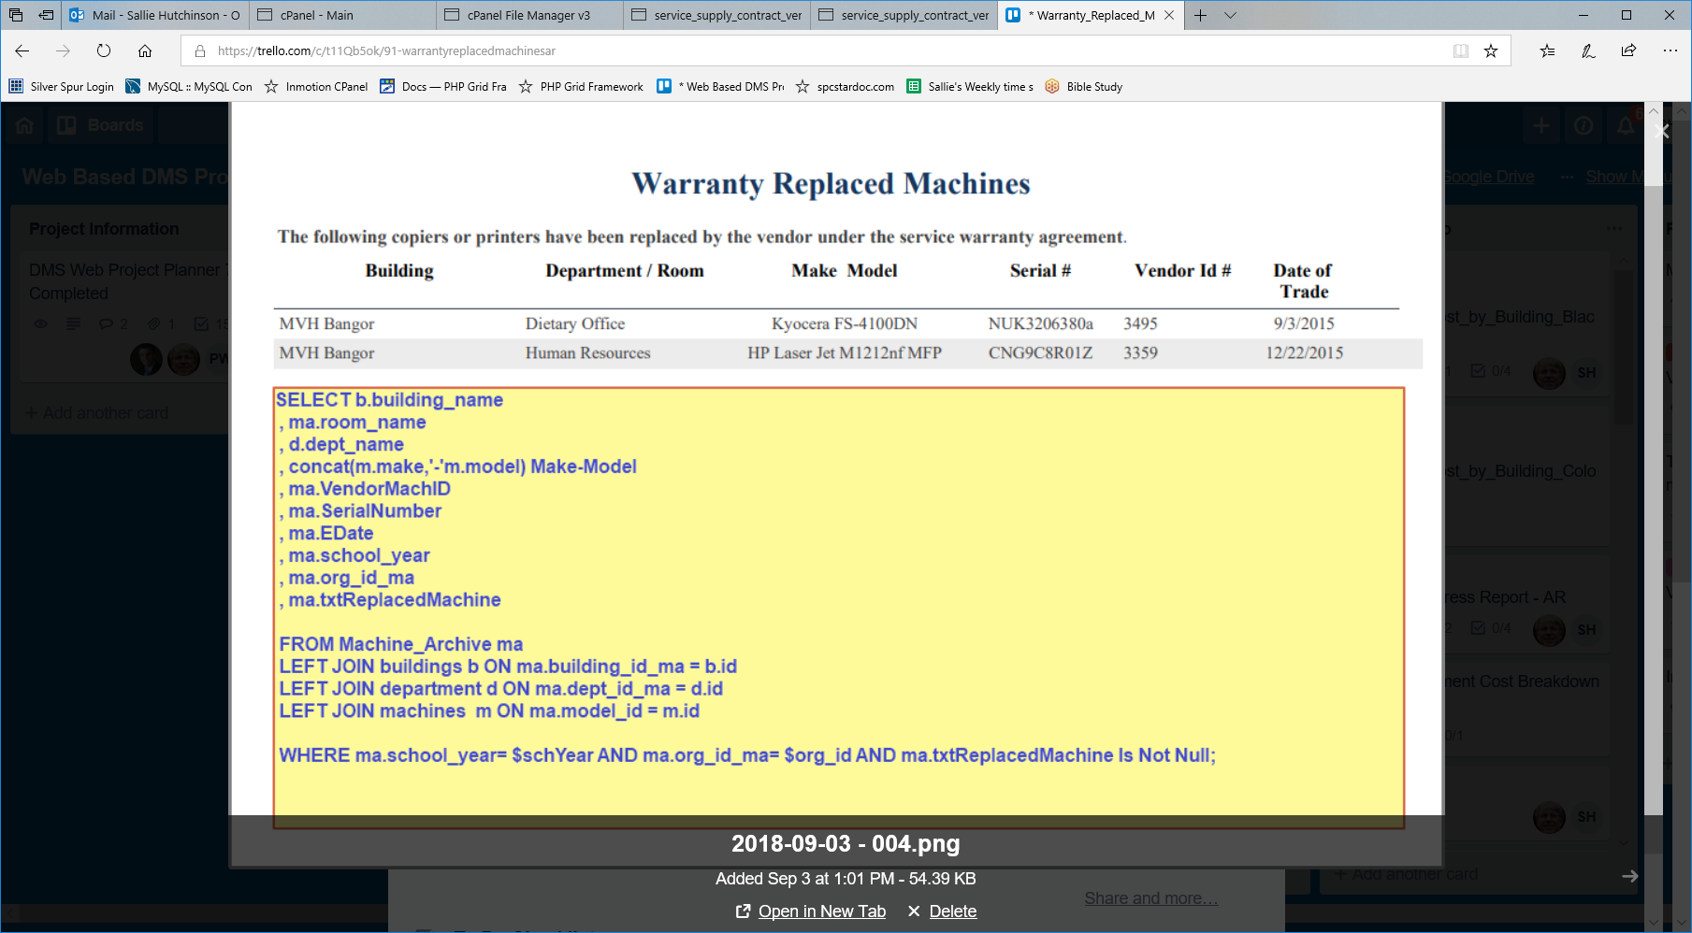
SELECT b.building_name , ma.room_name , d.dept_name , concat(m.make,'-'m.model) Make-Model , ma.VendorMachID , ma.SerialNumber , ma.EDate , ma.school_year , ma.org_id_ma , ma.txtReplacedMachine FROM Machine_Archive ma LEFT JOIN buildings b ON ma.building_id_ma = b.id LEFT JOIN department d ON ma.dept_id_ma = d.id LEFT JOIN machines m ON ma.model_id = m.id WHERE ma.school_year= $schYear AND ma.org_id_ma= $org_id AND ma.txtReplacedMachine Is Not Null;

