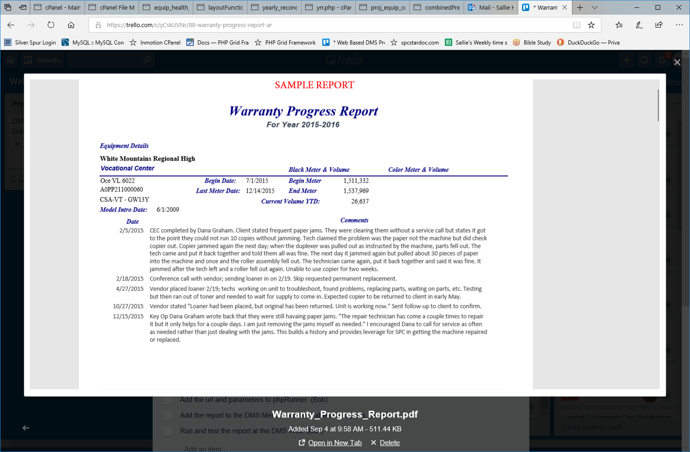
SELECT ma.org_id_ma , org.org_name , bldg.building_name , ma.room_name,
concat(mach.make, " - " ,mach.model) `Make-Model`,
#vnd.`VendorID#`,
ma.vendor_id_ma,
ma.VendorMachID,
mac.mac_serial_number AS SerialNumber,
mach.intro , ma.Begin , ma.End , ma.MstrBegin,
ma.MstrEnd , ma.End-ma.Begin `Black Volume`,
ma.MstrEnd-ma.MstrBegin `Color Volume`, ma.BDate,
ma.EDate , mach.is_color

FROM machine_analysis_complaints mac
INNER JOIN Machine_Archive ma ON mac.mac_serial_number = ma.SerialNumber
INNER JOIN buildings bldg ON ma.building_id_ma = bldg.id
INNER JOIN organization org ON ma.org_id_ma = org.id
#INNER JOIN Vendors vnd ON ma.vendor_id_ma = vnd.`VendorID#`
INNER JOIN machines mach ON ma.model_id = mach.id

WHERE mac.mac_complaint="Complaint"
#AND SerialNumber = "A0PP211000060"
AND ma.org_id_ma = 53
AND ma.school_year=14
GROUP BY ma.org_id_ma, org.org_name, bldg.building_name;# HAVING (((ma.org_id_ma)=53;
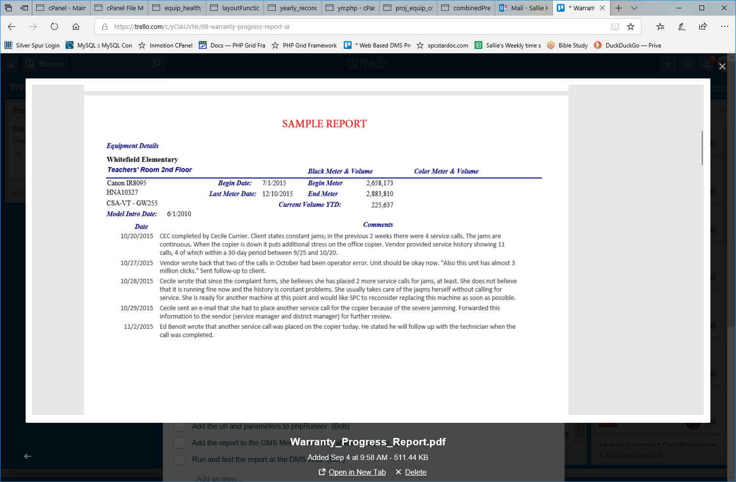
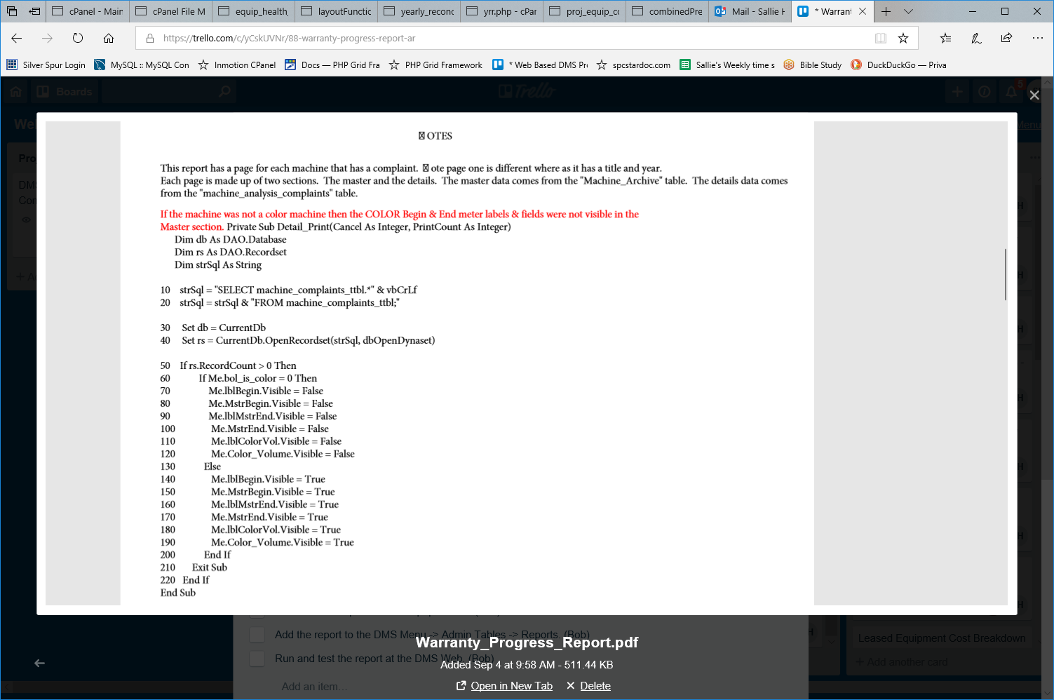
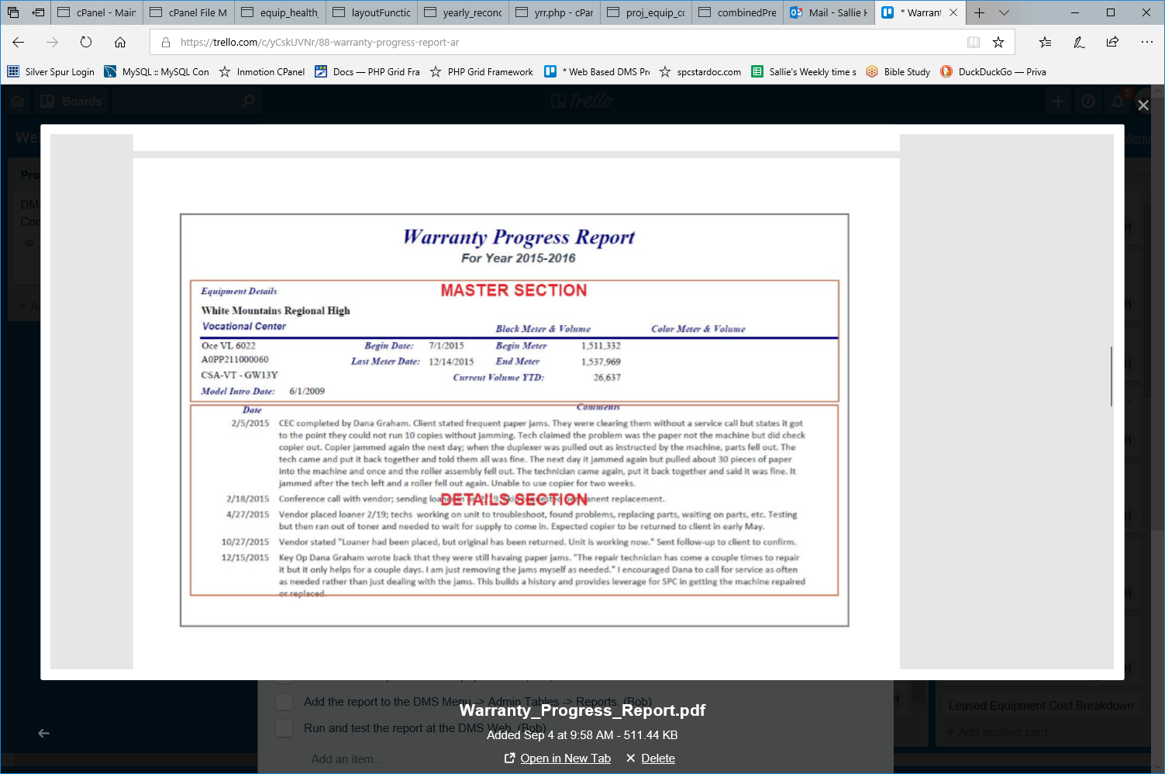

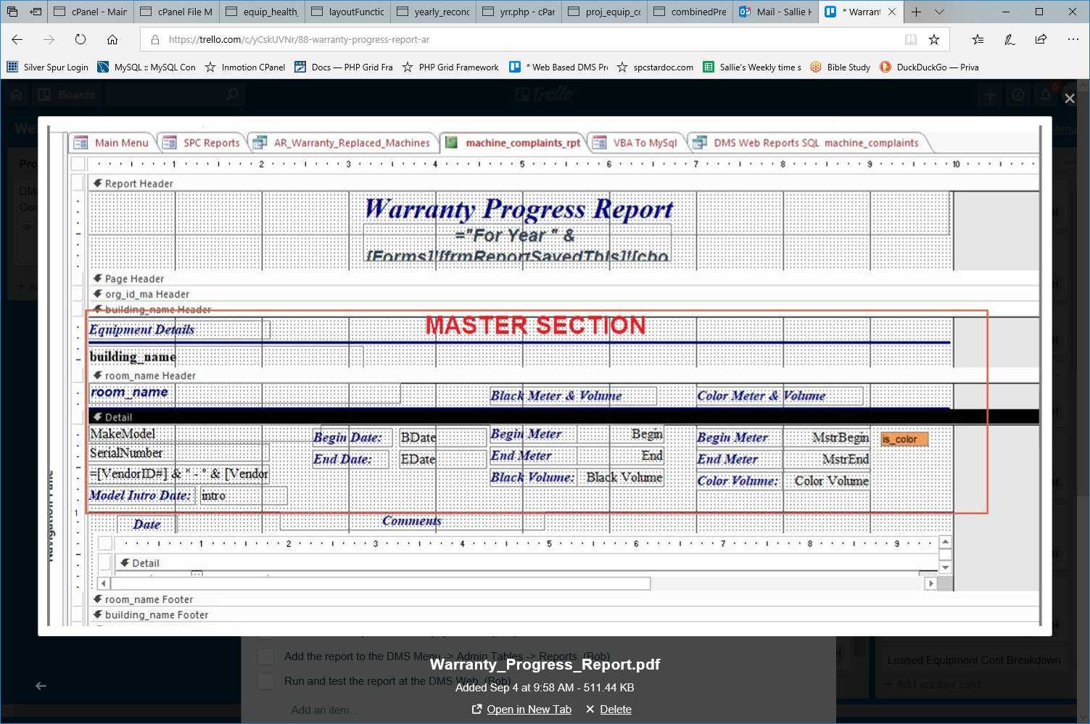
SELECT Machine_Archive.org_id_ma , o.org_name , b.building_name , ma.room_name , concat(m.make, " - " ,m.model) `Make-Model` , v.`VendorID#` , ma.VendorMachID , mac.mac_serial_number AS SerialNumber , m.intro , ma.Begin , ma.End , ma.MstrBegin , ma.MstrEnd , ma.End-ma.Begin `Black Volume` , ma.MstrEnd-ma.MstrBegin `Color Volume` , ma.BDate , ma.EDate , m.is_color FROM machine_analysis_complaints mac INNER JOIN Machine_Archive ma ON mac.mac_serial_number = ma.SerialNumber INNER JOIN buildings b ON ma.building_id_ma = b.id INNER JOIN organization o ON ma.org_id_ma = o.id INNER JOIN Vendors v ON ma.vendor_id_ma = v.`VendorID#` INNER JOIN machines m ON ma.model_id = m.id WHERE mac.mac_complaint="Complaint" AND ma.school_year=$schYear GROUP BY ma.org_id_ma , o.org_name , b.building_name HAVING (((ma.org_id_ma)=$org_id;
