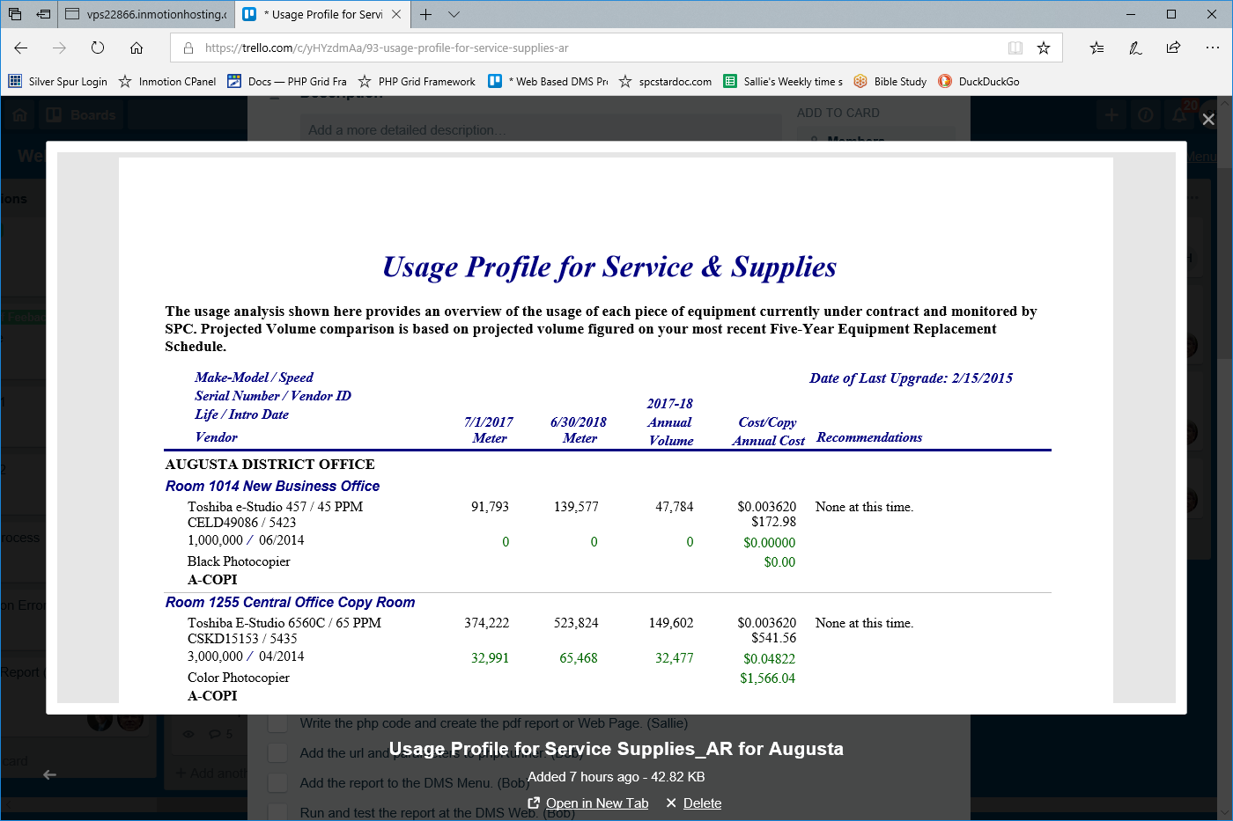
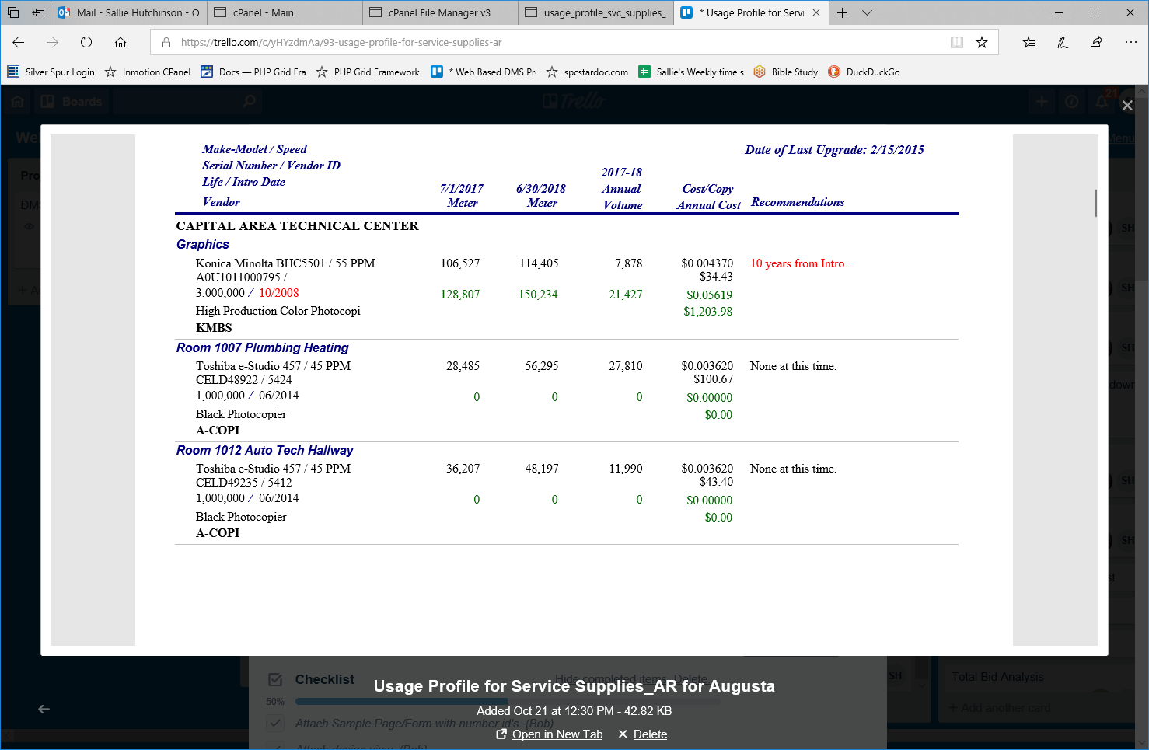
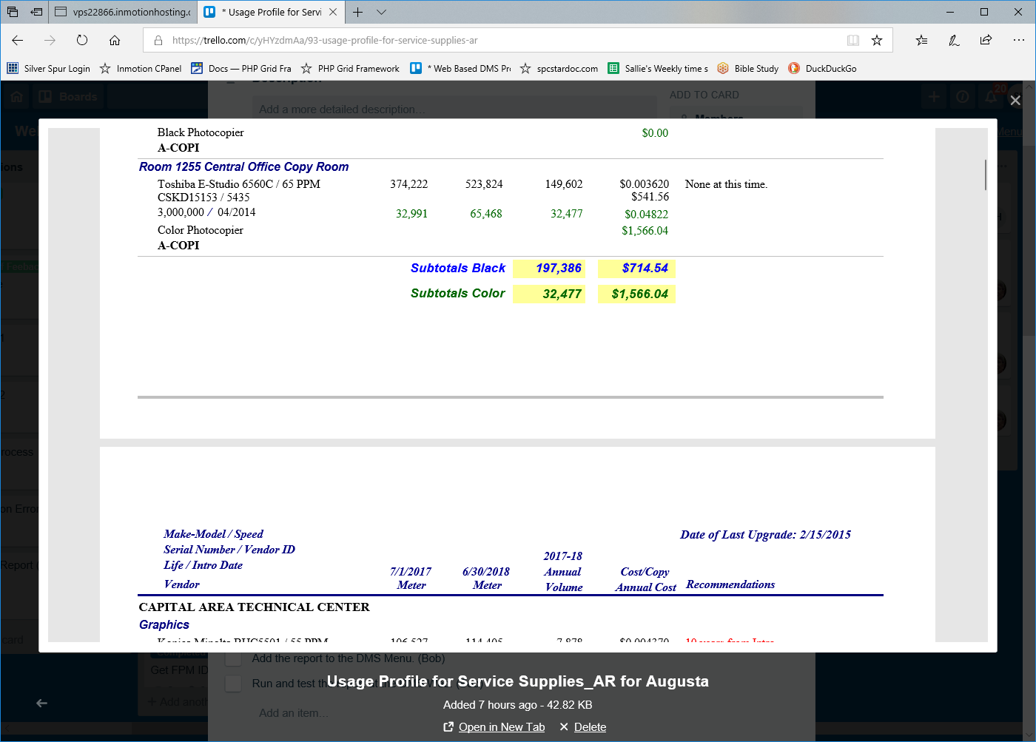
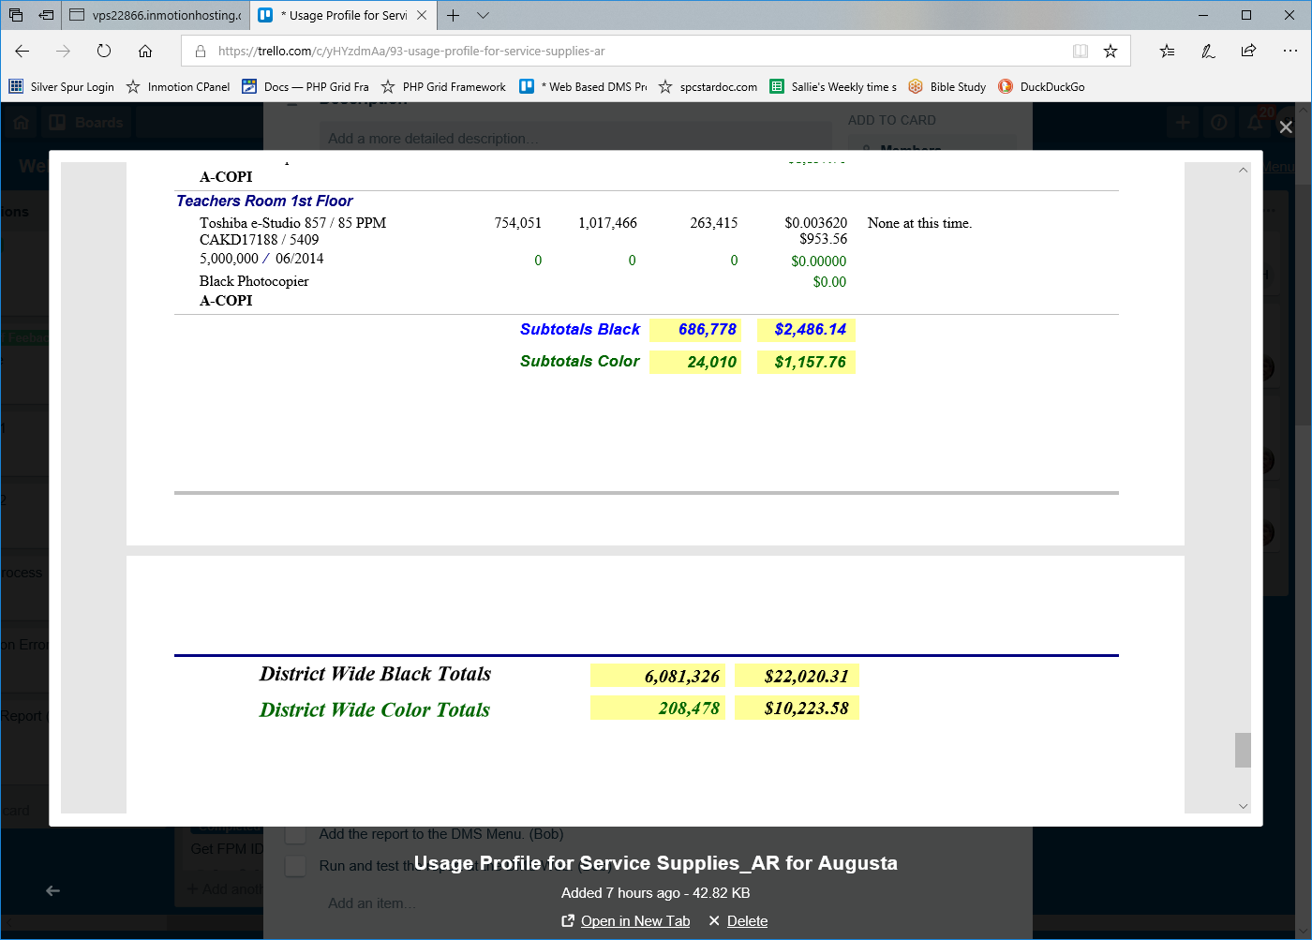
SELECT AR_Basic_Data_tempTable.org_id_ma ,
AR_Basic_Data_tempTable.org_name ,
AR_Basic_Data_tempTable.building_name ,
AR_Basic_Data_tempTable.room_name ,
[make] & " " & [model] AS [Make-Model] ,
AR_Basic_Data_tempTable.SerialNumber ,
AR_Basic_Data_tempTable.VendorMachID ,
AR_Basic_Data_tempTable.life ,
AR_Basic_Data_tempTable.intro ,
AR_Basic_Data_tempTable.type_name ,
AR_Basic_Data_tempTable.vendor_id_ma ,
AR_Basic_Data_tempTable.Begin ,
AR_Basic_Data_tempTable.End ,
AR_Basic_Data_tempTable.MstrBegin ,
AR_Basic_Data_tempTable.MstrEnd ,
[End]-[Begin] AS [Black Volume] ,
[MstrEnd]-[MstrBegin] AS [Color Volume] ,
AR_Basic_Data_tempTable.CostCopy ,
AR_Basic_Data_tempTable.Mstrcpc ,
[Black Volume]*[CostCopy] AS [Black Cost] ,
[Color Volume]*[Mstrcpc] AS [Color Cost] ,
AR_Basic_Data_tempTable.LastUpdate ,
lkp_school_year.school_year ,
AR_Basic_Data_tempTable.Comments ,
IIf([Traded]="Y" ,"Traded" ,IIf(DateDiff("yyyy" ,[Intro] ,Date())<7 ,"None at this time.",IIf([ContractExpDate]<Now(),"Service Contract Expired!" ,DateDiff("yyyy",[Intro] ,Date()) & " years from Intro."))) AS Recommendations ,
AR_Basic_Data_tempTable.ContractExpDate ,
AR_Basic_Data_tempTable.Traded , IIf([PrintMgmtSoftwareInstalled]=True ,"Connected","Not Connected") AS local_connection ,
AR_Basic_Data_tempTable.speed ,
DateDiff("yyyy",[Intro],Now()) AS Machine_Age INTO [Usage Profile for Service Supplies tbl]
FROM AR_Basic_Data_tempTable
INNER JOIN lkp_school_year ON AR_Basic_Data_tempTable.school_year = lkp_school_year.yr_id;

