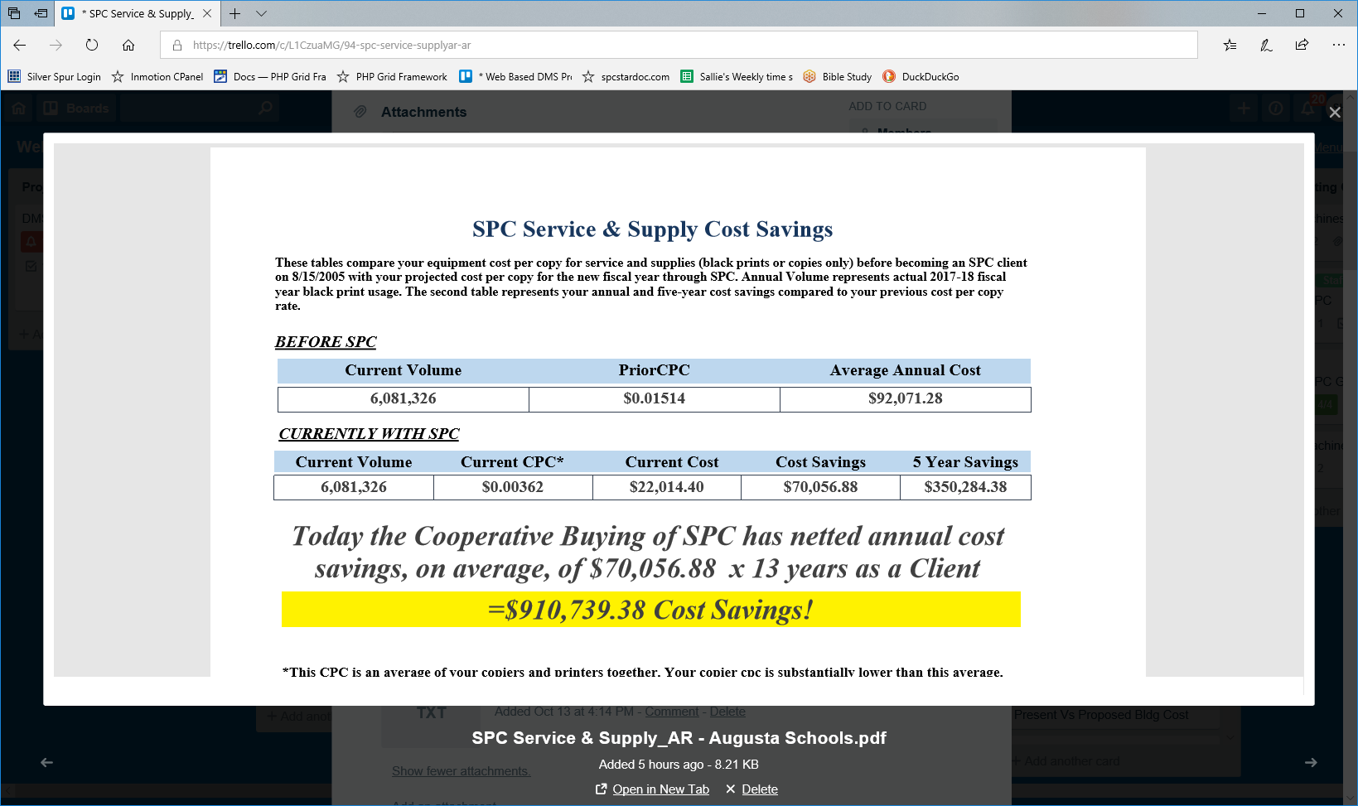
SELECT Machine_Archive.org_id_ma,
organization.org_name,
organization.ClientSince,
organization.PriorVolume,
organization.PriorCPC,
Current Volume * PriorCPC AS prior_cost,
Sum(End - Begin) AS current_volume,
AR_SPC Service Supply Current Cost.Current Black Cost AS current_cost,
AR_SPC Service Supply Current Cost.Current Black Cost,
Get Average CPC 03.TotalCost, Get Average CPC 03.AverageCPC AS current_cpc,
Cost Savings * 5 AS 5 Year Savings, DateDiff("yyyy", [ClientSince] ,Now()) AS Client_Yrs,
Left(lkp_school_year.school_year,5) & "" & Right([lkp_school_year].[school_year] ,2) AS [School YearLabel],
[Cost Savings]*[Client_Yrs] AS [District Savings],
[Prior Cost]-[TotalCost] AS [Cost Savings],
organization.ClientSince

FROM ((((Machine_Archive INNER JOIN organization ON Machine_Archive.org_id_ma = organization.id)
INNER JOIN buildings ON Machine_Archive.building_id_ma = buildings.id)
INNER JOIN [AR_SPC Service Supply Current Cost] ON Machine_Archive.org_id_ma = [AR_SPC Service Supply Current Cost].org_id_ma) INNER JOIN lkp_school_year ON Machine_Archive.school_year = lkp_school_year.yr_id)
INNER JOIN [Get Average CPC 03] ON Machine_Archive.org_id_ma = [Get Average CPC 03].org_id_ma
GROUP BY Machine_Archive.org_id_ma , organization.org_name , organization.PriorVolume , organization.PriorCPC , [AR_SPC Service Supply Current Cost].[Current Black Cost] , [Get Average CPC 03].TotalCost , [Get Average CPC 03].AverageCPC , DateDiff("yyyy",[ClientSince] ,Now()) , Left([lkp_school_year].[school_year],5) & "" & Right([lkp_school_year].[school_year],2) , organization.ClientSince , Machine_Archive.school_year , organization.ClientSince
HAVING (((Machine_Archive.org_id_ma)=[Forms]![frmReportSavedTbls]![cmbClient]) AND ((Machine_Archive.school_year)=[Forms]![frmReportSavedTbls]![cboSchoolYear]));

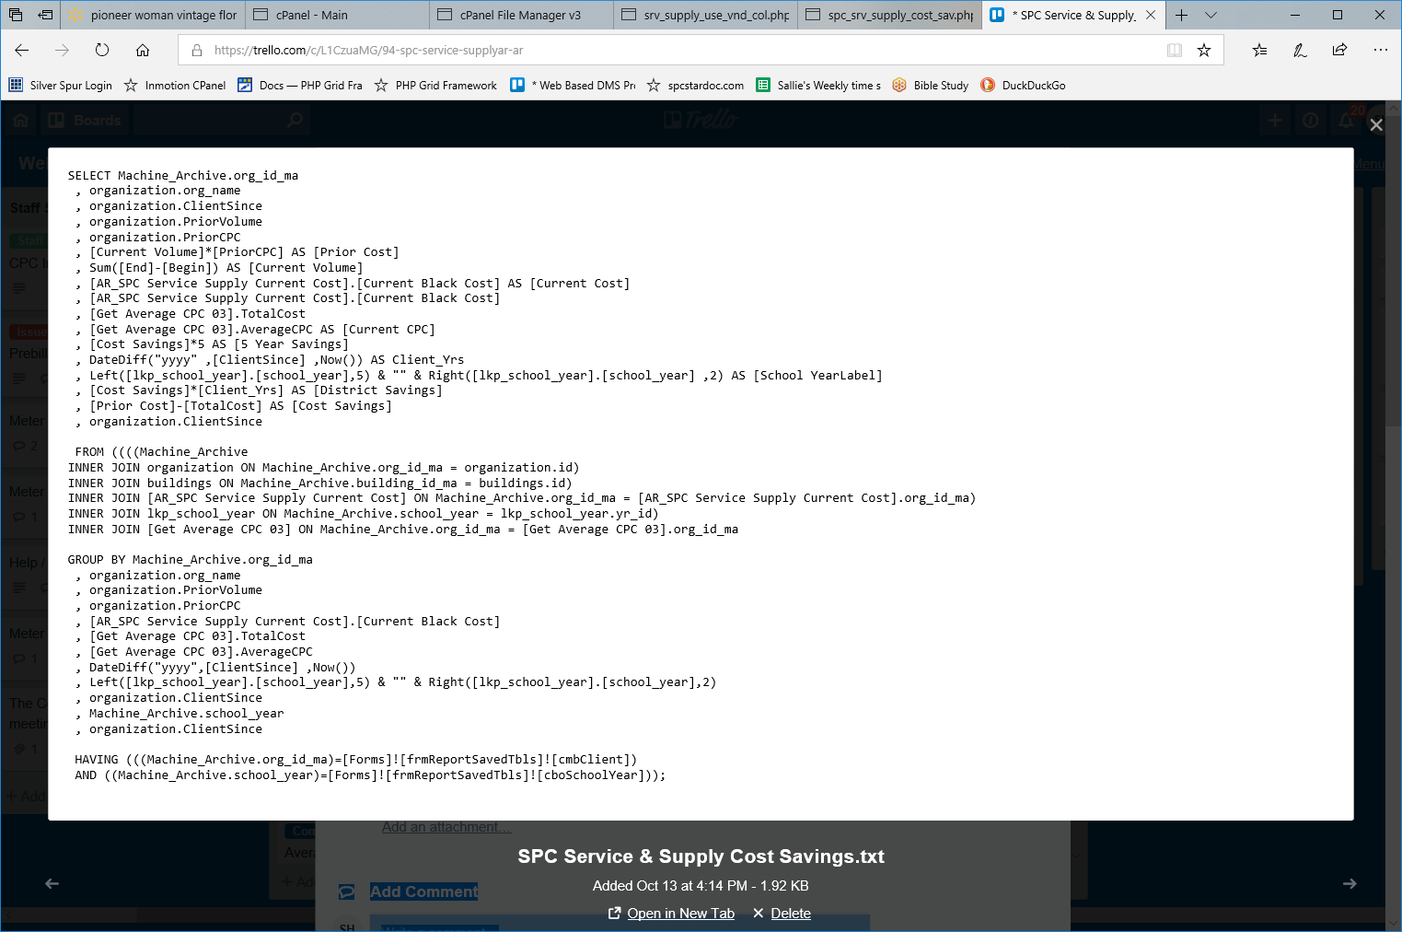

AR_SPC Service Supply Current Cost

SELECT Sum(End - Begin) * AvgCPC AS Current Black Cost,
Sum((MstrEnd - MstrBegin) * NewColorCPC) AS Current Color Cost,
Machine_Archive.org_id_ma,
Sum(End - Begin) AS Current Black Volume,
Sum(MstrEnd - MstrBegin) AS Current Color Volume,
organization.AvgCPC

FROM Machine_Archive
INNER JOIN local_organization ON Machine_Archive.org_id_ma = local_organization.id

WHERE Machine_Archive.org_id_ma = org_id AND Machine_Archive.school_year= SchoolYear
GROUP BY Machine_Archive.org_id_ma , organization.AvgCPC;

