Query WIP
SELECT twf.VendorName, twf.SerialNum, mt.type_name, tbc.`Job Title`, concat(tbc.`First Name`, ' ' , tbc.`Last Name`) by_name, twf.save_name_id, org.id, org.org_name, bldg.building_name, tbc.Notes, org.PhoneNumber, twf.present_type_id,
twf.present_room_number room_name, org.LastUpdate term_begin, org.address street, org.city, org.state, org.zipcode, twf.AdjCostCopy blk_cpc, twf.Color_CPC col_cpc, DATE(now()), concat(Year(org.LastUpdate) + 5, "-06-30") term_end

FROM tblWhatif twf
LEFT JOIN FYER_Group fg ON twf.save_name_id = fg.ID
INNER JOIN organization org ON org.id = fg.FyerOrg_id
INNER JOIN buildings bldg ON bldg.id = twf.building_id
LEFT JOIN machine_types mt ON mt.id = twf.present_type_id#mach.model_type
INNER JOIN tblContacts tbc ON tbc.org_id_contact = org.id

WHERE org.org_name = "Augusta Schools"
AND twf.VendorName = "A-COPI"
AND tbc.`Job Title` = "Superintendent"
ORDER BY bldg.building_name, twf.present_room_number;

SELECT twf.VendorName, twf.SerialNum, mach.make, mach.model, mt.type_name, twf.save_name_id, org.org_name, bldg.building_name, mc.room_name,
org.LastUpdate term_begin, org.address street, org.city, org.state, org.zipcode, twf.AdjCostCopy blk_cpc, twf.Color_CPC col_cpc, DATE(now()), concat(Year(org.LastUpdate) + 5, "-06-30") term_end FROM FYER_Group fg
INNER JOIN tblWhatif twf ON twf.save_name_id = fg.ID
INNER JOIN organization org ON org.id = fg.FyerOrg_id
INNER JOIN buildings bldg ON bldg.id = twf.building_id
INNER JOIN Machines_current mc ON mc.SerialNumber = twf.SerialNum
INNER JOIN machines mach ON mach.id = mc.model_id
INNER JOIN machine_types mt ON mt.id = mach.model_type
WHERE DATE(now()) BETWEEN org.LastUpdate AND concat(Year(org.LastUpdate) + 5, "-6-30");

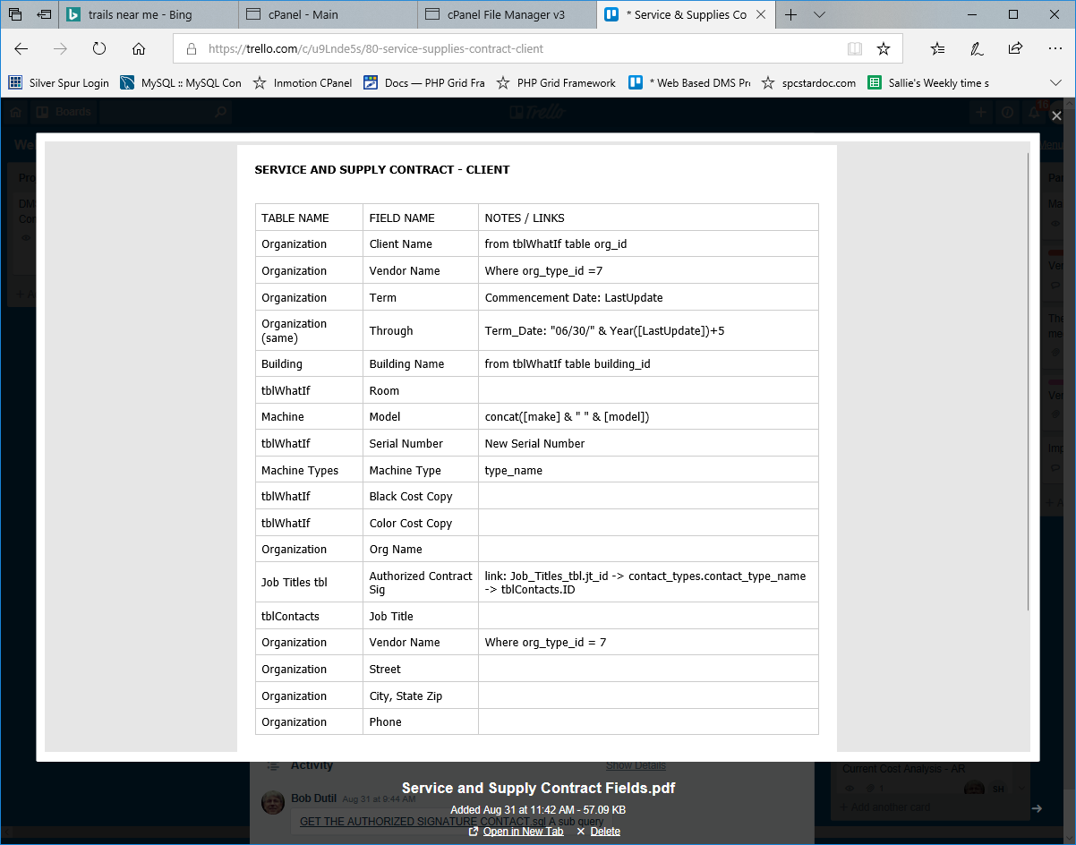
#GET THE AUTHORIZED SIGNATURE CONTACT

SELECT o.id
, c.ID AS ContactId
, c.[Job Title]
, c.[First Name]
, c.[Last Name]
, c.Notes
, o.org_name
, o.address
, [city] & ", " & [state] & " " & [zipcode] AS city_state_zip
, jt.jt_name

INTO FYER_Rpt_Client_Info_Auth_Contract_Sig

FROM ((organization o INNER JOIN tblContacts c ON o.id = c.org_id_contact)
LEFT JOIN contact_types_sp ct ON c.ID = ct.contact_id)
LEFT JOIN Job_Titles_tbl jt ON ct.contact_type_name = jt.jt_id
WHERE o.id= org_id
AND jt.jt_id=3;
