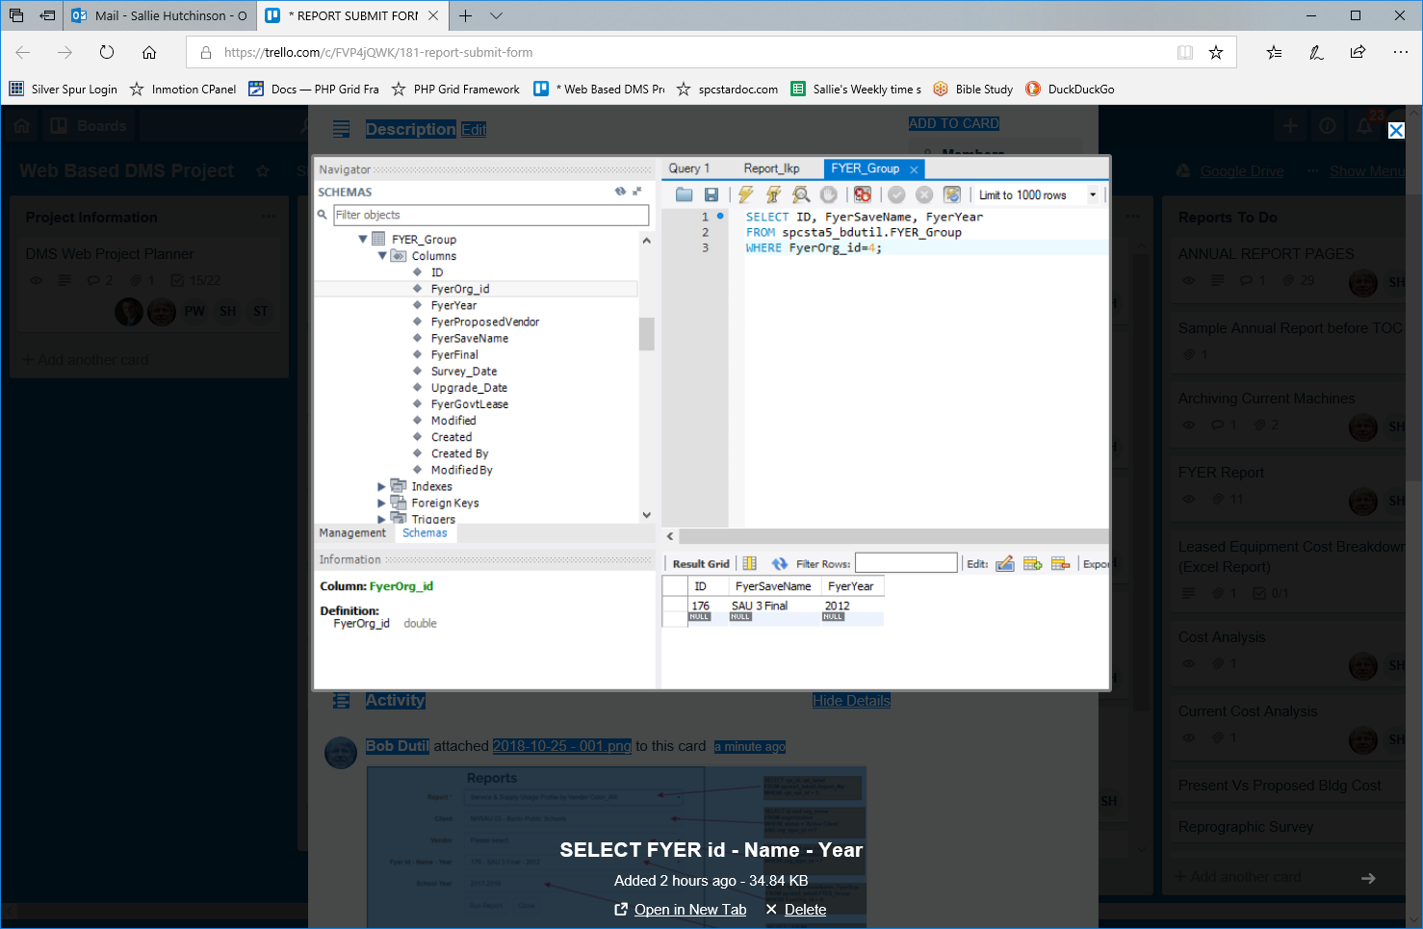
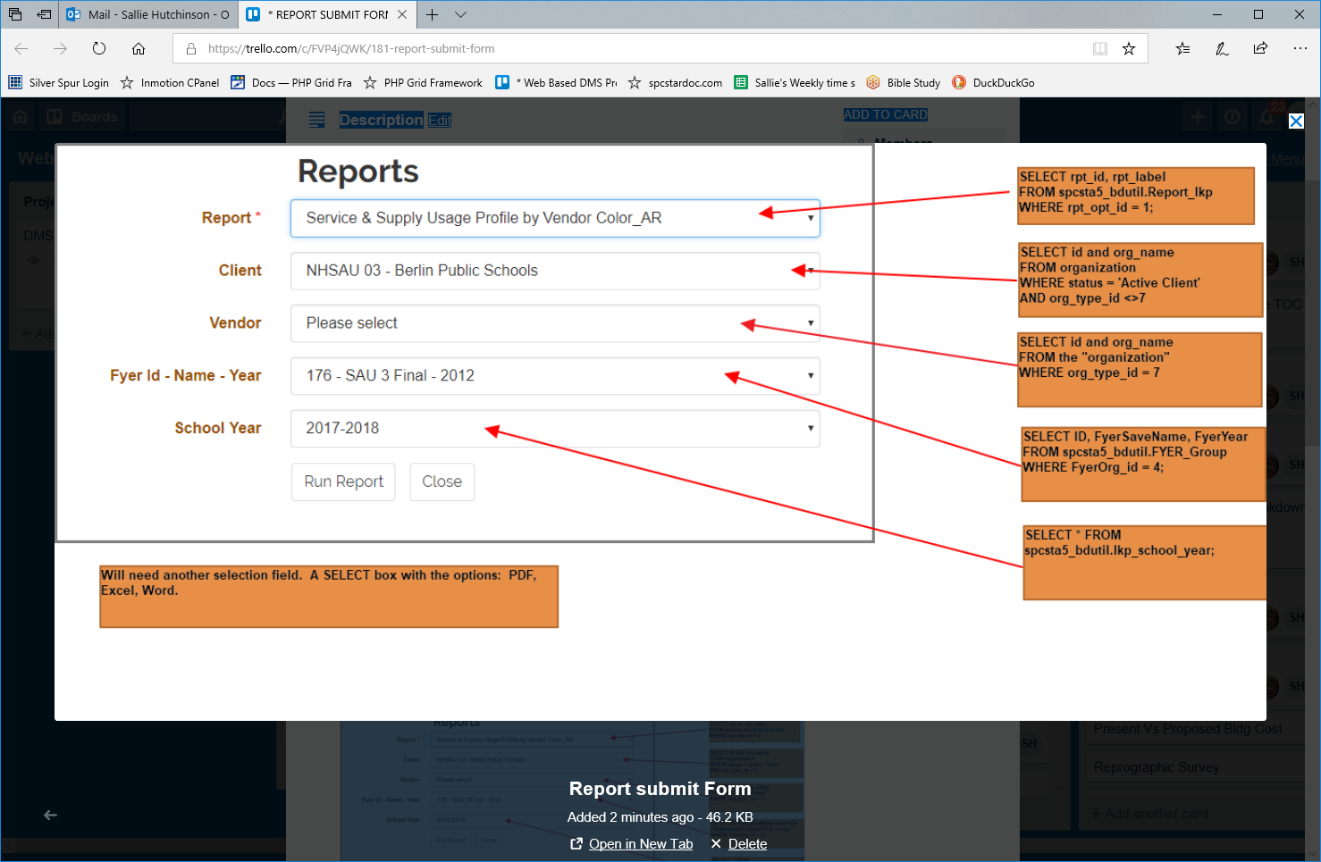
Pseudo
Report
- List ALL reports - keep same list. This will not be changed because of any selections that are made.
- When a report is selected
  - gray out any fields that are not needed for criteria to run the report.
School Year
- List ALL school years - keep same list. This will not be changed because of any selections that are made
Vendor
- List ALL vendors when page loads
Client
- List All clients when page loads
- If a client is selected
  - get only the vendors assoc with that client
  - get only Fyer names assoc with that client, If fyer names is not grayed out
Fyer Id
- List NONE or ALL when page loads - which should it be Bob?
- If an fyer id is selected
  - Select the client that is assoc with the selected fyer
