proj_equip_costs_bldg
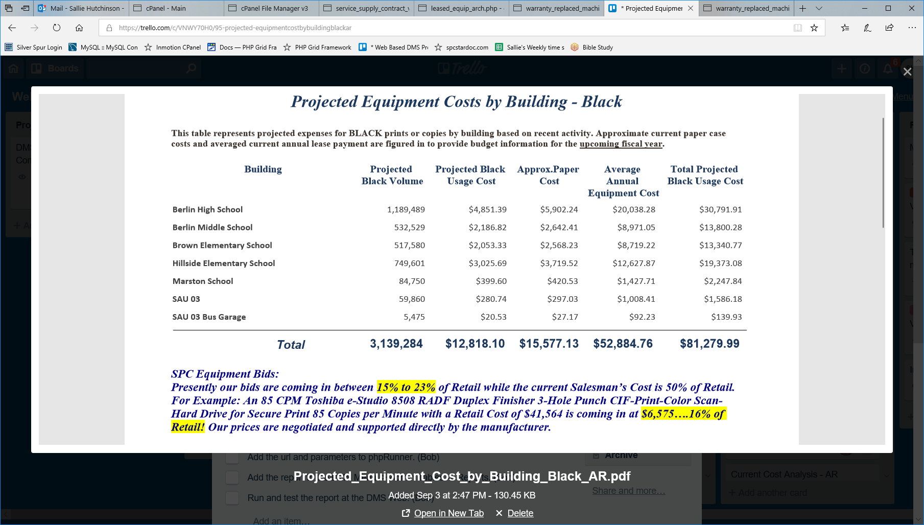

Projected_Equipment_Cost_by_Building_Black
SELECT ma.building_id_ma , b.building_name , Sum(ma.End‐ma.Begin) `Projected Volume , Sum((ma.End‐ma.Begin)*ma.NewCostCopy) `Usage Cost` , ma.`Projected Volume`*24.81/5000 `Paper Cost` , Sum((ma.government_lease/`Client Total Black Volume`)*(ma.End‐ma.Begin)) `Equipment Cost` , (`Usage Cost`+`Paper Cost`+`Equipment Cost`) `Total Cost` , ma.school_year , ma.org_id_ma
FROM Machine_Archive ma LEFT JOIN organization o ON ma.org_id_ma = o.id) LEFT JOIN buildings b ON ma.building_id_ma = b.id) LEFT JOIN department d ON ma.dept_id_ma = d.id) WHERE ma.school_year="$schYear" AND ma.org_id_ma="$org_id";
NOTE Client Total Black Volume: Sum([End]‐[Begin]) #The total volume of all machines for a client.

