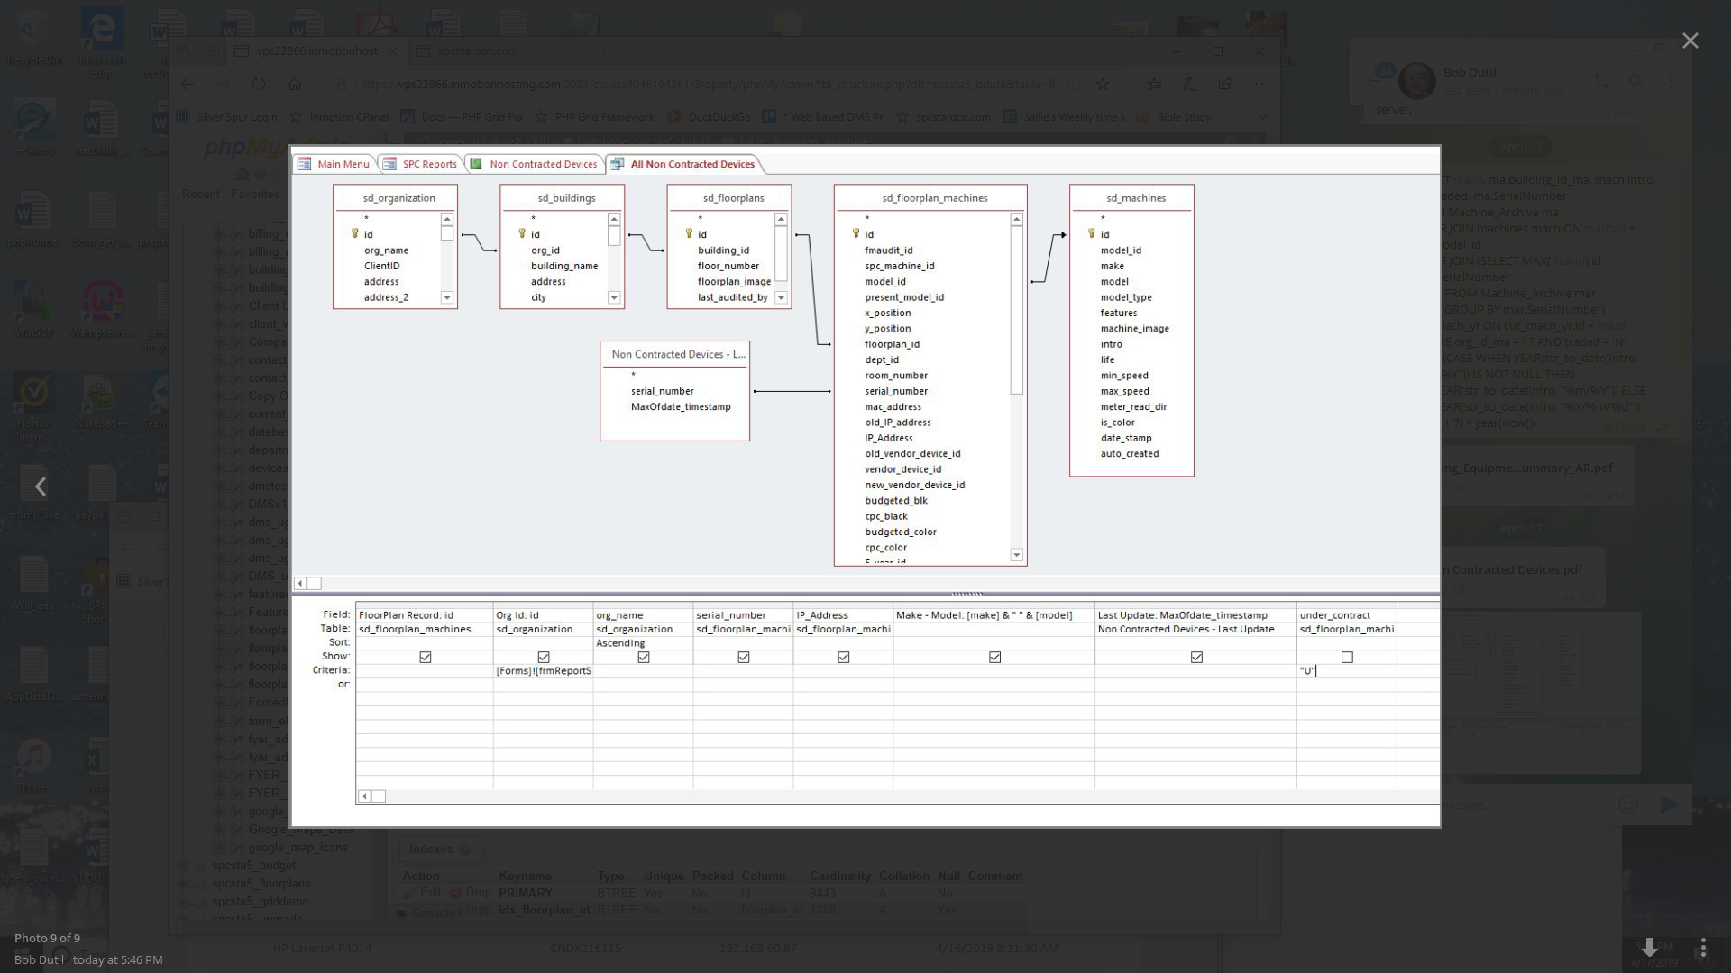

SELECT DISTINCT floorplan_machines.id FloorPlanRecord,
organization.id org_id,
organization.org_name,
floorplan_machines.serial_number,
floorplan_machines.IP_Address,
make|| " " & [model] AS [Make - Model]
, [Non Contracted Devices - Last Update].MaxOfdate_timestamp AS [Last Update]
FROM ((sd_floorplan_machines INNER JOIN (sd_floorplans INNER JOIN (sd_buildings INNER JOIN sd_organization ON sd_buildings.org_id = sd_organization.id) ON sd_floorplans.building_id = sd_buildings.id) ON sd_floorplan_machines.floorplan_id = sd_floorplans.id) LEFT JOIN sd_machines ON sd_floorplan_machines.model_id = sd_machines.id) INNER JOIN [Non Contracted Devices - Last Update] ON sd_floorplan_machines.serial_number = [Non Contracted Devices - Last Update].serial_number
WHERE (((sd_organization.id)=[Forms]![frmReportSavedTbls]![cmbClient]) AND ((sd_floorplan_machines.under_contract)="U"))
ORDER BY sd_organization.org_name;

SELECT DISTINCT sd_floorplan_machines.id AS [FloorPlan Record]
, sd_organization.id AS [Org Id]
, sd_organization.org_name
, sd_floorplan_machines.serial_number
, sd_floorplan_machines.IP_Address
, [make] & " " & [model] AS [Make - Model]
, [Non Contracted Devices - Last Update].MaxOfdate_timestamp AS [Last Update]
FROM ((sd_floorplan_machines INNER JOIN (sd_floorplans INNER JOIN (sd_buildings INNER JOIN sd_organization ON sd_buildings.org_id = sd_organization.id) ON sd_floorplans.building_id = sd_buildings.id) ON sd_floorplan_machines.floorplan_id = sd_floorplans.id) LEFT JOIN sd_machines ON sd_floorplan_machines.model_id = sd_machines.id) INNER JOIN [Non Contracted Devices - Last Update] ON sd_floorplan_machines.serial_number = [Non Contracted Devices - Last Update].serial_number
WHERE (((sd_organization.id)=[Forms]![frmReportSavedTbls]![cmbClient]) AND ((sd_floorplan_machines.under_contract)="U"))
ORDER BY sd_organization.org_name;

