Section 3
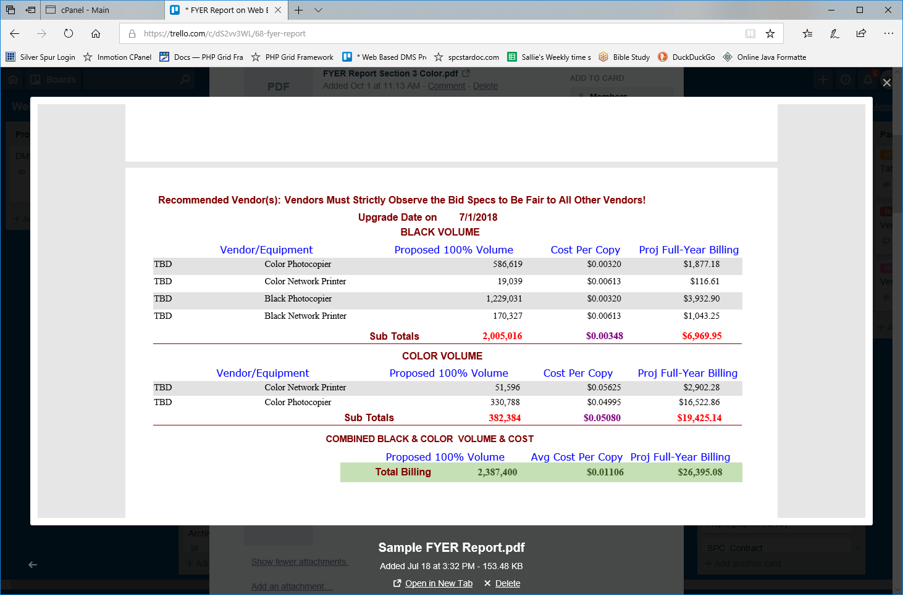
Section 2
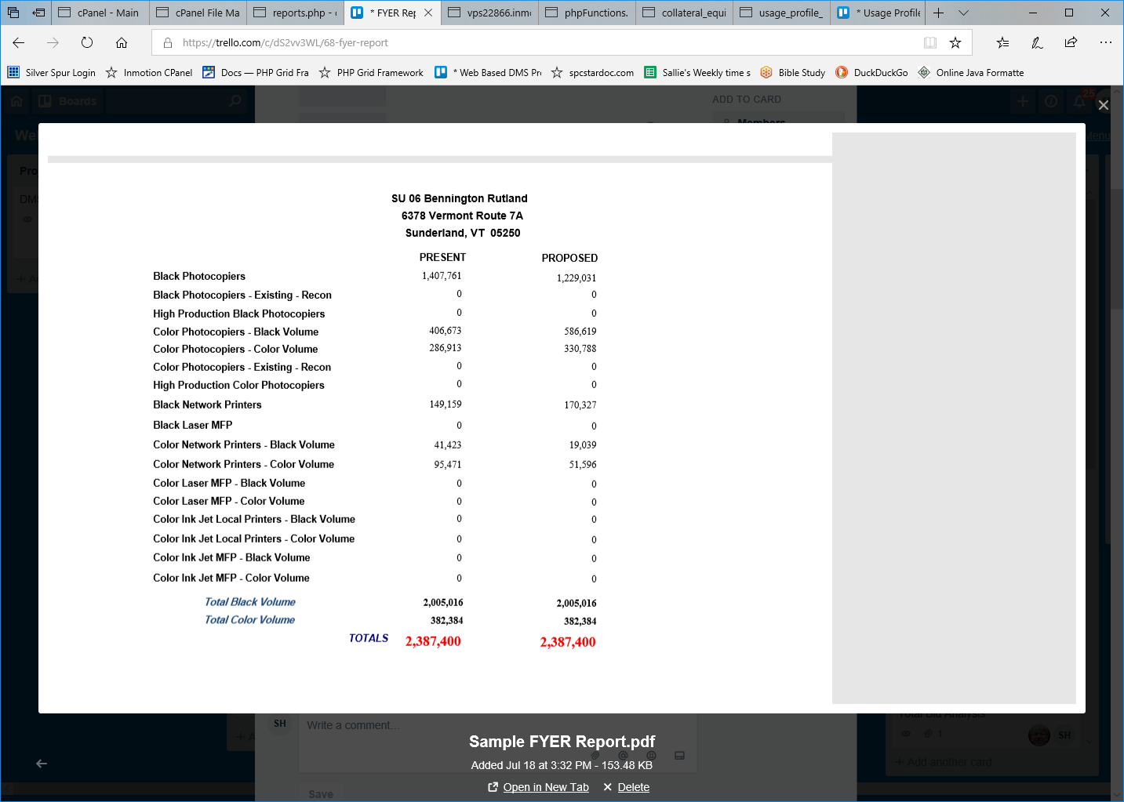
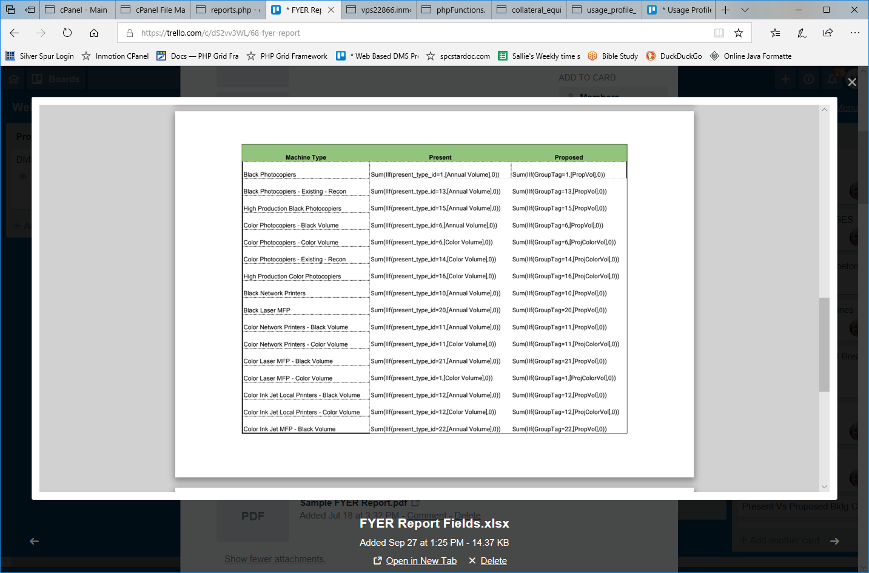
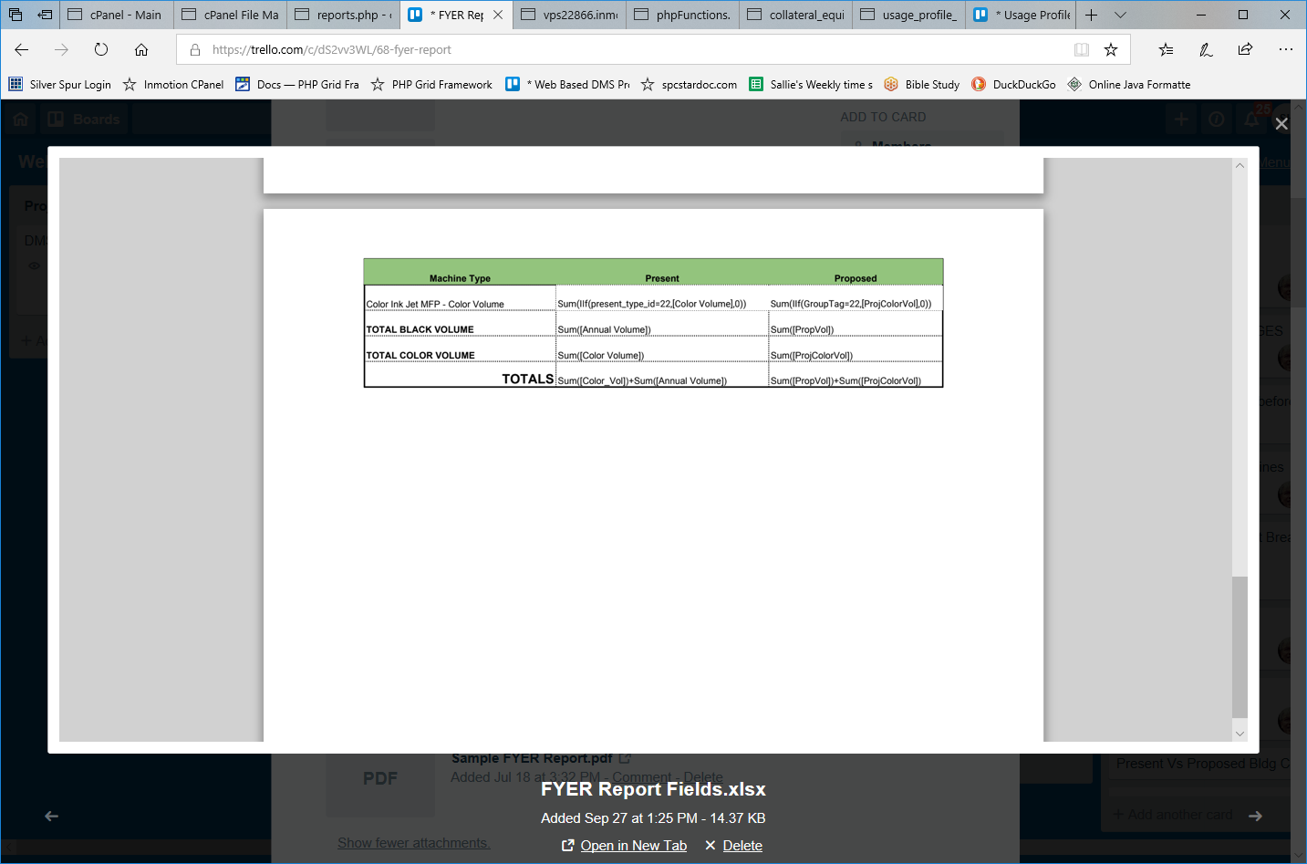
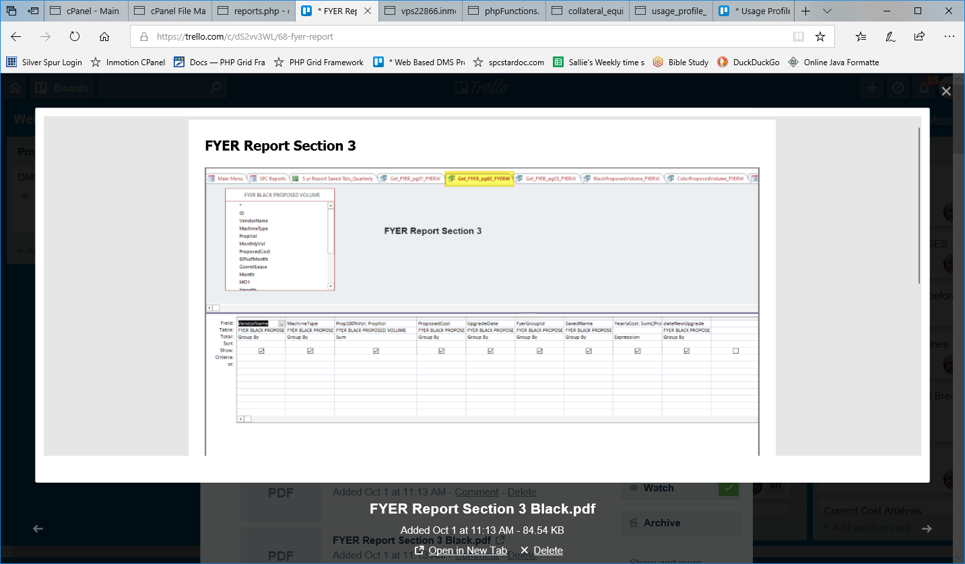
SELECT [FYER BLACK PROPOSED VOLUME].VendorName ,
[FYER BLACK PROPOSED VOLUME].MachineType ,
Sum([FYER BLACK PROPOSED VOLUME].PropVol) AS [Prop100%Vol] ,
[FYER BLACK PROPOSED VOLUME].ProposedCost ,
[FYER BLACK PROPOSED VOLUME].UpgradeDate ,
[FYER BLACK PROPOSED VOLUME].FyerGroupId ,
[FYER BLACK PROPOSED VOLUME].SavedName ,
Sum([PropVol]*[ProposedCost]) AS YearlyCost ,
[FYER BLACK PROPOSED VOLUME].dateNewUpgrade

#INTO FYER_Report_pg02_black
FROM [FYER BLACK PROPOSED VOLUME]
GROUP BY [FYER BLACK PROPOSED VOLUME].VendorName , [FYER BLACK PROPOSED VOLUME].MachineType , [FYER BLACK PROPOSED VOLUME].ProposedCost , [FYER BLACK PROPOSED VOLUME].UpgradeDate , [FYER BLACK PROPOSED VOLUME].FyerGroupId , [FYER BLACK PROPOSED VOLUME].SavedName , [FYER BLACK PROPOSED VOLUME].dateNewUpgrade;

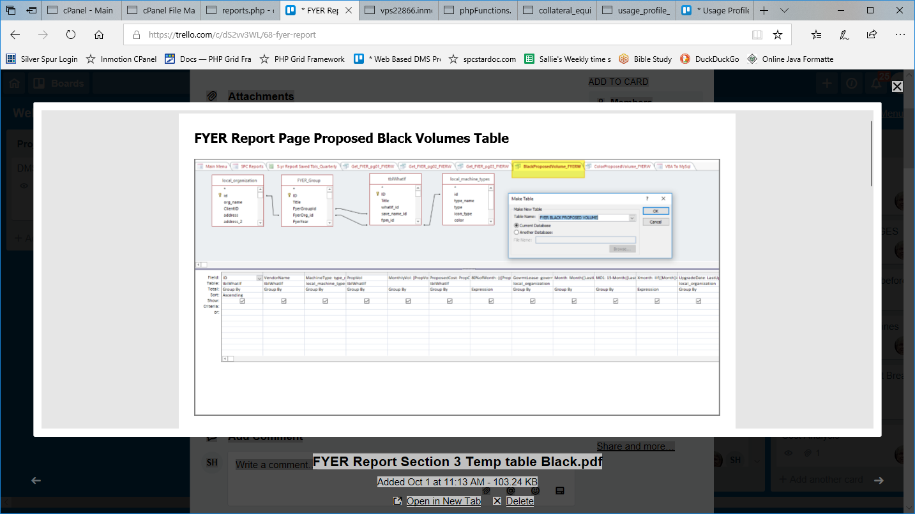
SELECT tblWhatIf.ID ,
tblWhatIf.VendorName ,
local_machine_types.type_name AS MachineType ,
tblWhatIf.PropVol ,
[PropVol]/12 AS MonthlyVol ,
tblWhatIf.PropCost AS ProposedCost ,
(([PropVol]*[PropCost])/12)*[XMonth] AS [80%ofMonth] ,
local_organization.government_lease AS GovrmtLease ,
Month([LastUpdate]) AS [Month] , 13-Month([LastUpdate]) AS MO1 ,
IIf([Month]>8 ,[MO1]+6 ,IIf([Month]<7 ,[MO1]-6 ,10)) AS Xmonth ,
local_organization.LastUpdate AS UpgradeDate ,
fg.FyerYear AS [Year] ,
IIf([Color]=1 ,"C" ,"B") AS BC ,
fg.FyerSavename AS SavedName ,
fg.FyerGroupId ,
fg.FyerFinal
#INTO [FYER BLACK PROPOSED VOLUME]
FROM local_organization
INNER JOIN ((tblWhatIf INNER JOIN local_machine_types ON tblWhatIf.GroupTag = local_machine_types.id)
INNER JOIN FYER_Group fg ON tblWhatIf.org_id = fg.FyerOrg_id
AND (tblWhatIf.save_name_id = FYER_Group.FyerGroupId)) ON local_organization.id = FYER_Group.FyerOrg_id
GROUP BY tblWhatIf.ID , tblWhatIf.VendorName , local_machine_types.type_name , tblWhatIf.PropVol , [PropVol]/12 , tblWhatIf.PropCost , local_organization.government_lease , Month([LastUpdate]) , 13-Month([LastUpdate]) , local_organization.LastUpdate , FYER_Group.FyerYear , IIf([Color]=1 ,"C" ,"B") , FYER_Group.FyerSavename , FYER_Group.FyerGroupId , FYER_Group.FyerFinal HAVING (((FYER_Group.FyerGroupId)=[Forms]![frmWhatIf_Main]![frmWhatIf_subfrm].[Form]! [save_name_id])) ORDER BY tblWhatIf.ID;
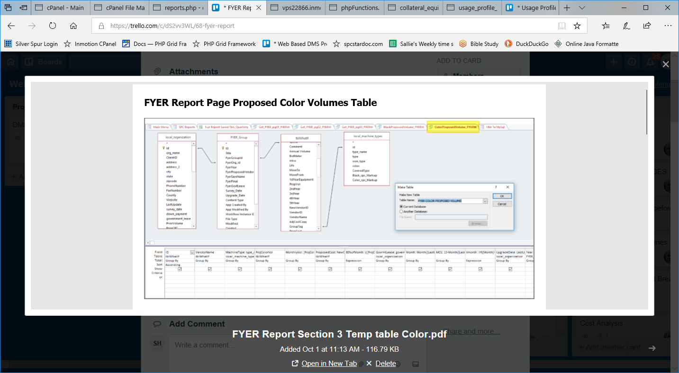
SELECT tblWhatIf.ID , tblWhatIf.VendorName , local_machine_types.type_name AS MachineType , tblWhatIf.ProjColorVol , [ProjColorVol]/12 AS MonthlyVol , tblWhatIf.NewColorCPC AS ProposedCost , (([ProjColorVol]*[NewColorCPC])/12)*[XMonth] AS [80%ofMonth] , local_organization.government_lease AS GovrmtLease , Month([LastUpdate]) AS [Month] , 13-Month([LastUpdate]) AS MO1 , IIf([Month]>8 ,[MO1]+6 ,IIf([Month]<7 ,[MO1]-6 ,10)) AS Xmonth , local_organization.LastUpdate AS UpgradeDate , FYER_Group.FyerYear AS [Year] , local_machine_types.color AS BC , FYER_Group.FyerSavename AS SavedName , FYER_Group.FyerGroupId , FYER_Group.FyerFinal
INTO [FYER COLOR PROPOSED VOLUME] FROM local_organization INNER JOIN ((tblWhatIf INNER JOIN local_machine_types ON tblWhatIf.GroupTag = local_machine_types.id) INNER JOIN FYER_Group ON tblWhatIf.save_name_id = FYER_Group.FyerGroupId) ON local_organization.id = FYER_Group.FyerOrg_id GROUP BY tblWhatIf.ID
, tblWhatIf.VendorName , local_machine_types.type_name , tblWhatIf.ProjColorVol , [ProjColorVol]/12 , tblWhatIf.NewColorCPC , local_organization.government_lease , Month([LastUpdate]) , 13-Month([LastUpdate]) , local_organization.LastUpdate , FYER_Group.FyerYear , local_machine_types.color , FYER_Group.FyerSavename , FYER_Group.FyerGroupId , FYER_Group.FyerFinal HAVING (((local_machine_types.color)<>0) AND ((FYER_Group.FyerGroupId)=[Forms]![frmWhatIf_Main]! [frmWhatIf_subfrm].[Form]![save_name_id])) ORDER BY tblWhatIf.ID;
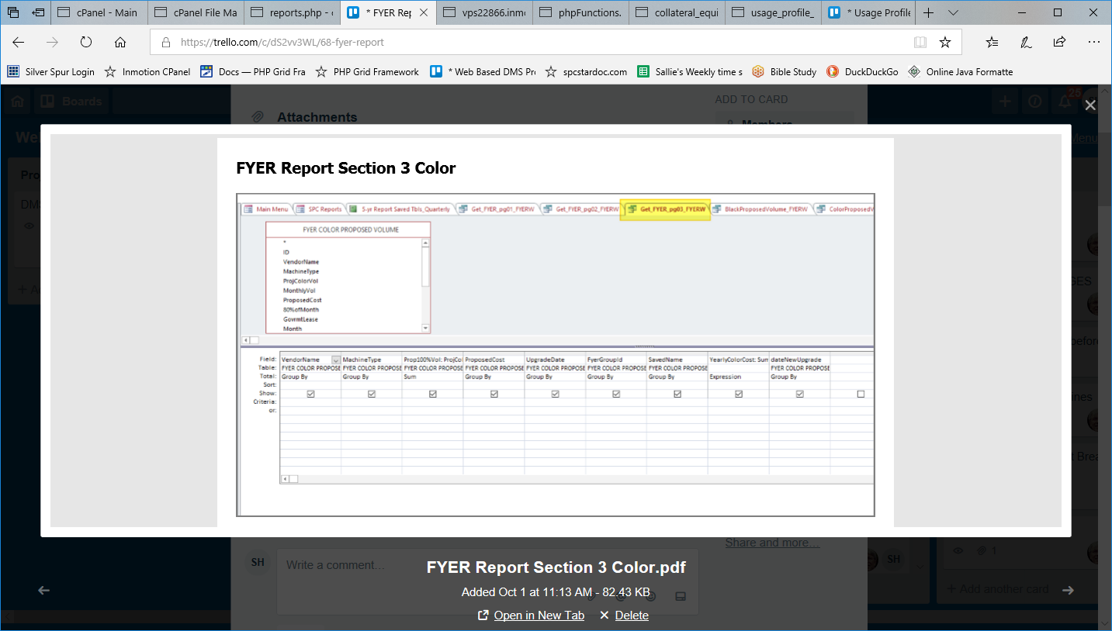
SELECT [FYER COLOR PROPOSED VOLUME].VendorName ,
[FYER COLOR PROPOSED VOLUME].MachineType ,
Sum([FYER COLOR PROPOSED VOLUME].ProColorVol) AS [Prop100%Vol] ,
[FYER COLOR PROPOSED VOLUME].ProposedCost ,
[FYER COLOR PROPOSED VOLUME].UpgradeDate ,
[FYER COLOR PROPOSED VOLUME].FyerGroupId ,
[FYER COLOR PROPOSED VOLUME].SavedName ,
Sum([ProColorVol]*[ProposedCost]) AS YearlyColorCost ,
[FYER COLOR PROPOSED VOLUME].dateNewUpgrade

#INTO FYER_Report_pg0_color
FROM [FYER COLOR PROPOSED VOLUME]
GROUP BY [FYER COLOR PROPOSED VOLUME].VendorName , [FYER COLOR PROPOSED VOLUME].MachineType , [FYER COLOR PROPOSED VOLUME].ProposedCost , [FYER COLOR PROPOSED VOLUME].UpgradeDate , [FYER COLOR PROPOSED VOLUME].FyerGroupId , [FYER COLOR PROPOSED VOLUME].SavedName , [FYER COLOR PROPOSED VOLUME].dateNewUpgrade;

See Trello for Section 2 Compare Volumes.pdf. It was rotated sideways, so not printable.

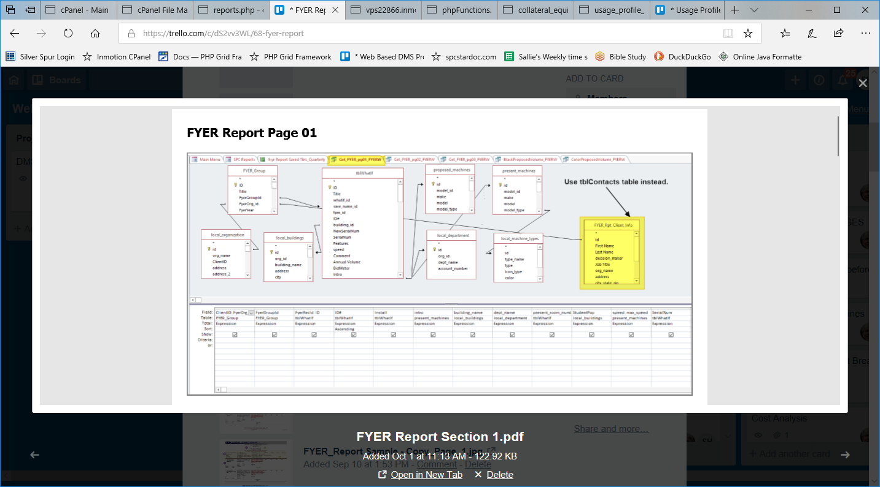
SELECT DISTINCT FYER_Group.FyerOrg_id AS ClientID , FYER_Group.FyerGroupId , tblWhatIf.ID AS FyerRecId , tblWhatIf.[ID#] , tblWhatIf.Install , present_machines.intro , local_buildings.building_name , local_department.dept_name , tblWhatIf.present_room_number , local_buildings.StudentPop , present_machines.max_speed AS speed , tblWhatIf.SerialNum , tblWhatIf.Features , tblWhatIf.present_type_id , tblWhatIf.proposed_model_id , tblWhatIf.[Annual Volume] , local_organization.LastUpdate AS BidDate , tblWhatIf.BidMeter , present_machines.life , tblWhatIf.MoveTo , tblWhatIf.MoveFrom , tblWhatIf.[1stYearEquipment] , tblWhatIf.PropVol , tblWhatIf.[2ndYear] , tblWhatIf.[3rdYear] , tblWhatIf.[4thYear] , tblWhatIf.[5thYear] , tblWhatIf.VendorName , FYER_Group.FyerProposedVendor
, tblWhatIf.AdjCostCopy , tblWhatIf.PropCost , local_buildings.BldgEquipCost , tblWhatIf.[S&&S] , tblWhatIf.PropVol AS [Prop100%Vol] , [PropVol]/10 AS MonthlyVol , [PropVol]*[PropCost] AS [100%BillingMo] , ([PropVol]*[PropCost])*0.8 AS [80%Billing12Mo] , (([PropVol]*[PropCost])*0.8)/10 AS [80%ofMo] , local_organization.Equip AS AnnualCost , local_organization.LastUpdate AS UpgradeDate , FYER_Group.FyerSaveName AS SavedName , tblWhatIf.NewSerialNum , tblWhatIf.NewVendorID , tblWhatIf.VerDate , FYER_Group.FyerYear AS [Year] , tblWhatIf.present_type_id AS CPCType , tblWhatIf.Color_Vol , tblWhatIf.Color_CPC , [Color_Vol]*[Color_CPC] AS ColorCost , tblWhatIf.NewColorCPC , tblWhatIf.ProjColorVol , tblWhatIf.IP_Address , tblWhatIf.old_IP_Address , tblWhatIf.Special_Notes , proposed_machines.life AS prop_life , proposed_machines.intro AS prop_intro , tblWhatIf.mac_address , tblWhatIf.map_id , tblWhatIf.present_model_id , tblWhatIf.under_contract , tblWhatIf.present_floorplan_id , tblWhatIf.proposed_floorplan_id , local_machine_types.id , local_machine_types.type_name , [present_machines]![make] & " " & [present_machines]![model] AS [Present Model] , tblWhatIf.GroupTag , present_machines.is_color AS Color , FYER_Group.FyerGovtLease AS GovrmtLease , FYER_Rpt_Client_Info.org_name AS ClientName , [First Name] & " " & [Last name] AS Contact , FYER_Rpt_Client_Info.address , FYER_Rpt_Client_Info.city_state_zip , local_organization.survey_date INTO FYER_Report_pg01 FROM (((((((FYER_Group LEFT JOIN tblWhatIf ON FYER_Group.FyerGroupId = tblWhatIf.save_name_id) LEFT JOIN local_machines AS proposed_machines ON tblWhatIf.proposed_model_id = proposed_machines.id) LEFT JOIN local_machines AS present_machines ON tblWhatIf.present_model_id = present_machines.id) INNER JOIN local_organization ON FYER_Group.FyerOrg_id = local_organization.id) LEFT JOIN local_buildings ON tblWhatIf.building_id = local_buildings.id)
LEFT JOIN local_machine_types ON present_machines.model_type = local_machine_types.id) INNER JOIN FYER_Rpt_Client_Info ON FYER_Group.FyerOrg_id = FYER_Rpt_Client_Info.id) LEFT JOIN local_department ON tblWhatIf.dept_id = local_department.id WHERE (((FYER_Group.FyerGroupId)=[Forms]![frmWhatIf_Main]![frmWhatIf_subfrm].[Form]! [save_name_id])) ORDER BY tblWhatIf.[ID#];

