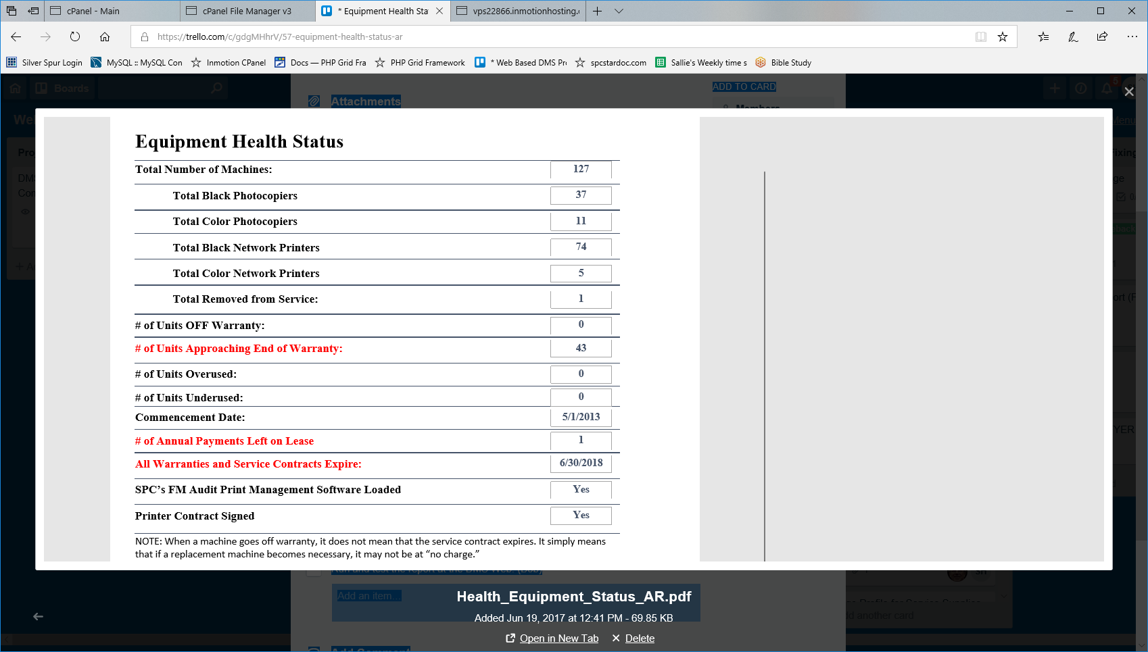

AR_Basic_Connections SELECT sd_floorplan_machines.present_local_connection , sd_floorplan_machines.serial_number , sd_floorplan_machines.under_contract FROM sd_floorplan_machines WHERE (((sd_floorplan_machines.serial_number) Is Not Null));
AR_Basic_Data_tempTable
SELECT organization.org_name,
Machine_Archive.building_id_ma,
buildings.building_name,
Machine_Archive.room_name,
Machine_Archive.dept_id_ma,
department.dept_name,
Machine_Archive.VendorMachID,
Machine_Archive.vendor_id_ma,
Vendors.VendorName,
machines.make,
machines.id AS [Model ID],
machines.model,
machine_types.id AS [Model Type Id],
machines.intro, #14th col
machine_types.type_name , machine_types.color , Machine_Archive.ID AS [Archive Record ID] , Machine_Archive.SerialNumber , Machine_Archive.Anticipated , Machine_Archive.Condition , Machine_Archive.Traded , organization.EndContractDate , Machine_Archive.EndServiceYear , Machine_Archive.CostCopy , Machine_Archive.NewCostCopy , Machine_Archive.BDate,
Machine_Archive.Begin , Machine_Archive.EDate , Machine_Archive.End,
Machine_Archive.MstrBegin , Machine_Archive.MstrEnd,
Machine_Archive.Mstrcpc , Machine_Archive.NewColorCPC,
Machine_Archive.ProjColorVol , Machine_Archive.BidDate,
Machine_Archive.BidMeter , Machine_Archive.CopyQlty,
Machine_Archive.Reliability , Machine_Archive.Service,
Machine_Archive.Comments , Machine_Archive.lease,
Machine_Archive.ContractExpDate , Machine_Archive.Ouside_Lease,
organization.lease_company , organization.lease_end_date,
Machine_Archive.Storage , Machine_Archive.Black_Vendor_cpc,
Machine_Archive.Color_Vendor_cpc , Machine_Archive.New_Blk_Ven_cpc , Machine_Archive.New_Color_Ven_cpc , organization.LastUpdate, organization.survey_date,
organization.PriorVolume, organization.PriorCPC,
organization.AvgCPC , organization.Equip, organization.government_lease , organization.down_payment , organization.ClientSince, organization.term,
organization.PrintMgmtSoftwareInstalled, organization.LENPContractSigned,
[End]-[begin] AS machine_black_volume, [mstrend]-[mstrbegin] AS machine_color_volume,
([end]-[begin])*[CostCopy] AS black_machine_cost,
([MstrEnd]-[MstrBegin])*[Mstrcpc] AS Color_Machine_Cost, ([end]-[begin])*[NewCostCopy] AS projected_black_machine_cost , ([MstrEnd]-[MstrBegin])*[NewColorCPC] AS Projected_Color_Machine_Cost , Machine_Archive.school_year , Machine_Archive.org_id_ma , Machine_Archive.txtReplacedMachine , buildings.BldgEquipCost ,
buildings.StudentPop , machines.life , machines.max_speed AS speed ,
AR_Basic_Connections.present_connection

INTO AR_Basic_Data_tempTable
FROM (((((Machine_Archive LEFT JOIN organization ON Machine_Archive.org_id_ma = organization.id) LEFT JOIN buildings ON Machine_Archive.building_id_ma = buildings.id) LEFT JOIN department ON Machine_Archive.dept_id_ma = department.id) LEFT JOIN Vendors ON Machine_Archive.vendor_id_ma = Vendors.[VendorID#]) LEFT JOIN (machines LEFT JOIN machine_types ON machines.model_type = machine_types.id) ON Machine_Archive.model_id = machines.id) LEFT JOIN AR_Basic_Connections ON Machine_Archive.SerialNumber = AR_Basic_Connections.serial_number
WHERE (((Machine_Archive.school_year)=[Forms]![frmReportSavedTbls]![cboSchoolYear]) AND ((Machine_Archive.org_id_ma)=[Forms]![frmReportSavedTbls]![txtOrgId]));

AR Equipment Health Status mktbl - Access Qry:
AR_Basic_Data qry
SELECT AR_Basic_Data_tempTable.[Model Type Id] AS [Machine Type ID],
AR_Basic_Data_tempTable.SerialNumber , AR_Basic_Data_tempTable.school_year,
AR_Basic_Data_tempTable.type_name , AR_Basic_Data_tempTable.intro,
AR_Basic_Data_tempTable.Traded,
DateDiff("yyyy",[AR_Basic_Data_tempTable].[intro], Now()) AS Years_Old,
IIf([Years_Old]>=10,1,0) AS OW , IIf([Years_Old]<10 And [Years_Old]>=7,1,0) AS AUW,
IIf([Model Type Id]=10 Or [Model Type Id]=11,1,0) AS TotalLENP,
IIf([LENPContractSigned]=True,"Yes","No") AS under_contract, IIf([AR_Basic_Data_tempTable]![present_local_connection]="N",0,1) AS local_connection, AR_Basic_Data_tempTable.LastUpdate AS [Commencement Date],
CDate("8/1/" & DatePart("yyyy",[LastUpdate])+5) AS lease_end_date,
DatePart("yyyy",[lease_end_date])-DatePart("yyyy",Now()) AS [Lease Payment Left] , IIf([PrintMgmtSoftwareInstalled]=True,"Yes","No") AS [PMS Loaded],
IIf([LENPContractSigned]=-1,"Yes","No") AS [LENP Signed],
AR_Basic_Data_tempTable.org_id_ma, AR_Basic_Data_tempTable.EndContractDate, AR_Basic_Data_tempTable.lease_company,
DateDiff("yyyy",Now(),[EndContractDate]) AS AEWYr

INTO [Equipment Health Status]
FROM AR_Basic_Data_tempTable
WHERE (((AR_Basic_Data_tempTable.school_year)=[Forms]![frmReportSavedTbls]! [cboSchoolYear])
AND ((AR_Basic_Data_tempTable.org_id_ma)=[Forms]![frmReportSavedTbls]![cmbClient]));

Equipment Health Status Totals_tbl
INSERT INTO [Equipment Health Status Totals_tbl] ( [Black Photo Copier] , [Color Photo Copier] , [Black Network Printers] , [Color Network Printers] , [Low End Network Printers],
[Traded Machines] , TotalMachines , [Off Warranty] , [Approaching End Warranty] , Overused , Underused , [Total LENP] , Contract , [Local Connection] , [Commencement Date] , [Lease Payment Left] , [PMS Loaded] , lease_end_date , [LENP Signed] , org_id_ma , EndContractDate , lease_company )
SELECT Sum(IIf([Machine Type ID]=1 Or [Machine Type ID]=15 Or [Machine Type ID]=20,1,0)) AS [Black Photo Copier] , Sum(IIf([Machine Type ID]=6 Or [Machine Type ID]=16 Or [Machine Type ID]=21 Or [Machine Type ID]=22,1,0)) AS [Color Photo Copier] , Sum(IIf([Machine Type ID]=10,1,0)) AS [Black Network Printers] , Sum(IIf([Machine Type ID]=11,1,0)) AS [Color Network Printers] , [Black Network Printers]+[Color Network Printers] AS [Low End Network Printers] , Sum(IIf([Traded]="Y",1,0)) AS [Traded Machines] , Count([Equipment Health Status].org_id_ma) AS TotalMachines , Sum([Equipment Health Status].OW) AS [Off Warranty] , Sum([Equipment Health Status].AUW) AS [Approaching End Warranty] , 0 AS Overused , 0 AS Underused , Sum([Equipment Health Status].TotalLENP) AS [Total LENP] , Sum(IIf([under_contract]="Y",1,0)) AS Contract , Sum([Equipment Health Status].local_connection) AS [Local Connection] , [Equipment Health Status].[Commencement Date] , [Equipment Health Status].[Lease Payment Left] , [Equipment Health Status].[PMS Loaded] , [Equipment Health Status].lease_end_date , [Equipment Health Status].[LENP Signed] , [Equipment Health Status].org_id_ma , [Equipment Health Status].EndContractDate , [Equipment Health Status].lease_company
FROM [Equipment Health Status]
GROUP BY 0 , [Equipment Health Status].[Commencement Date] , [Equipment Health Status].[Lease Payment Left] , [Equipment Health Status].[PMS Loaded] , [Equipment Health Status].lease_end_date , [Equipment Health Status].[LENP Signed] , [Equipment Health Status].org_id_ma , [Equipment Health Status].EndContractDate
, [Equipment Health Status].lease_company;

SELECT AR_Basic_Data_tempTable.[Model Type Id] AS [Machine Type ID] , AR_Basic_Data_tempTable.SerialNumber , AR_Basic_Data_tempTable.school_year , AR_Basic_Data_tempTable.type_name , AR_Basic_Data_tempTable.intro , AR_Basic_Data_tempTable.Traded , DateDiff("yyyy" ,[AR_Basic_Data_tempTable].[intro] ,Now()) AS Years_Old , IIf([Years_Old]>=10,1,0) AS OW , IIf([Years_Old]<10 And [Years_Old]>=7,1,0) AS AUW , IIf([Model Type Id]=10 Or [Model Type Id]=11,1,0) AS TotalLENP , IIf([LENPContractSigned]=True,"Yes","No") AS under_contract , IIf([AR_Basic_Data_tempTable]![present_local_connection]="N",0,1) AS local_connection , AR_Basic_Data_tempTable.LastUpdate AS [Commencement Date] , CDate("8/1/" & DatePart("yyyy",[LastUpdate])+5) AS lease_end_date , DatePart("yyyy",[lease_end_date])-DatePart("yyyy",Now()) AS [Lease Payment Left] , IIf([PrintMgmtSoftwareInstalled]=True,"Yes","No") AS [PMS Loaded],
IIf([LENPContractSigned]=-1,"Yes","No") AS [LENP Signed], AR_Basic_Data_tempTable.org_id_ma,
AR_Basic_Data_tempTable.EndContractDate, AR_Basic_Data_tempTable.lease_company, DateDiff("yyyy",Now(),[EndContractDate]) AS AEWYr

INTO [Equipment Health Status]
FROM AR_Basic_Data_tempTable
WHERE (((AR_Basic_Data_tempTable.school_year)=[Forms]![frmReportSavedTbls]![cboSchoolYear]) AND ((AR_Basic_Data_tempTable.org_id_ma)=[Forms]![frmReportSavedTbls]![cmbClient]));

OnPrint Event.txt
'Private Sub Report_Load() 'Me.Text65.Caption = "Dear , " & DLookup("[First Name]", "[FYER_Rpt_Client_Info]") & " Regards, Skip" 'End Sub ============================================================================================================== Private Sub Detail_Print(Cancel As Integer, PrintCount As Integer) 10 If Me.txtContractSigned = "No" Then 20 Me.lblContractSigned.ForeColor = vbRed 30 Else 40 Me.lblContractSigned.ForeColor = vbBlack 50 End If 60 If Me.txtFMAuditLoaded = "No" Then 70 Me.lblFMAuditLoaded.ForeColor = vbRed 80 Else 90 Me.lblFMAuditLoaded.ForeColor = vbBlack 100 End If 110 If Me.[Off Warranty] > 0 Then 120 Me.lblOffWarranty.ForeColor = vbRed 130 Else 140 Me.lblOffWarranty.ForeColor = vbBlack 150 End If 160 If Me.[Approaching End Warranty] > 0 Then 170 Me.lblApproachEOW.ForeColor = vbRed 180 Else 190 Me.lblApproachEOW.ForeColor = vbBlack 200 End If 210 If Me.[Lease Payment Left] < 2 Then 220 Me.lblNumPayLeft.ForeColor = vbRed 230 Else 240 Me.lblNumPayLeft.ForeColor = vbBlack 250 End If 260 If DateDiff("yyyy", Now(), Me.txtEndContractDate) < 2 Then 270 Me.lblContractExpireDate.ForeColor = vbRed Else: 280 Me.lblContractExpireDate.ForeColor = vbBlack 290 End If 300 If Me.txtOverused > 0 Then 310 Me.lblOverUsed.ForeColor = vbRed 320 Else 330 Me.lblOverUsed.ForeColor = vbBlack 340 End If 350 If Me.txtUnderUsed > 0 Then 360 Me.lblUnderUsed.ForeColor = vbRed 370 Else 380 Me.lblUnderUsed.ForeColor = vbBlack 390 End If 400 If Me.lease_company = "Cash Sale" Then 410 Me.lblNumPayLeft.Caption = "Five Year Straight Line Depreciation" 420 Else 430 Me.lblNumPayLeft.Caption = "# of Annual Payments Left on Lease" 440 End If End Sub
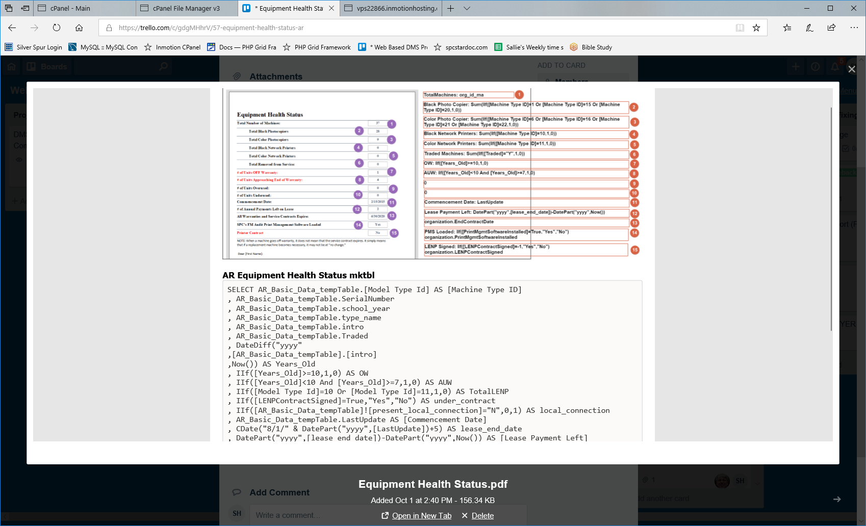
onPrint Event
'Private Sub Report_Load() 'Me.Text65.Caption = "Dear , " & DLookup("[First Name]", "[FYER_Rpt_Client_Info]") & " Regards, Skip" 'End Sub ============================================================================================================== Private Sub Detail_Print(Cancel As Integer, PrintCount As Integer) 10 If Me.txtContractSigned = "No" Then 20 Me.lblContractSigned.ForeColor = vbRed 30 Else 40 Me.lblContractSigned.ForeColor = vbBlack 50 End If 60 If Me.txtFMAuditLoaded = "No" Then 70 Me.lblFMAuditLoaded.ForeColor = vbRed 80 Else 90 Me.lblFMAuditLoaded.ForeColor = vbBlack 100 End If 110 If Me.[Off Warranty] > 0 Then 120 Me.lblOffWarranty.ForeColor = vbRed 130 Else 140 Me.lblOffWarranty.ForeColor = vbBlack 150 End If 160 If Me.[Approaching End Warranty] > 0 Then 170 Me.lblApproachEOW.ForeColor = vbRed 180 Else 190 Me.lblApproachEOW.ForeColor = vbBlack 200 End If 210 If Me.[Lease Payment Left] < 2 Then 220 Me.lblNumPayLeft.ForeColor = vbRed 230 Else 240 Me.lblNumPayLeft.ForeColor = vbBlack 250 End If 260 If DateDiff("yyyy", Now(), Me.txtEndContractDate) < 2 Then 270 Me.lblContractExpireDate.ForeColor = vbRed Else: 280 Me.lblContractExpireDate.ForeColor = vbBlack 290 End If 300 If Me.txtOverused > 0 Then 310 Me.lblOverUsed.ForeColor = vbRed 320 Else 330 Me.lblOverUsed.ForeColor = vbBlack 340 End If 350 If Me.txtUnderUsed > 0 Then 360 Me.lblUnderUsed.ForeColor = vbRed 370 Else 380 Me.lblUnderUsed.ForeColor = vbBlack 390 End If 400 If Me.lease_company = "Cash Sale" Then 410 Me.lblNumPayLeft.Caption = "Five Year Straight Line Depreciation" 420 Else 430 Me.lblNumPayLeft.Caption = "# of Annual Payments Left on Lease" 440 End If End Sub

