Cost comparison black
SELECT SUM(DistrictPop) FROM organization org #total = 84884 is correct
WHERE org.temp_inactive = 'N' AND org.org_type_id = 1
AND DistrictPop != 0 AND org.Status = 'Active Client'
GROUP BY org.org_type_id;

SELECT SUM(`End` - `Begin`), org.org_type_id # -422570535 is correct
FROM current_devices cd
INNER JOIN organization org ON org.id = cd.org_id_ma
WHERE org.temp_inactive = 'N' AND org.org_type_id = 1 AND org.Status = 'Active Client'
GROUP BY org.org_type_id;

Total District Cost Black Only: Total Black Cost (from billing - usage not reconciliation) + Annual Equipment Cost (lease amount) + Paper Cost (use formula [#total copies *27 / 5000] = $
Returns the correct amount of lease total for all districts
SELECT SUM(org.government_lease)
FROM organization org
WHERE org.temp_inactive = 'N' AND org.org_type_id = 1 AND org.Status = 'Active Client'
GROUP BY org.org_type_id;

Returns all pertinent data plus some for testing calculations
SELECT SUM(cd.`End` - cd.`Begin`) fy_vol, lease_pop.s_pop,
SUM((cd.`End` - cd.`Begin`) * cd.`CostCopy`), lease_pop.equip_cost,
(SUM((cd.`End` - cd.`Begin`) * cd.`CostCopy`) + SUM((cd.`End` - cd.`Begin`) * 27/5000) + lease_pop.equip_cost) tot_dist_cost,
SUM((cd.`End` - cd.`Begin`) * 27/5000)
FROM current_devices cd
INNER JOIN organization orgz ON orgz.id = cd.org_id_ma

INNER JOIN (SELECT SUM(org.government_lease) equip_cost, SUM(DistrictPop) s_pop, org.org_type_id
FROM organization org
WHERE org.temp_inactive = 'N' AND org.org_type_id = 1 AND org.Status = 'Active Client'
GROUP BY org.org_type_id) lease_pop ON lease_pop.org_type_id = orgz.org_type_id

WHERE orgz.temp_inactive = 'N' AND orgz.org_type_id = 1
AND orgz.Status = 'Active Client'
GROUP BY orgz.org_type_id;

Code from avg_student_to_copy_usage
(SUM((ma.End - ma.Begin) * ma.NewCostCopy)) + (SUM((End-Begin) * 24.81/5000)) +
(SUM((org.government_lease /(SELECT SUM(End-Begin) FROM Machine_Archive WHERE org_id_ma = ?
AND school_year = ? GROUP BY org_id_ma)) * (End-Begin))) tot_sch_cost

$annual_cost_per_student = $tot_sch_cost / $pop;

wip for augusta 5/28. Remove org_id for district totals
SELECT SUM((cd.`End` - cd.`Begin`) * cd.`CostCopy`) totCost, #95,391.316
SUM(cd.`End` - cd.`Begin`) fy_vol,
SUM((cd.`End` - cd.`Begin`) * 27/5000) paperCost,
org.government_lease,
SUM((cd.`End` - cd.`Begin`) * cd.`CostCopy`) + SUM((cd.`End` - cd.`Begin`) * 27/5000) + org.government_lease allCosts

#SUM(`End` - `Begin`) fy_vol
FROM current_devices cd
INNER JOIN organization org ON org.id = cd.org_id_ma
WHERE org.org_type_id = 1 AND org.Status = 'Active Client' AND org_id_ma = 17;
#GROUP BY org.org_type_id;

/*************************wip 5/1**********************/
SELECT SUM(End - Begin) anl_bk_vol,
SUM(MstrEnd - MstrBegin) anl_col_vol,

#SUM(End - Begin) / bldg.StudentPop blk_copy_per_student,
#SUM(MstrEnd - MstrBegin) / bldg.StudentPop col_copy_per_student,

(SUM((ma.End - ma.Begin) * ma.NewCostCopy)) + (SUM((End-Begin) * 27/5000)) +
(SUM((org.government_lease /(SELECT SUM(End-Begin)
FROM Machine_Archive
WHERE school_year = 19))
* (End - Begin))) tot_sch_cost,

(SUM((MstrEnd - MstrBegin) * ma.NewColorCPC)) col_tot_sch_cost

FROM Machine_Archive ma
INNER JOIN organization org ON org.id = ma.org_id_ma
WHERE org.org_type_id = 1 AND org.Status = 'Active Client'
# AND org.temp_inactive = 'N'
AND ma.school_year = 19;

SELECT (SUM((MstrEnd - MstrBegin) * ma.NewColorCPC)) col_tot_sch_cost
FROM Machine_Archive ma WHERE school_year = 17;
/*************************wip 5/1**********************/

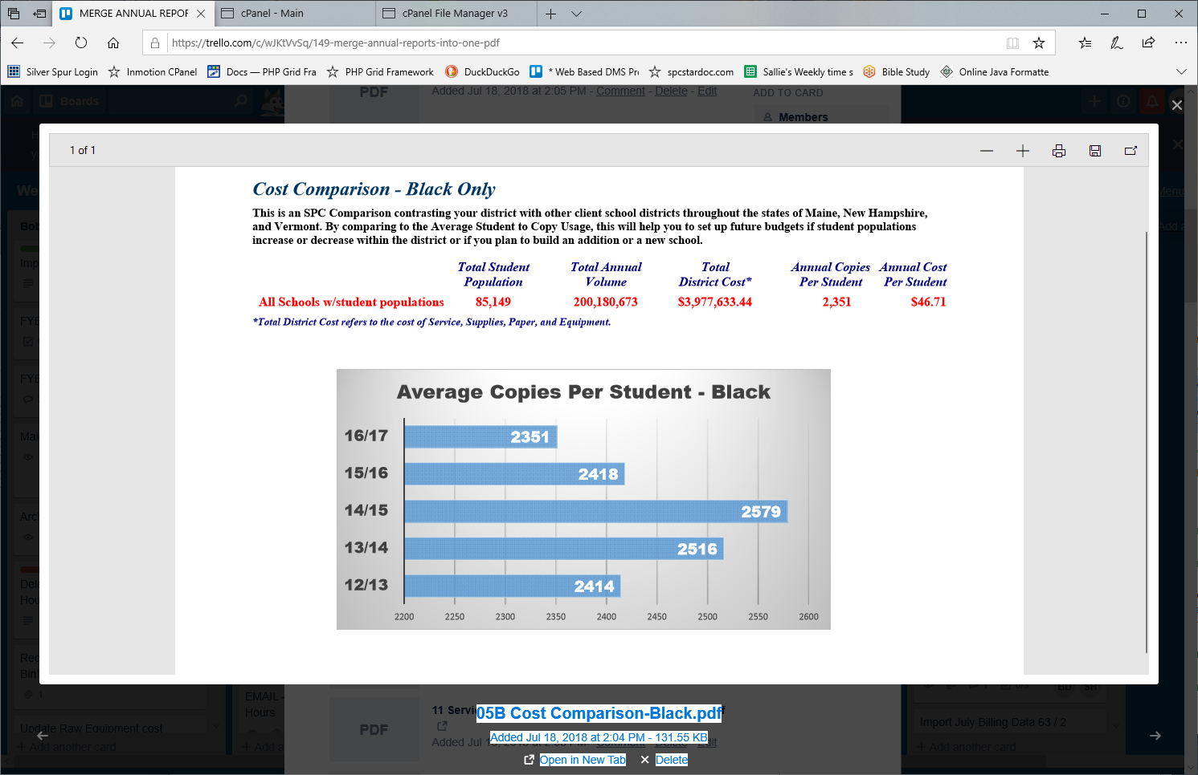
/*$q = "SELECT (SELECT SUM(DistrictPop) FROM organization org
WHERE org.org_type_id = 1 AND Status = 'Active Client'
AND DistrictPop != 0
GROUP BY org.org_type_id) dPop,

SUM(`End` - `Begin`) fy_vol
FROM Machines_current cd
INNER JOIN organization org ON org.id = cd.org_id_ma
WHERE org.org_type_id = 1
GROUP BY org.org_type_id;";

/*prepare the stmt*/
$stmt = $dbLink->prepare($qc);

/*bind the criteria params*/
$stmt->bind_param('iiiiii', $recordId, $schYear, $lastYr, $twoYrsAgo, $threeYrsAgo, $fourYrsAgo);

/*execute the stmt*/
$stmt->execute();

/*store the result*/
$stmt->store_result();

/*check for success*/
if($stmt->num_rows > 0){

}*/
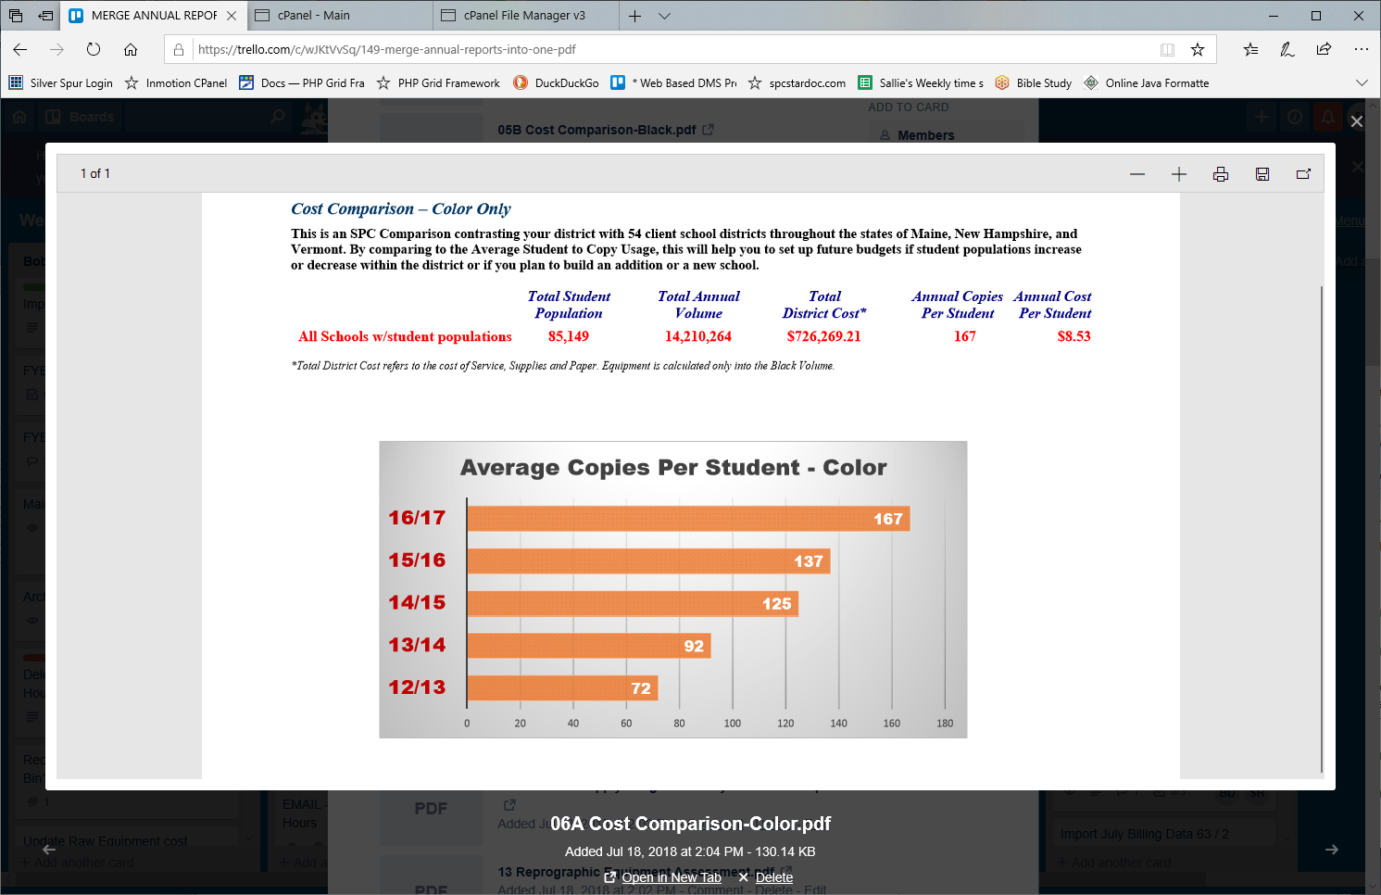

SELECT * FROM organization WHERE org_name LIKE '%NHSAU 34%' OR org_name LIKE '%NHSAU 43%'
OR org_name LIKE '%NHSAU 45%' OR org_name LIKE '%RSU 22%' ORDER BY org_name; #WHERE org_name LIKE 'SAU 34%';#id NOT IN(SELECT org_id_ma FROM Machine_Archive);
#WHERE Status != 'Active Client'; #89395 prod 88524 test SUM(DistrictPop)

#SELECT DISTINCT org_id_ma FROM Machine_Archive WHERE org_id_ma IN(51, 1634, 1863, 1710);
#SELECT DISTINCT org_id_ma FROM billing_data_archive WHERE org_id_ma IN(51, 1634, 1863, 1710);

SELECT * FROM organization org
LEFT JOIN Machine_Archive ma ON ma.org_id_ma = org.id
WHERE org.org_type_id = 1 AND org.Status = 'Active Client' AND ma.org_id_ma IS NULL
ORDER BY org.id; #id NOT IN(SELECT org_id_ma FROM Machine_Archive);

