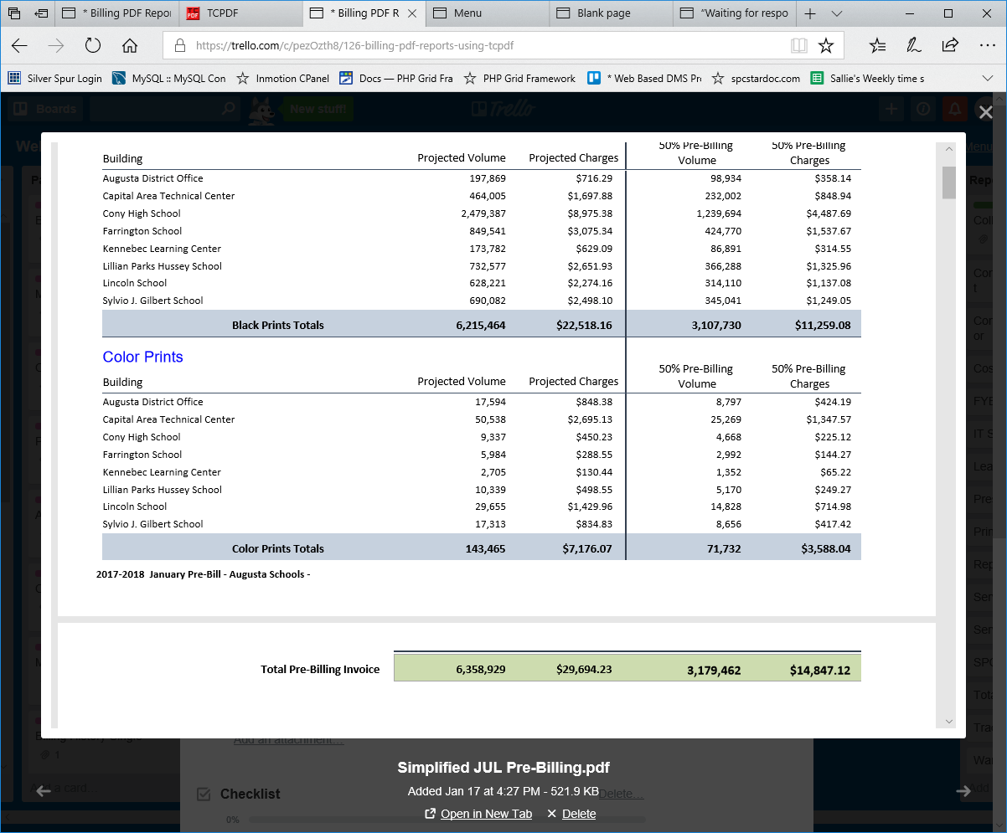
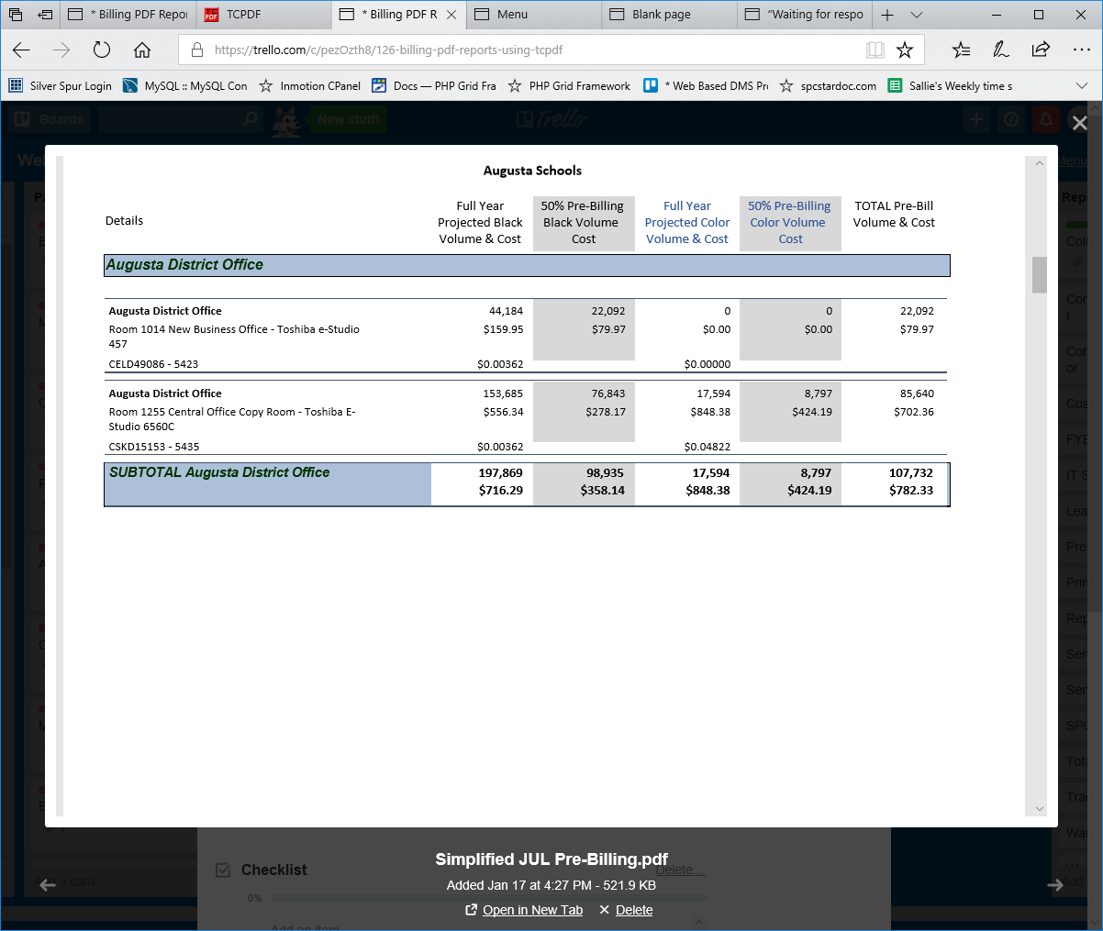
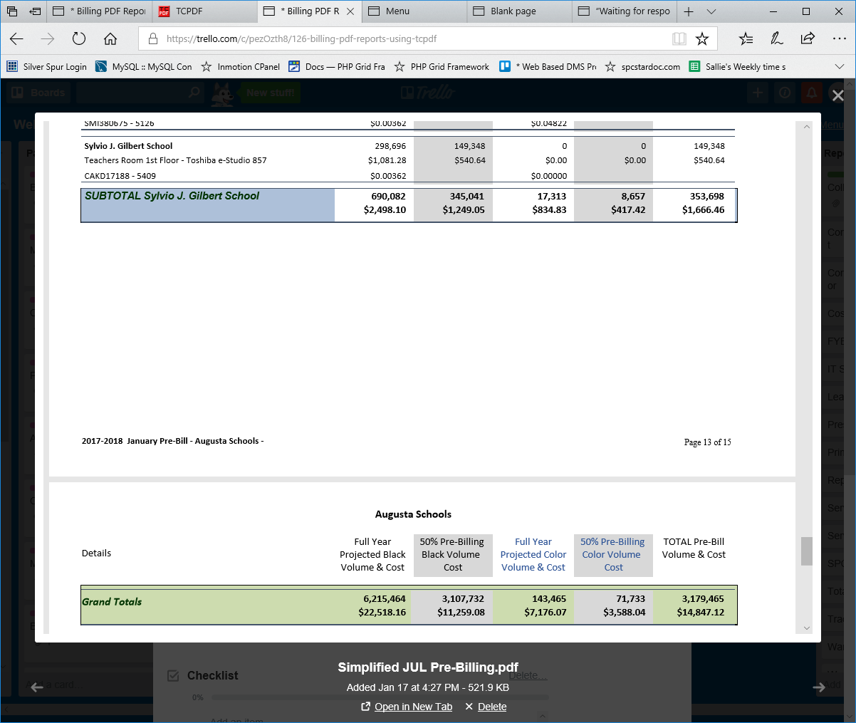

Summary by Vendor
SELECT
o.org_name,
mt.type_name model_type,
mc.vendor_id_ma vendor,
'Black Prints' AS black_color,
Sum(bd.projected_volume_black) AS `Annual Volume`,
Sum(( bd.projected_volume_black * cpc_black )) AS `Annual Cost`,
Sum(bd.billed_projected_volume_black) AS `PreBill Volume`,
Sum(( bd.billed_projected_volume_black * cpc_black )) AS `PreBill Charge`
FROM
billing_data AS bd
INNER JOIN organization AS o ON bd.org_id_ma = o.id
INNER JOIN machines AS m ON bd.model_id = m.id
INNER JOIN machine_types AS mt ON m.model_type = mt.id
INNER JOIN machines_current mc ON mc.model_id = m.id
WHERE
bd.billing_id = 27
GROUP BY #mc.vendor_id_ma,
o.org_name,
mt.type_name;

SELECT bd.projected_volume_black FROM billing_data bd Where bd.billing_id = 27;

SELECT DISTINCT vendor_id_ma FROM machines_current;

SELECT org.org_name,
mt.type_name model_type,
mc.vendor_id_ma vendor,
'Black Prints' AS black_color,
Sum(bd.projected_volume_black) AS `Annual Volume`,
Sum(( bd.projected_volume_black * cpc_black )) AS `Annual Cost`,
Sum(bd.billed_projected_volume_black) AS `PreBill Volume`,
Sum(( bd.billed_projected_volume_black * cpc_black )) AS `PreBill Charge`
FROM
billing_data AS bd
INNER JOIN organization org ON bd.org_id_ma = org.id
INNER JOIN machines AS ma ON bd.model_id = ma.id
INNER JOIN machine_types AS mt ON ma.model_type = mt.id
INNER JOIN machines_current mc ON mc.model_id = ma.id
WHERE
bd.billing_id = 27
GROUP BY
org.org_name,
mt.type_name;

