Formulas for cost values
usage cost = SUM((ma.End - ma.Begin) * ma.NewCostCopy)
paper cost = SUM((End-Begin) * 24.81/5000)
equip cost = SUM((org.government_lease /(SELECT SUM(End-Begin)
FROM Machine_Archive
WHERE org_id_ma = ?
AND school_year = ?
GROUP BY org_id_ma)) * (End-Begin))

total school cost = all 3(usage, paper, equip) - The following is the formula for this value
(SUM((ma.End - ma.Begin) * ma.NewCostCopy)) + (SUM((End-Begin) * 24.81/5000)) +
(SUM((org.government_lease /(SELECT SUM(End-Begin)
FROM Machine_Archive
WHERE org_id_ma = ?
AND school_year = ?
GROUP BY org_id_ma)) * (End-Begin)))

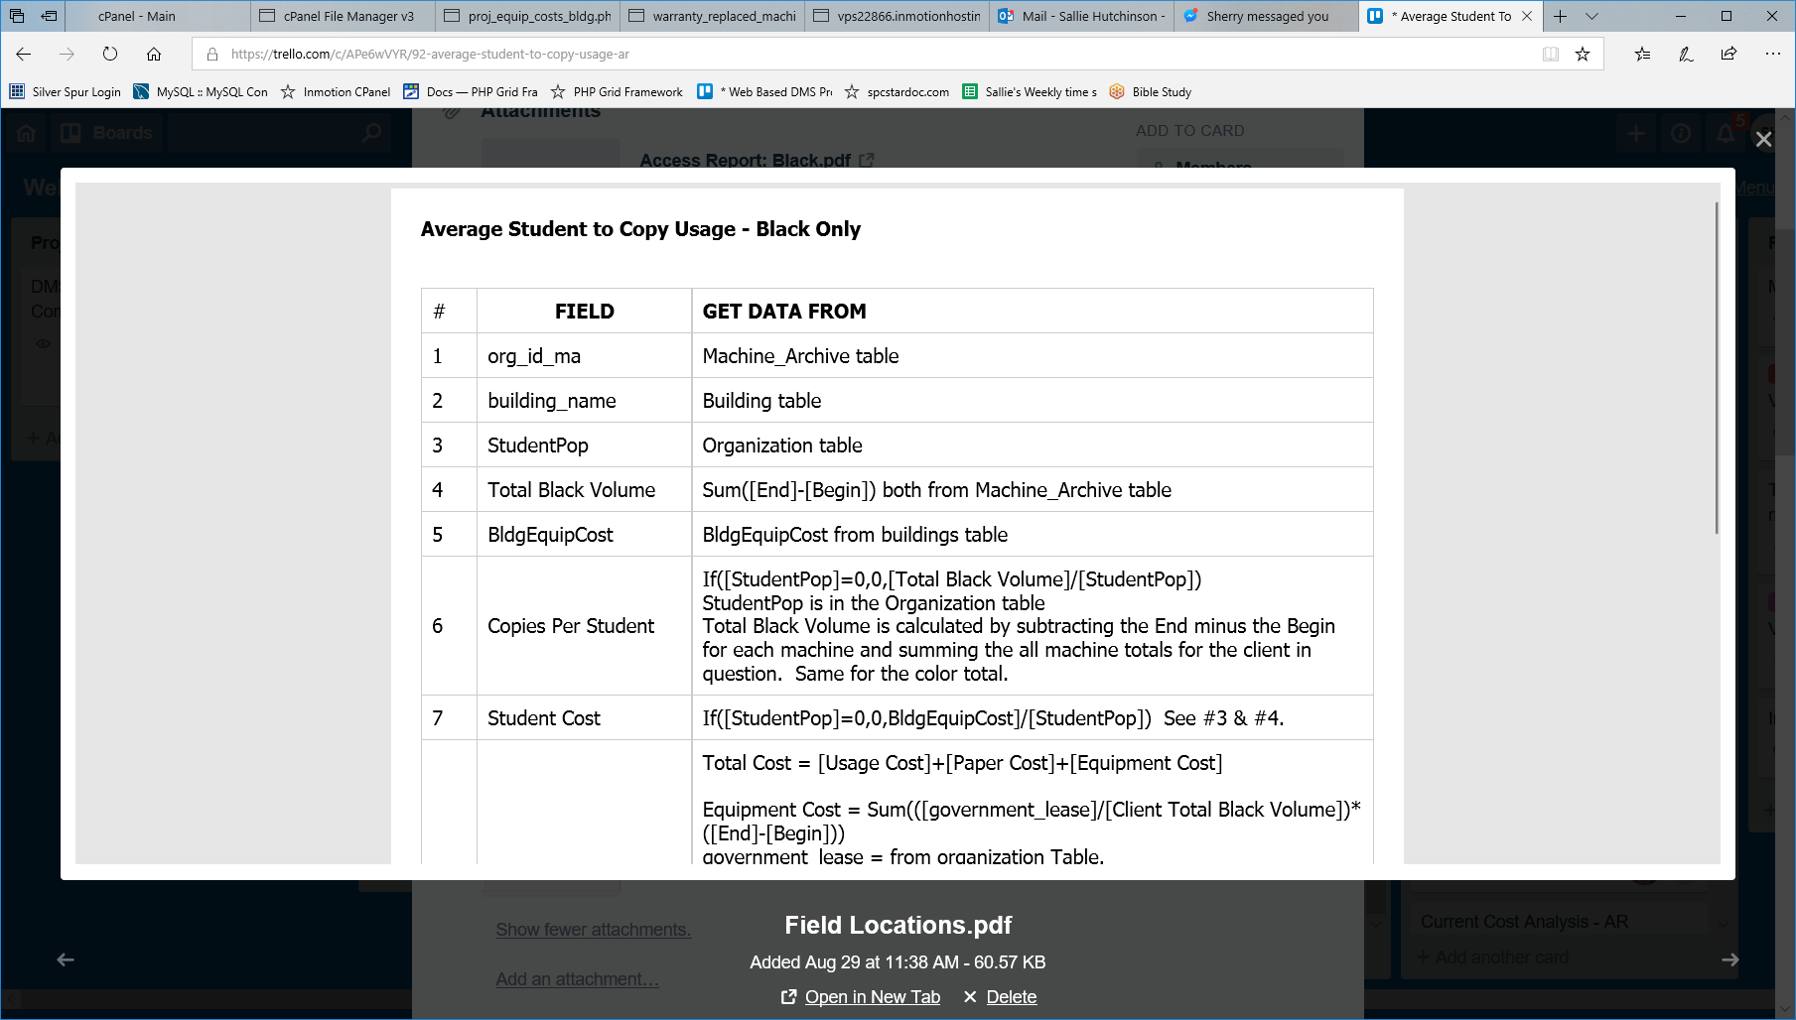
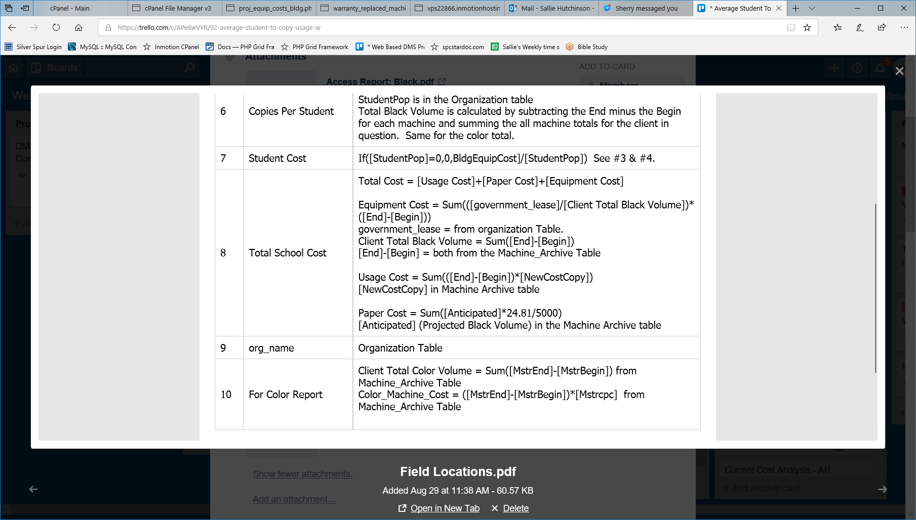

sp_getAvgStudentCopyUsage - STORED PROCEDURE
CREATE DEFINER=`spcsta5`@`cpe-67-255-194-115.maine.res.rr.com` PROCEDURE `sp_getAvgStudentCopyUsage`(IN var_org_id INT(11), var_school_year double) BEGIN DECLARE var_bldg_id INT(11); DECLARE var_bldg varchar(45); DECLARE var_pop INT(11); DECLARE var_blk_volume double(8,0); DECLARE var_blk_cost double(8,2); DECLARE var_clr_volume double(8,0); DECLARE var_clr_cost double(8,2); DECLARE var_copie_per_student double(8,0); DECLARE var_cost_per_student double(8,2); DECLARE n INT DEFAULT 0; DECLARE i INT DEFAULT 0; #Clear the `avg_student_copy_usage` table. DELETE FROM `avg_student_copy_usage`; #Get the Organization id, building id and building name INSERT INTO `avg_student_copy_usage`( org_id , building_id , building_name) SELECT b.org_id , b.id , b.building_name FROM spcsta5_bdutil.buildings b WHERE b.org_id = var_org_id ORDER BY b.building_name; #Loop thru each recordset and get the population for each building SELECT COUNT(*) FROM `avg_student_copy_usage` INTO n; SET i=0; WHILE i<n DO SELECT b.StudentPop, b.id INTO var_pop , var_bldg_id FROM spcsta5_bdutil.buildings b INNER JOIN avg_student_copy_usage a ON b.id = a.building_id WHERE b.id = a.building_id GROUP BY b.id LIMIT i,1; UPDATE spcsta5_bdutil.avg_student_copy_usage a SET a.population = var_pop WHERE a.building_id = var_bldg_id; SET i = i + 1; END WHILE; #Get the volume and cost for each building #SELECT COUNT(*) FROM `avg_student_copy_usage` INTO n; SET i=0; WHILE i<n DO SELECT ma.building_id_ma , SUM(ma.End-ma.Begin) black_volume , SUM((ma.End-ma.Begin)*ma.CostCopy) black_cost , SUM(ma.MstrEnd-ma.MstrBegin) color_volume , SUM((ma.MstrEnd-ma.MstrBegin)*ma.Mstrcpc) color_cost INTO var_bldg_id , var_blk_volume , var_blk_cost , var_clr_volume , var_clr_cost FROM spcsta5_bdutil.Machine_Archive ma INNER JOIN avg_student_copy_usage a ON ma.building_id_ma = a.building_id
WHERE ma.org_id_ma = var_org_id AND ma.school_year = var_school_year GROUP BY ma.building_id_ma LIMIT i,1; UPDATE spcsta5_bdutil.avg_student_copy_usage a SET a.black_volume = var_blk_volume , a.black_cost = var_blk_cost , a.color_volume = var_clr_volume , a.color_cost = var_clr_cost , a.black_copies_per_student = a.black_volume/a.population , a.black_cost_per_student = a.black_cost/a.population , a.color_copies_per_student = a.color_volume/a.population , a.color_cost_per_student = a.color_cost/a.population WHERE a.building_id = var_bldg_id; SET i = i + 1; END WHILE; #Get the copies per student in each building #Get the cost per student in each building END

