Bob,

I am sorry to bother you about billing, but I have a problem I have to try to sort through and I need your help.

In reviewing the Split AR for Norway I found that the Reconciliation report had 9 duplicate serial numbers (7 at Norway Main, 1 each at Norway Ops and Portland Congress St.). In digging further I found that each of these shows a pre-bill at one rate and a billing at another rate, inflating the credit given to the client by almost $1900. I have been trying to wade through all of this and also compare it to the data in the Split AR, but I am struggling with it.

Is it possible to re-run JUST the S&S Usage Profile by Vendor for Black and Color (upgrade version) in alphabetical order showing vendor first, then billing type, then equipment type in order? It will help me out because the issues are with the Ricoh machines, and it would be helpful to have them grouped together. Please NOTE: I am really only interested in the UPGRADE (post-upgrade) section of everything. The Pre-Upgrade (or Close-Out) figures are correct.

I also tried re-running a Reconciliation based on Archive data for 2020-2021 but the Web DMS would not let me. I got a server error. Probably for the same reason I cannot run an Annual Report. See the details of the error further below.

At any rate, can you try running a Reconciliation report based on a Start Date of 8/1/2020 with the post-upgrade data? It is the data that is found in the regular Archive table. I need to see if it will run correctly based on issues you and Sallie fixed some time back during the Reconciliations so I can see if what I am seeing and calculating is correct. We will have to charge the client and owe Ricoh.

I appreciate your help. I included Sallie as she may be able to help as well. Thank you very much!
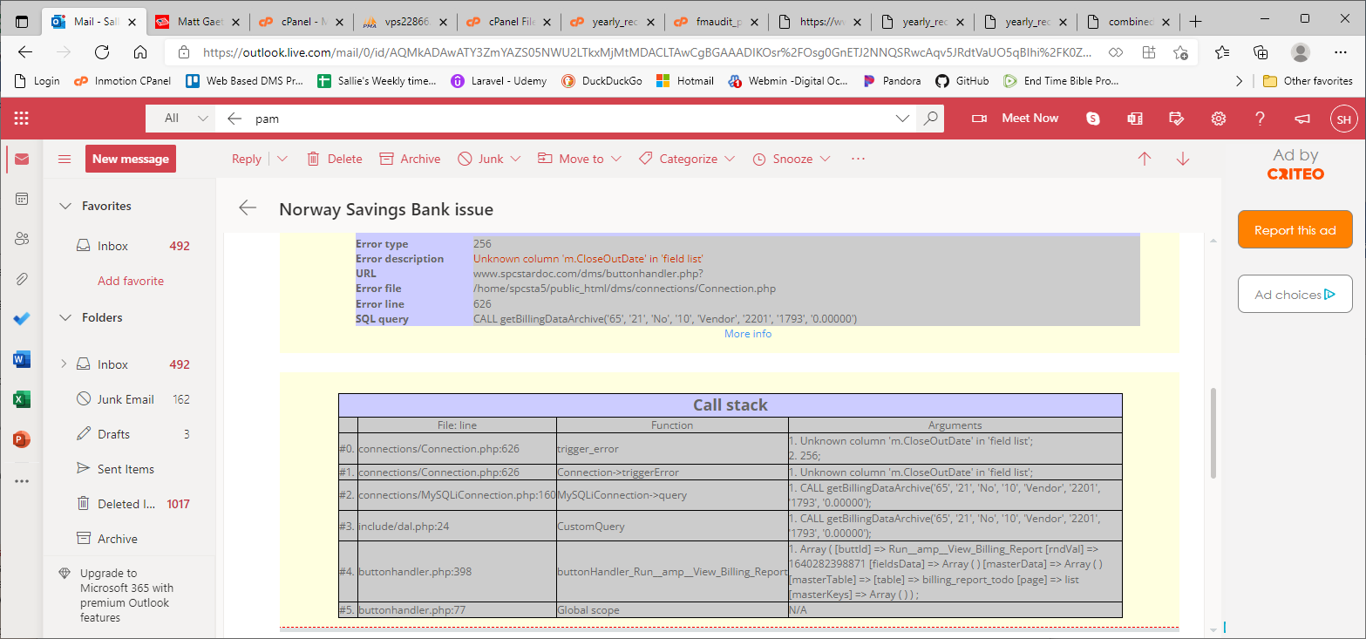

Analysis
- Reconciliation reports are based off current_devices. See comment from code.
/*The deviceTable var will either be current_devices for the reconciliation before it is
a completed report or Machine_Archive for a completed report. When a report is completed,
the data is moved from current_devices into the Machine_Archive table.*/
- Trying to run a billing to do report for a past year will NOT work because the data from that year has already been moved to the Machine_Archive table. I could add code that will give an error if a previous year is entered for a yearly reconciliation report.
- I ran the recon for Norway/Ricoh (1788) for 2021 and it shows more volumes.
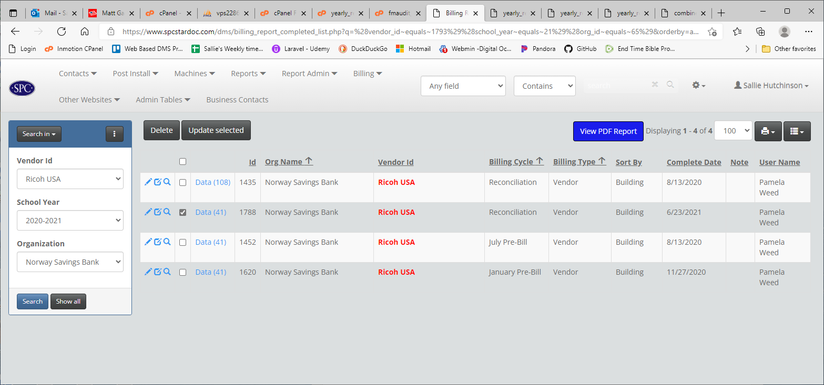
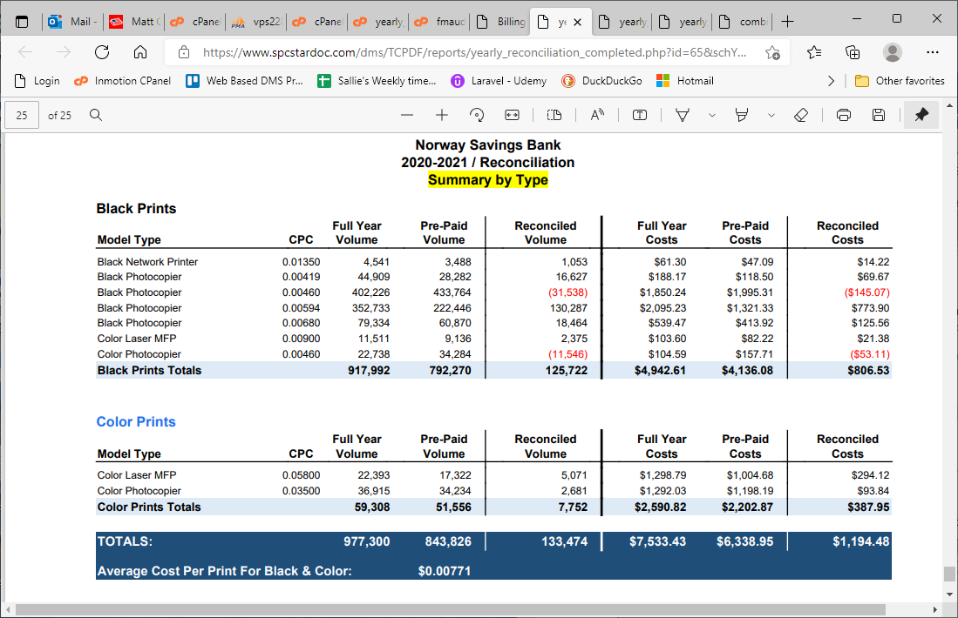
- The yearly_reconciliation_completed report HAS NOT BEEN MODIFIED to get pre and post upgrade machines like the yearly_reconciliation was.

