- Paper Size still shows 8.3 x 11.7. It needs to be 8.5x11 or much closer. The size difference causes the pages to look off balance and not centered vertically (i.e., Cover Page has about 2 inches of white space at the bottom)

- Cover letter signature is way at the bottom as opposed to being in its appropriate place.

- Team Page is missing Alex’s new photo and there needs to be a space after my blurb and the line separating it from Jamin’s info.
I don't have his new photo.

- Time Line needs to be the updated version. Sallie I updated this one but it doesn't seem to be displaying. Bob fixed this.

- 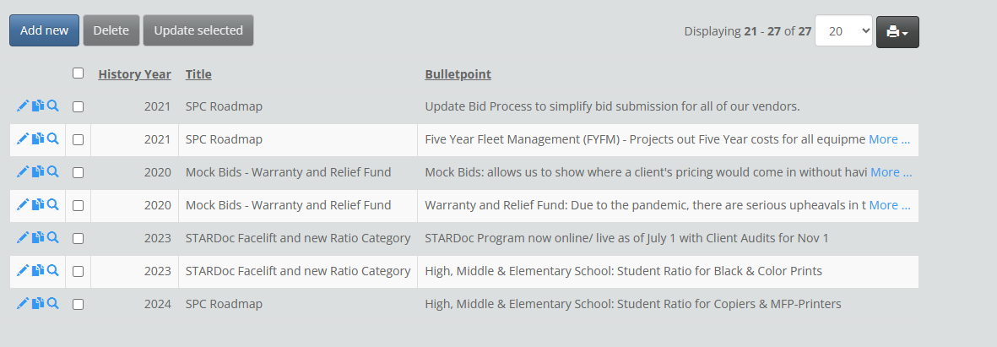

- Non-Contracted devices columns could be more balanced. I think this one depends on the length of the Make/Model name. The reports I checked were very balanced. Is there a specific org that is not?

- Average Student to Copy Ratio Black – Footnote needs to be a size or two smaller and not bold NOTE: I also did the same for the upgrade version.

- Industry Average Black – adjust colums to be spaced better – all too far to the left

- Average Student to Copy Ratio Color – see Item 6

- Industry Average Color – see Item 7 NOTE: If you meant to reference item 9, I have finished it, but if you are saying it is like item 7 non-contracted devices, I do not see an issue.

- NOTE: THIS CHART WAS CREATED BY PAM. New chart looks terrible – title of page and chart needs to be “Average Volume to Student Ratio by Building Type”; needs more space around the whole chart so it looks like it is added to the page, not that it is the page; the bottom legend has oMiddle and 0High. These need to be corrected

- Service & Supply by Vendor Black and Color – better column spacing

