Hi Pam

I need the projected (for year 2024) annual copies per student for black and color. This is needed for the top bar of these 2 reports. Do you have the values? It would be better if we could get this data from the db sometime in the future.

Thanks,
Sallie

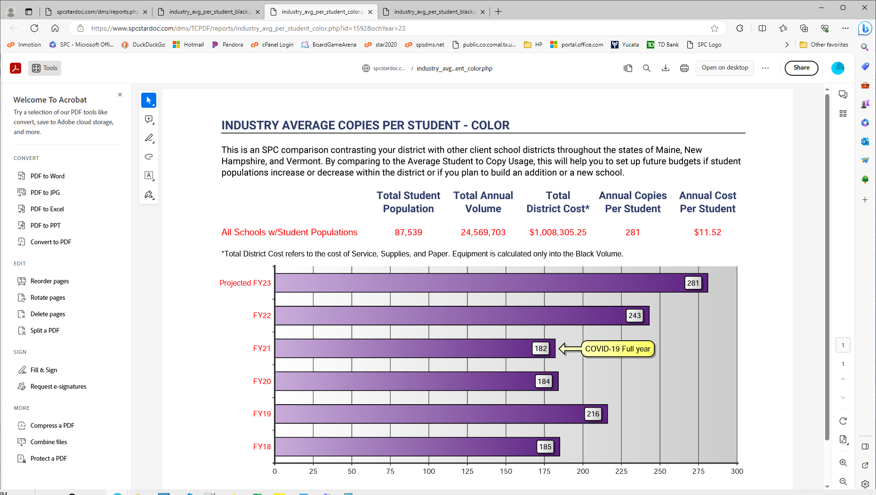

From Pam on 10/17/2023
To be honest, I don’t even know/remember how we got projected for next year in the past, so I am going by the recent % increases:

Black projected 1927
Color projected 326

