I need this calculation for the 2 INDUSTRY AVERAGE COPIES PER STUDENT reports and for the popups on the gauges pages.
tot_dist_cost = (tot volume x cpc) + (tot volume x 31.62 / 5000) + equipment cost

The values in this table agree with Pam’s values EXCEPT for the black and color district cost values.
SELECT tot_student_pop s_pop,
tot_annual_vol_blk anl_blk_vol,
tot_district_cost_blk tot_dist_cost_blk
FROM cost_compare_yrly_totals
WHERE school_year = 22

$anl_copies_student_blk = $anl_blk_vol / $s_pop;
$anl_cost_student_blk = $tot_dist_cost_blk / $s_pop

The total district cost value comes from this calculation
From the INDUSTRY AVERAGE COPIES PER STUDENT - BLACK report (cost_comparison_black.php)

The formula above is the one used to get the values in the screenshot below.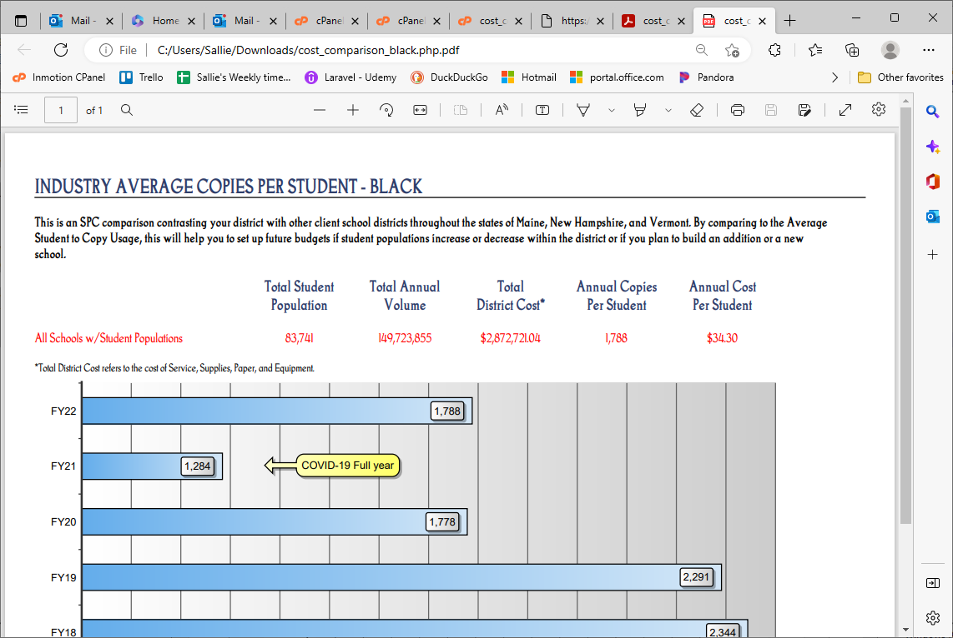

This screenshot shows the values Pam had (these were used instead of the ones above)
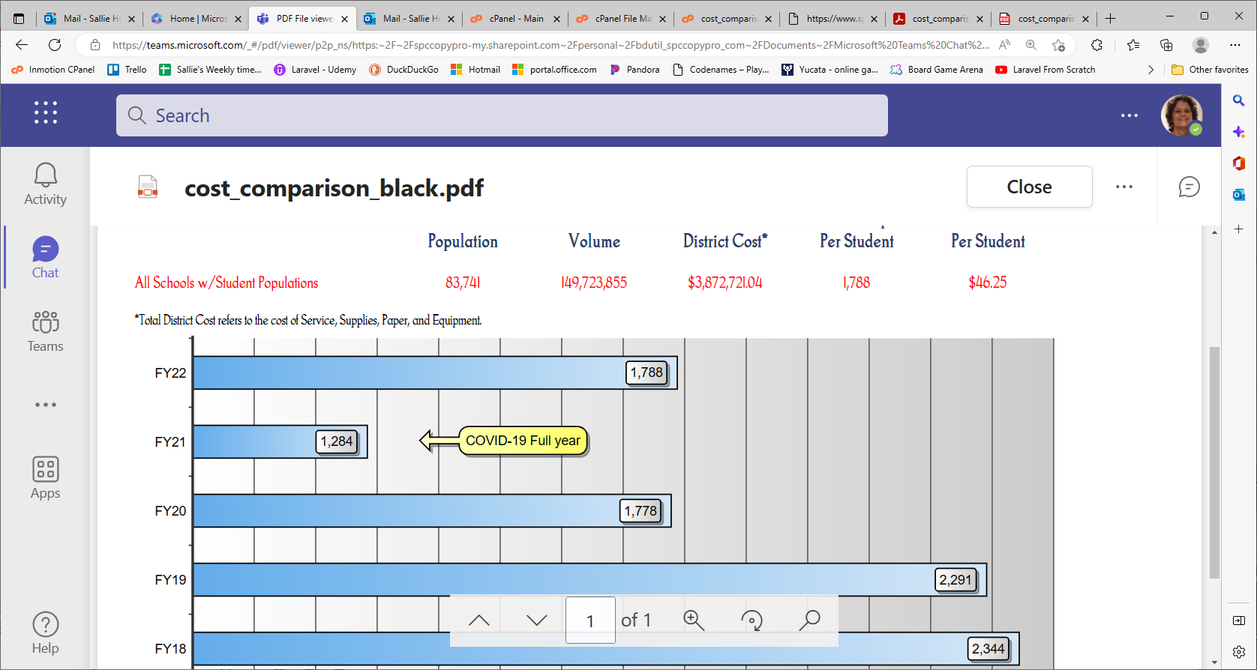

The following is the INDUSTRY AVERAGE COPIES PER STUDENT – COLOR report that was created using the calculation above
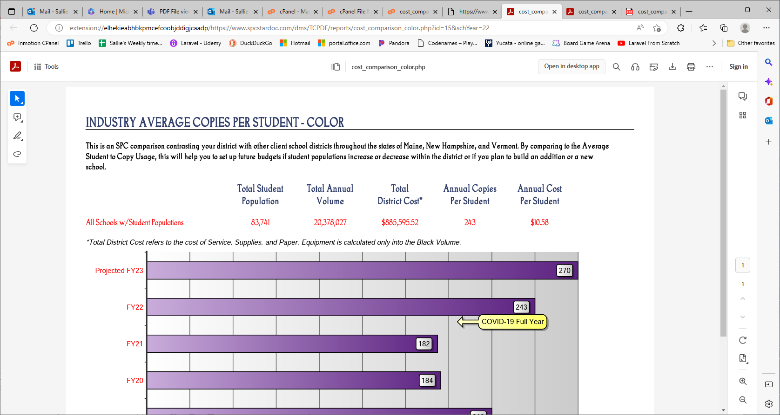

This screenshot shows the values Pam had (these were used instead of the ones above)
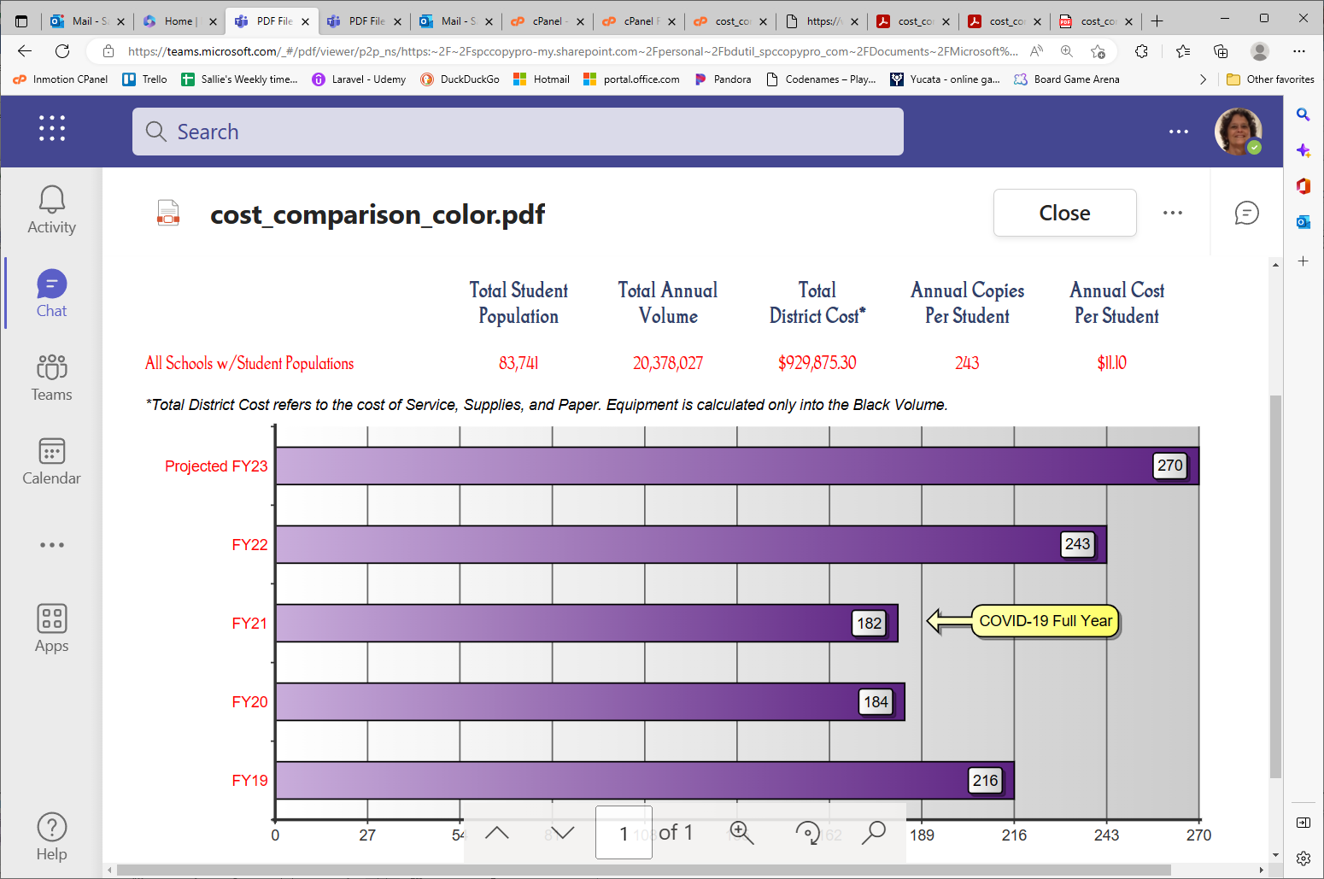

Possible reasons for the $1,000,000.00 diff between Pam’s Total District Cost (black) and mine.
- If org was upgraded, should I be getting their vol from Machine_Archive_Upgrades as well as from Machine_Archive? Bob says both should now be in the Machine_Archive table.
- There are 4 orgs (not counting the demo org) that have temp_inactive set to Y. My query limits orgs to those who are NOT temporarily inactive. These should NOT be temp_inactive now.
- Since we are well into the 2023 school year, should I be using the Y2022_organization table for the District Pop and government_lease? Yes. Normally the organization table is the correct one to use, but just for this time when the report is being sent so late, the data for the org should come from the Y2022_organization table. . . BUT there is NO Y2022_organization table.

SELECT SUM(cd.`End` - cd.`Begin`) fy_vol,
lease_pop.s_pop,
(SUM((cd.`End` - cd.`Begin`) * cd.`CostCopy`) +
SUM((cd.`End` - cd.`Begin`) * 31.62/5000) +
lease_pop.equip_cost) tot_dist_cost

FROM Machine_Archive cd
INNER JOIN organization orgz ON orgz.id = cd.org_id_ma
INNER JOIN (SELECT SUM(org.government_lease) equip_cost, SUM(DistrictPop) s_pop, org.org_type_id
FROM organization org
WHERE org.temp_inactive = 'N' AND org.org_type_id = 1 AND org.Status = 'Active Client'
GROUP BY org.org_type_id) lease_pop ON lease_pop.org_type_id = orgz.org_type_id

WHERE orgz.temp_inactive = 'N' AND orgz.org_type_id = 1
AND orgz.Status = 'Active Client'
AND cd.school_year = 22
GROUP BY orgz.org_type_id;

temp_inactive = N
fy_vol s_pop tot_dist_cost
143476784 83290 3987453.2880559987

temp_inactive = Y
fy_vol s_pop tot_dist_cost
5173964 3667 131744.80302599998

Total dist_cost for inactive and not inactive
4,119,197

Equipment cost and student pop from the organization table
SELECT SUM(org.government_lease) equip_cost, SUM(DistrictPop) s_pop
FROM organization org
WHERE org.org_type_id = 1 AND org.Status = 'Active Client';
2023
equip_cost s_pop
2586204.68 86957

2021
2271471.32 86083

