Hi Alex

I am trying to figure out why I don't get the same count as what is shown in the blue totals box for toner alert, while the count I get does match the table that is displayed when clicking the 13 link. Can you please help me out to understand this?

The totals in the blue box for toner and service_needed are:
Toner Alert = 13
Service_needed = 1
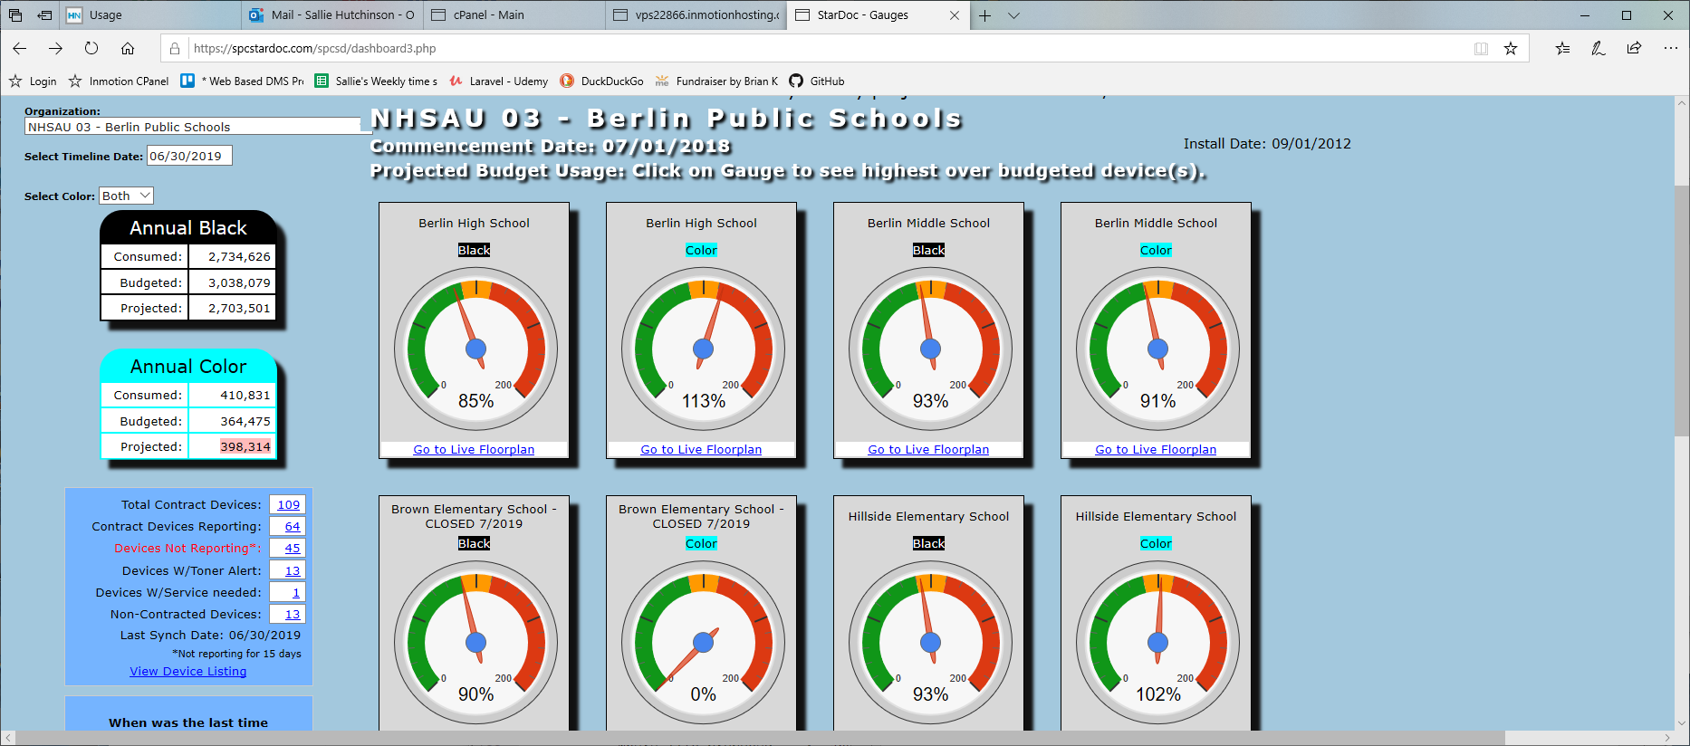

But. . .On this page there are only 10 that need toner. My query returns the same 10 records. Where do the other 3 come from?
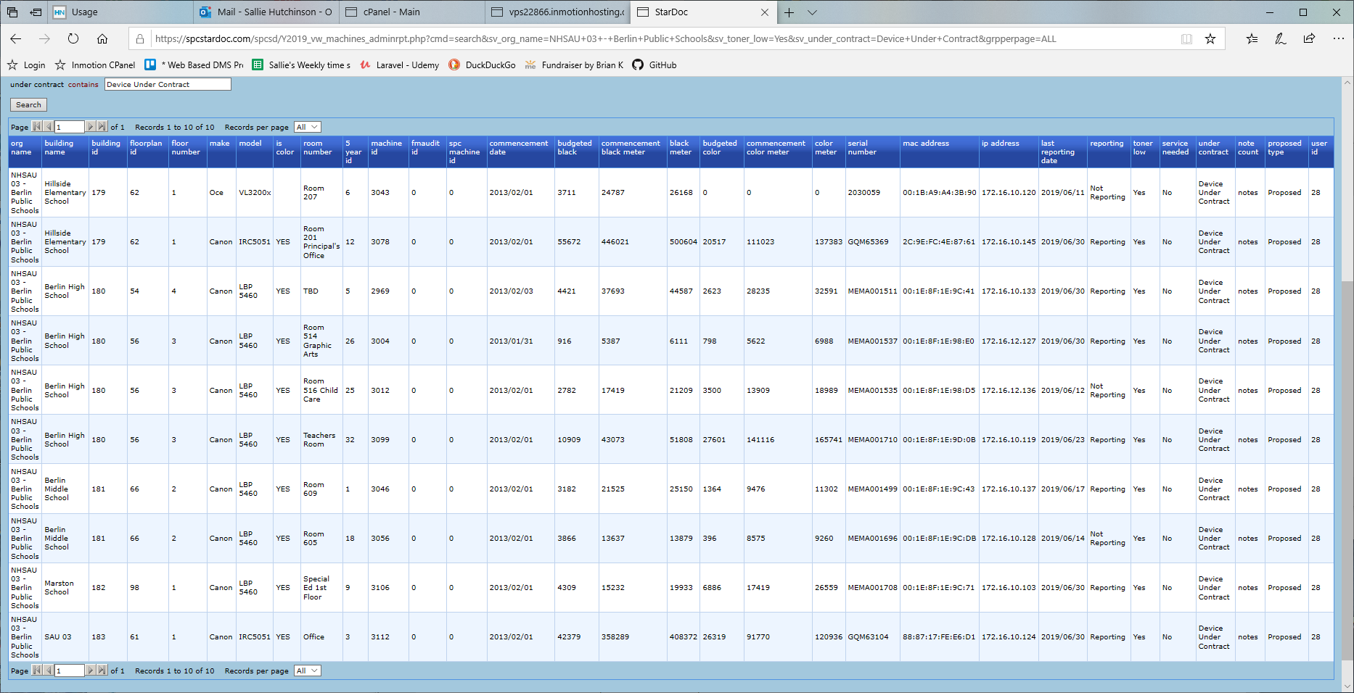

On this page there IS only 1 where service is needed.
