Total Contract Devices
- Should this be the total of all devices belonging to a specific org for the given school_year that are listed as under_contract in the floorplan_machines tables (floorplans, Y2019_floorplan_machines, etc)?
- With this query I get the same 109 machines that stardoc shows.
SELECT * FROM Y2019_floorplan_machines WHERE serial_number in
(SELECT SerialNumber FROM Machine_Archive WHERE org_id_ma = 4 AND school_year = 19)
AND under_contract = 'Y';

From Alex in meeting on 12/4/20:
Currently, Contract devices are selected using
- is_proposed
- under_contract
Going forward, for contracted devices he would like to drop both of these columns and only use
- save_name_id IS NOT NULL
- model_id != 790 (these machines are no longer be under_contract)
Non-contracted devices will have the saved_name of 'created by fm audit', which is entered directly by the feed

Alex would also like to drop the dependence on machine_id from x reports and drop the column from the meter table. Only serial numbers should be used to identify the machines.

New query criteria following Alex's request/suggestion (Note: This is good for now, but checking for 2 non-numerical values takes more time than checking for 1 numerical value. If we could eventually get the feed data to include a number for the save_name_id, there would be no upper/lower case or different spellings to check for.)

SELECT * FROM Y2019_floorplan_machines WHERE serial_number in
(SELECT SerialNumber FROM Machine_Archive WHERE org_id_ma = 4 AND school_year = 19)
AND model_id != 790 AND savedname NOT IN('**Created from FM Audit Feed**', '**CREATED FROM FMAUDIT FEED**');

Bob and I revisited this on 8/2/23 because starDoc is NOT displaying machines that have N for is_proposed. If we go by the criteria Alex gave on 12/4/20, the is_proposed column does NOT match the data Alex is expecting. From our discussion and looking into the data, Bob and I believe the is_proposed values are not correct and that may be why Alex wants to drop this column. To show our findings, I am including a screenshot of a resultset where many is_proposed values are N while the model_id values are NOT 790 and save_name_id is not null. According to Alex’ criteria, these SHOULD be is_proposed = Y. If we are correct and these machines should be Y for is_proposed, then these machines should be shown on starDoc.
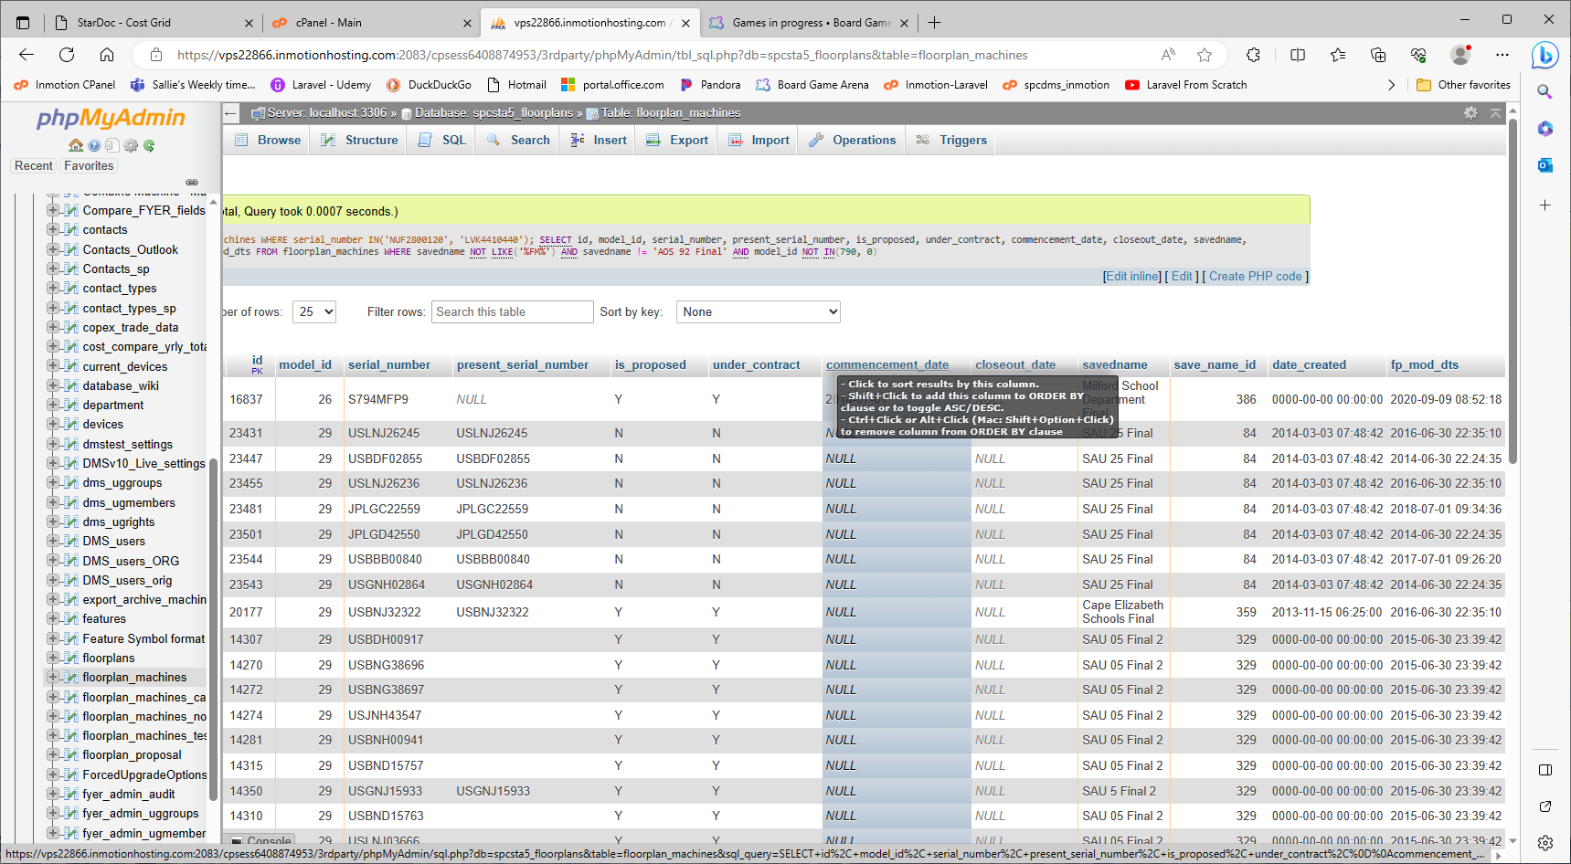

***********************************************************************************************
Non-Contracted Devices - - 'Y' means yes (under contract), 'U' undecided?, there are also NULL and empty strings in this column
- Should this be the total of all devices in the floorplan_machines table for an org for the given school_year that are under_contract (floorplan_machines.under_contract) OR where is_proposed = Y?
- Will there ever be a time when is_proposed = Y and under_contract does NOT = N? If not, then the extra criterion of under_contract = 'N' can be dropped.
- Will any of these ever happen? - I do not believe so.
  - Will there ever be a time when a machine will be in floorplan_machines, but NOT in the floorplans table?
  - Will there ever be a time when there will be a floorplan that is not tied to a specific building in the buildings table?
  - Will there ever be a time when there will be a building that is not tied to an organization in the organization table?
- If these are all no, then I can change the left outer joins to inner joins (smaller resultsets take less time to perform). I can also drop the join to the org table because org_id is in the buildings table.
- Note that with this query criteria, I get 13 non-contracted devices (same as totals box), but if I remove the is_proposed = 'Y' and under_contract = 'N') or I get the 73 machines that stardoc has when you click the 13.
SELECT count(*) as device_count
FROM Y2019_floorplan_machines fpm
LEFT OUTER JOIN Y2019_floorplans fp on fpm.floorplan_id = fp.id
LEFT OUTER JOIN Y2019_buildings bd on fp.building_id = bd.id
LEFT OUTER JOIN Y2019_organization org on bd.org_id = org.id
where ((is_proposed = 'Y' and under_contract = 'N') or under_contract = 'U') and org.id = 4;
- So it seems that the proposed machines are listed in the sub-table, but only the 'U' values are counted. Is this what is desired/needed?

REVISIT - - - From Alex in meeting on 12/4/20:

SELECT fpm.*
FROM Y2019_floorplan_machines fpm
INNER JOIN Y2019_floorplans fp ON fpm.floorplan_id = fp.id (changed from full outer join)
INNER JOIN Y2019_buildings bd ON fp.building_id = bd.id (changed from full outer join)
#LEFT OUTER JOIN Y2019_organization org on bd.org_id = org.id (This is not needed. org_id is in buildings)
WHERE savedname IN('**Created from FM Audit Feed**', '**CREATED FROM FMAUDIT FEED**')
/*AND model_id = 790 (This returns 0 records for this floorplan. The model_id values are all different.)*/
AND bd.org_id = 4;

WIP 2/22/2021
This query does NOT return the close out machines for Augusta, City Of (org_id 18) or NHSAU03 (org_id 4)
The reason is that there are 81 records in Y2019_floorplan_machines that do have serial_numbers, but do not have model_id values. We will need to update the records with model_id values to make this query work.
SELECT * FROM Y2019_floorplan_machines WHERE serial_number is not null AND model_id is null;

Possibly use this to get the serial_numbers for fpm.id values
SELECT fpm.id, mtr.machine_id, fpm.serial_number fpm_ser_num, mtr.serial_number mtr_ser_num
FROM Y2019_floorplan_machines fpm
INNER JOIN Y2019_meter mtr ON mtr.machine_id = fpm.id
AND fpm.serial_number is null AND mtr.serial_number is not null
AND mtr.serial_number NOT IN('', '0')
GROUP BY mtr.serial_number, fpm.serial_number, mtr.machine_id, fpm.id;

I would also like to get approval to delete all records from all of the following tables for records where there is no serial_number.
- floorplan_machines
- Y2019_floorplan_machines
- all other Yxxx_floorplan_machines tables

***********************************************************************************************

Contract Devices Reporting
- Should this be the total of all devices that have had a meter read within the last 15 days from the current date?
Devices Not Reporting
- Should this be the total of all devices that have not had a meter read within the last 15 days from the current date? Or from some other date (possibly the date in the Select Timeline Date box?)
SELECT * FROM meter WHERE serial_number IN(SELECT SerialNumber FROM Machine_Archive
WHERE org_id_ma = 4 AND school_year = 19);

This partial conditional came from stardoc
if ( ($rs['meter_timestamp'] == null) || ($rs['meter_timestamp'] < date_format($notReportingDate,'Y-m-d')) )
{ $reporting = "N"; }
else
{ $reporting = "Y"; }

Devices W/Toner Alert
- Should this be the total of all devices for an org that exist in Machine_Archive for the given school_year that Need toner (machine_status.toner = 1)
- Current site shows 13 in totals box, but only 10 on the page returned when clicking the 13 link. Where are the other 3?
- Should all machines in floorplan_machines exist in Machine_Archive (or current_devices) - Yes
- A client can have 100 in current_devices (or Machine_Archive) but maybe only 95 in fm_audit (extra service to keep track of status). This is because SPC services the 100, but the client only wants 95 to have the extra service. So, every machine in current_devices (or Machine_Archive) does not have to be in floorplan_machines.
Devices W/Service Needed
- Should this be the total of all devices for an org that exist in Machine_Archive for the given school_year and Need service (machine_status.service_needed = 1)

Last Sync Date
- finish this thought - don't need to join organization and these should be inner joins as above.
SELECT DATE_FORMAT(max( mtr.date_timestamp),'%m/%d/%Y') as created_date
FROM Y2019_floorplan_machines fpm
LEFT OUTER JOIN Y2019_floorplans fp ON fpm.floorplan_id = fp.id
LEFT OUTER JOIN Y2019_buildings bd ON fp.building_id = bd.id
#LEFT OUTER JOIN Y2019_organization org ON bd.org_id = org.id
LEFT OUTER JOIN Y2019_meter mtr ON fpm.id = mtr.machine_id
AND mtr.date_timestamp = (SELECT max( i.date_timestamp) FROM Y2019_meter i WHERE i.machine_id = fpm.id and black_meter > 0)
where bd.org_id =4;

