IT Management Page
Hi Alex

The Dashboards / IT Management page has me wondering about data entry.
Bob thinks that this data is entered by the users at client organizations. If so, how do they enter data? I see no place on the page where data can be entered.

Thanks,
Sallie

The Edit Other Devices button in the bottom right is the link to where users can enter data for the IT Management page.
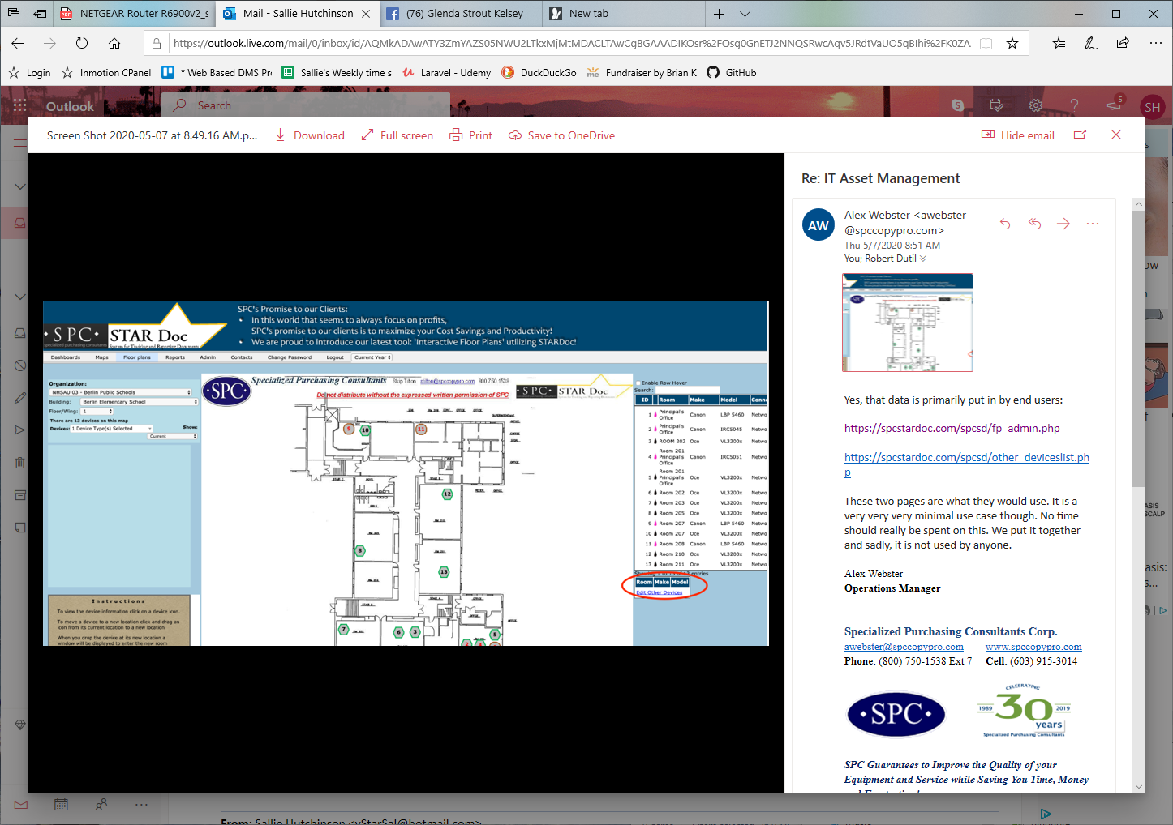
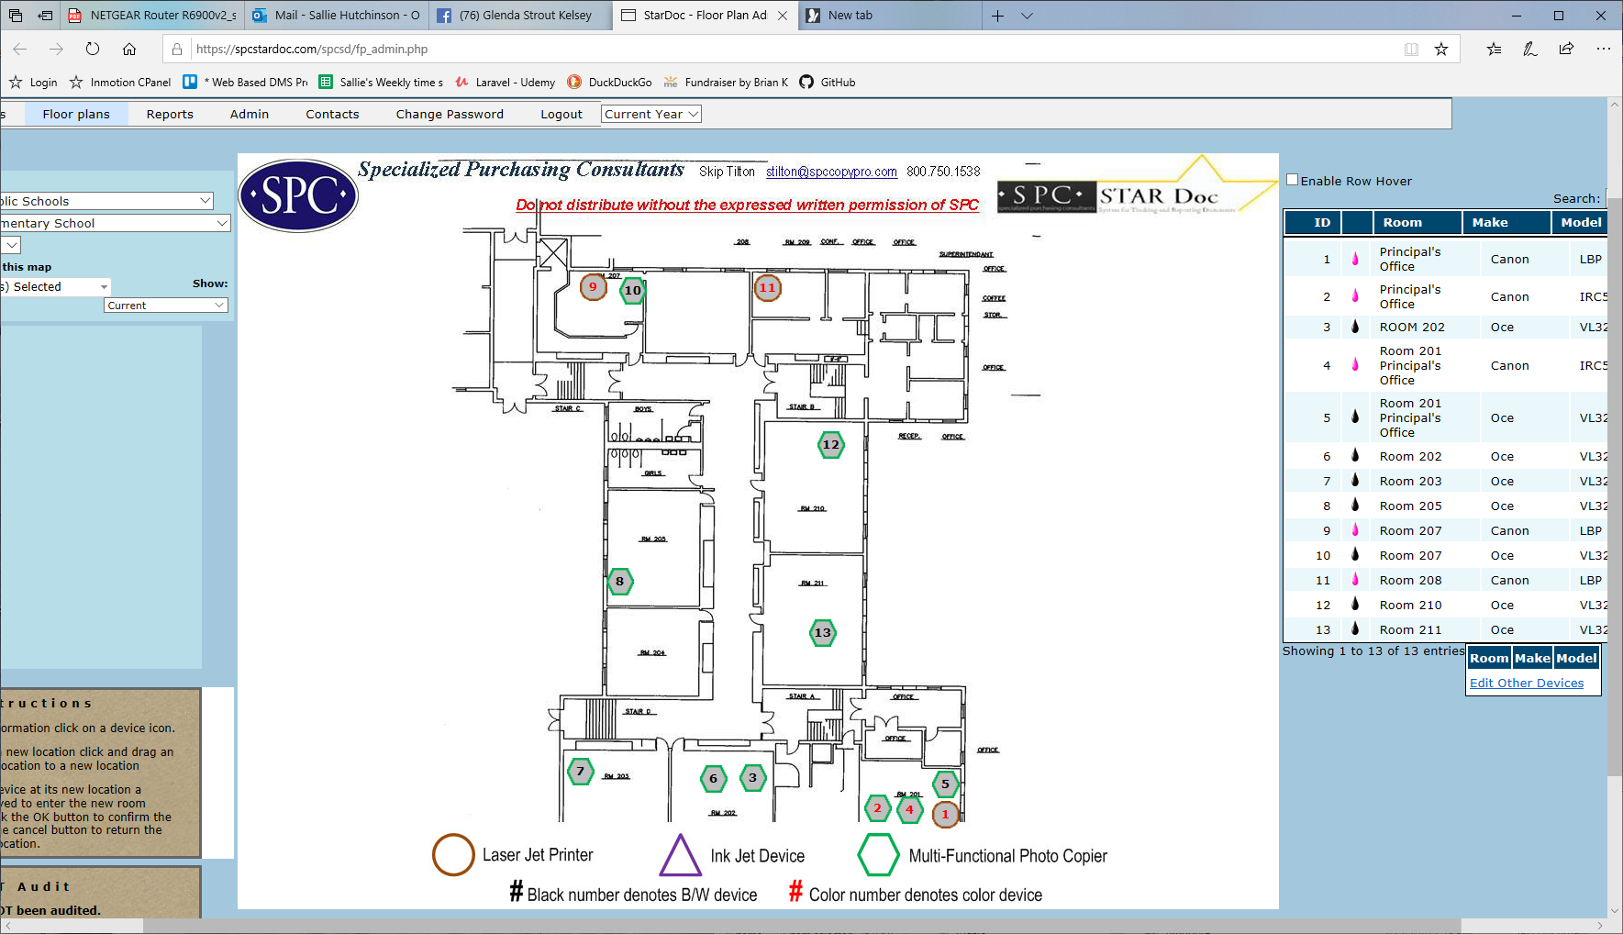

Yes, that data is primarily put in by end users:

https://spcstardoc.com/spcsd/fp_admin.php

https://spcstardoc.com/spcsd/other_deviceslist.php

These two pages are what they would use. It is a very very very minimal use case though. No time should really be spent on this. We put it together and sadly, it is not used by anyone.

