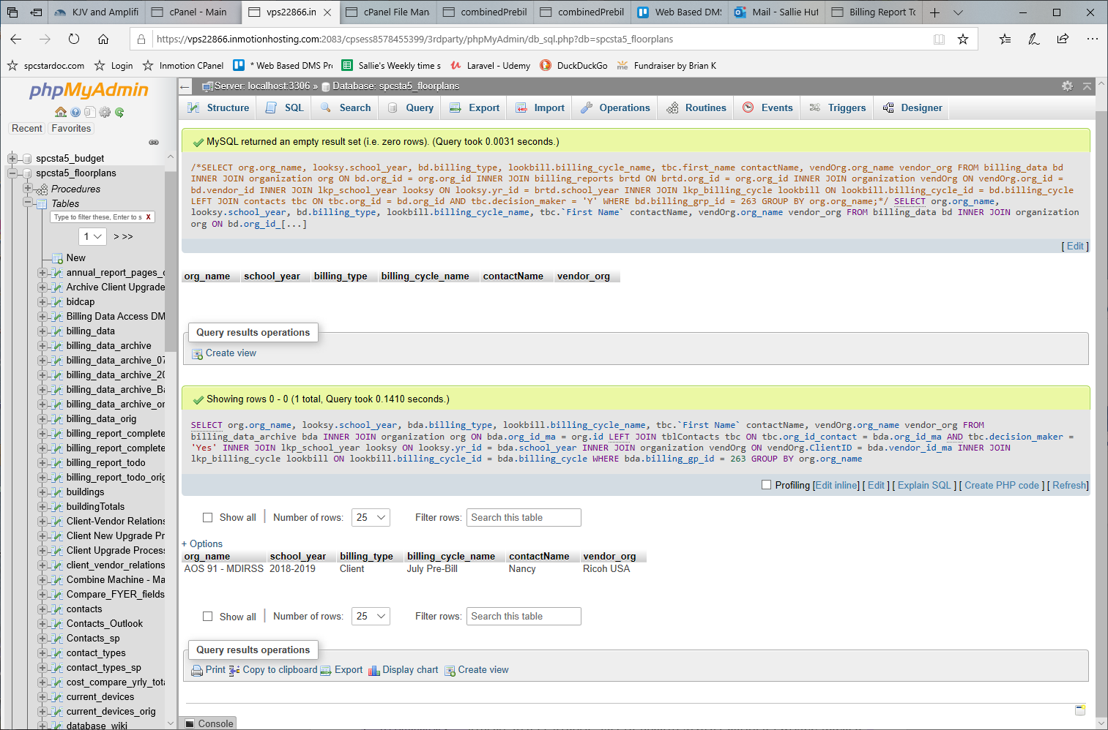
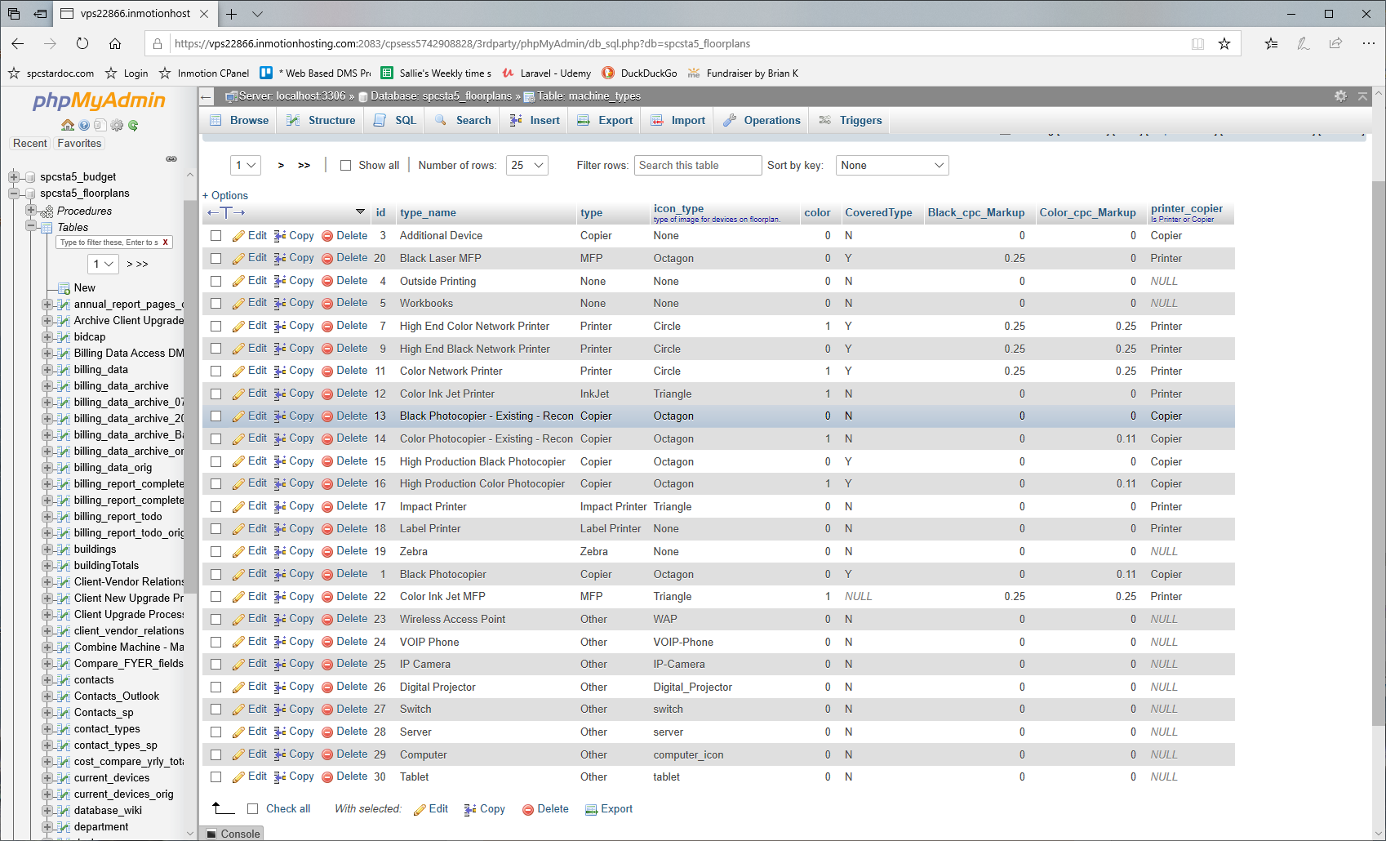
Using a LEFT JOIN organization vendOrg ON vendOrg.ClientID = bd.vendor_id_ma returns a record for a black Network Printer (vendor is Rosetta Tehnologies). The ClientID for org_id 1867 is ROTECH, instead of Rosetta Tec, which is the vendor_id_ma in billing_data PRODUCTION. The amt of records returned in TEST is also wrong. Test uses the vendor_id, but the vendor_id for 4 of the 5 records for RosettaTec are NULL. Neither Prod nor test returns correct data because of Null vendor_id or vendor_id_ma values that don't match those in organization.
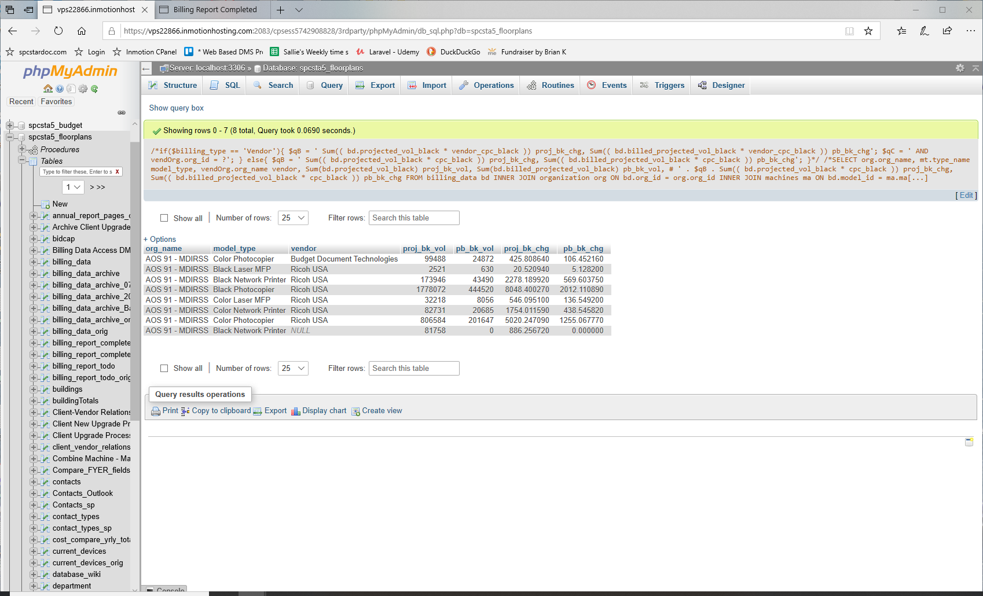

PRODUCTION Updates 12/29/19
zipcode queries to fix values
#SELECT DISTINCT zipcode FROM organization;# WHERE LENGTH(zipcode) = MAX(LENGTH(zipcode));
#SELECT * FROM organization WHERE zipcode LIKE "%-%";
I updated these via gui.

SELECT * FROM organization WHERE LENGTH(zipcode) = 4;
SELECT id, zipcode, CONCAT("0", zipcode) FROM organization WHERE LENGTH(zipcode) = 4;
UPDATE organization SET zipcode = CONCAT("0", zipcode) WHERE LENGTH(zipcode) = 4;
SELECT * FROM organization WHERE id IN(95, 212, 214, 86, 74, 73, 64, 43, 33, 29)
zipcodes that I removed the hyphens from and removed the extra preceding 0 from the first record. IN PRODUCTION!
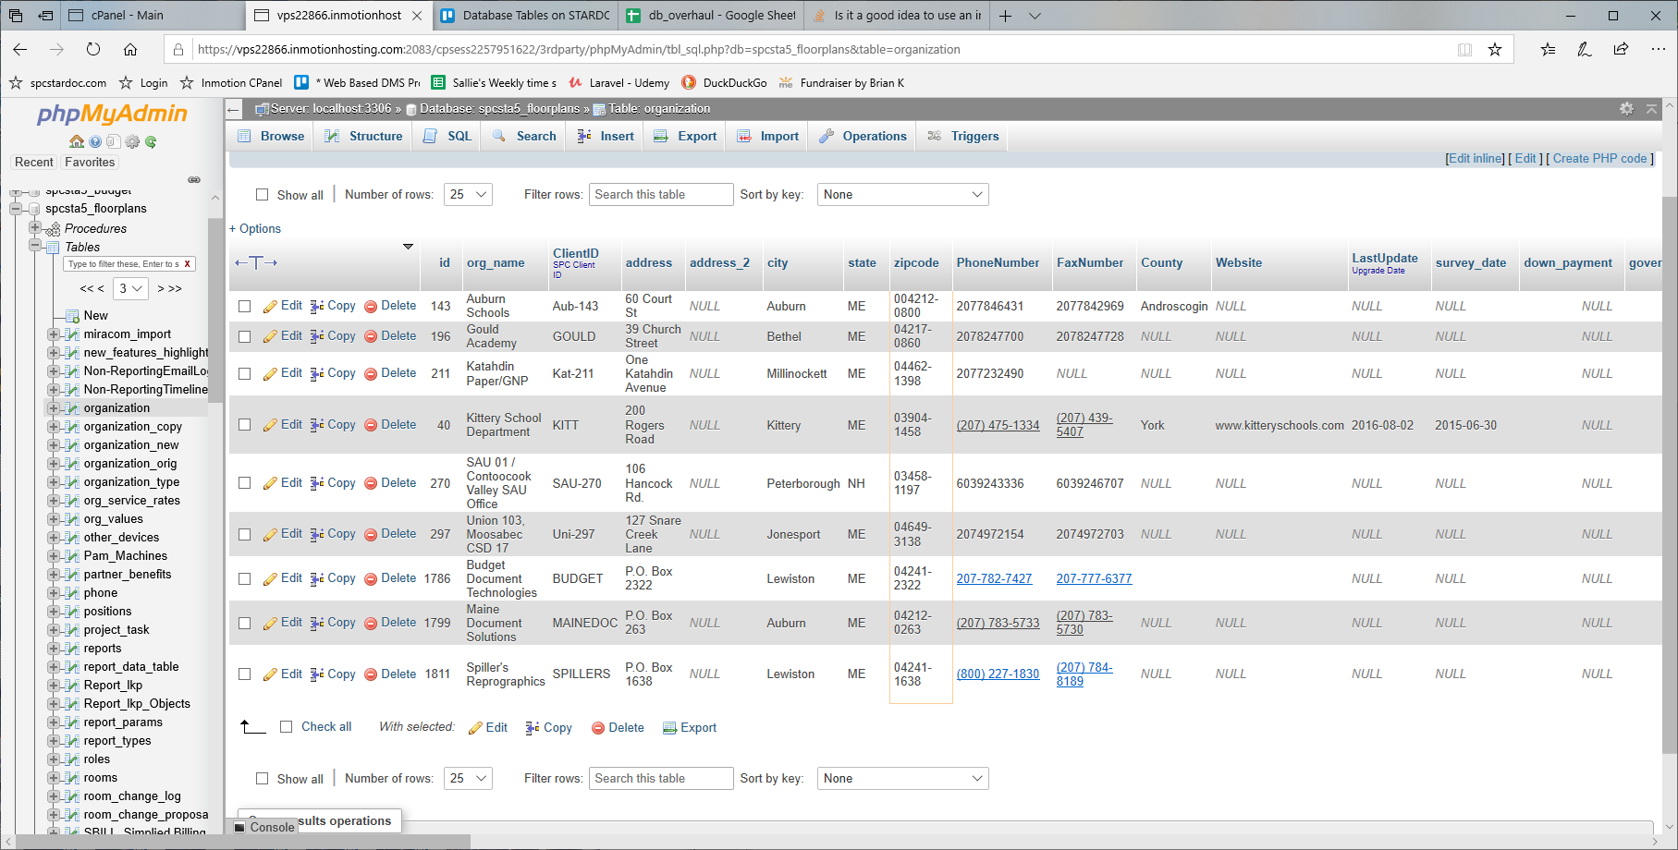

zipcode values where I prepended a 0
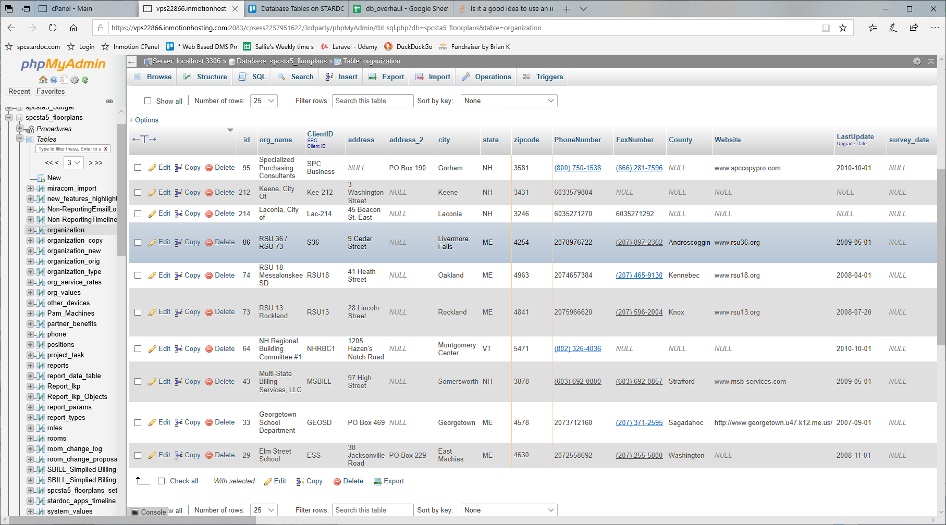

po box
#SELECT * FROM `tblContacts` WHERE con_pobox is not null; #257
#SELECT * FROM `tblContacts` WHERE con_pobox LIKE '%ox%';
SELECT * FROM `tblContacts` WHERE con_address LIKE 'PO Box%' AND con_pobox is null;
#SELECT * FROM `tblContacts` WHERE con_pobox is not null AND con_address is not null; #252
#SELECT * FROM `tblContacts` WHERE con_pobox is null AND con_address is not null; #525

#SELECT * FROM `tblContacts` WHERE con_pobox is not null AND con_pobox != '' AND con_address is null; #4

#SELECT * FROM `tblContacts`; #2069
#SELECT * FROM `tblContacts` WHERE con_pobox is null AND con_address is null; #1287 2069-1424=645

#UPDATE tblContacts SET con_address = "140 Pine Hill Road", con_pobox= "PO Box 190" WHERE `ID` = 2258;
#UPDATE tblContacts SET con_address = "388 Somersworth Road", con_pobox= "PO Box 819" WHERE `ID` = 2411;
#UPDATE tblContacts SET con_address = "320 Ocean House Road", con_pobox= "PO Box 6267" WHERE `ID` = 2421;
#UPDATE tblContacts SET con_address = "6 Elm Street", con_pobox= "PO Box 566" WHERE `ID` = 2729;
#UPDATE tblContacts SET con_address = "408 Main Street", con_pobox= "PO Box 279" WHERE `ID` = 2738;
#UPDATE tblContacts SET con_address = "320 Ocean House Road", con_pobox= "PO Box 6260" WHERE `ID` = 4051;
#UPDATE tblContacts SET con_address = "512 Meadow Street", con_pobox= "PO Box 226" WHERE `ID` = 570;
#UPDATE `tblContacts` SET con_pobox = "PO Box 289", con_address = "190 Presque Isle Rd" WHERE `ID` = 1823;
#UPDATE tblContacts SET con_address = "78 Main Street", con_pobox= "PO Box 846" WHERE `ID` = 460;
#UPDATE tblContacts SET con_address = "43 Merdolia Rd", con_pobox= "PO Box 97" WHERE `ID` = 676;
#UPDATE tblContacts SET con_pobox= NULL WHERE `ID` = 1455;
#UPDATE tblContacts SET con_pobox= NULL WHERE `ID` = 3679;
#UPDATE tblContacts SET con_zip = CONCAT("0", con_zip) WHERE LENGTH(con_zip) = 4;

