Skip decided to go with the white navbar w/no gradient, because this is the one Alex likes. 8/25/2023

Original version
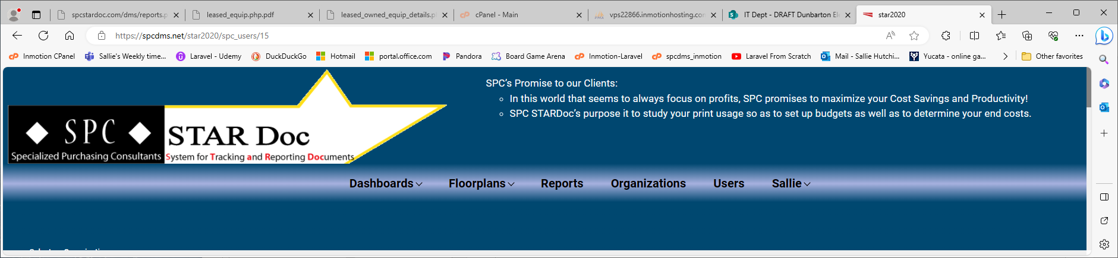
More of the light blue in the gradient and less gradient above and below links.
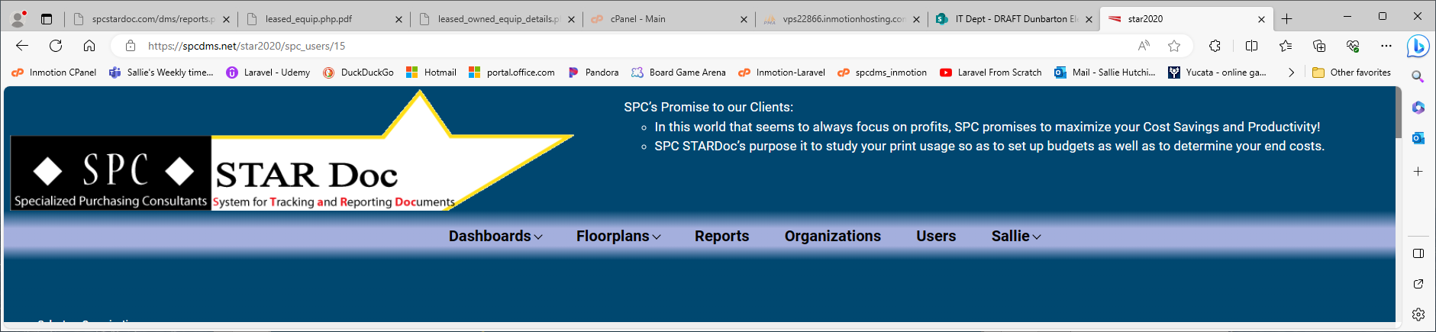
Even more light blue in the gradient and less gradient above and below. These 2 are only a tiny bit different.
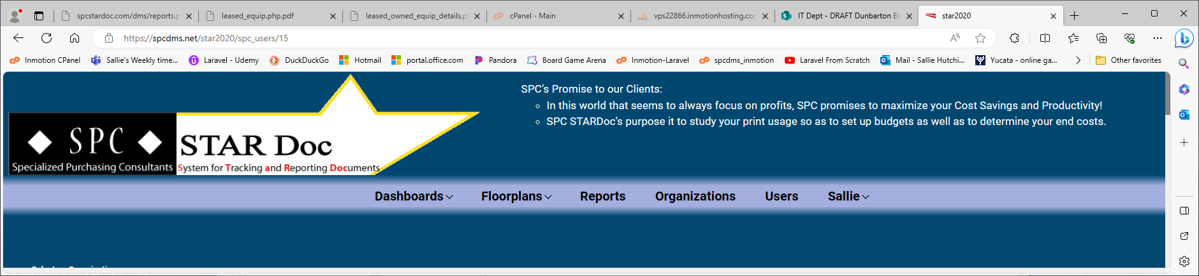
White background instead of the blue background and a tiny bit of gradient to separate navbar from logo.
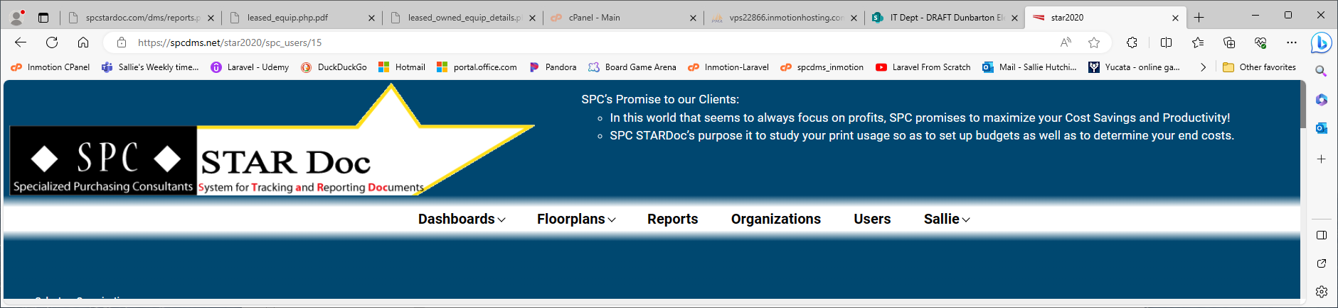
White background with a black border to separate somewhat from the logo. No gradient here.
