Site Notes for star2020.net/star2020
Device Summary pages use table of id usage_data
- styling for the pagination is in css stylesheet custom/plugins/DataTables/datatables.css
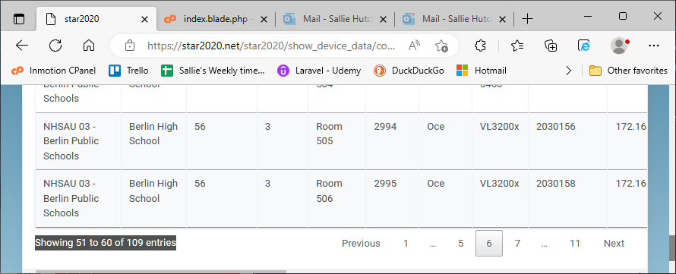

To implement the bootstrap-tables buttons (print, export, etc) there MUST be a div with id of toolbar. Just adding the table attributes in the <table> tag is NOT ENOUGH! Follow these 3 steps.
Place this just before the <table> tag
<!--To implement export for this table create an empty select with ID of toolbar-->
<div id="toolbar" class="select">
<select class="form-control">

</select>
</div>

Add the desired attributes to the table tag
/*Create the table tag*/
<table id="myDataTable" class="myDataTable"
data-toggle="myDataTable"
data-show-export="true"
data-click-to-select="true"
data-toolbar="#toolbar"
data-show-toggle="true"
data-show-columns="true"
data-show-footer="true"
data-show-print="true"
data-export-types=['xml', 'csv', 'excel']>

Include this in the document.ready function on the app.php page
$(function() {
$('#toolbar').find('select').change(function () {
$('.myDataTable').bootstrapTable({
exportDataType: $(this).val(),
exportTypes: ['excel', 'pdf', 'csv'],
exportOptions: {
ignoreColumn: ["button1", "button2", "button3"]
}
})
}).trigger('change')
});

A bootstrap-table toolbar with an added button to return cols to orig order. This is because I have enabled dragging and dropping the columns to different orders.
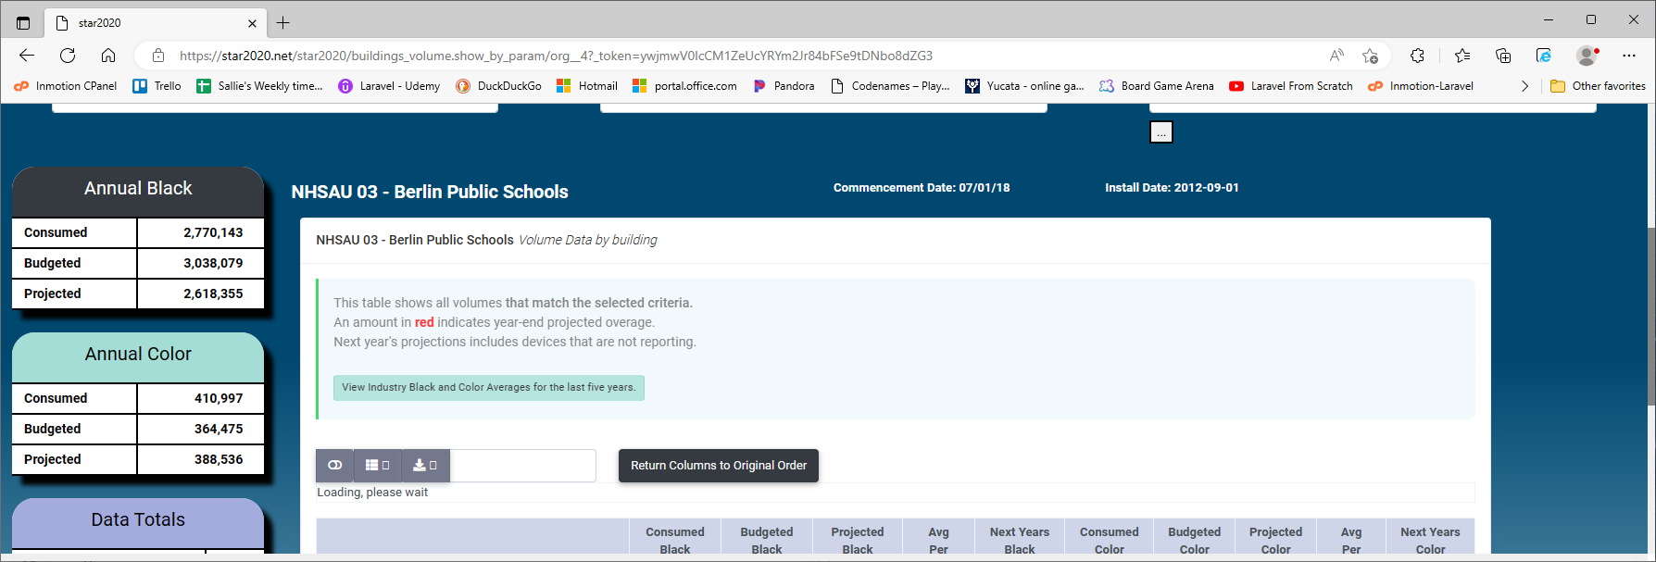

To keep the toolbar within its parent div, I had to make the toolbar div position: absolute and the select position:relative as in code snippet below.
<!--To implement bootstrap-table export functionality for this table, add an empty toolbar div with select element.-->
<div id="toolbar" class="select col-xl-12" style="position:absolute;">
<div class="row">
<div class="col-xl-3">
<select class="form-control" style="display: position:relative;">

</select>
</div>
<div class="col-xl-3">
<button class="btn btn-dark" id="reorder_to_orig">
Return Columns to Original Order
</button>
</div>
</div>
</div>

The Loading, please wait message just below the toolbar never goes away, so I added this code to the jQuery function for the toolbar. Now, no message appears.
formatLoadingMessage: function() {
return '';
}
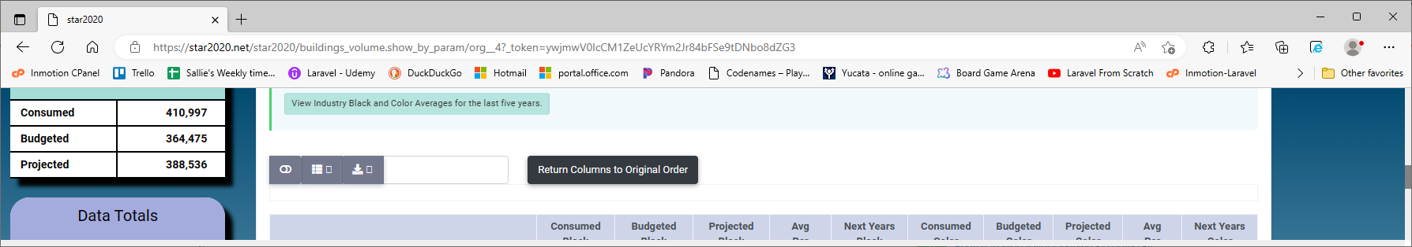

I do not like the first button, which just toggles between the user friendly view and a ‘card’ view. to remove it I had to delete the data-show-toggle="true" from the table tag (shown below).

<table id="myDataTable" class="myDataTable"
data-toggle="myDataTable"
data-show-export="true"
data-click-to-select="true"
data-toolbar="#toolbar"
data-show-toggle="true"
data-show-columns="true"
data-reorderable-columns="true"
data-show-footer="true"
data-show-print="true"
data-export-types=['xml', 'csv', 'excel']>

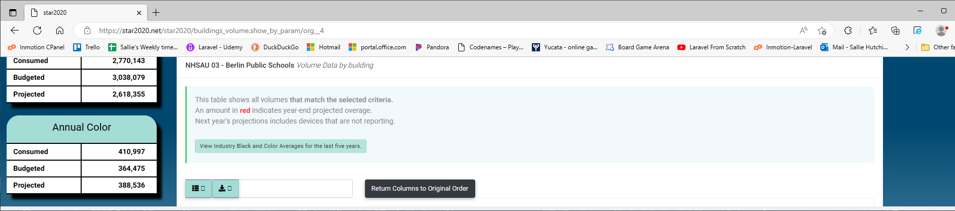

Just for information. The card view is shown below

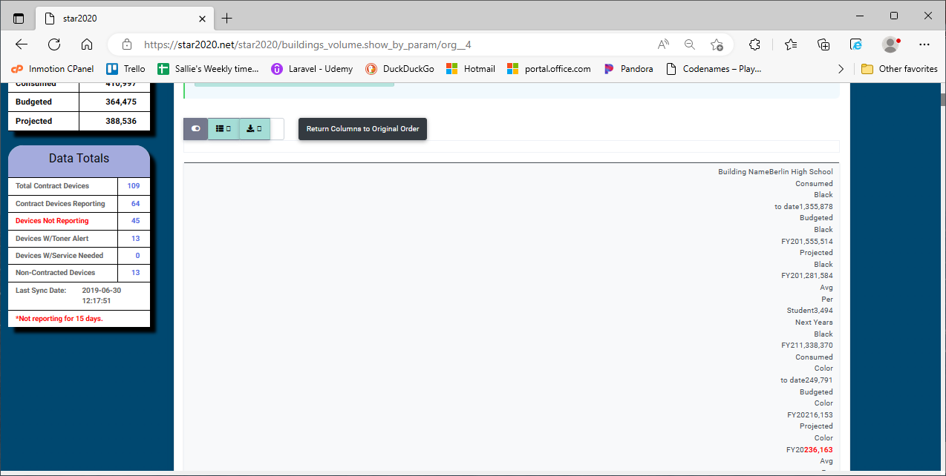
bootstrap-table column reordering will NOT work if the table is large enough to scroll. If you hide columns to the visible ones do not require scrolling, the drag and drop reordering WILL work. In the screenshot below, I have unchecked 3 columns and now the table fits without scrolling. I CAN drag and drop the columns to reorder them. If I select to show all of the columns, then I lose the drag and drop functionality.
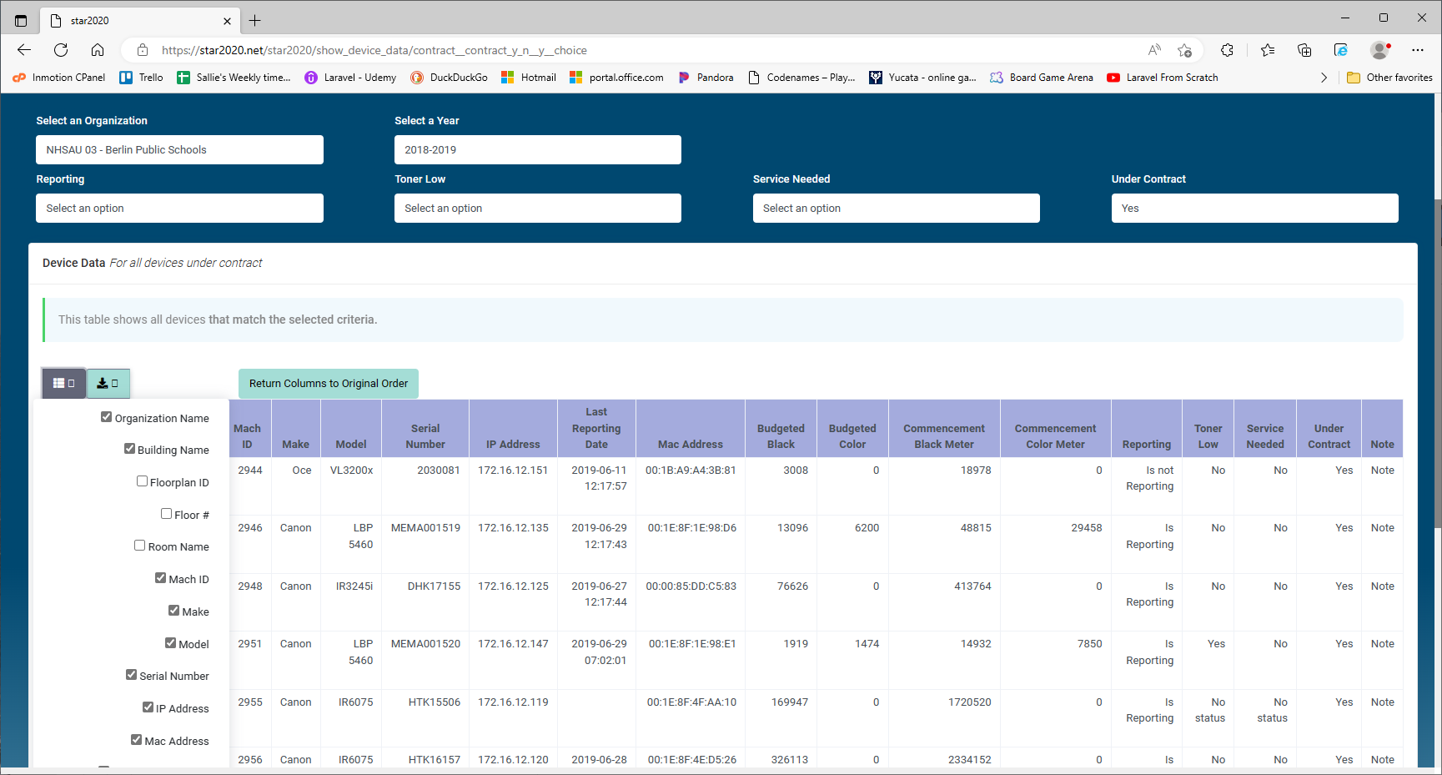

NOTE: data-pagination does NOT work with accordion tables.

more info
Bootstrap Table Examples (bootstrap-table.com)

Roles and Permissions are handled using a Gate, which is defined in AuthServiceProvider and called by separate controllers; GaugesController, ReportsController, etc.

IMPORTANT FOR MIGRATING DATA.
The AI (autoincrement) in the table structure of php my admin needs to be uncchecked. Once the beginning increment number is defined, it needs to be turned back on.
org_year_specific_data needs to be updated when the org_commencement_date is changed in the organizations table. This date is displayed at the top of the dashboard pages as Commencement Date.

