Hi Dave

I am working on the Dashboard pages and cannot locate the queries and formulas that are used for the gauges, Volume, and Cost pages in the Dashboard. Can you please tell me where to find them? I looked into some of the files you put on GitHub, but none of the ones that seemed like would have that code did have it.

Thanks,
Sallie

Hi Sallie,

You will find most of queries and formulas in the PHP files included from the dashboard pages.

For example, here are some of the key included PHP files for the Building Gauges dashboard:

spcsd/dashboard3.php = Building Gauges
dashboardheader3.php
device_data.inc.php
phpincludes/summary_tables.inc.php
phpincludes/devices_reporting.inc.php
phpincludes/org_service_history.inc.php
phpincludes/date_calc.inc.php
phpincludes/overbudget.inc.php

The other key dashboard pages will have some of the same or different includes depending on what was needed for the specific page:

dashboard.php = Building - Volume
dashboard7.php = Building - Cost

dashboard_department_gauges.php = Department - Gauges
dashboard_department_volume.php = Department - Volume
dashboard_department_cost.php = Department - Cost

I hope this helps.

Thanks,

Dave Hammond
Systems Consultant
Mason Associates, Inc.

Hi Sallie,

Here are some key portions of code for the gauges dashboard data.

dashboardheader3.php:

$projectedBlackPercent = round($total_projected_black_array[$ary_count]/$total_budgeted_blk_array[$ary_count]*100);

/* NOTE: $total_projected_black_array has one element per device*/
$total_projected_black_array[$ary_count] += $device['projected_black'];

/*NOTE: $total_budgeted_blk_array has one element per device*/
$total_budgeted_blk_array[$ary_count] += $device['budgeted_black'];

device_data.inc.php:

Here are some key portions of code from Function Get_Device_Data:
Around line 162:

$rs = ew_ExecuteRow("
SELECT fpm.id as machine_id, fpm.fmaudit_id, fpm.model_id, fpm.floorplan_id, fpm.room_number,
fpm.5_year_id, fpm.cpc_black, fpm.cpc_color,
fpm.commencement_date,
fpm.commencement_black_meter, fpm.commencement_color_meter,
fpm.x_position as x_pos, fpm.y_position as y_pos,
fpm.budgeted_blk as budgeted_black, fpm.budgeted_color,
fpm.serial_number, fpm.ip_address, fpm.vendor_device_id, fpm.under_contract,
fpm.is_proposed, fpm.present_floorplan_id, fpm.present_room_number, fpm.local_connection,
fpm.present_local_connection, fpm.present_serial_number, fpm.savedname, fpm.save_name_id,
fpm.new_vendor_device_id, fpm.present_x_position as present_x_pos, fpm.present_y_position as
present_y_pos, fpm.closeout_date, ma.make, ma.model, ma.is_color,
coalesce(ma.machine_image,'MissingDeviceImage.png') as machine_image, ma.features,
ma_pr.make as present_make, ma_pr.model as present_model,
ma_pr.is_color as present_is_color,
coalesce(ma_pr.machine_image,'MissingDeviceImage.png') as present_machine_image,
ma_pr.features as present_features, fp.id as floorplan_id, fp.building_id, fp.floor_number,
bd.id as build_id,
bd.building_name, org.id as org_id, org.org_name, org.org_type_id,
org.commencement_date as org_commencement_date, DisplayMeterData, MeterDataFeed,
org_message, org.cs_pres_black_rate, org.cs_pres_color_rate,
cs_prop_black_w_service, cs_prop_black_wo_service,
cs_prop_color_w_service, cs_prop_color_wo_service,
coalesce(mt.icon_type,'Unknown') as icon_type, coalesce(mt.type_name,'Unknown') as type_name,
mt.type as machine_type, mt.CoveredType,
coalesce(mt_pr.icon_type,'Unknown') as present_icon_type,
coalesce(mt_pr.type_name,'Unknown') as present_type_name,
me.black_meter, me.color_meter,
me.date_timestamp as meter_timestamp,
me_first.black_meter as first_black_meter, me_first.color_meter as first_color_meter,
me_first.date_timestamp as first_meter_timestamp,
ms.toner, ms.service_needed, dp.dept_name, orgcs.org_id as orgcs_id, orgcs.org_present_black_rate,
orgcs.org_present_color_rate, orgcs.org_proposed_black_without_service,
orgcs.org_proposed_color_with_service, rgcs.org_proposed_black_with_service,
orgcs.org_proposed_color_without_service, fpmc.fmc_costSavingsWithoutService,
fpmc.fmc_costSavingsWithService

FROM ".$table_year."floorplan_machines fpm
LEFT OUTER JOIN ".$table_year."machines ma on fpm.model_id = ma.id
LEFT OUTER JOIN ".$table_year."machines ma_pr on fpm.present_model_id = ma_pr.id
LEFT OUTER JOIN ".$table_year."floorplans fp on fpm.floorplan_id = fp.id
LEFT OUTER JOIN ".$table_year."buildings bd on fp.building_id = bd.id
LEFT OUTER JOIN ".$table_year."organization org on bd.org_id = org.id
LEFT OUTER JOIN ".$table_year."machine_types mt on ma.model_type = mt.id
LEFT OUTER JOIN ".$table_year."machine_types mt_pr on ma_pr.model_type = mt_pr.id
LEFT OUTER JOIN ".$table_year."meter me on fpm.id = me.machine_id AND me.date_timestamp = (SELECT max(i.date_timestamp) FROM ".$table_year."meter i WHERE i.machine_id = fpm.id and black_meter > 0 and date_timestamp < '".date_format($session_datetime,'Y/m/d H:i:s')."' and date_timestamp > '".date_format($startingDate,'Y/m/d H:i:s')."')

LEFT OUTER JOIN ".$table_year."meter me_first on fpm.id = me_first.machine_id AND me_first.date_timestamp = (SELECT min(k.date_timestamp) FROM ".$table_year."meter k WHERE k.machine_id = fpm.id and k.black_meter > 0 and k.date_timestamp < '".date_format($session_datetime,'Y/m/d H:i:s')."' and k.date_timestamp >= '".date_format($startingDate,'Y/m/d H:i:s')."')

LEFT OUTER JOIN ".$table_year."machine_status ms on fpm.id = ms.machine_id AND ms.date_timestamp = (select max(j.date_timestamp) from ".$table_year."machine_status j where j.machine_id = fpm.id and date_timestamp < '".date_format($session_datetime,'Y/m/d H:i:s')."' and date_timestamp > '".date_format($startingDate,'Y/m/d H:i:s')."')

LEFT OUTER JOIN ".$table_year."department dp on fpm.dept_id = dp.id
LEFT OUTER JOIN ".$table_year."org_service_rates orgcs on org.id = orgcs.org_id
LEFT OUTER JOIN floorplan_machines_calculations fpmc on fpm.id = fpmc.fmc_id
where fpm.id = ". $in_device_id);

Around line 362:

//Budgeted
if ($rs['org_commencement_date'] == NULL || $rs['org_commencement_date'] < date_format($startingDate,'Y-m-d'))
{
$budgeted_black = $rs['budgeted_black'];
$budgeted_black_cpc = $rs['budgeted_black'] * $rs['cpc_black'];
$budgeted_color = $rs['budgeted_color'];
$budgeted_color_cpc = $rs['budgeted_color'] * $rs['cpc_color'];
}
else {
$budgeted_black = ($rs['budgeted_black'] / $fiscalDays) * $org_fiscal_days;
$budgeted_black_cpc = ($rs['budgeted_black'] / $fiscalDays) * $org_fiscal_days * $rs['cpc_black'];
$budgeted_color = ($rs['budgeted_color'] / $fiscalDays) * $org_fiscal_days;
$budgeted_color_cpc = ($rs['budgeted_color'] / $fiscalDays) * $org_fiscal_days * $rs['cpc_color'];
}

Around line 435:

if ($rs['org_commencement_date'] == NULL || $rs['org_commencement_date'] < date_format($startingDate,'Y-m-d')) {
$projected_black = $consumed_black / $last_diff * 345;
$projected_black_cpc = $consumed_black_estimated_cpc / $last_diff * 345;
$projected_color = $consumed_color / $last_diff * 345;
$projected_color_cpc = $consumed_color_estimated_cpc / $last_diff * 345;
$projected_black_year = $projected_black;
$projected_black_year_cpc = $projected_black_cpc * 1.035;
$projected_color_year = $projected_color;
$projected_color_year_cpc = $projected_color_cpc * 1.035;
$projected_source = "first";
}
else {
$projected_black = $consumed_black / $cm_diff * min($org_fiscal_days, 345);
$projected_black_cpc = $consumed_black_cpc / $cm_diff * min($org_fiscal_days, 345);
$projected_color = $consumed_color / $cm_diff * min($org_fiscal_days, 345);
$projected_color_cpc = $consumed_color_cpc / $cm_diff * min($org_fiscal_days, 345);
$projected_black_year = $consumed_black / $cm_diff * min($org_fiscal_days, 345);
$projected_black_year_cpc = $consumed_black_cpc / $cm_diff * min($org_fiscal_days, 345) * 1.035;
$projected_color_year = $consumed_color / $cm_diff * min($org_fiscal_days, 345);
$projected_color_year_cpc = $consumed_color_cpc / $cm_diff * min($org_fiscal_days, 345) * 1.035;
$projected_source = "second";
}

Example for NHSAU42 - Nashua School District Amherst Street Elementary School

Projected Black / Budgeted Black = Projected Budget Usage
668231 / 795923 = 0.839 => 84%

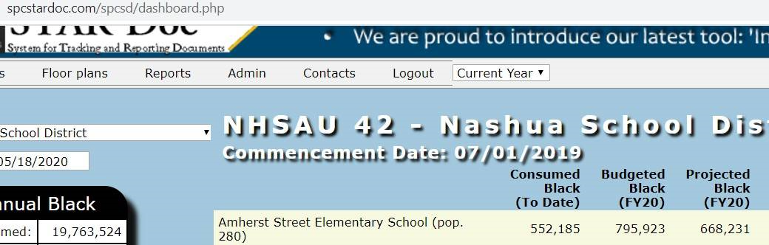

Y2019_ tables
Dave Hammond <daveh@masonassociates.com>
Mon 5/18/2020 10:35 AM

Hi Sallie,

Yes, the Ynnnn are tables are fiscal year-end snapshots that allow users to use the drop down year list to select a year to look at.

The primary SQL statement in Function Get_Device_Data sent in my prior email should provide information about how the floorplan_machines table is related to the other tables. An org may have multiple buildings; buildings may have multiple floorplans; floorplans may have multiple floorplan_machines.

Thanks,

Dave Hammond
Systems Consultant
Mason Associates, Inc.

From: Sallie Hutchinson <vStarSal@hotmail.com>
Sent: Sunday, May 17, 2020 8:44 PM
To: Robert Dutil <bobdutil@gmail.com>; Alex Webster <awebster@spccopypro.com>; Dave Hammond <daveh@masonassociates.com>
Subject: Dashboard pages

Hi Bob

I am having issues finding what data to bind to the gauges, as we discussed the other day. I also need to know about the Year tables (example Y2019_buildings). It looks like they are just year-end copies of the regular tables. Also, how do floorplan_machines_calculations and floorplan_machines connect to orgs or buildings?

We may need a meeting to discuss this. I am having difficulty with an estimate because I am not sure about these tables and how the data is connected.

Thanks,
Sallie

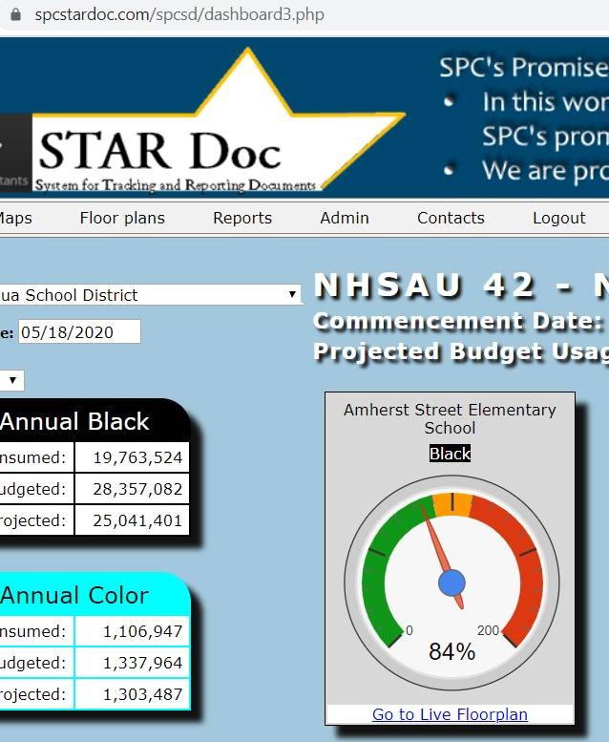

spcsd/phpincludes/overbudget.inc.php
$overUnderBudget = round($device['projected_black_cpc']) - round($device['budgeted_black_cpc']);
'overbudgetAmt' => money_format('%(.0n',$overUnderBudget)

$overUnderBudget = round($device['projected_color_cpc']) - round($device['budgeted_color_cpc']);
'overbudgetAmt' => money_format('%(.0n',$overUnderBudget)

// Calculate and set copy average per student by building
$overbudgetY = 0;
foreach ($building_name_array as $_total_building) {
$population_data = getBuildingPopulation($building_ID_array[$overbudgetY]);

if (isset($overbudgetBlackArray[$building_ID_array[$overbudgetY]])) {
$projected_black_building_total =
$buildingTotalsBlackArray[$building_ID_array[$overbudgetY]]['projected_black_building_total'];

if ($population_data[0]['StudentPop'] > 0) {
$buildingAverage =
number_format($projected_black_building_total/$population_data[0]['StudentPop']);
}

else {
$buildingAverage = 'N/A';
}

$overbudgetBlackArray[$building_ID_array[$overbudgetY]]['buildingBlackAverage'] = $buildingAverage;
}
$overbudgetY += 1;
}

