Create the project and install any dependencies and Set up authentication

- In the command line navigate to the laragon/www directory
- laravel new star2020 --auth //this is the newest and best way because it includes auth - NOTE: the auth option is no longer accepted as an option because it is automatically created when creating a new project. This is wrong. The routes were not created to see in routes:list till I used php artisan ui:auth. Now that I have run this command, maybe I can use the code in purple.
- 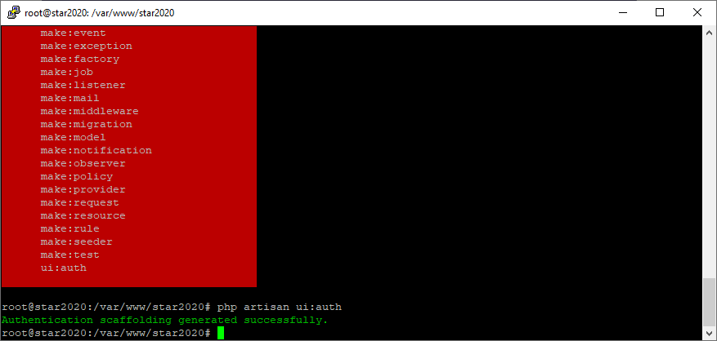

- use php artisan make:auth
- 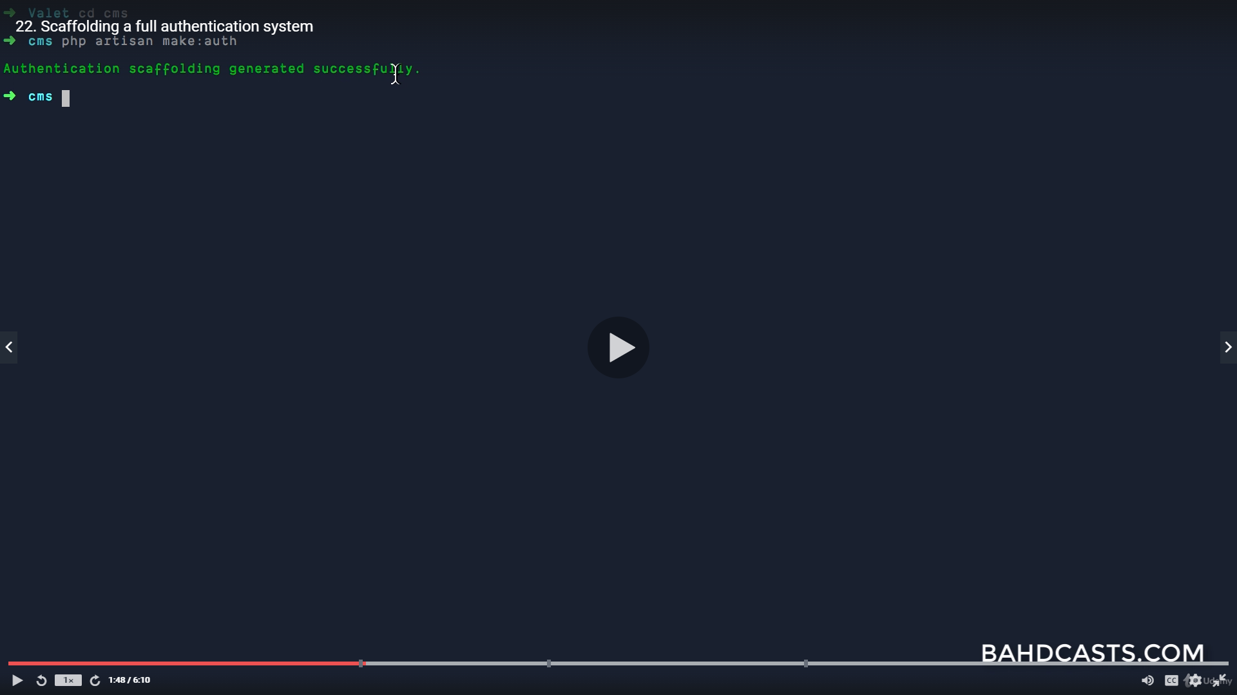
- composer create-project --prefer-dist laravel/laravel star2020 //this is the old way w/o auth
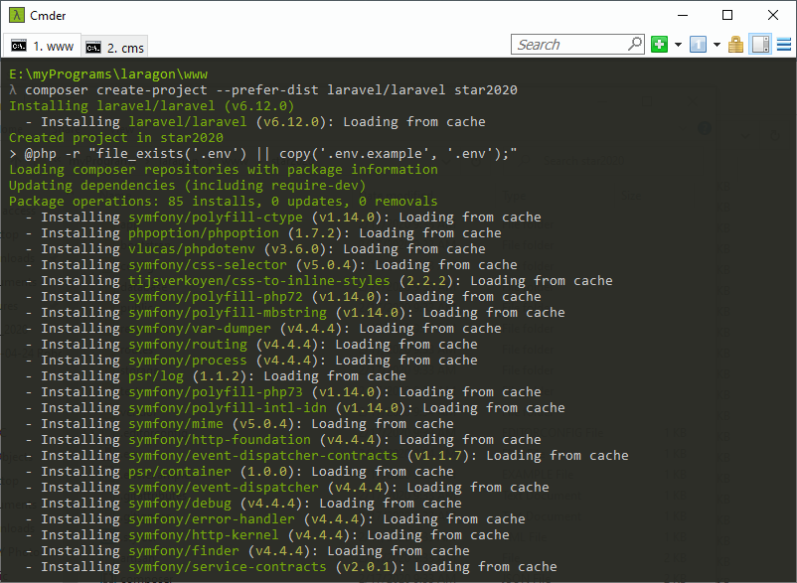
- Using the newer command will add Auth::routes and a route for home to web.php. 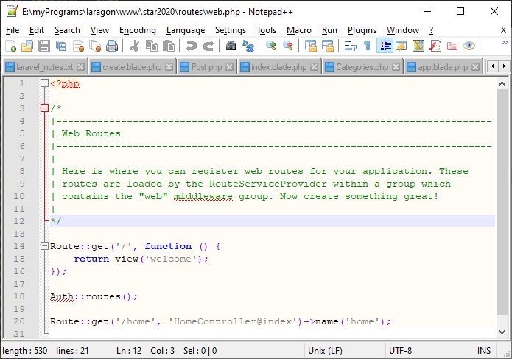

Auth::routes registers a list of routes for authentication. To see this list use php artisan route:list
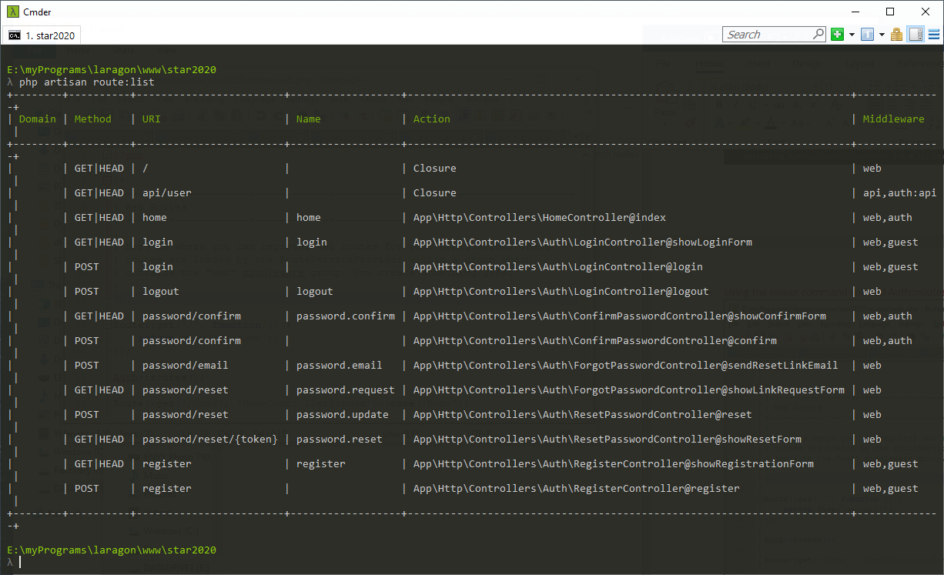

Create a db
- Using cPanel – go to MySQL Databases to create a new one.
- in command line type mysql -u root (mysql -u [root username] -p)
- then type create database star2020;
- Exit back to star2020 command line

Update the star2020/.env file to match application
- App_NAME = Star2020
- DB_DATABASE = star2020
- DB_USERNAME = root
- DB_PASSWORD = ""
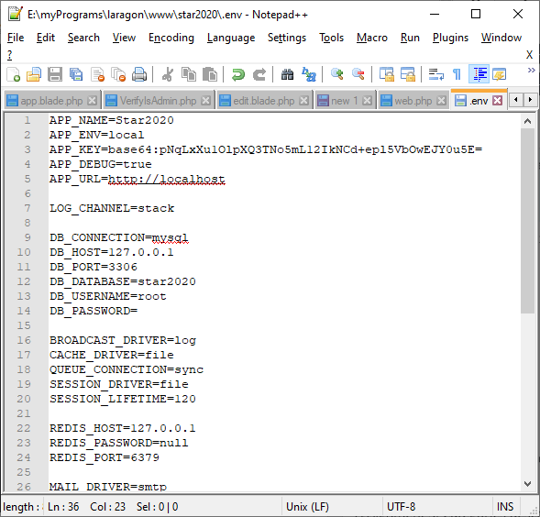

Create Model and table migration script at same time
php artisan make:model Phone -m
php artisan make:model Post -m

If ONLY a table migration is needed, prefix the table name with create and add table as a suffix.
This will cause laravel to create the stub for the table in the UP function

php artisan make:migration create_y2022_meters_table

stub created
Schema::create('y2021_meters', function (Blueprint $table) {
$table->id();
$table->timestamps();
});

Update migration scripts for custom columns
Beware:
- Integer columns cannot have length defined w/o causing error, due to the incrementing primary key column.
- Adding a comment to the laravel column timestamps causes an error, because it is actually a function that adds 2 date columns.
- If you delete the timestamps (default function) from migrations, then to avoid db errors when updating or creating - make the $timestamps = false; (in the model)
/*This is required if not using the default timestamps, because CRUD will look for these columns.*/
public $timestamps = false;
- Alter table statements are not allowed in the table definition. See below.

Create a migration script for table updates after creation. Alter statements must be done this way in laravel.
php artisan make:migration alter_tables_after_creation
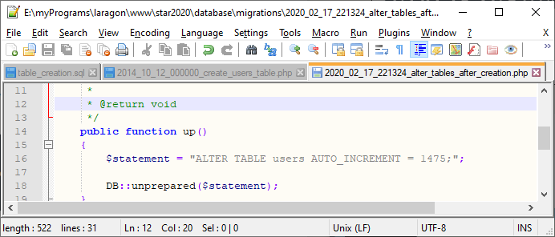

Run php artisan migrate to actually create the tables
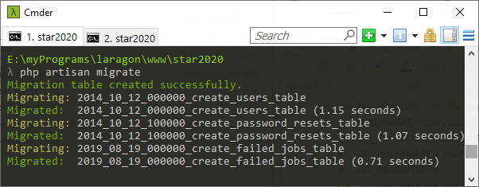

To migrate a single script use this command as shown below
php artisan migrate:refresh --path=/database/migrations/[the entire file name and extension goes here]
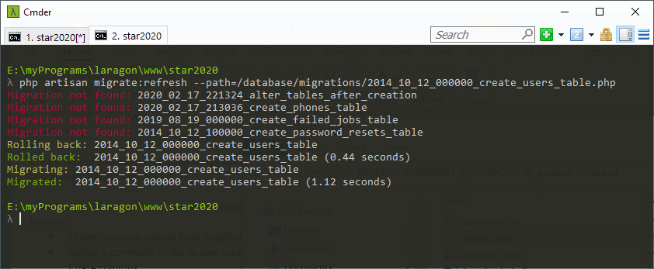

Directory structure should be:
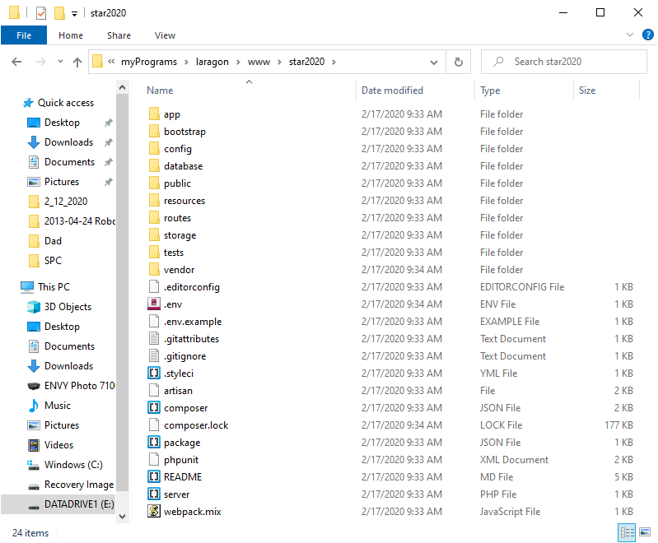

Start Server
- php artisan serve
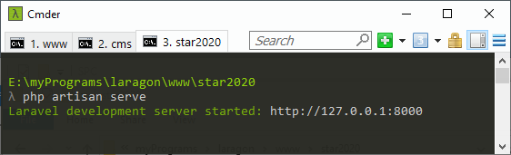

View in Browser on localhost at 127.0.0.1:8000
- This will display the home page of whichever project is currently started
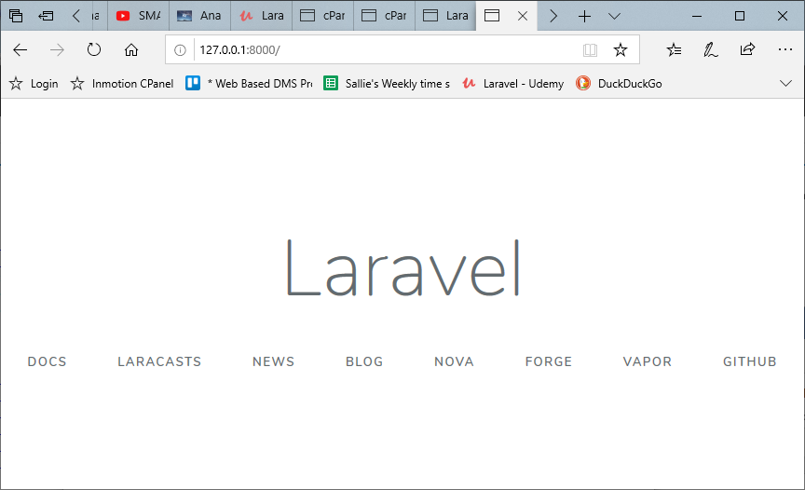

Create view in resources/views directory

Add the route to routes/web.php so the project knows which page to show.
- The path of the view is relative to the views folder. In the screenshot, welcome.php exists in views. If the path for welcome is views/basePages/welcome.php, this needs to be reflected in the return view method call.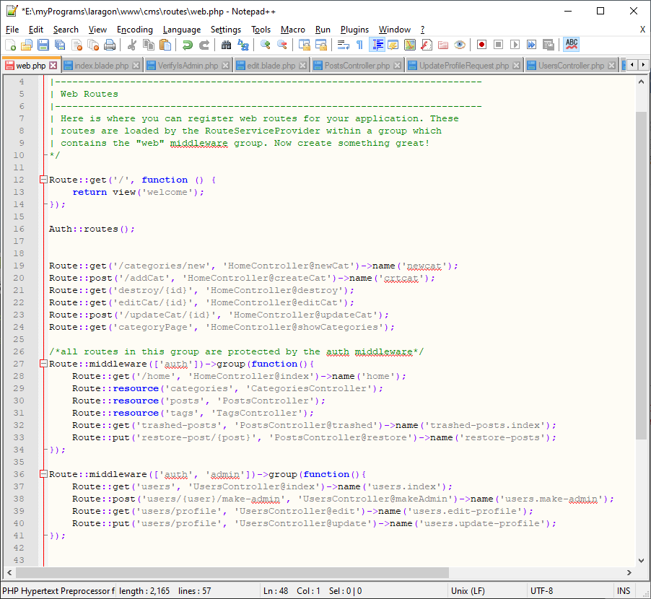
Controllers control what happens when a user visits a specific route
Controllers can be created in 2 ways
- In the folder hierarchy, manually create a .php page inside the Http/Controllers directory.
- In the command line, use php artisan
  - php artisan make:controller UsersController
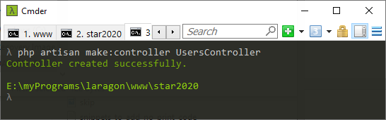

- using the command line is easier because it adds 3 necessary lines
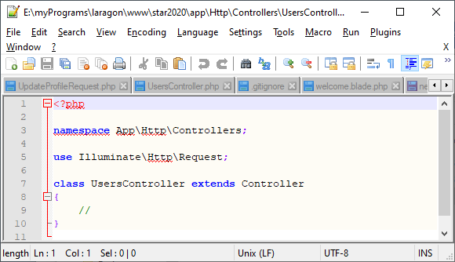

- Even better is to use the resource flag to add the default auth routes automatically
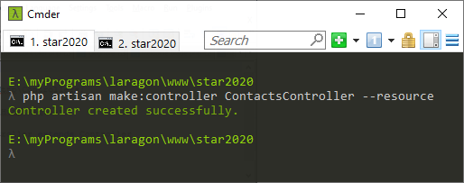

View the routes before registering all routes (below)
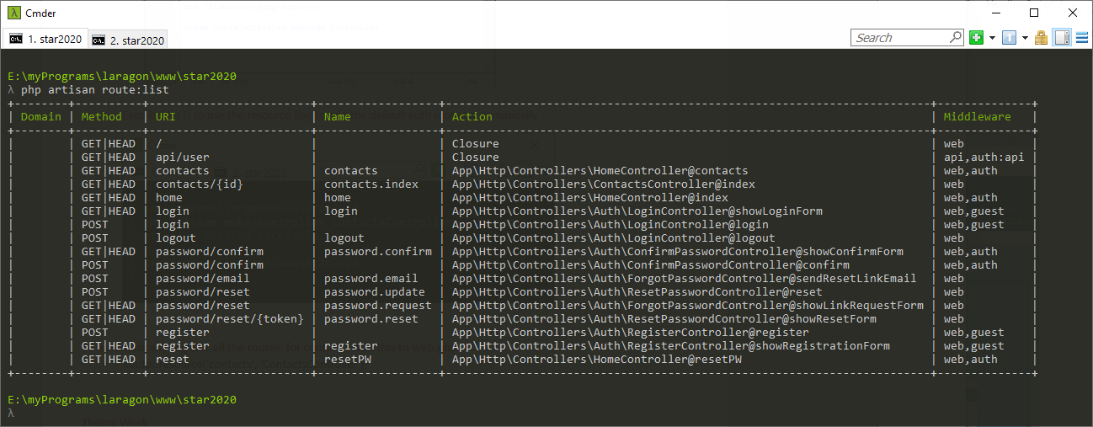
To automatically register all the routes for contacts. Add this to web.php
- Route::resource('contacts', 'ContactsController');

View the routes again, after registering the routes (above) - The default routes are now in the list.
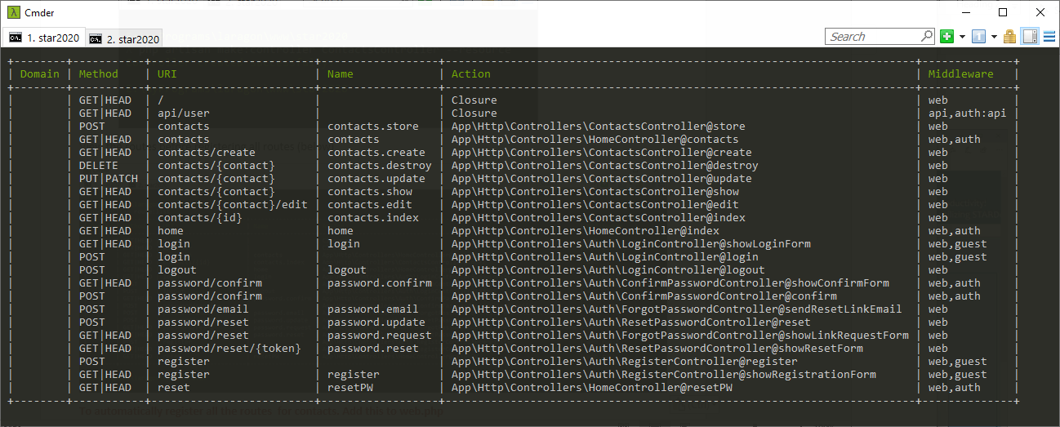

Two ways to call a route - The first is best because it is dynamic. It uses the route name instead of the route uri
- <a href="{{route('categories.create')}}" class="btn btn-success"><Add Category</a>
- <a href="categories/create" class="btn btn-success"><Add Category</a>

Naming custom routes
Route::get('home', 'HomeController@index')->name('home');

Using Request data
To save data to the db, in the controller add to the store function.
public function store(Request $request){
$this->validate($request, [
'name' => 'required|unique:categories' /*name is required and must unique in the categories table*/
]);
}

Message alerts
@if($errors->any())
<div class="alert alert-danger">
<ul class="list-group">
@foreach($errors->all() as $error)
<li class="list-group-item text-danger">
{{$error}}
</li>
@endforeach
</ul>
</div>
@endif

session()->flash('success', 'Category created successfully');

view #26 intro to request objects again to restrict views to roles, etc.

Add a custom request
php artisan make:request ShowContactRequest
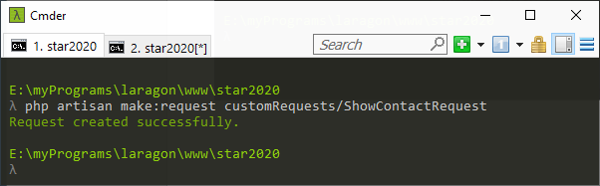

Middleware

CheckForMaintenanceMode
php artisan down - puts app into maintenance mode
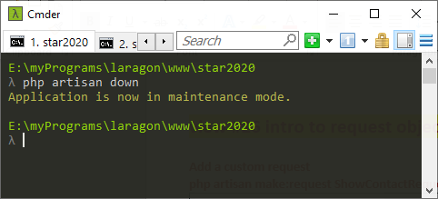
php artisan up - puts it back online
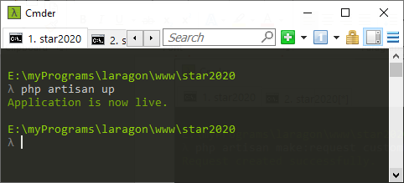

When in maintenance mode this error is displayed
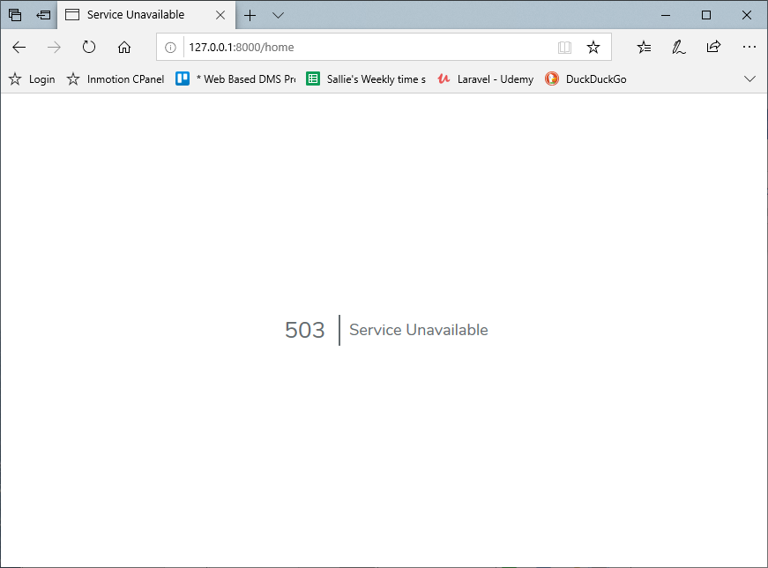

RedirectIfAuthenticated
If a user is authenticated, they will not be able to get to the login page, but will be redirected to HOME.

To apply existing middleware
- Add to web.php
  - This works! Route::resource('contacts', 'ContactsController')->middleware('auth');
  - This won't work because the middleware must be chained to a resource???
    - Route::get('contacts/{id}', 'ContactsController@index')->name('contacts.index')->middleware('auth');
To create custom middleware
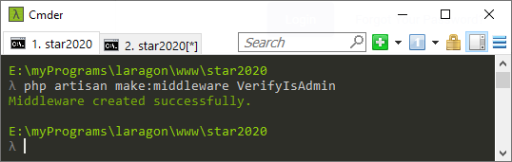
This creates a middleware file called VerifyIsAdmin and places it into the app/ Http/Middleware directory
- Go to Kernel.php, which is the controller for middleware:
  - Add this at the top of Kernel.php - - use App\Http\Middleware\VerifyIsAdmin;
  - Add this to the list of protected $routeMiddleware - - 'verifyIsAdmin' => VerifyIsAdmin::class
- Go to web.php and add the new middleware in an array (using the camelcase name) - this applies to all routes
  - Route::resource('contacts', 'ContactsController')->middleware(['auth', 'verifyIsAdmin']);
- To only apply the verifyIsAdmin to specific routes, add it into the controller instead, by creating a constructor
public function __construct(){
$this->middleware('verifyIsAdmin')->only(['create', 'store']); //will verify admin for only these 2 routes.
}
- Add column to users table using enum type - - $table->enum('role', ['writer', 'admin'])->default('writer');
- Or, add column as regular string - - $table->string('role')->default('writer');
- Go into User.php model and create function isAdmin
public function isAdmin(){
return $this->role == 'admin';
}
- Go into app.blade and add this wrapper to content that is visible by role
@if(auth()->user()->isAdmin())
@endif

Grouping routes for middleware
In the web.php file - add a function that will protect all routes within that function, with the auth middleware.
Route::middleware(['auth'])->group(function(){
Route::get('home', 'HomeController@index')->name('home');
Route::resource('posts', 'PostsConroller');
});

These follow the @csrf in the form
@method('PUT")
@method('PATCH")
@method('DELETE")

{{isset($organization) ? 'go to the contacts page : else load the org list }}

Link the storage folder to the public folder using
php artisan storage:link

Relationships
public function category() /*The name of the model in lowercase is category. This function goes in the Post model*/
{
return $this->belongsTo(Category::class); /* Category is the name of the class*/
}

public function posts()
{
return $this->hasMany(Post::class); /*This means Category has many posts*/
}

For this to work, the foreign key col in the child table must be the name of the model in lowercase + _id. Here it would be category_id. Make sure this col is in the posts table.

Using Tinker to interact with the db via the command line
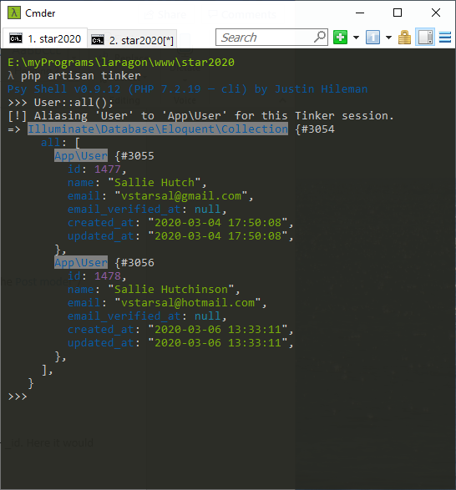

Route::get('/posts/{post}', [PostsController::class, 'show']);

in PostsController create function show()
public function show(){
return view('blog.show');
}
Creating custom request objects
- php artisan make:request CreateMeterRequest

- Add validation rules in the rules function
public function rules()
{
return [
'machines_id' => 'required'

];
}

- Set the authorize function to return true (for now). This can limit access.
public function authorize()
{
return true;
}

- Add a use import to the controller that will use this request object
use App\Http\Requests\CreateMeterRequest;

Data from joined tables
create JoinTableController

add this declaration at top - - use DB;

function index(){
$data = DB::table('city')
->join('state', 'state.state_id', '=', 'city.state') /*joins the state table where state_id = city.state */
->join('country', 'country.country', '=', 'state.country')
->select('country.country_name', 'state.state_name', 'city.city_name')
->get(); /*executes the query and returns data, in an array, which will be stored in the $data variable.*/
return view('join_table', compact('data'));
}

web.php - add route
Route::get('join-table', JoinTableController@index');

Adding a where clause to a joined query
public function show($contact)
{
$data = DB::table('organizations')
->join('people', function ($join) {
$join->on('people.organization_id', '=', 'organizations.id')
->where('organization_id', '=', '56');
})
->get();

return view('contacts.show', compact('data'));
}

I couldn't access the organizations.id because the organization_types.id was overwriting it, so I changed the order of
tables listed, making the organizations table the 2nd table. I do not know why the 2nd would overwrite the first, but it works with the tables ordered like this.

$orgdata = DB::table('organization_types')
->join('organizations', function ($join) use ($type_id){
$join->on('organization_types.id', '=', 'organizations.org_type_id')
->select(DB::raw('organizations.*', 'organization_types.org_type_name'))
->where('org_type_id', '=', DB::raw($type_id));
})
->get();

return view('organizations.index', compact('orgdata', 'type_id'))->with('data', OrganizationType::orderBy('org_type_name')->get());

Issues using contacts as route - (apparently reserved in SmartAdmin theme)
I struggled with this for a day and found that there are contacts routes in the smartAdmin theme. My contacts.index was not being registered, so I changed the name of my Model to OrgContact and the controller to OrgContactsController and now it works.

Using a variable ($contact was passed to the function in the controller)
$data = DB::table('organizations')
->join('people', function ($join) use ($contact){
$join->on('people.organization_id', '=', 'organizations.id')
->where('organization_id', '=', DB::raw($contact));
})
->get();

Select option = selected
@foreach($categories as $category)
<option value="{{$category->id}}"
@if(isset($post))
@if($category->id == $post->categories_id)
selected
@endif
@endif
>{{$category->category_name}}</option>
@endforeach

if/else
<!--Display all orgs from the resultset. If org.id = the id that was passed in the compact args, make that org the selected one in the dropdown.-->
@if($org->id == $id)
<option value="{{$org->id}}" selected>{{$org->org_name}}</option>
@else
<option value="{{$org->id}}">{{$org->org_name}}</option>
@endif

Theme Work view #27 updating categories
copy fonts folder from the theme/assets folder to cms/public

Great urls of information:
https://xpertphp.com/laravel-6-joins-example-tutorial/

To add to the $PATH variable (~ is the root folder named root, NOT the doc root for the site, I believe)
export PATH=~/.composer/vendor/bin:$PATH

root@star2020:/usr/local/bin# echo $PATH
/root/.composer/vendor/bin:/usr/local/sbin:/usr/local/bin:/usr/sbin:/usr/bin:/sbin:/bin:/usr/games:/usr/local/games:/snap/bin

root@star2020:/usr/local/bin# export PATH=/usr/local/sbin:/usr/local/bin:/usr/sbin:/usr/bin:/sbin:/bin:/usr/games:/usr/local/games:/snap/bin

root@star2020:/usr/local/bin# echo $PATH
/usr/local/sbin:/usr/local/bin:/usr/sbin:/usr/bin:/sbin:/bin:/usr/games:/usr/local/games:/snap/bin

export PATH=~/var/www/star2020/storage:$PATH

