Bad data
floorplan_machines has 2 records for serial_number PHB5D59270.
- id = 0
  - save_name_id 1739
  - commencement_date 2022-01-21
  - commencement_black_meter 36467
  - commencement_color_meter 0
  - 5_year_id 387
- id = 44808
  - save_name_id NULL (**CREATED FROM FMAUDIT FEED**)
  - commencement_date 2022-06-20
  - commencement_black_meter 13261
  - commencement_color_meter 0
  - 5_year_id NULL

Counts discrepancies – StarDoc vs stardms
Stardoc has 19 non-reporting machines. All but 1 of them have no meter reads after 6-30-2023. I did not import meter records earlier than 2023-07-01. SHOULD I ???

Dunbarton – not reporting count is off. Consumed and projected are also off.
I have 4 machines as not reporting, while starDoc has only 3.
Dunbarton has serial number AAFK011001518 as last reporting on 9/17/23, 10/24/23, but there are no records in the meter table beyond 2023-06-30 00:00:00. The last reporting date in machine_status is 2021-06-23 04:09:08. I don’t know where this date of 9/17/23 10/24/23 comes from.
select * from meter where serial_number = 'AAFK011001518' order by date_timestamp desc;
select * from machine_status where serial_number = 'AAFK011001518' order by date_timestamp desc;
Consumed is also off for this same serial_number because starDoc lists a consumed volume of 1,272. Since there are NO METER READS after 2023-06-30 00:00:00, I do not know where tis 1,272 comes from.
StarDoc total consumed 113400
- Star2020 consumed 112128
equals 1272 This is the exact amount that is listed as consumed for this serial_number

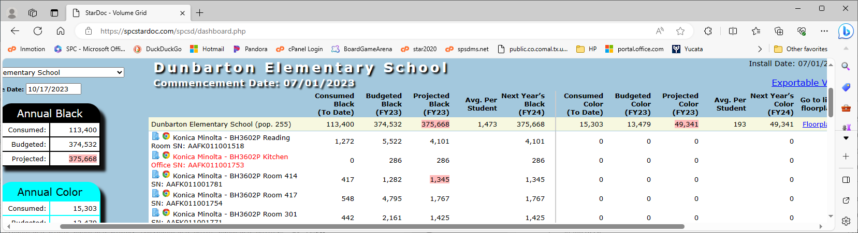
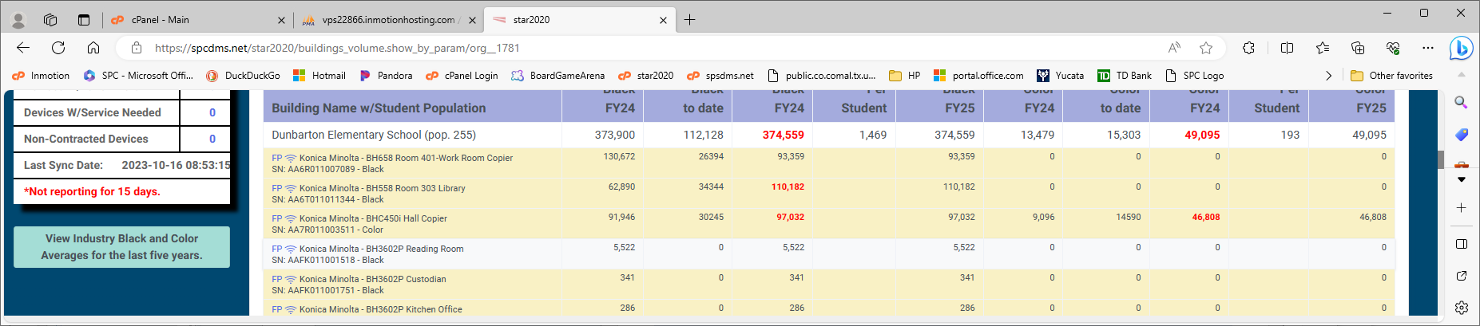
Serial number AAFK011001775 has a budgeted blk vol of 632, which also makes the projected by 632. This machine is not listed on star2020.
StarDoc total budgeted 374532
- Star2020 budgeted 373900
equals 632 This is the exact amount that is listed as consumed for this serial_number

This was caused because this machine was NOT in star2020.floorplan_machines. I have resolved it . . .
I have updated fpm record for AAFK011001775, id 39752. FYER_Group 1770 is Dunbarton Elementary KMBS. This savedname value was NULL. I updated it to Dunbarton Elementary KMBS. Is this correct? It was causing this machine to NOT be selected for migration into star2020 due to the criteria AND savedname != '**CREATED FROM FMAUDIT FEED**'.

NHSAU 40 Milford School District – toner count is off.
I have 0 machines needing toner, while StarDoc shows 7 . The toner value in the prod db is 0 for all 7. A boolean 0 represents no/false.
select * from machine_status where serial_number IN('CRBN47623',
'CRCN49179',
'CRBN47606',
'CRBN47586',
'CRBN47638',
'701931710G8K9',
'CSFN47305') order by serial_number asc, date_timestamp desc;

My findings
- 'CRBN47638' is not even in the machine_status table
- All of the other 6 machines have 2 status records for the EXACT time, with different machine_ids, but all still have 0 for toner.

Missiquoi Valley School District – toner count is off.
I have 0 machines needing toner, while StarDoc has 1.
This is ok, because I have not imported this record into stardms and all of the previous records for this machine (ACET011002216) showed no toner was needed.
Oddly, in reference to the previous findings in orange, there is a 1 for toner, which means yes/true.

Essex Westford – toner count is off – After import on 10/8/23, counts are correct.
I have 7 machines needing toner, while StarDoc has 8.
Stardoc has ACET011008195 as needing toner with a last reporting date of 9/18/2023
This is ok, because I have not imported this record into stardms and all of the previous records for this machine (ACET011008195) showed no toner was needed.

Harwood Unified Union School District
I have 6 machines needing toner, while StarDoc has 7.
Stardoc has RF70405884 as needing toner with a last reporting date of 9/18/2023
This is ok, because I have not imported this record into stardms and all of the previous records for this machine (RF70405884) showed no toner was needed.

NHSAU 36 White Mountains RSD -Consumed black is off by 5,975.
Serial number AA7R011021261 is off by this much. Star2020 does NOT list this machine.
This machine has a closeout date of 2022-04-12 so it should not be listed on stardoc either.

NHSAU 64 – Milton – Consumed black is off – Star2020 has more vols and also has 1 extra machine
Star2020 has consumed value of 196,288. StarDoc has 194,761. The diff of 1,527 is the amount belonging to serial_number 701930810FXFP
This machine SHOULD be listed as it is on star2020. The is_proposed field in floorplan_machines is NULL in the prod db.
StarDoc relies on the is_proposed field being Y. In star2020, we are NOT relying on this field. We are relying on whether or not the machine is in floorplan_machines AND has a save_name_id.

RSU 37 – MSAD 37 Consumed black is off by 484
StarDoc has an extra machine, that is NOT on star2020. This machine has 484 consumed black.
This machine has a closeout date of 2021-06-30, so should NOT be displayed on starDoc either.
The is_proposed field is Y for this machine. Possibly that is why it is in starDoc???

Essex Westford – consumed is off (way off for Albert Lawton building) – STAR2020 is accurate for consumed and budgeted, I believe.
Thomas Fleming Elementary shows serial_number ACET011007922 with consumed of 81, which is the amt off from star2020 for that building. Budgeted value is 992. This machine has a closeout_date of 2022-01-17, which was BEFORE the end of the previous fiscal year. I do not believe this should be counted in the volumes for this fiscal year. Am I correct??

Albert D. Lawton Intermediate shows a 0 consumed volume and 202,681 budgeted for serial_number ACV7011001648. Star2020 has 33,249 for consumed and 202,681 for budgeted.The discrepancy is because starDoc is using the value associated with the **CREATED FROM FMAUDIT FEED** record. There are 2 records in floorplan_machines for this serial_number. See Berlin issue below.

Essex Elementary School shows serial_number AA7N011007342 with a consumed value of 40,900, which is the amt off from star2020 for that building. Budgeted value is 196,065. This machine has a closeout_date of 2022-01-31, which was BEFORE the end of the previous fiscal year. I do not believe this should be counted in the volumes for this fiscal year. Am I correct??
40,900 + 81 – 33,249 = 7,732. This is the total amount that consumed is off for Essex.
The extra volumes on starDoc total - - - 196,065 + 992 = 197,057
Subtracting star2020 total budgeted from starDoc total budgeted gives 6,456,374 -6,259,317 = 197,057

Essex Westford – not reporting is off
I have 28 rows as not reporting, while starDoc only has 21.
Bad data -
There is an extra machine listed for stardoc; machine ACV7011001648 and (last reporting date as NULL), which is not in my list. There are 2 records in floorplan_machines for this serial_number. The records have different floorplan ids and different building ids. My query is based on a machine only having 1 of each of these ids, so this record will not show in my list. This needs to be addressed. For now, I have remigrated the floorplan_machines table with criteria
savedname != '**CREATED FROM FMAUDIT FEED**'.
I still do NOT have this machine as not reporting, but that is CORRECT. The most current date in meters is 9/16/23. So. . . this should NOT be on starDoc’s list either.

These 8 machines are in my list, but not in stardoc’s. I have modified my query to correct this.

These machines DO have fyer_groups_id, non proposed_model_ids = 790, and they are in the meters and machine_statuses tables with current reporting dates. So they should NOT be in my list.

select * from floorplan_machines where proposed_serial_number IN('ACET011006730',
'ACET011006714',
'ACET011006689',
'ACET011007920',
'ACET011008051',
'ACET011006612',
'ACET011006628',
'ACET011007068');

NHSAU 43 – Newport – Consumed black is off by 47,522 - - - - Budgeted is off by 2,779,131
Star2020 has 46 more contracted devices listed than starDoc.
There are 55 machines in floorplan_machines(prod) with the save_name_id of 1703, but Alex says there are only 10.
One of these 4, Serial number JPBCJ8H0SK, is off by this much. Black meter = 47522 on 10/25
The other 3 machines are listed in the floorplan_machines table. All closeout dates are NULL, BUT the 5year id = 0 for all 4. The save_name_id for all 4 is 1703, which is the ID in tblWhatif. The save_name_id in tblWhatif for this ID of 1703 = 272. There is NO record in tblWhatif with a save_name_id of 1703. ???????
- CGCG65257 -no meter reads
- CGDG68415 -no meter reads
- CIIF11849 – most current meter read 2017-03-14 09:33:53 -most current status report 2017-03-30 03:02:02

Wiscasset School District – Budgeted volumes off.
The org_commencement date is 2023-07-01. starDoc checks to see if the org_comm_date < starting date, but it is = the starting date, so with starDoc’s code the value is determined as pro-rated by calculating budgeted_black/ fiscalDays * org_fiscal_days. THIS IS BAD DATA due to the calculation.
To test this, I changed the org comm date temporarily in the production db, then refreshed starDoc and the values were consistent with star2020.

NHSAU 03 Berlin Public Schools – non-contract devices count is off
Issue is the records with savedname of **CREATED FROM FMAUDIT FEED**
2SQ02638 has 2 records in floorplan_machines; 1 record with this savedname and 1 with a real savedname. The real record has a save_name_id, so it is a contracted device, but StarDoc lists it as noncontract because their code is using the other record.
The remaining machines have ONLY records in floorplan_machines with **CREATED FROM FMAUDIT FEED**. There are no duplicates, which leads to the question; Are these records that should be in floorplan_machines? In order to get other counts to come out true to the data, I did NOT import any records with this savedname.
If these SHOULD be in the table, then the floorplan_machines data should be cleaned up so there are not dupes of serial_numbers. If this is done, then I could migrate data over with this savedname. If no contracted machines have this savedname, then importing records, with this savedname, into stardms would be reasonable.
select * from floorplan_machines
where serial_number IN('MEMA001713',
'HQR02193',
'HQR12669',
'CN37G4B0KN05YY',
'CN37G4B0N605YY',
'CN28E2B1VP05XX',
'CN37G4B0K805YY',
'HJY53465',
'CN81A6M00J',
'U63571J6F174049',
'2SQ02638',
'X7WM001017')

Floorplan_machines has a lot of bad data
- 44 records with serial_number = 0 and present_serial_number = empty space.
select * from floorplan_machines where serial_number = '0' and present_serial_number = '';
- 114 records of dupes, where 1 of each record has the savedname of **CREATED FROM FMAUDIT FEED**. These records are causing bad data on starDoc because there are 2 records in floorplan machines for many serial numbers. StarDoc code is reading the wrong record.
select id, fmaudit_id, serial_number, present_serial_number, savedname, save_name_id, date_created, fp_mod_dts, model_id, floorplan_id, 5_year_id, is_proposed, under_contract, commencement_date, commencement_black_meter, commencement_color_meter
from floorplan_machines
where serial_number IN(select serial_number
from floorplan_machines
group by serial_number
having count(serial_number) > 1)
#and savedname != '**CREATED FROM FMAUDIT FEED**'
and serial_number != ''
order by serial_number desc, date_created asc;

