Changing the dropdown timeline date changes the total in the totals box, but when you click on the total hyperlink, the page displays the total based on 06/30 of the year in the year dropdown.
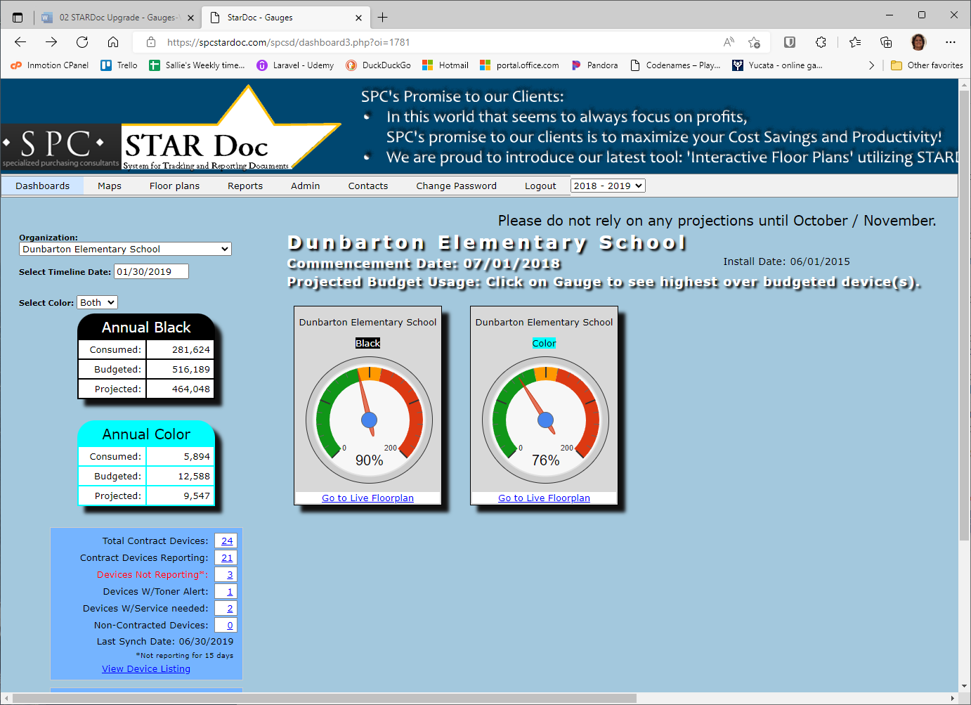
I clicked the 21 and the page displays 23.
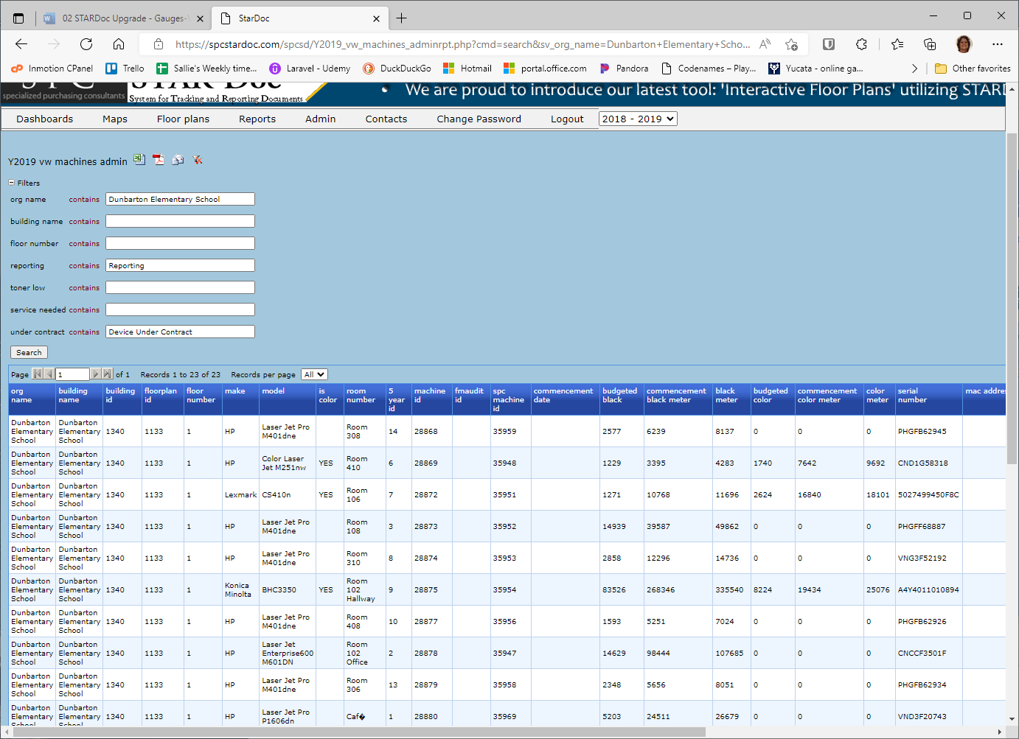
Clicking on the year dropdown, resets the timeline date to 06/30/2019 (I selected 2018-2019), so the total for Contract Devices Reporting is now 23.
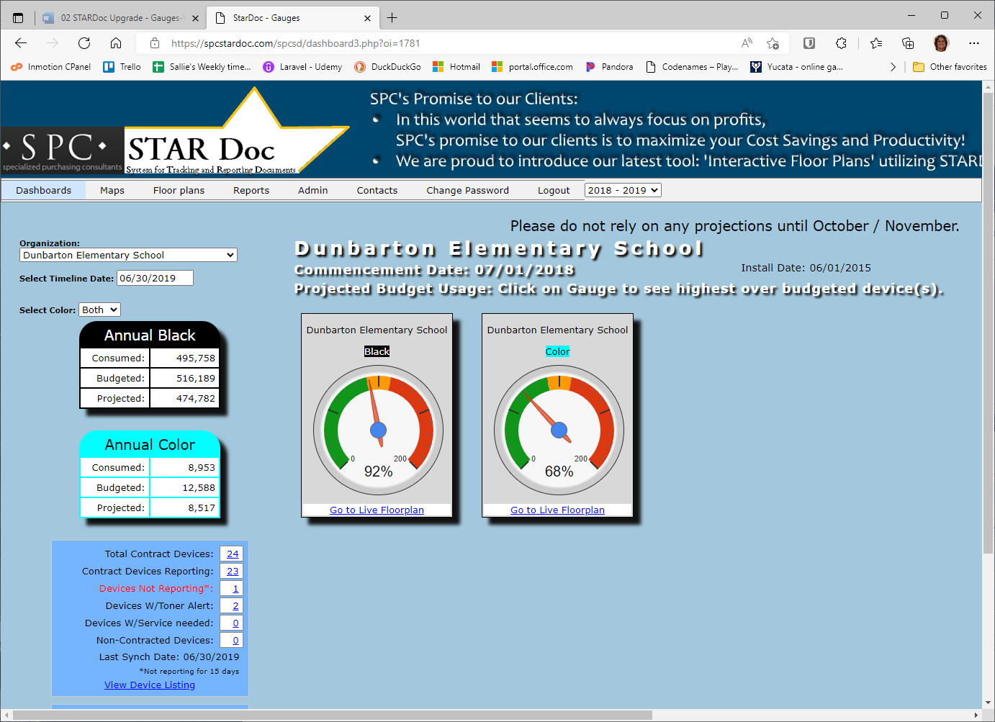
The page displayed with the 23 hyperlink contains 23 records.
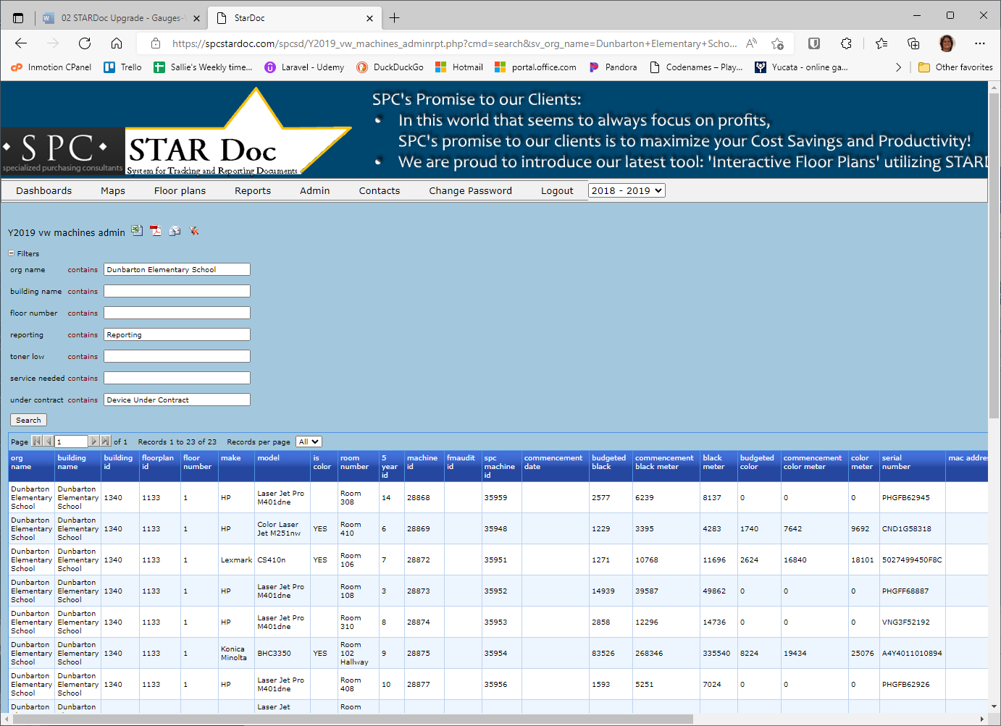

My questions are:
- Do you want the records displayed on the page returned by the hyperlink to be the same amount as the total in the box? If so, they would be determined by the snapshot in time by the date in the timeline box.
- Do you want the total to be determined by the timeline date as it is now? I believe this is a yes.

