Passing id to edit route

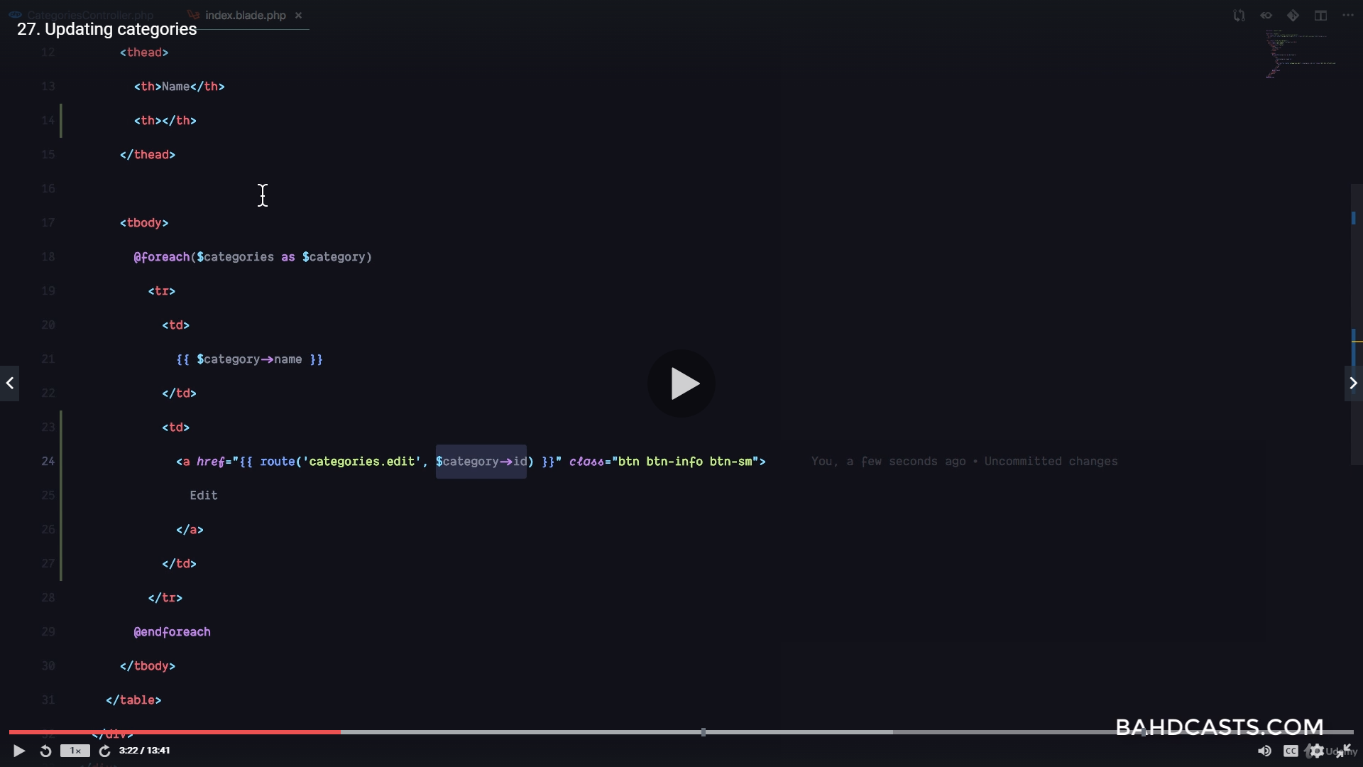
if isset
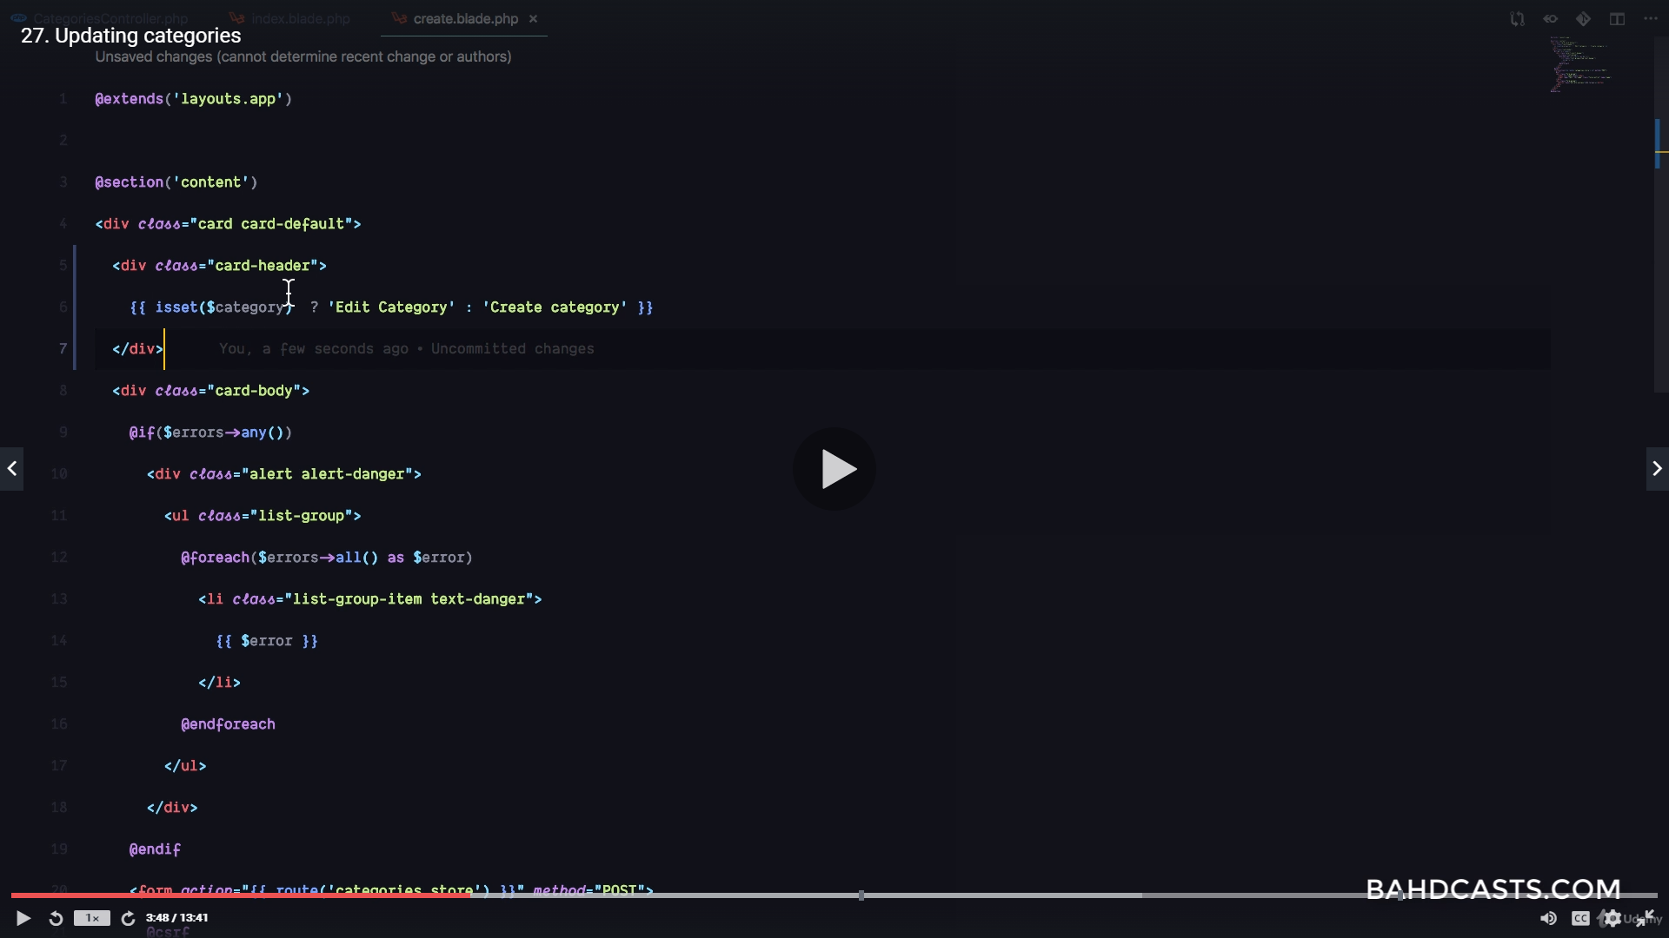
if isset put $category->name here, else leave it an empty string
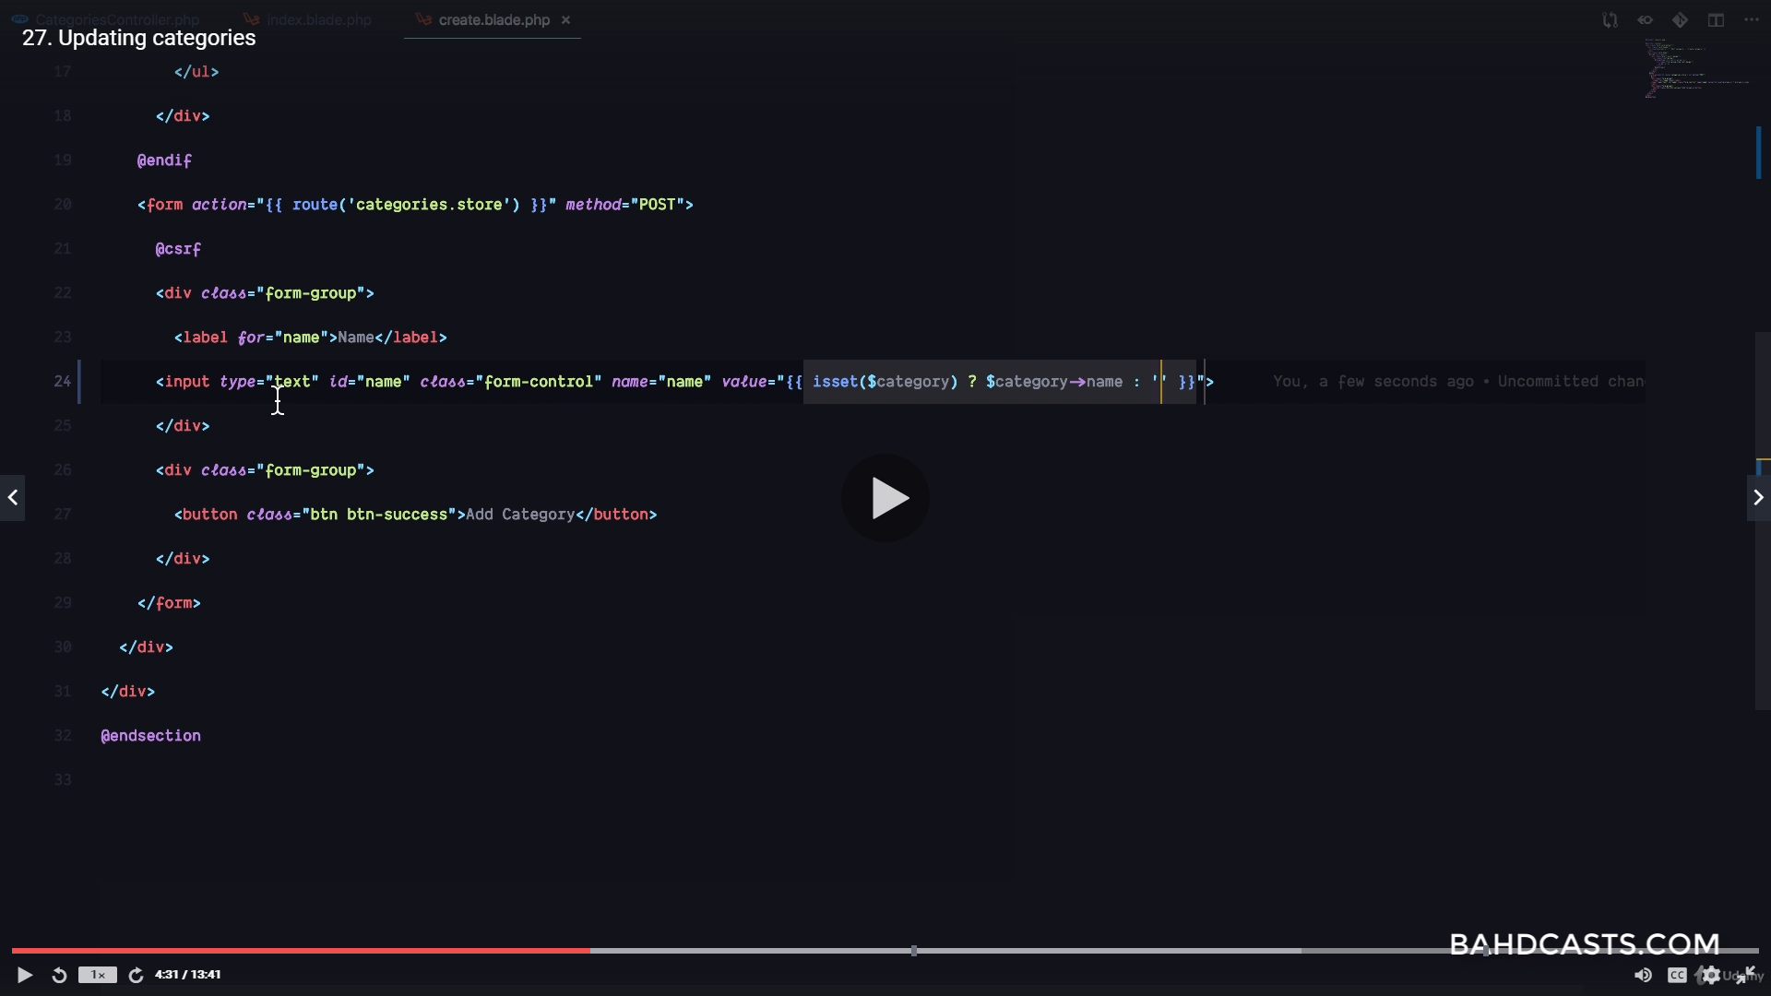
isset with routes
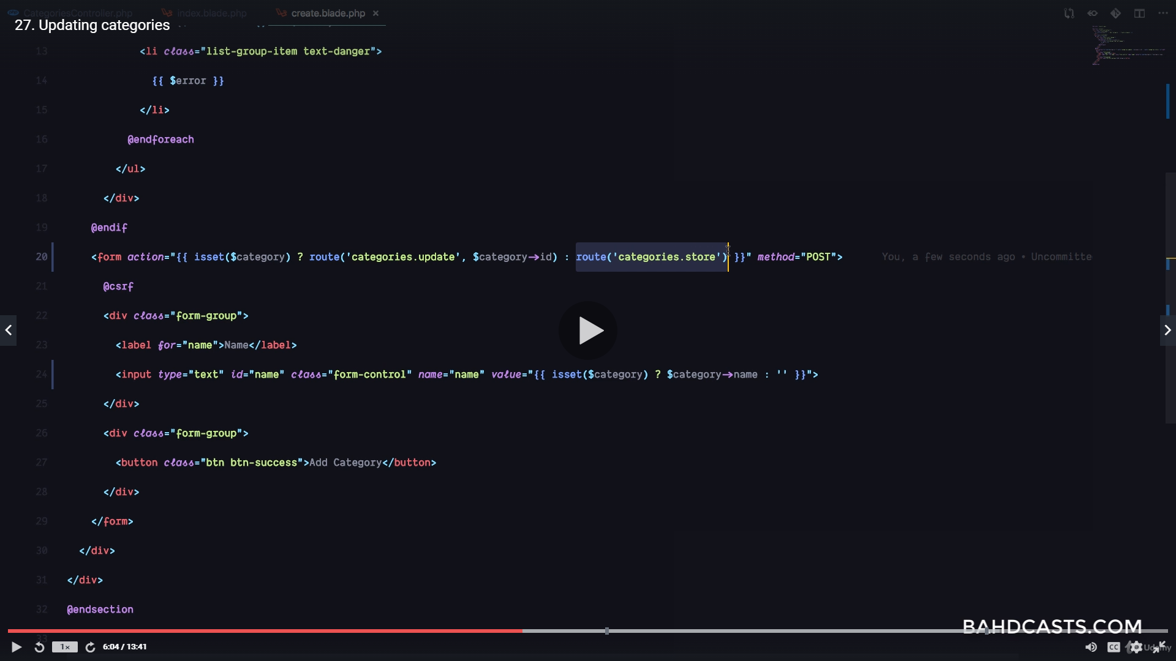
using put and patch for update
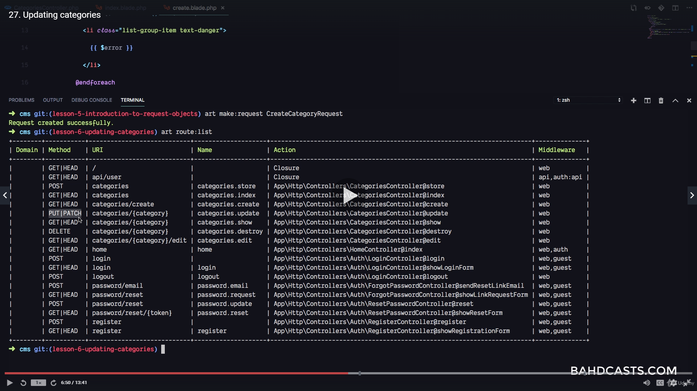
add directive for put, patch, or delete
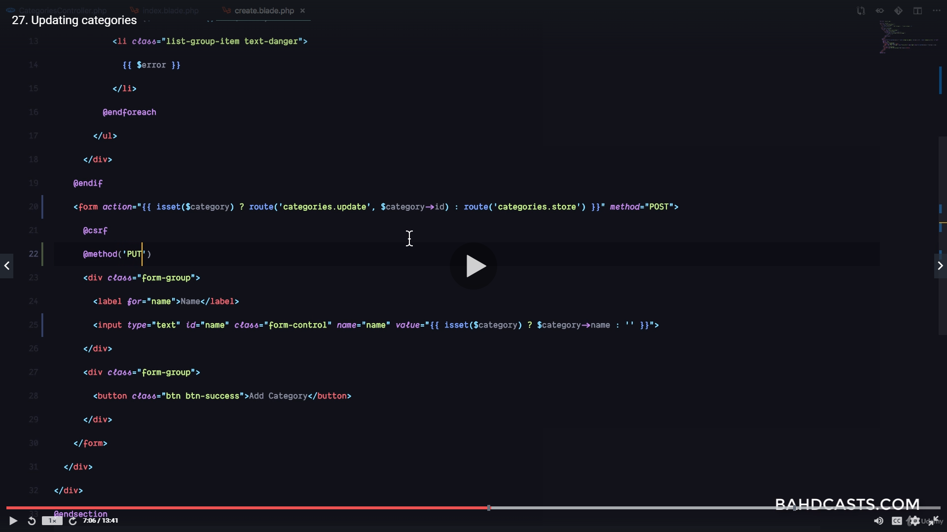
we only want to add the put directive if a value has been passed for update
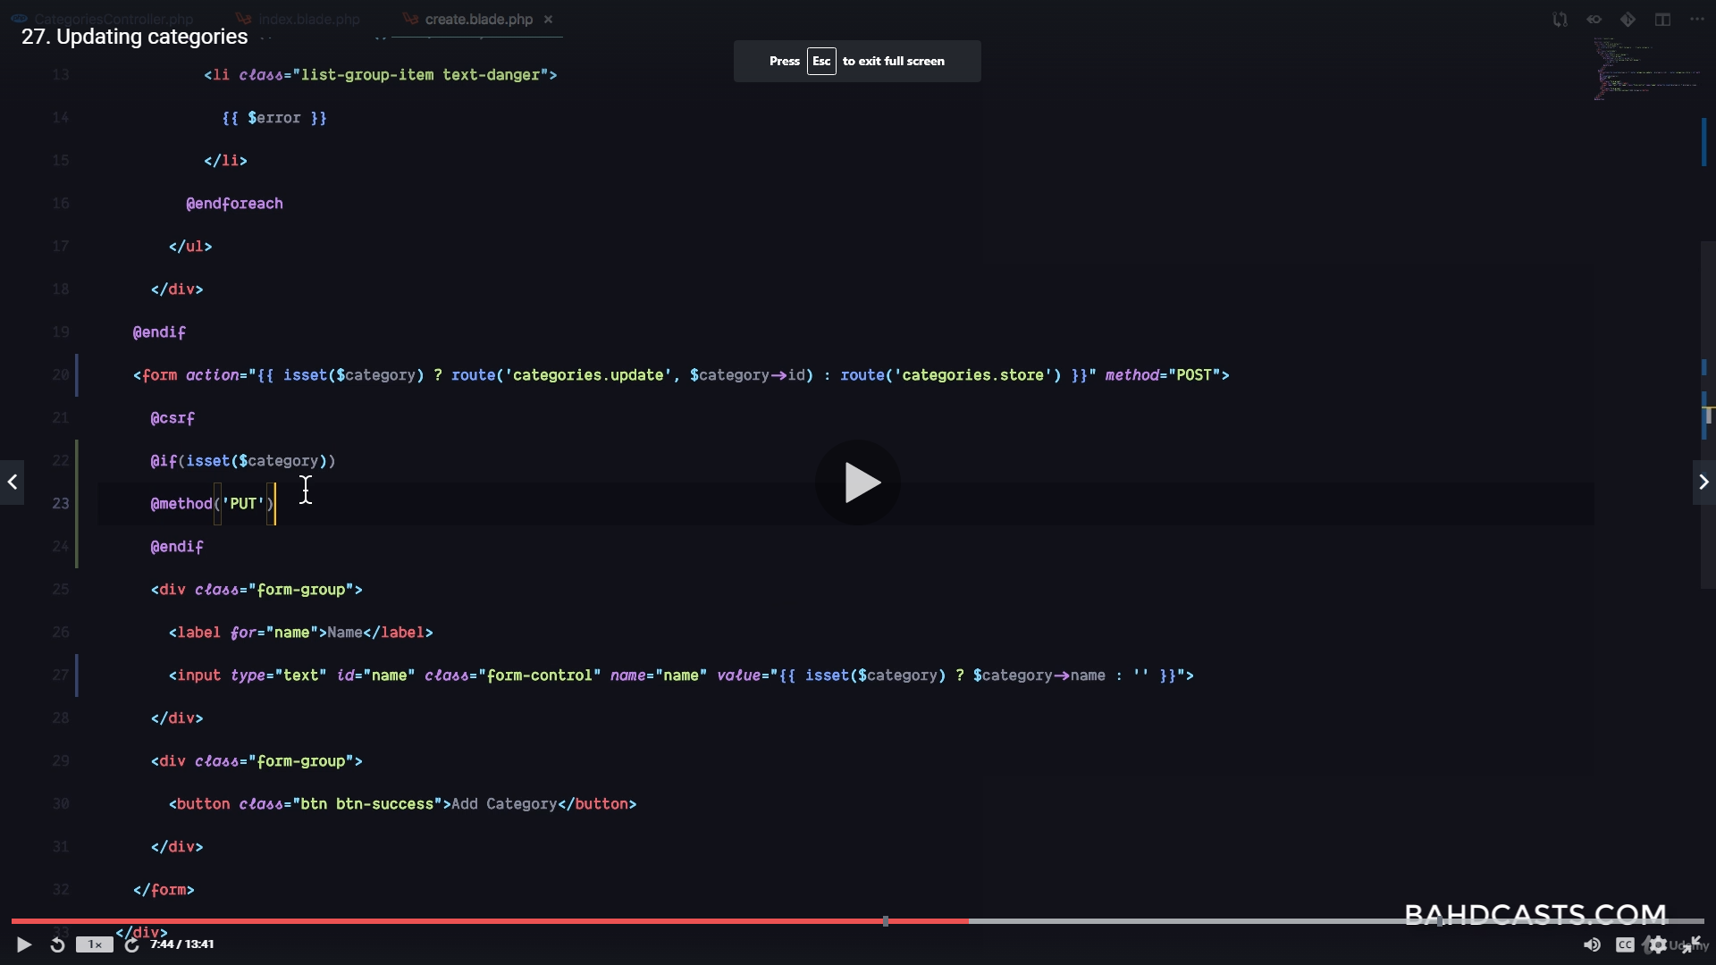
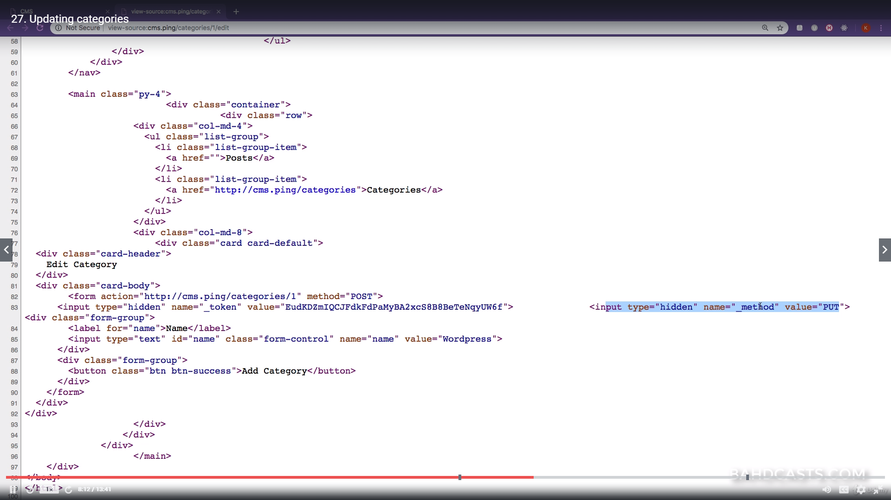
isset for button text
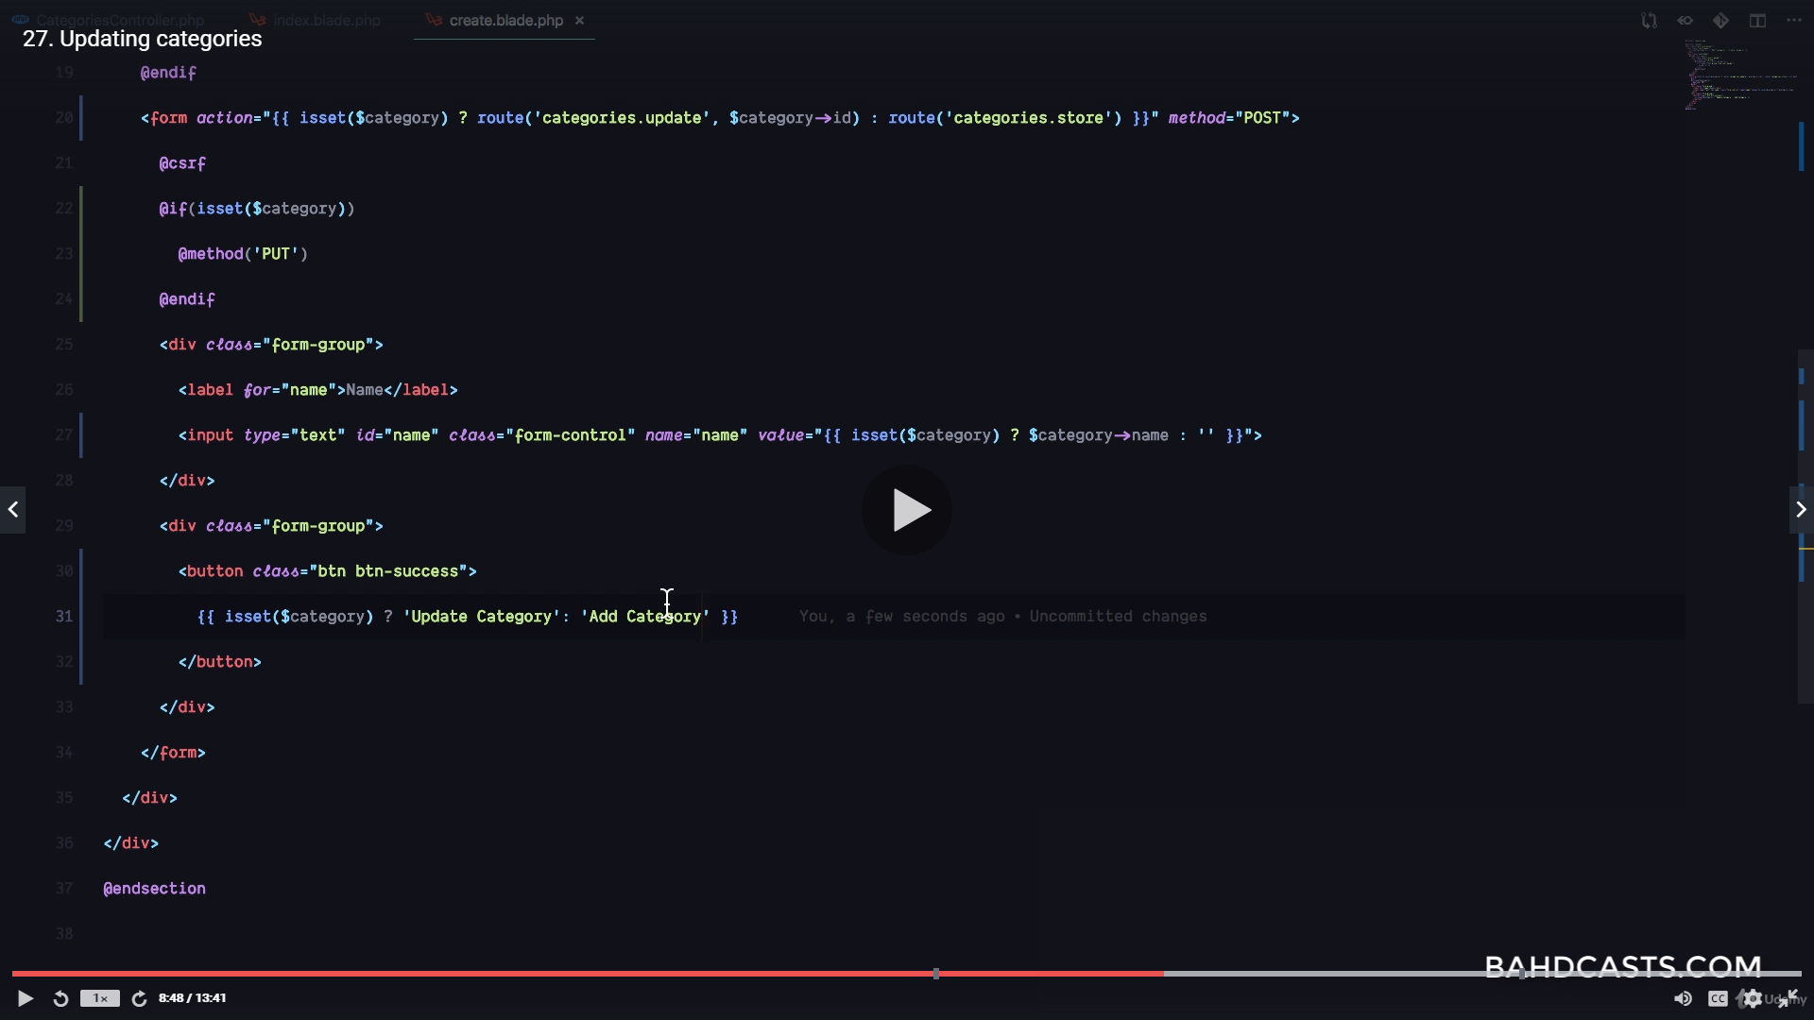
Requests for updating. Type hint the request first, then type hint the dynamic property (Category $category)
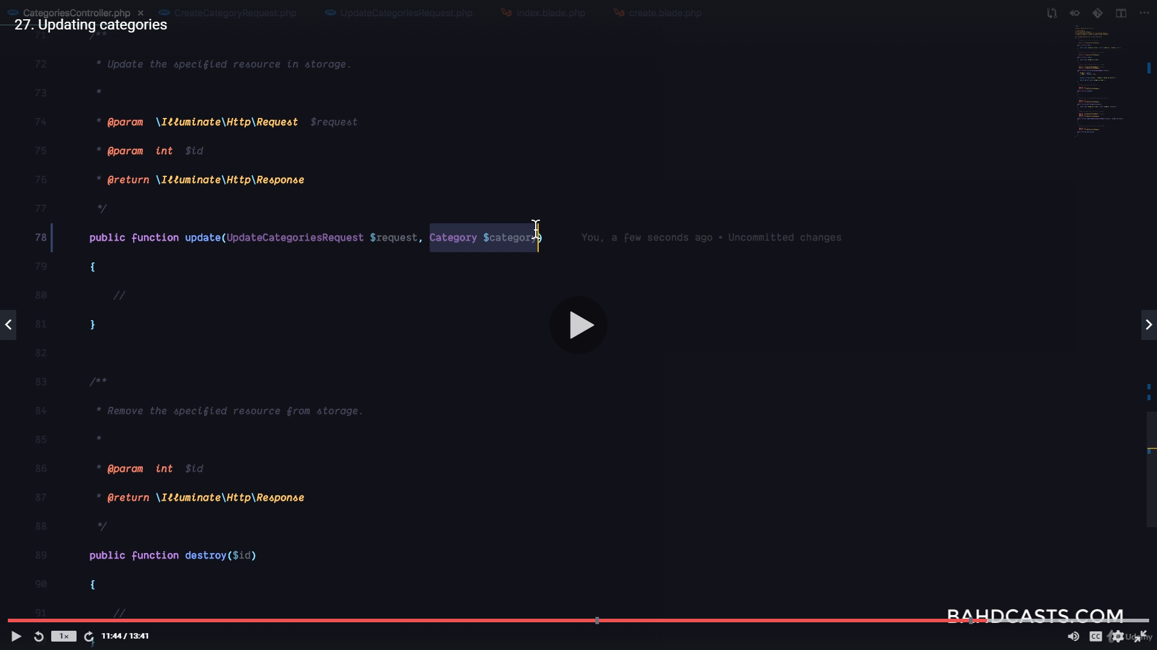
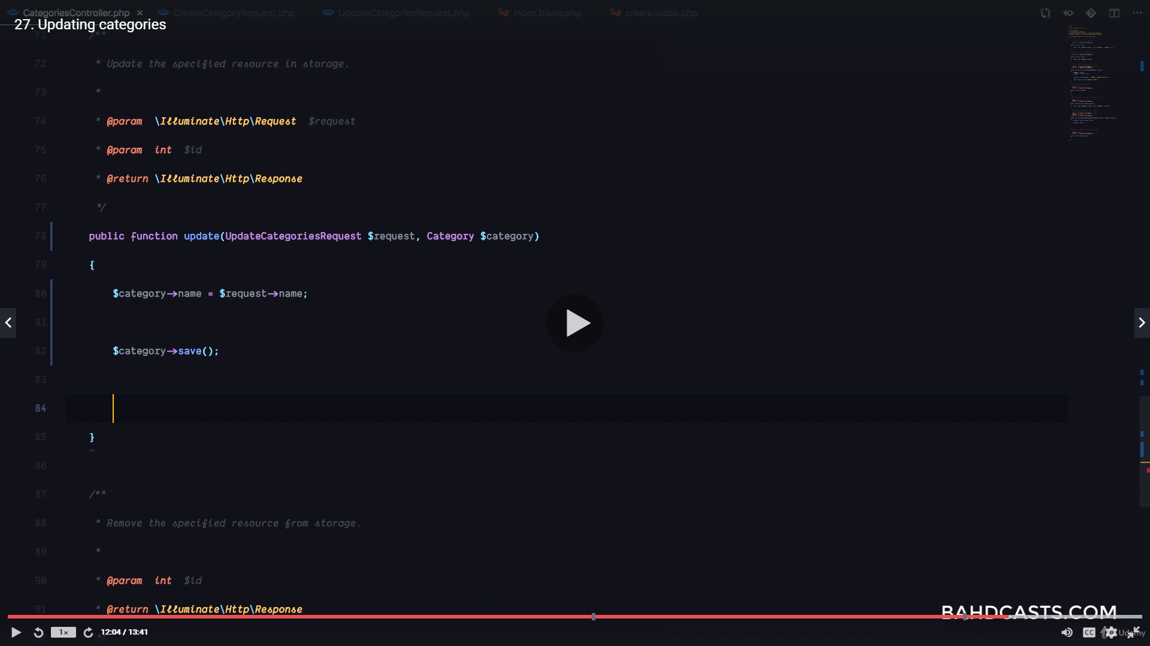
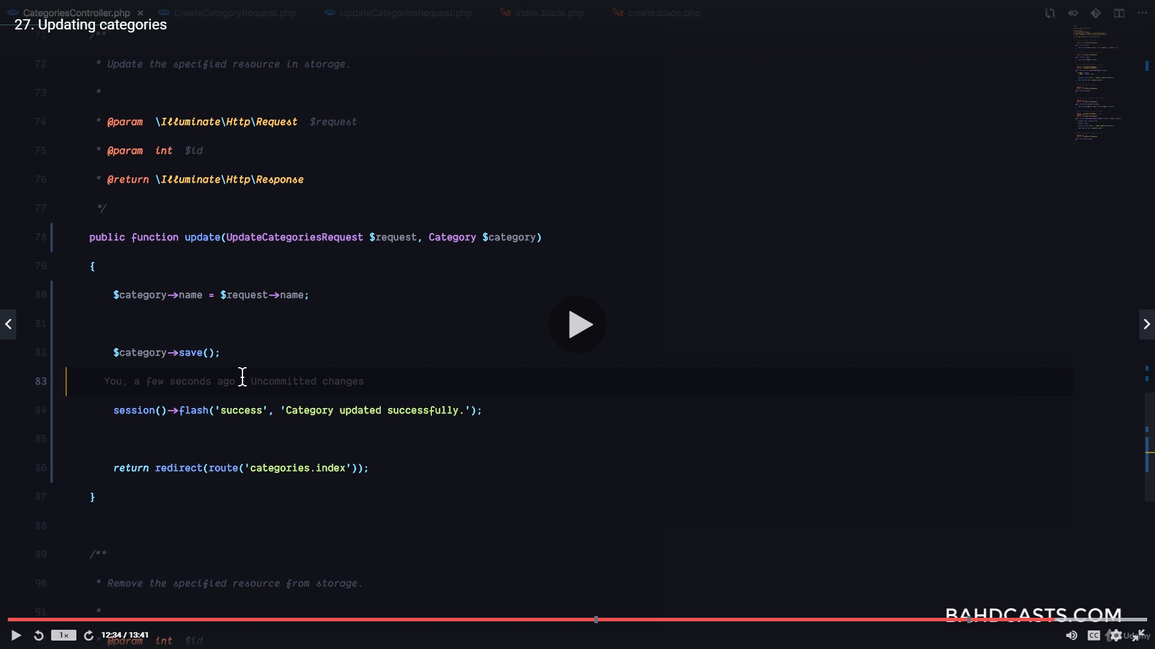
alternative code for updating is below.
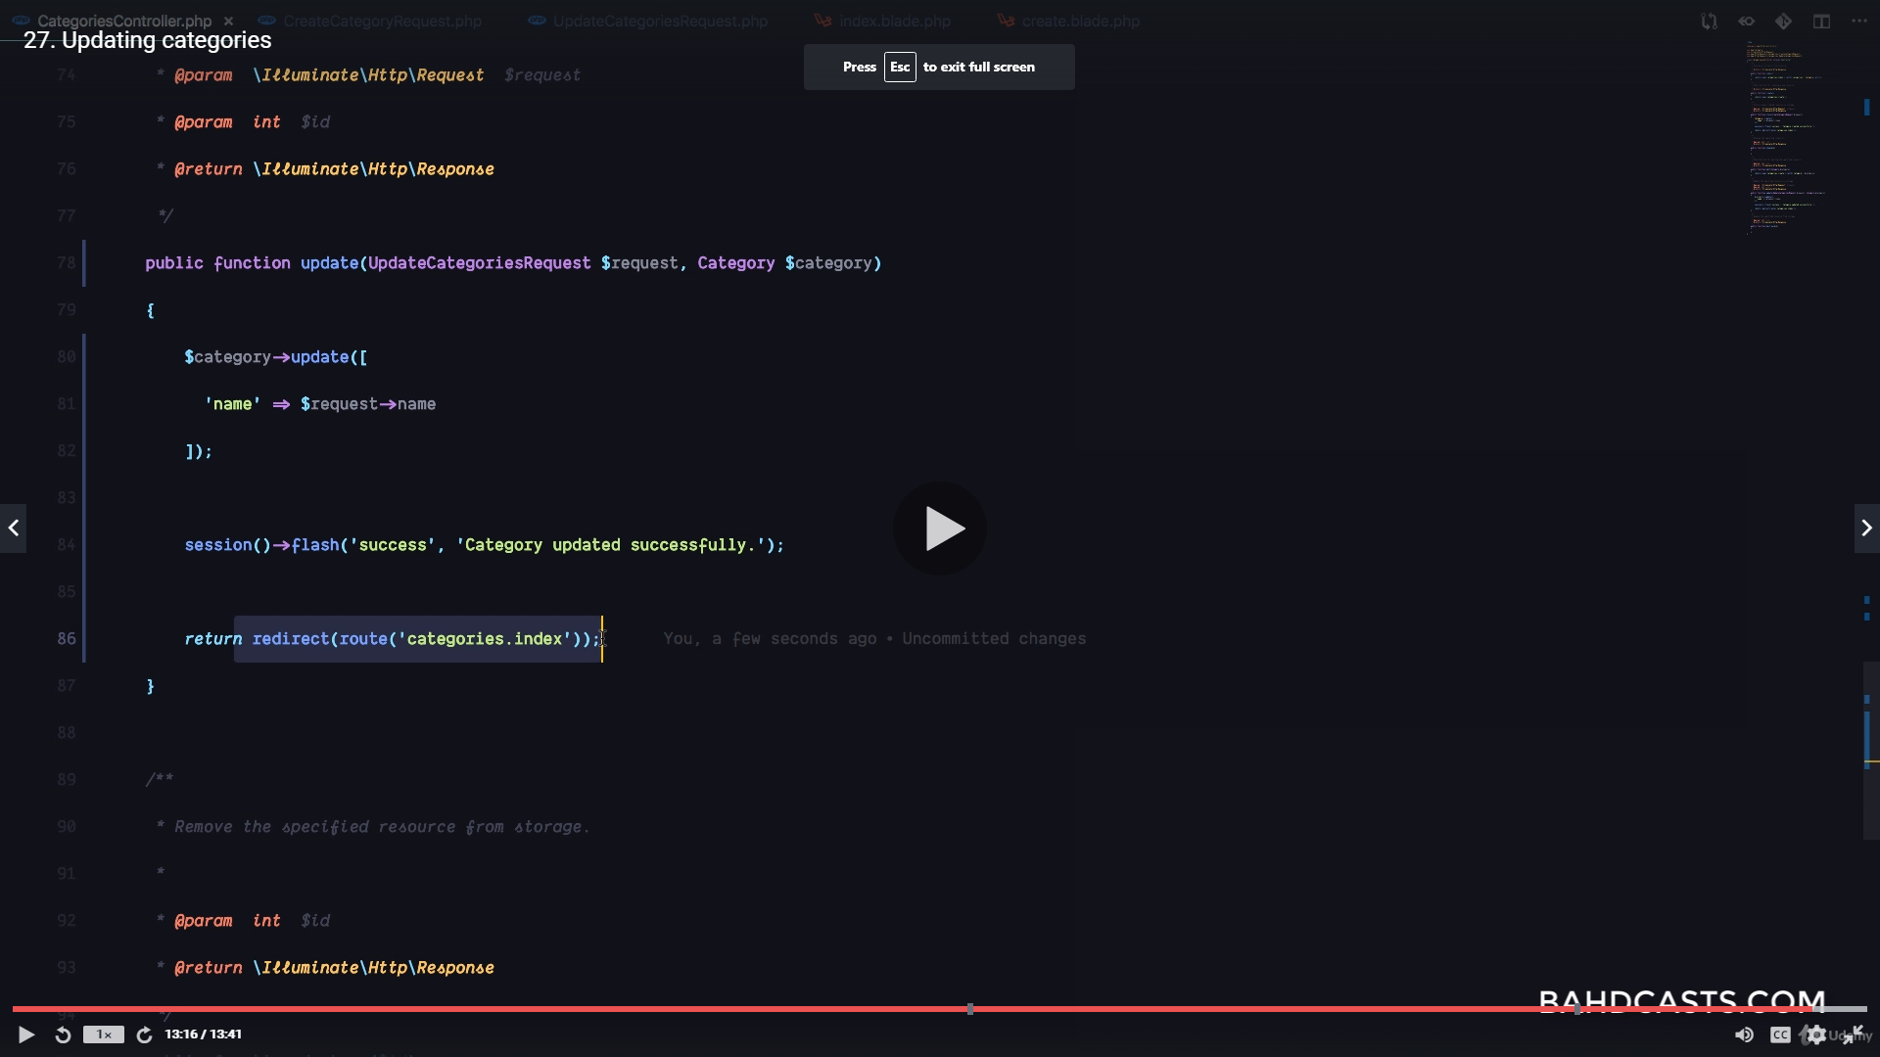
Passing id to function that is called onclick
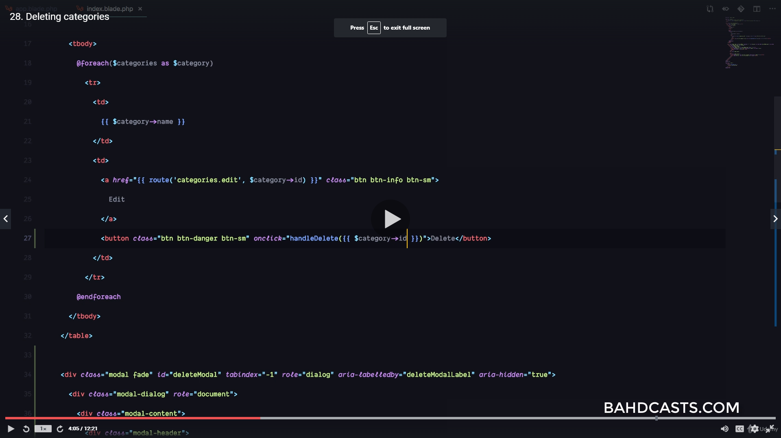
the function
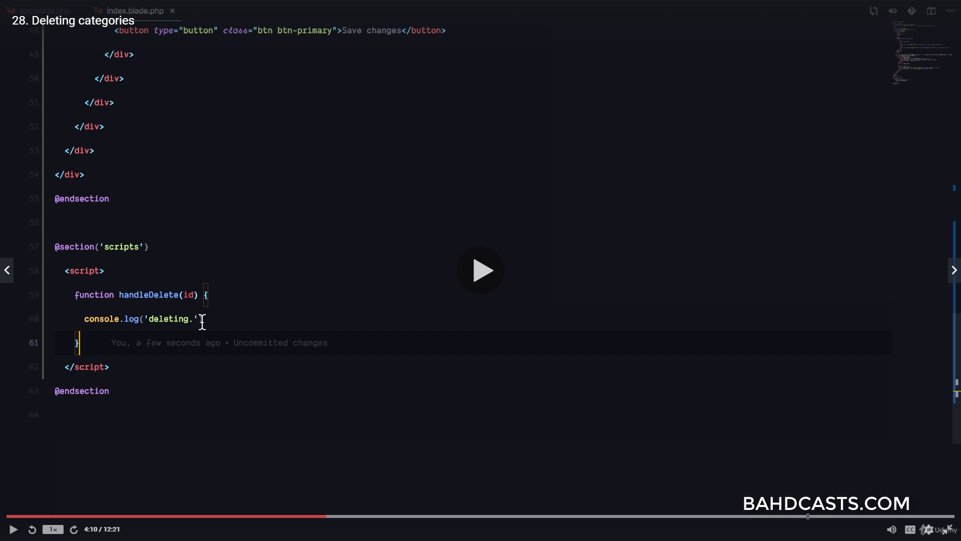
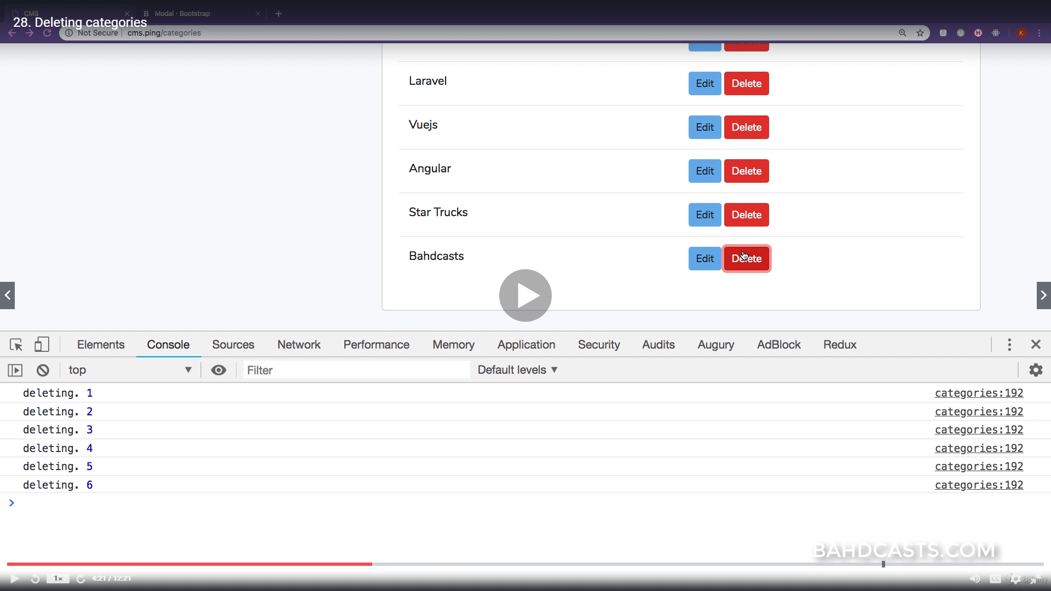
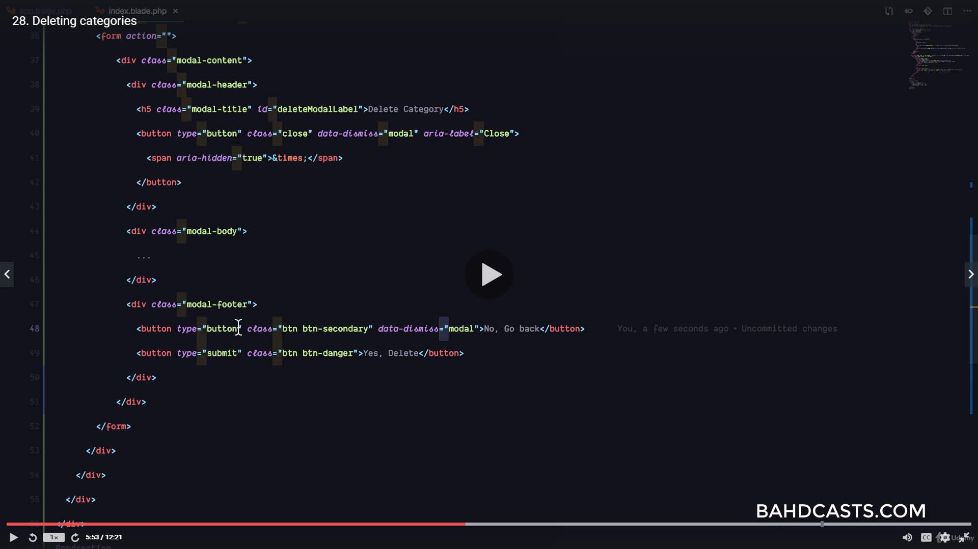
request rules in custom request
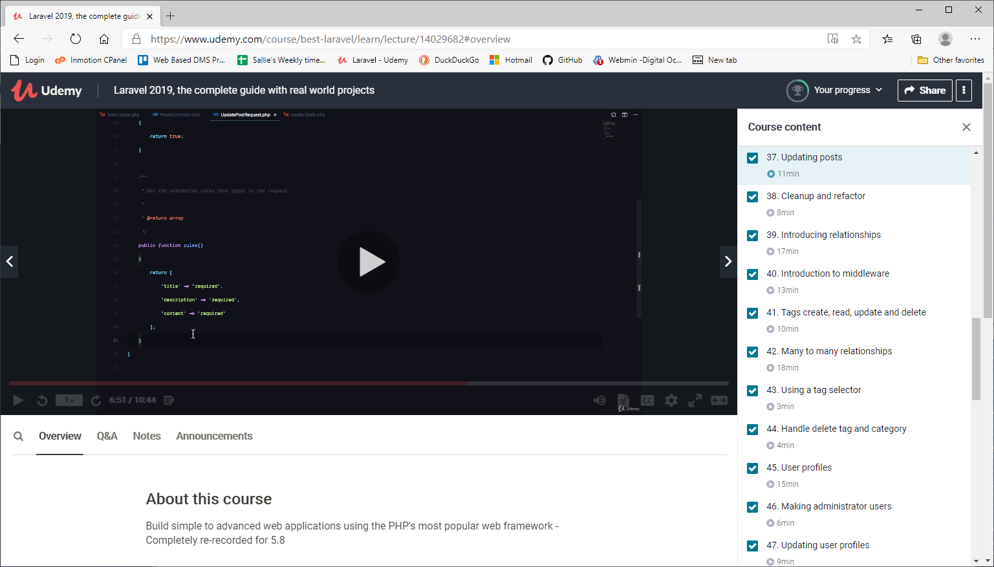

I kept getting this error
Illuminate\Database\QueryException
SQLSTATE[HY000]: General error: 1364 Field 'id' doesn't have a default value (SQL: insert into `buildings` () values ())
http://127.0.0.1:8000/buildings/1

Then I set the strict value to false. It defaulted to true in the config/database.php. No more error!
'mysql' => [
'driver' => 'mysql',
'url' => env('DATABASE_URL'),
'host' => env('DB_HOST', '127.0.0.1'),
'port' => env('DB_PORT', '3306'),
'database' => env('DB_DATABASE', 'forge'),
'username' => env('DB_USERNAME', 'forge'),
'password' => env('DB_PASSWORD', ''),
'unix_socket' => env('DB_SOCKET', ''),
'charset' => 'utf8mb4',
'collation' => 'utf8mb4_unicode_ci',
'prefix' => '',
'prefix_indexes' => true,
'strict' => false,
'engine' => null,
'options' => extension_loaded('pdo_mysql') ? array_filter([
PDO::MYSQL_ATTR_SSL_CA => env('MYSQL_ATTR_SSL_CA'),
]) : [],

