Wrong ID being selected when multiple tables joined (all have ID col)
The order of the joins matters. In the example below organizations is the first table, so I thought that would be the ID selected, but NO. The buildings.ID is the one selected.
$data = DB::table('organizations')
->join('buildings', 'buildings.organizations_id', '=', 'organizations.id')
->leftJoinSub($addresses, 'addr', function($join){
$join->on('buildings.id', '=', 'addr.owner_id');
})

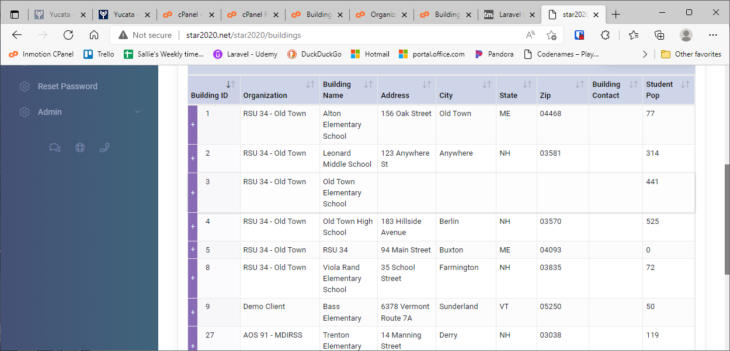

If I change the order to have buildings first and organizations last, the organizations.ID is the one that will be selected.
$data = DB::table('buildings')
->join('organizations', 'buildings.organizations_id', '=', 'organizations.id')
->leftJoinSub($addresses, 'addr', function($join){
$join->on('buildings.id', '=', 'addr.owner_id');
})

