Essex Westford 5/31/2021 - StarDoc has mostly negative budgeted values, but there are No values for this that are < 0

query for star2020
SELECT * FROM y2021_floorplan_machines fpm
inner join floorplans fp on fp.fp_id = fpm.floorplans_id
inner join buildings bldg on bldg.bldg_id = fp.buildings_id
where bldg.organizations_id = 96 AND fpm.budgeted_black < 0;

query for starDoc
SELECT * FROM Y2021_floorplan_machines fpm
inner join floorplans fp on fp.id = fpm.floorplan_id
inner join buildings bldg on bldg.id = fp.building_id
where bldg.org_id = 96 AND fpm.budgeted_blk < 0;

The note at the top says that the Budgeted numbers are accurate. Where do these numbers come from??
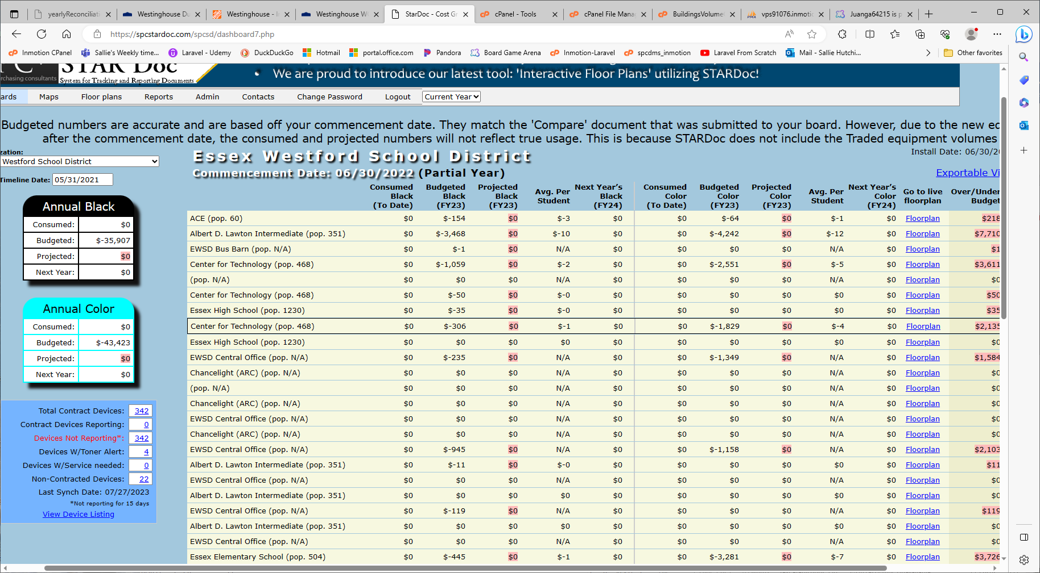

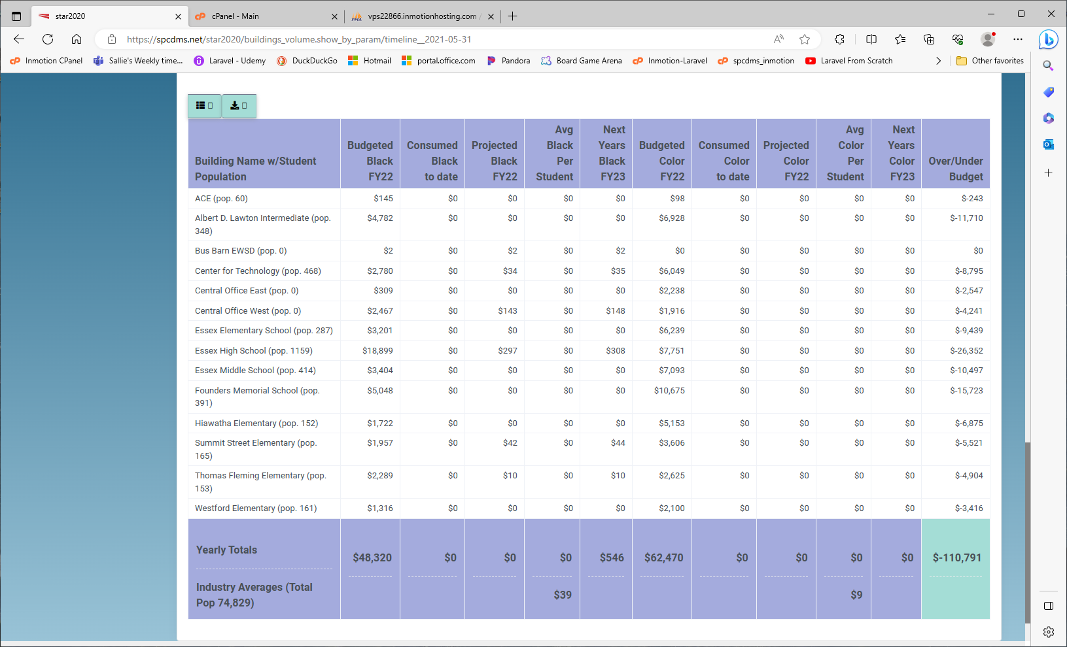

Essex High School (pop.1230) is listed 10 times with different budgeted volumes for each. Why is this??
