This is just a tooltip when hovering over the Floorplans link.
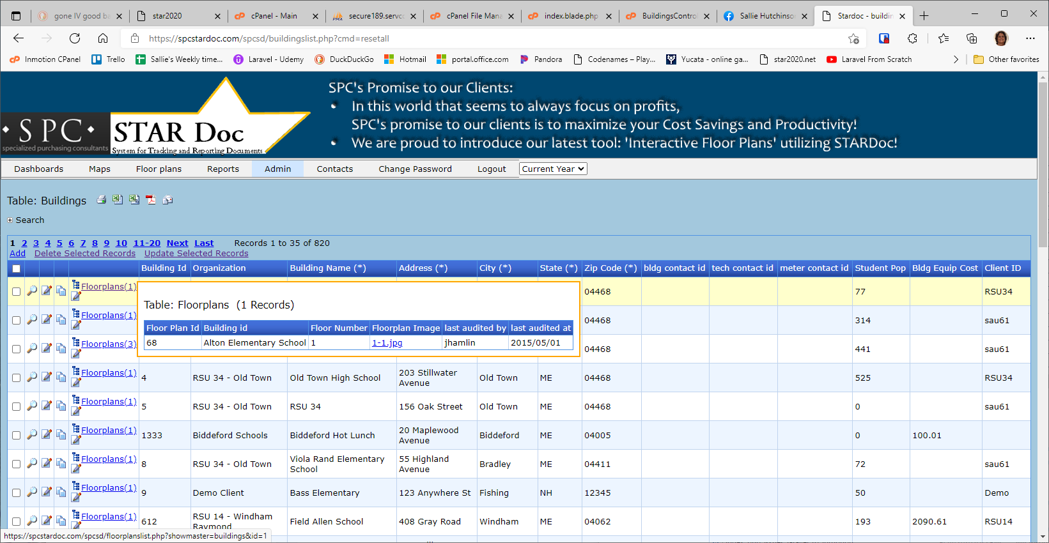

This is the page that the link goes to
