404 error when clicking login from the welcome page

Resolution from https://stackoverflow.com/questions/41268058/404-error-in-login-laravel
You are trying to access http://elgloborojocatalogos.com.mx/login , But it shows file not found. which is pretty obvious, because you are missing index.php before login like below
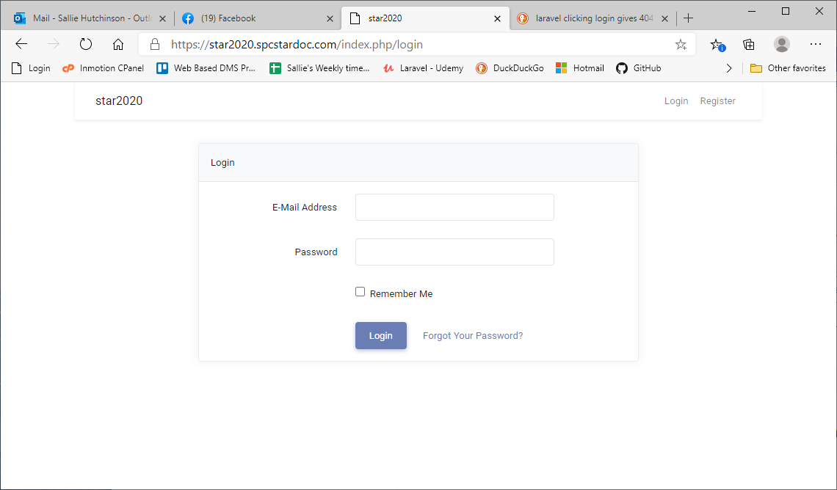
http://elgloborojocatalogos.com.mx/index.php/login
Now it will do the trick, but sure it looks ugly. So for removing index.php you need to add a .htaccess file in the public_html folder, which is root. So, simply create a file and name it .htaccess and copy paste this following line of code to the file.
<IfModule mod_rewrite.c>
RewriteEngine On
RewriteBase //
RewriteCond %{REQUEST_FILENAME} !-f
RewriteCond %{REQUEST_FILENAME} !-d
RewriteRule ^(.*)$ index.php?$1 [L]
</IfModule>
It should work as expected now

/***********************************************************************/
https://stackoverflow.com/questions/18740419/how-to-set-allowoverride-all
In case you are on Ubuntu, edit the file /etc/apache2/apache2.conf (here we have an example of /var/www):
<Directory /var/www/>
Options Indexes FollowSymLinks
AllowOverride None
Require all granted
</Directory>
and change it to;
<Directory /var/www/>
Options Indexes FollowSymLinks
AllowOverride All
Require all granted
</Directory>
then,
sudo service apache2 restart
You may need to also do sudo a2enmod rewrite to enable module rewrite.

